Core Flight System

Command and Data Dictionary Utility

User’s Guide

Engineering Directorate

Software, Robotics, and Simulation Division

Version 2.1.4

June 2023



National Aeronautics and Space Administration

Lyndon B. Johnson Space Center

Houston, Texas 77058-3696

**Contents**

1.0 Description 7

2.0 Requirements 8

3.0 Installation 8

4.0 Operation 8

4.1 Getting Started 8

4.2 Database 25

4.2.1 Setup 25

4.2.2 Authentication 26

4.2.3 Roles 26

4.2.4 Connection recovery 26

4.2.5 Project access control 26

4.3 Event Log 27

4.4 Mouse and Keyboard Navigation 28

4.5 Data Tables 30

4.5.1 Table types 30

4.5.1.1 Structure tables 30

4.5.1.2 Command tables 33

4.5.1.3 Enum tables 34

4.5.2 Table groups 35

4.5.3 Table tree 35

4.5.3.1 Variable tree 37

4.5.4 Data types 38

4.5.5 Bit fields 39

4.5.6 Enumerations 40

4.5.7 Macros 40

4.6 Data Fields 41

4.6.1 Data field editor 42

4.7 Input Types 44

4.8 Data Streams 49

4.9 Command Menu 49

4.9.1 File 49

4.9.1.1 Select user 49

4.9.1.2 Database server 50

4.9.1.3 Read log 51

4.9.1.4 Print log 51

4.9.1.5 Search log 51

4.9.1.6 Web server 53

4.9.1.7 Preferences 64

4.9.1.8 Exit 70

4.9.2 Project 70

4.9.2.1 Open 71

4.9.2.2 Close 71

4.9.2.3 New 71

4.9.2.4 Rename 72

4.9.2.5 Copy 73

4.9.2.6 Delete 74

4.9.2.7 Backup 75

4.9.2.8 Restore 76

4.9.2.9 Unlock 77

4.9.2.10 Verify 78

4.9.2.11 Change owner 80

4.9.2.12 Manage users 81

4.9.2.13 Recently opened project(s) 83

4.9.3 Data 83

4.9.3.1 New table(s) 83

4.9.3.2 Edit table(s) 84

4.9.3.3 Recent 96

4.9.3.4 Rename table 96

4.9.3.5 Copy table 97

4.9.3.6 Delete table(s) 97

4.9.3.7 Import data 98

4.9.3.8 Export data 103

4.9.3.9 Manage groups 108

4.9.3.10 Manage table types 112

4.9.3.11 Manage data types 119

4.9.3.12 Manage input types 122

4.9.3.13 Manage macros 125

4.9.3.14 Message IDs 127

4.9.3.15 Manage project fields 131

4.9.3.16 Show/edit fields 132

4.9.3.17 Padding 135

4.9.3.18 Show variables 137

4.9.3.19 Show commands 139

4.9.3.20 Search tables 140

4.9.3.21 Search variables 143

4.9.4 Scheduling 146

4.9.4.1 Manage links 146

4.9.4.2 Telemetry 151

4.9.4.3 Applications 155

4.9.4.4 Rate parameters 157

4.9.4.5 App parameters 158

4.9.5 Script 159

4.9.5.1 Manage 159

4.9.5.2 Execute 163

4.9.5.3 Store 165

4.9.5.4 Retrieve 165

4.9.5.5 Delete 166

4.9.5.6 Search 167

4.9.6 Help 169

4.9.6.1 Guide 169

4.9.6.2 About 169

Appendix A. Acronyms 170

Appendix B. Definitions 171

Appendix C. Import and Export Format 173

Appendix C.1. CSV 178

Appendix C.2. EDS 185

Appendix C.3. JSON 194

Appendix C.4. XTCE 207

Appendix D. Error & Warning Messages 217

Appendix E. Program Notes 246

Appendix E.1. Key reference 246

Appendix E.2. Program preferences 248

Appendix E.3. CCDD class files 254

Appendix E.4. PostgreSQL tables 261

Appendix E.5. PostgreSQL Functions 269

Appendix E.6. Known Issues 274

**Figures**

Figure 1. CCDD inputs and outputs 7

Figure 2. CCDD main window 25

Figure 3. Example array display 32

Figure 4. Example dialog 32

Figure 5. Command to argument relation 34

Figure 6. Enum Structure 34

Figure 7. Enum table representing enum structure in figure 6 35

Figure 8. Table tree 36

Figure 9. Table tree expansion 36

Figure 10. Data field editor 42

Figure 11. Select User dialog (no server connection) 50

Figure 12. Select User dialog (server connected) 50

Figure 13. Database server dialog 51

Figure 14. Search event log dialog 52

Figure 15. Web Server dialog 64

Figure 16. Preferences dialog; look and feel preferences 64

Figure 17. Example look and feel differences 65

Figure 18. Font preferences 65

Figure 19. Font selection dialog 66

Figure 20. Color preferences 66

Figure 21. Color selection dialog 67

Figure 22. Size preferences 67

Figure 23. Spacing preferences 68

Figure 24. Path preferences 69

Figure 25. Other settings 70

Figure 26. Select Project dialog 71

Figure 27. Create Project dialog 72

Figure 28. Rename Project dialog 73

Figure 29. Copy Project dialog 74

Figure 30. Delete Project dialog 75

Figure 31. Backup Project dialog 76

Figure 32. Unlock Project(s) dialog 78

Figure 33. Verification and termination dialog 79

Figure 34. Example Perform Corrections dialog 80

Figure 35. Change Project Owner dialog 81

Figure 36. Manage User Access Level dialog 82

Figure 37. New Table dialog 84

Figure 38. Edit Table dialog 85

Figure 39. Example table editor 85

Figure 40. Import data and fields into an existing table dialog 88

Figure 41. Import options 89

Figure 42. Data table search and replace dialog 90

Figure 43. Example of macro name display and pop-up dialog in a data table 93

Figure 44. Special indicator flag example 93

Figure 45. Rename Table dialog 96

Figure 46. Copy Table dialog 97

Figure 47. Delete Table dialog 98

Figure 48. CSV import dialog 100

Figure 49. EDS import dialog 100

Figure 50. JSON import dialog 101

Figure 51. XTCE import dialog 101

Figure 52. C header import dialog 102

Figure 53. CSV export dialog 105

Figure 54. EDS export dialog 106

Figure 55. JSON export dialog 107

Figure 56. XTCE export dialog 108

Figure 57. Manage Groups dialog 109

Figure 58. New Group dialog 110

Figure 59. Table type editor 112

Figure 60. New table type dialog 115

Figure 61. Data Type Editor dialog 120

Figure 62. Example pointer to a structure data type 121

Figure 63. Structure name pop-up 121

Figure 64. Input Type Editor dialog 122

Figure 65. Macro Editor dialog 125

Figure 66. Example of macro name selection pop-up dialog in a macro value cell 126

Figure 67. Assign Message IDs dialog 127

Figure 68. Assign Group Message IDs dialog 128

Figure 69. Reserved Message ID Editor dialog 129

Figure 70. Example Show all IDS dialog 130

Figure 71. Example Duplicate Message IDs dialog 131

Figure 72. Project data field management dialog 131

Figure 73. Example Select Data Field(s) dialog 132

Figure 74. Example Show/Edit Data Fields dialog 133

Figure 75. Padding adjustment dialog 135

Figure 76. Structure table showing highlighted padding variables 136

Figure 77. Example padding adjustment progress/cancellation dialog 136

Figure 78. Example variable paths & names dialog 139

Figure 79. Example command information dialog 140

Figure 80. Search tables dialog 141

Figure 81. Select Column(s) dialog 142

Figure 82. Variable search dialog 143

Figure 83. Example of Show all variables 145

Figure 84. Search via table tree example 146

Figure 85. Manage Links dialog 147

Figure 86. New Link dialog 148

Figure 87. Copy Link(s) dialog 149

Figure 88. Example link copy failure dialog 150

Figure 89. Telemetry Scheduler dialog 151

Figure 90. Telemetry message auto-fill progress/cancellation dialog 152

Figure 91. Assign telemetry message names and IDs dialog 153

Figure 92. Application Scheduler dialog 155

Figure 93. Application time slot auto-fill progress/cancellation dialog 156

Figure 94. Rate Parameters dialog 157

Figure 95. Application Parameters dialog 159

Figure 96. Manage Script Associations dialog 160

Figure 97. Execute Script(s) dialog 164

Figure 98. Halt script execution dialog 164

Figure 99. Script selection dialog 165

Figure 100. Retrieve Script(s) dialog 166

Figure 101. Delete Script(s) dialog 167

Figure 102. Script search dialog 168

Figure 103. About dialog 169

Figure 104. Structure table for import/export format examples 173

Figure 105. Command table for import/export examples 173

Figure 106. No-op command payload structure 174

Figure 107. Arm command payload structure 174

Figure 108. Fire command payload structure 174

Figure 109. Thrust level command payload structure 175

Figure 110. Command reference table for import/export examples 175

Figure 111. Structure table type definition for import/export example 176

Figure 112. Command table type definition for import/export example 176

Figure 113. Data field and macro definitions for import/export example 178

**Tables**

Table 1. Command line arguments 21

Table 2. Structure column names and input data types 31

Table 3. Command column names and input data types 33

Table 4. Variable tree icons 38

Table 5. Default primitive data types 39

Table 6. Web data access commands 63

Table 7. XML special data fields 106

# Description

The Core Flight System (CFS) Command and Data Dictionary (CDD) utility, or CCDD, is a software tool for managing the command and telemetry data for CFS and CFS applications. CCDD is written in Java™ and interacts with a PostgreSQL database, so it can be used on any operating system that supports the Java Runtime Environment (JRE) and PostgreSQL. CCDD is released as open source software under the NASA Open Source Software Agreement, version 1.3, and is hosted on GitHub.

The CCDD application uses tables, similar to a spreadsheet, to display and allow manipulation of telemetry data structures, command information, and other data pertinent to a CFS project. The data is stored in a PostgreSQL database for manipulation and data security. The PostgreSQL database server can be run locally or centralized on a remote host for easier access by multiple users. Data can be imported into the application from files in comma-separated values (CSV), JavaScript Object Notation (JSON), electronic data sheet (EDS), and extensible markup language (XML) telemetric and command exchange (XTCE) formats. Data can be exported from the application to files in CSV, JSON, EDS, and XTCE formats. The CCDD tables also allow simple cut and paste operations from the host operating system’s clipboard. To make use of the project’s data, CCDD can interact with Java Virtual Machine (JVM)-based scripting languages via a set of supplied data access methods. Using scripts, the user can translate the data stored in the CCDD’s database into output files. Example scripts for creating common CFS related output files are provided in four of these scripting languages. An embedded web server can be activated, allowing web-based application access to the data. Figure 1 shows the basic relation between CCDD and external sources.

**Legend**

Data output

Data input

Data request

**Script Access**

**Output Files**

C headers, ITOS record and display, etc.

**Scripts**

JavaScript, Python, Ruby, Groovy, Scala, etc.

**CCDD**



**CSV Files**

**JSON Files**

**XML Files**

EDS

XTCE

**Clipboard**

**Web Applications**

**Embedded Web Server**

1. CCDD inputs and outputs

**Project Database**

Questions or comments concerning this document or the CCDD application should be addressed to:

Johnson Space Center

Software, Robotics, and Simulation Division

Spacecraft Software Engineering Branch, Mail Code ER6

Houston, TX 77058

# Requirements

CCDD is written based on the following Java and PostgreSQL versions:

* Java 1.8
  + Developed in Linux using JavaSE 1.8 and tested on CentOS 7 Linux, Microsoft Windows 10, and Apple OS X using JavaSE 1.8
* PostgreSQL 9.2 and subsequent (*note: CCDD has not been tested above PostgreSQL 12*)

CCDD comes with the following Java Database Connectivity (JDBC) driver, embedded Jetty web server, and JavaScript Object Notation (JSON) versions:

* JDBC driver 42.5.2
* Jetty 9.2.18.v20160721
* JSON simple 1.1.1

Scripting language testing was performed using the following languages and versions:

* JavaScript (ECMAScript) 1.8 (Mozilla Rhino 1.7 release 3)
* JavaScript ECMA – 262 Edition 5.1 (Oracle Nashorn 1.8.0_131)
* Python 2.7 (Jython 2.7)
* Python 2.7 and 3 (Py4J 0.10.9.7)
* Ruby 9.4.2.0 (JRuby 9.4.2.0)
* Groovy 2.4.4 (Groovy Scripting Engine 2.0)
* Scala 2.12.4 (Scala REPL 2.0) - *requires Java 1.8*

EDS and XTCE XML schema versions:

* EDS 1.3.112.4.17.1
* XTCE 1.1

Compatibility with other versions, in particular earlier ones, is not guaranteed.

# Installation

See the CCDD Installation Guide.

# Operation

## Getting Started

To run the application open a command prompt window and type:

java –classpath *class_paths* CCDD.CcddMain [*args…*]

Example with no arguments

java -classpath CCDD.jar:CCDD_lib/*:/path/jython-standalone-2.7.2.jar CCDD.CcddMain

where *class_paths* includes the paths and .jar file names for the CCDD application (CCDD.jar) and supporting libraries, separated by colons (:) with no intervening spaces, and *args* are optional command line arguments in the form:

[<- or />*command* [*value*] […]]

If no args or additional libraries are going to be supplied than you can launch the tool using

java –jar CCDD.jar

Versions of the JDBC driver, Jetty server, and JSON conversion libraries are included in the CCDD_lib folder as well as embedded in the CCDD.jar file. If the default version is incompatible with the installation or an updated version is desired then the defaults can be overridden by including the library path(s) and .jar file name(s) in the *class_paths* argument. The library files needed are shown below; <*version*> is the specific version number of the installed file that is part of the file’s name.

*<Apache Commons path>*/commons-io-*<version>*.jar

*<Apache Commons path>*/commons-lang3-*<version>*.jar

*<path>*/EDS.jar

*<path>*/XTCE.jar

*<JAXB path>*/jaxb-api-*<version>*.jar

*<JAXB path>*/jaxb-core-*<version>*.jar

*<JAXB path>*/jaxb-impl-*<version>*.jar

<*JDBC path*>/postgresql-*<version>*.jar

<*Jetty path*>/lib/jetty-http-*<version>*.jar

<*Jetty path*>/lib/jetty-io-*<version>*.jar

<*Jetty path*>/lib/jetty-security-*<version>*.jar

<*Jetty path*>/lib/jetty-server-*<version>*.jar

<*Jetty path*>/lib/jetty-servlet-*<version>*.jar

<*Jetty path*>/lib/jetty-util-*<version>*.jar

<*Jetty path*>/lib/servlet-api-*<version>*.jar

<*JSON path*>/json-simple-*<version>*.jar

The library class path(s) must be specified for each scripting language other than JavaScript. The library files required by Ruby, Python, Groovy, and Scala are shown below; <*version*> is the specific version number of the installed file that is part of the file’s name. Library files for other JSR-223 scripting languages should follow a similar format.

<*JRuby path*>/lib/jruby-complete-*<version>*.jar

*Note: the JRuby reference must precede the other scripting language library references*

<*Jython path*>/jython-standalone-*<version>*.jar

<*Py4J path*>/py4j*<version>*.jar

<*Groovy path*>/lib/groovy-<*version*>.jar:<*Groovy path*>/lib/groovy-jsr223-<*version*>.jar

<*Scala path*>/lib/scala-compiler.jar

Each command line argument consists of a command, preceded by either a ‘-‘ or ‘/’, followed by a space, then the command value. The available commands and acceptable values are described in Table 1. The commands can be entered in any order. If the same command is entered more than once then each instance is applied/executed in the order of appearance on the command line. The commands are not case-sensitive, so “-user” is the same as “-USER”, “-User”, etc.

The import and export commands require one or more sub-commands. The sub-commands are listed in Table 1 directly beneath the entries for the export and import commands. The sub-commands have the same constraints as the commands, as described in the previous paragraph. However, the entire list of sub-commands must be bounded by single or double quotes. For example, the arguments for an export command would look similar to:

java –jar CCDD.jar –project project_name -export “-tablePaths tableName –filePath /user/name/exportFolder” -shutdown

or

java -classpath CCDD.jar:CCDD_lib/*:/path/jython-standalone-2.7.2.jar CCDD.CcddMain –project project_name -export “-tablePaths tableName –filePath /user/name/exportFolder” -shutdown

Single quotes may be used to bound command values within the export sub-command string if the string is bounded by double quotes, and vice versa.

| **Command** | | **Description** | **Value** | **Default Value** |
| --- | --- | --- | --- | --- |
| backup | | Sets the file path and name to which to automatically backup the project database once it is successfully connected. The extension “.dbu” is automatically appended to the file name if not already present. Only applies to the first successful connection | File path and name of the project backup file | *None* |
| command | | Selects whether or not to display event log command messages | “true” to display event log command messages in the main application window; “false” to hide event log command messages. The value text is case insensitive | true |
| create | | Create a new project database. The project is opened if the *project* command is included and specifies this project name. The *import* command can then be used to populate the project and the *execute* command can then execute scripts | Quoted (single or double) string containing one or more create sub-commands. See paragraph 4.9.2.3 for details | *None* |
| create commands | description | Description of the new project | Text (optional) | *None* |
| name | Name of the new project | Project database name. The project’s database name is case sensitive | *None* |
| owner | Owner and administrator of the new project | Must be a valid PostgreSQL server role. If not specified then the current user becomes the owner | *None* |
| restore | Name of a backup file, or directory if restoring from multiple JSON/CSV files, to restore into the newly created project database | File path and name of the project backup file to restore (Can be a file of type .dbu, .json or .csv if restoring from a single file. Must be a directory if restoring from multiple files via JSON/CSV) | *None* |
| delete | | Delete an existing project database. The user must have administrative level access for the project in order to delete it | Project database name. The project’s database name is case sensitive | *None* |
| delete commands | name | Name of the project to delete | Project database name. The project’s database name is case sensitive | *None* |
| continueIfMissing | Continue to process subsequent commands even if the project doesn't exist | *None* | *N/A* |
| events | | Selects whether or not to display all event log messages | “true” to display all event log messages in the main application window; “false” to hide all event log messages. The value text is case insensitive | true |
| execute | | Runs the supplied script association(s), or script(s) using the supplied table(s) and/or group(s). The application’s graphical user interface (GUI) is not displayed; exits upon completion of the script(s). See paragraph 4.9.5.1 for more detail | Script association name or script file name and associated table(s). Script file paths are required if the script is in a folder other than the one from which the application is executed. If the script requires one or more tables to be specified then the table name(s) and/or group name(s) are placed after the script name and a colon. Group names must be preceded by ‘Group:’. If multiple tables/groups are specified the table/group names must be separated by a plus (+) character. When multiple scripts are run each definition, as described above, is separated by a semicolon (the string describing the associations must be bounded by quotes in this case; alternately, multiple *execute* commands can be issued from the command line). Bounding the value with quotes allows spaces and the semicolon to be used | *None* |
| export | | Exports the specified table(s) to the specified file | Quoted (single or double) string containing one or more export sub-commands. See paragraph 4.9.3.8 for details | *None* |
| export commands  export sub-commands  export commands  export commands | classification1 | (XTCE only) Sets the first level classification used in the XML headers. See paragraph 4.9.3.8.4 for details | Text | DOMAIN |
| classification2 | (XTCE only) Sets the second level classification used in the XML headers. See paragraph 4.9.3.8.4 for details | Text | SYSTEM |
| classification3 | (XTCE only) Sets the third level classification used in the XML headers. See paragraph 4.9.3.8.4 for details | Text | INTERFACE |
| endianess | (EDS & XTCE only) See paragraph 4.9.3.8 for the description of the **Endianess Big** and **Little** radio buttons | Sets the appropriate XML tags to indicate the endianness of the table data; “big” for big endian, “little” for little endian. The value text is case insensitive | big |
| externalFileName | (EDS & XTCE only) See paragraph 4.9.3.8.4 for the description of the **Enter script file name** input field | Name of the script, including its folder path, containing the export methods that replace the internal EDS or XTCE export methods. Omit this command to use the internal methods | *None* |
| filePath | See paragraph 4.9.3.8 for details. The file path is required by the export command when exporting in the EDS or XTCE formats, or in the CSV or JSON formats when singleFile is true | Path for the folder into which the export file is placed | *None* |
| format | See paragraph 4.9.3.8 for details | Determines the output file format: “csv” for CSV, “eds” for EDS, “json” for JSON, or “xtce” for XTCE. The value text is case insensitive | csv |
| hideDataType | (CSV & JSON only) See paragraph 4.9.3.18 for the description of the **Hide data types** check box | “true” or “false”. The value text is case insensitive | *Program preference value;* false *if no preference is set* |
| exportFullDatabase | (CSV & JSON only) Sets includeAllDataTypes, includeAllInputTypes, includeAllMacroTypes,  includeAllTableTypes, includeAssociations, includeGroups, includeTlmSched and includeAppSched to true. | “true” or “false”. The value text is case insensitive | false |
| includeAllDataTypes | (CSV & JSON only) See paragraph 4.9.3.8 for the description of the **Include all data type definitions** check box | “true” or “false”. The value text is case insensitive | false |
| export commands | includeAllInputTypes | (CSV & JSON only) See paragraph 4.9.3.8 for the description of the **Include all user-defined input type definitions** check box | “true” or “false”. The value text is case insensitive | false |
| includeAllMacroTypes | (CSV & JSON only) See paragraph 4.9.3.8 for the description of the **Include all macro definitions** check box | “true” or “false”. The value text is case insensitive | false |
| includeAllTableTypes | (CSV & JSON only) See paragraph 4.9.3.8 for the description of the **Include all table type definitions** check box | “true” or “false”. The value text is case insensitive | false |
| includeAssociations | (CSV & JSON only) See paragraph 4.9.3.8 for the description of the **Include script associations** check box | “true” or “false”. The value text is case insensitive | false |
| includeBuildInformation | Include CCDD version, project name, host, and user name information in the export file | “true” or “false”. The value text is case insensitive | true |
| includeGroups | (CSV & JSON only) See paragraph 4.9.3.8 for the description of the **Include group definitions and data fields** check box | “true” or “false”. The value text is case insensitive | false |
| includeTlmSched | (CSV & JSON only) See paragraph 4.9.3.8 for the description of the **Include Tlm Sched** check box | “true” or “false”. The value text is case insensitive | false |
| includeAppSched | (CSV & JSON only) See paragraph 4.9.3.8 for the description of the **Include Tlm Sched** check box | “true” or “false”. The value text is case insensitive | false |
| *includeProjectFields* | *(CSV & JSON only) See paragraph 4.9.3.8 for the description of the* ***Include project data fields*** *check box* | *“true” or “false”. The value text is case insensitive* | *false* |
| includeReservedMsgIDs | (CSV & JSON only) See paragraph 4.9.3.8 for the description of the **Include reserved message IDs** check box | “true” or “false”. The value text is case insensitive | false |
| includeVariablePaths | (CSV & JSON only) See paragraph 4.9.3.8 for the description of the **Include variable paths** check box | “true” or “false”. The value text is case insensitive | false |
| isHeaderBigEndian | (EDS & XTCE only) See paragraph 4.9.3.8 for the description of the **Headers are big endian** check box | “true” or “false”. The value text is case insensitive | true |
| overwriteFile | See paragraph 4.9.3.8 for the description of the **Overwrite existing file(s)** check box | “true” or “false”. The value text is case insensitive | false |
|  | clearTargetDirectory | See paragraph 4.9.3.8 for the description of the **Clean Target Directory** check box | “true” or “false”. The value text is case insensitive | false |
| export commands | replaceMacros | (CSV & JSON only) See paragraph 4.9.3.8 for the description of the **Substitute macro values for macro names** check box | “true” or “false”. The value text is case insensitive | false |
| singleFile | (CSV & JSON only) See paragraph 4.9.3.8 for the description of the **Store in Multiple files** and **Single file** radio buttons | “true” or “false”. The value text is case insensitive | false |
| tablePaths | Sets the paths for one or more tables or table groups to export. At least one table or group is required by the export command. See paragraph 4.9.3.8 for details | Names of the table(s) and/or group(s) to export. Group names must be preceded by ‘Group:’. If multiple tables/groups are specified the table/group names must be separated by a plus (+). You may also specify ‘all’ to export ALL tables within the database. | *None* |
| typeNameSep | (CSV & JSON only) See paragraph 4.9.3.18 for the description of the **Enter data type/variable name separator character(s)** check box | Text | *Program preference value;* _ *if no preference is set* |
| validationStatus | (EDS & XTCE only) Sets validation status used in the XML headers. See paragraphs 4.9.3.8.2 and 4.9.3.8.4 for details | Text | Working |
| variableSep | (CSV & JSON only) See paragraph 4.9.3.18 for the description of the **Enter variable path separator character(s)** check box | Text | *Program preference value;* _ *if no preference is set* |
| version | (EDS & XTCE only) Sets the version used in the XML headers. See paragraphs 4.9.3.8.2 and 4.9.3.8.4 for details | Text | 1.0 |
| fail | | Selects whether or not to display event log fail messages | “true” to display event log fail messages in the main application window; “false” to hide event log fail messages. The value text is case insensitive | true |
| fontScale | | Sets the font scaling factor. The scale factor must be between 0.1 and 25 (inclusive); fractional values are allowed. Each of the application’s fonts has its size adjusted by multiplying the currently set font size by the scaling factor, which is rounded down to the nearest integer value | Scale factor | 1.0 |
| host | | Sets the name of the PostgreSQL server’s host | PostgreSQL server host name. The host name is case sensitive | *Previous session’s PostgreSQL host (*localhost *for the first use)* |
| import | | Imports the table(s) from the specified file(s). The user must have read/write level access for the project in order to import tables into it | Quoted (single or double) string containing one or more import sub-commands. See paragraph 4.9.3.8 for details | *None* |
| import commands | appendExistingFields | See paragraph 4.9.3.7 for the description of the **Append existing data fields** check box | “true” or “false” | false |
| ignoreErrors | (CSV & JSON only) See paragraph 4.9.3.7 for the description of the **Ignore all import file errors** check box. If this option is set to “false”, the GUI is hidden, and an error occurs then the user input to ignore, ignore all, or cancel is requested on the command line | “true” or “false” | false |
| fileName | Sets the import file path+name(s). See paragraph 4.9.3.7 for details. The file name is required by the import command. | Name(s) of the file(s), including the folder path, containing the tables to import. The file extension determines the format (“csv”, “eds”, “json”, or “xtce”).  Multiple files in the same path can be specified by separating the first path+name from the subsequent names with a plus (+). Example:  -fileName "/path/to/fileA+fileB+subPath/fileC"  specifies files /path/to/fileA, /path/to/fileB, and /path/to/subPath/fileC.  Multiple path groups can be specified by separating each grouping with a semi-colon (;). Example:  -fileName "/path1/to/fileA+fileB;/path2/to/fileC"  specifies files /path1/to/fileA, /path1/to/fileB, and /path2/to/fileC. | *None* |
| import commands | folder | Sets the import file path to a folder. All contents of the folder will be imported as long as they have the correct extension. The accepted extension will be based on the value of importFileType. Only JSON, CSV, EDS or XTCE can be selected. | Example of a JSON import  -import “-folder /path1/to/export/folder -importFullDatabase true -importFileType json" | *None* |
| importFileType | What type of files need to be imported? Can choose between JSON, CSV, EDS or XTCE. | “json”, “csv”, “eds”, “xtce" The value text is case insensitive | *None* |
| openEditor | See paragraph 4.9.3.7. Ignored if the GUI is hidden | “true” or “false” | false |
| replaceExistingGroups | See paragraph 4.9.3.7 for the description of the **Replace existing groups** check box | “true” or “false” | false |
| replaceExistingMacros | See paragraph 4.9.3.7 for the description of the **Replace existing macro values** check box | “true” or “false” | false |
| replaceExistingTables | See paragraph 4.9.3.7 for the description of the **Replace existing tables** check box | “true” or “false” | false |
| useExistingFields | See paragraph 4.9.3.7 for the description of the **Use existing field if duplicate** check box | “true” or “false” | false |
| import commands | deleteAbsentFiles | See paragraph 4.9.3.7 for the description of the **Delete absent files** check box | “true” or “false” | false |
| backupFirst | See paragraph 4.9.3.7 for the description of the **Backup project before importing** check box | “true” or “false” | false |
| includesReservedMsgIds | See paragraph 4.9.3.7 for the description of the **Includes reserved message IDs** check box | “true” or “false” | false |
| includesProjectFields | See paragraph 4.9.3.7 for the description of the **Includes project fields** check box | “true” or “false” | false |
| importFullDatabase | Sets replaceExistingTables, replaceExistingGroups, replaceExistingMacros and deleteAbsentFiles to true | “true” or “false” | false |
| laf | | Sets the application look & feel | “Look and feel” name (e.g., “Nimbus”, “Windows”, etc.). The names are case sensitive | *Previous session’s L&F (*Metal *for the first use)* |
| logPath | | Sets the path to the folder where the session event log is stored. This path only applies to the current session, and does not alter the one stored in the program preferences. If the folder indicated by the path doesn’t exist then it is created (if the user has the appropriate file permissions) | Path to the folder in which to store the session event log | *None (the folder in which the application is started is used)* |
| mainSize | | Sets the main application window’s size | Main application window size in pixels. The parameter format must be in the form *width*x*height* where *width* and *height* are positive integer values. A width or height less than the minimum allowed (750 for width, 400 for height) is replaced by the minimum value | 750x400 |
| patch | | Automatically apply any applicable patches to the open database. | None | *N/A* |
| password | | Sets the user’s PostgreSQL password | Password for user name for PostgreSQL. The password is case sensitive | *None* |
| port | | Sets the port of the PostgreSQL server’s host | PostgreSQL server port. The server port must be blank or a positive integer | *Previous session’s PostgreSQL port (*5432 *for the first use)* |
| project | | Selects the project database to which to initially connect | Project database name. The project’s database name is case sensitive | *Previous session’s project name (none for the first use)* |
| scriptOutPath | | Sets the path to the folder where the script output files should be stored. The scripts can access this path and use it to set the folder for the output files. This command may be used more than once in order to set the path for different execute commands. The path remains in effect for the execute commands until another scriptOutPath command is used to change it. This path only applies to the current session, and does not alter the one stored in the program preferences | Path to the folder in which to store the script output files | *None (the folder in which the application is started is used)* |
| server | | Selects whether or not to display event log web server messages | “true” to display event log web server messages in the main application window; “false” to hide event log web server messages. The value text is case insensitive | true |
| shutdown | | Disables display of the GUI and forces the application to exit following completion of the command line commands. This command is provided for use with the **create**, **delete**, **execute**, **import**, and **export** command line options so that these operations can be performed without user interaction. If an error occurs that requires user input normally supplied via a dialog then the input is requested on the command line. Other messages (warning, error, etc.) are output to the command line instead of a dialog; the message text in this case is the detailed version that is normally displayed in the event log. Note: The GUI is only hidden; the capability to display it must exist when the application is executed and running (e.g, the -X flag must be specified when executing the application over a SSH connection). | *None* | *N/A* |
| ssl | | Enables or disables a secure socket layer (SSL) connection to the PostgreSQL server. SSL must be set to “on” if the server expects an SSL connection, and “off” if it does not | “off” to disable SSL; “on” to enable SSL. The value text is case insensitive | *Previous session’s SSL state (*off *for the first use)* |
| status | | Selects whether or not to display event log status messages | “true” to display event log status messages in the main application window; “false” to hide event log status messages. The value text is case insensitive | true |
| success | | Selects whether or not to display event log success messages | “true” to display event log success messages in the main application window; “false” to hide event log success messages. The value text is case insensitive | true |
| user | | Sets the user name to use when connecting to the PostgreSQL server | User name for PostgreSQL. The user name is case sensitive | *Previous session’s user name (none for the first use)* |
| version | | Displays the CCDD version number and build date, then terminates the application. Any other commands are ignored |  |  |
| webport | | Set the port for the embedded web server. See paragraph 4.9.1.6.2 for more detail | Valid port number for the web server to listen to for queries | *Previous session’s web server port (*7070 *for the first use)* |
| webserver | | Enables the embedded web server. See paragraph 4.9.1.6.1 for more detail | “nogui” to start the application and enable the web server without displaying the user interface; “gui” to start the application, enable the web server, and display the user interface | nogui *or* gui |

1. Command line arguments

The following is an example of starting the application in Linux. In this example the CCDD application is installed in the current folder, the default libraries in the CCDD_lib folder are used, and the script library files are installed in the folder /opt. The project initially opened is “myProject” by user “userName”:

java ‑classpath ./CCDD.jar:/opt/jruby‑9.0.1.0/lib/jruby.jar:/opt/jython2.7.0/jython.jar:/opt/groovy‑2.4.4/lib/groovy‑2.4.4.jar:/opt/groovy‑2.4.4/lib/groovy‑jsr223‑2.4.4.jar:/opt/scala-2.12.4/lib/scala-compiler.jar CCDD.CcddMain ‑project myProject ‑user userName

To make execution easier an alias can be created. Using the example above the Linux alias command is as follows:

alias CCDD=’java ‑classpath ./CCDD.jar:/opt/jruby‑9.0.1.0/lib/jruby.jar:/opt/jython2.7.0/jython.jar:/opt/groovy‑2.4.4/lib/groovy‑2.4.4.jar:/opt/groovy-2.4.4/lib/groovy-jsr223-2.4.4.jar:/opt/scala-2.12.4/lib/scala-compiler.jar CCDD.CcddMain’

For Microsoft Windows, the doskey command can be used to create an alias (the individual class paths must be separated by semi-colons instead of colons):

doskey CCDD=java -classpath "*class_paths*" CCDD.CcddMain $*

Having created an alias, the application can then be started by simply typing:

CCDD [*args*…]

An invalid command or command parameter results in program termination. An invalid parameter displays an error message at the command prompt. An invalid command or a valid command without an associated parameter produces the following output at the command prompt:

usage:

java -classpath <class_paths> CCDD.CcddMain [[<- or />]<command> <value> [...]]

Command line arguments:

Command Value Description

------------------------- --------------------------------- --------------------------------------

backup backup file name Backup project on connecting

command true or false Show command events

create '<create sub-commands>' Create a new project database

create sub-commands:

--------------------

description project description Description of the new project

name project name Name of project to create

owner project owner Owner of the new project

restore backup file name Backup file to restore

delete <delete sub-commands> Delete an existing project database

delete sub-commands:

--------------------

continueIfMissing Continue to process commands if the

project doesn't exist

name project name Name of the project to delete

events true or false Show events

execute [association name] or Execute script(s)

[" or ']script file name[:table1

or Group:group1[+...[+tableN or

Group:groupN]]][;...][" or ']

export '<export sub-commands>' Export tables, etc. in CSV, EDS, JSON,

or XTCE format

export sub-commands:

--------------------

classification1 text (default: DOMAIN) Classification level 1 (XTCE)

classification2 text (default: SYSTEM) Classification level 2 (XTCE)

classification3 text (default: INTERFACE) Classification level 3 (XTCE)

endianess big or little (default: big) Endianess (EDS, XTCE)

externalFileName external export script file name External export script file name

(EDS, XTCE)

filePath export file name Export file path + name (required for

EDS, XTCE, and for CSV, JSON if

exporting to a single file). This

path is in effect for the current

session only

format csv, eds, json, or xtce Export file format

(default: csv)

hideDataType true or false (default: false) Hide the data type in the variable

paths

includeAllDataTypes true or false (default: false) Include all data type definitions

(CSV, JSON)

includeAllInputTypes true or false (default: false) Include all user-defined input type

definitions (CSV, JSON)

includeAllMacros true or false (default: false) Include all macro definitions

(CSV, JSON)

includeAllTableTypes true or false (default: false) Include all table type definitions

(CSV, JSON)

includeAssociations true or false (default: false) Include script associations

(CSV, JSON)

includeBuildInformation true or false (default: true) Include the CCDD version, project,

host, and user information

includeGroups true or false (default: false) Include group definitions and data

fields (CSV, JSON)

includeProjectFields true or false (default: false) Include project data fields

includeReservedMsgIDs true or false (default: false) Include reserved message ID list

(CSV, JSON)

includeTlmScheduler true or false (default: false) Include the telemetry scheduler data

includeAppScheduler true or false (default: false) Include the application scheduler data

includeVariablePaths true or false (default: false) Include variable path list (CSV, JSON)

isHeaderBigEndian true or false (default: true) Force telemetry & command header to

big endian (EDS, XTCE)

overwriteFile true or false (default: false) Overwrite existing file(s). If the

GUI is hidden then any existing

files are always overwritten

replaceMacros true or false (default: false) Replace macros with values

singleFile true or false (default: false) Store in single file (CSV, JSON)

tablePaths <table1 or Group:group1[+... Table paths (required)

[+tableN or Group:groupN]]]

[;...]>

typeNameSep default: . Data type/variable name separator

character(s)

validationStatus text (default: Working) Validation status (EDS, XTCE)

variableSep default: , variable path separator character(s)

version text (default: 1.0) Version (EDS, XTCE)

exportFullDatabase true or false (default: false) Will set includeAllDataTypes,

includeAllInputTypes,

includeAllMacros,

includeAllTableTypes,

includeGroups,

includeAssociations,

includeTlmScheduler,

includeAppScheduler to True.

fail true or false Show fail events

fontScale 0.1 <= scale <= 25 Set font scale factor

host host name Set PostgreSQL server host

import '<import sub-commands>' Import tables, etc. from a CSV, EDS,

JSON, or XTCE file

import sub-commands:

--------------------

appendExistingFields true or false (default: false) Append existing data field(s) if

table exists. Only used if

replaceExisting is true

fileName [path1]nameA[+nameB[+...] Import path+file name(s)

[;[path2]nameC[+...][;...]]

(required)

ignoreErrors true or false (default: false) Ignore all import file errors and

continue processing the file

(CSV, JSON)

openEditor true or false (default: false) Open an editor for each imported table

replaceExistingGroups true or false (default: false) Replace existing group definitions

replaceExistingMacros true or false (default: false) Replace existing macros values

replaceExistingTables true or false (default: false) Replace existing table(s)

useExistingFields true or false (default: false) Use existing data field if imported

one matches. Only used if

replaceExisting and

appendExistingFields are true

deleteAbsentFiles true or false (default: false) Delete data from the database that

does not exist in the files to be

imported.

includesReservedMsgIds true or false (default: false) The files to be imported include

reserved message ids

includesProjectFields true or false (default: false) The files to be imported include

project fields

importFullDatabase true or false (default: false) Will set replaceExistingTables,

replaceExistingGroups,

deleteAbsentFiles to True.

laf look & feel Load look & feel

logPath file path Set event log file path. This

path is in effect for the

current session only

mainSize widthxheight Set main window size

patch Automatically apply patches to the

database

password user password Set user password

port port number Set PostgreSQL server port

project project name Set the CCDD project to open

scriptOutPath file path Set the script output file path. This

command may be used more than once.

This path is in effect for the

current session only

server true or false Show web server events

shutdown Shutdown the application after

completing the command line

commands (e.g., script

execution(s), table imports, or

table exports. The GUI is not

displayed

ssl on or off Enable/disable SSL

status true or false Show status events

success true or false Show success events

user user name Set user name

version Display CCDD version and exit

webport port number Set web server port

webserver nogui or gui Enable web server

Once the application is executed the CCDD main window appears as shown in Figure 2. If password authentication is enforced (see paragraph 4.2.2) and a password is not supplied on the command line then the Select User dialog appears (see paragraph 4.9.1.1), allowing the user and password to be entered. The graphical user interface (GUI) “look and feel” (L&F) can be selected by the user from a list of those installed on the operating system. If the L&F is changed then the application window and dialogs may differ in appearance (but not function) from those shown in the figures below. See paragraph 4.9.1.7.1 on how to alter the L&F.

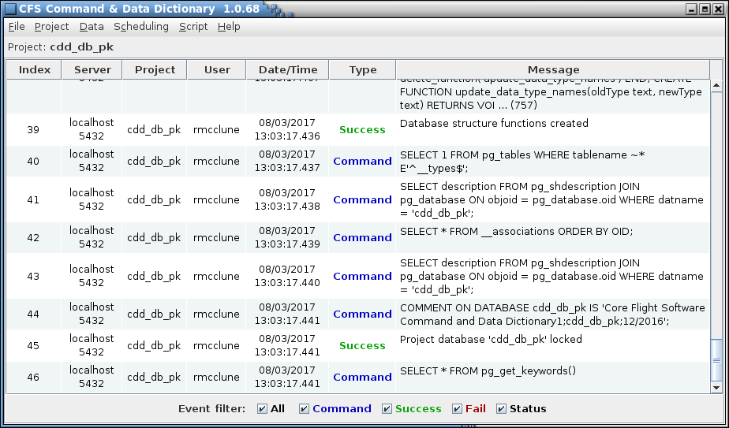

1. CCDD main window

The main window header contains the program name and version number. The main window is divided into a menu bar along the top and a session event log display area underneath. See paragraph 4.2 for further information on the event log. The window can be resized as desired. Each menu contains one or more menu items or sub-menus. A menu item that is grayed-out indicates that the affected item is not available at that time; for example, if no project database is open then the table commands are not available. A description of each of the menu items is provided in section 4.9.

## Database

### Setup

CCDD interacts with a PostgreSQL database. A description of installing and configuring the PostgreSQL software and server is beyond the scope of this document; see the PostgreSQL web site at [www.postgresql.org](http://www.postgresql.org) for this information.

### Authentication

The password authentication configuration for the PostgreSQL server affects the behavior of the CCDD application. Password authentication is controlled via the pg_hba.conf file. Super user status is required in order to make changes to this file. The location of this file can be determined by executing the “SHOW hba_file;” command in the PostgreSQL server command line utility **psql**. There are a number of authentication methods described in the documentation on the PostgreSQL web site; e.g. “trust”, “password”, “md5”, etc. The methods can be applied to all users or to individual users based on the connection type (local or remote). When set to “trust” no password is required to log into the server and access a database. The methods “password” and “md5” are similar in that the user must provide a password to log into the server. This is preferred in multi-user scenarios to control who may access the server and databases.

### Roles

PostgreSQL allows only the owner of a database element (table, sequence, etc.) to make changes to that object. This would be problematic if multiple users require the capability to make updates. The restriction is overcome by means of *roles*. Every user login is a role in the server. Group roles can be created to which other roles (e.g., users) are assigned membership; any role belonging to the group inherits the privileges assigned to the group role. The PostgreSQL administrator must create a role for each user (the user’s login identity), and one or more group roles that are used as the owner role when a project is created. The administrator must also assign membership in the group role to the appropriate users. Role creation and maintenance is performed outside the CCDD application and must be completed prior to creating a project database. When a project database is created, one of the group roles is assigned as the owner (see paragraph 4.9.2.3; note that for a single-user project the user’s role can be selected as the owner). Since all elements of the database are owned by the selected group, all members of the group have write privileges to these elements. Other roles (users) not in the group are prevented from changing the project elements. To control the ability of a specific user within the group to alter the database, CCDD implements individual user access levels – see paragraph 4.2.5.

### Connection recovery

If a database transaction fails due to a lost connection an attempt is made to reestablish the connection. If successful then the transaction is automatically repeated. If the reconnection attempt is unsuccessful then the error condition is propagated to the calling method. The PostgreSQL server timeout value, used when attempting to reestablish the server connection, is a program preference value (see Appendix E.2).

### Project access control

It’s desirable sometimes to allow users access to the data within a project, but not allow these users to alter the data. CCDD implements user access levels to accomplish this. *This is intended only as a low level security measure to prevent inadvertent alteration of project data and does not prevent access to a project’s database and/or alteration of the data via other applications*. The three access levels are administrative, read/write, and read only. When a project is created the user creating the project is automatically granted administrative privileges. Users with administrative access can assign access levels to the other users associated with the project. A user with read only access can still alter the contents of any of the editors in CCDD, but is unable to store the changes. Users granted read/write access have full access to the project, but are not allowed to alter access levels for any user. The enable state or operational capability for a command menu item is based on the user’s access level.

Following project creation only the project’s creator has a defined access level. Users that are not explicitly assigned an access level have read only privileges. Therefore, all other users with a role in the project can’t alter the project’s data until the project’s administrator assigns them read/write or administrative privileges via the user access level manager - see paragraph 4.9.2.11.

## Event Log

The application automatically records all interactions with the PostgreSQL and web servers. The information includes the exact commands issued to the server and the server responses (success, or failure with supporting information). All events are logged to the session’s log file, even if the GUI is disabled.

When the GUI is enabled the main application windows displays the current session’s event log. Previous sessions’ event logs can be reviewed using the **Read log** command; see paragraph 4.9.1.3. The log automatically scrolls to the latest entry when an event is logged. Each log entry contains the following information arranged in a tabular format:

**Index** This is a sequential number assigned to each log entry, beginning with 1 and incrementing by one as transactions occur with the database.

**Server** Name or address of the computer hosting the PostgreSQL server and the port number.

**Project** Name of the project database to which the transaction applies.

**User** Name of the user that initiated the transaction.

**Data/Time** Date (month/day/year) and time stamp (hours:minutes:seconds) when the transaction occurred.

**Type** One of five log entry types:

**Command** Indicates a PostgreSQL command issued to the database.

**Success** Indicates the database transaction completed successfully.

**Fail** Indicates the database transaction or web server command failed.

**Status** Indicates the log entry provides application status information.

**Server** Indicates a web server command.

**Message** The text in this column is dependent on the message **Type**. For a **Command** type the text is the PostgreSQL command issued to the database. If a data base transaction succeeds then a **Success** type message indicates what was accomplished by the database command. A **Fail** type message provides details on the cause of the transaction or web server failure. Failed transactions are rolled back so that no change is made to the database. The **Status** type message shows the results for an application operation (for example, the database table consistency check). A **Server** command displays web server command information. The message length displayed is limited by default to 250 characters in order to prevent bogging down the application. Truncated messages are denoted by a trailing ellipsis (…) followed by the number of truncated characters in parentheses. The full text of the message can be viewed by double clicking the right mouse button while the mouse pointer is over a log entry row – a log entry viewer is opened showing the full message text for that row.

Beneath the logged entries are entry filter check boxes that can be used to determine which messages are displayed, based on the message type(s). If a message type’s check box is unchecked then messages of that type are hidden. Checking the box restores the messages. Messages for hidden types are still logged even if not currently displayed. The **Server** check box only appears once the web server is activated. The **All** check box affects the other check boxes – unchecking it clears the other check boxes, and checking it selects the others. If none of the check boxes are selected no log entries are displayed. Note that for the single log entry viewer the filter check boxes are not displayed.

A large number of **Command** log entries are generated during normal program operation. The display of these events can slow program execution under some circumstances (for example, when exporting a large number of tables). Deselecting the **Command** check box hides the command entries, making the GUI more responsive. The check box can be reselected, causing the command entries to be displayed, if the entries need to be reviewed. A command line option can be used to deselect the check box at program startup.

## Mouse and Keyboard Navigation

The application’s menus, dialogs, and GUI components can be manipulated using the mouse pointer, mouse buttons, and mouse wheel, as well as with the keyboard. Keyboard mnemonics are provided for the menu items and dialog buttons. These are accessed by pressing the Alt key in addition to another key; i.e., Alt+*key*, where *key* is the underlined character in the menu or button text (the key case is ignored). For example, pressing Alt+F or Alt+f in the main application window opens the **File** menu. The Tab and arrow keys can be used to navigate between the components in a dialog or window, and the pressing the Enter or space key actuates a control (e.g., a button or check box). See Appendix E.1 for a list of special keys and key sequences.

When a dialog containing a table is initially displayed it has no table row selected. A row can be selected by positioning the mouse pointer over a cell in the row and pressing the left mouse button, or by using the keyboard. To select an initial row with the keyboard press the Tab key, then the Enter or Space key when the table has the keyboard focus (which it does initially); this selects the table’s topmost visible row and sets the focus to that row’s leftmost column. The up and down arrow keys can then be used to change the selected row and the left and right arrows can change the selected column. The selected cell is highlighted. Multiple cell selection behavior is dependent on the particular table, but in general behaves as follows. Multiple, contiguous cells can be selected using a combination of the mouse/keyboard and the Shift key. Highlight the starting cell, then either (a) continue to press the left mouse button and drag the pointer, (b) hold the Shift key and left-click the mouse on another row (the two rows, plus any in between, are highlighted), or (c) hold the Shift key and press the arrow key to highlight as many cells as desired. Individual cells can be selected/deselected by pressing the Ctrl key and selecting the cell with the mouse. The entire table may be selected by pressing Ctrl-A. For row operations (e.g., Move up or Delete row) the row(s) indicated by the highlighted cell(s) are affected. Similarly, for column operations (e.g., Move left) the column(s) indicated by the highlighted cell(s) are affected. Once one or more cells are selected the highlighted data can be copied by pressing Ctrl-C. To paste the data into another application (e.g., spreadsheet or text document) or another table use the Ctrl-V or Ctrl-I key sequence.

Navigation within a table can be accomplished via mouse or keyboard. Note that some of these keys perform different functions if a cell is actively being edited. The Insert key inserts a row at the current selection point and the Delete key erases the contents of the currently selected cell(s) (see above paragraph concerning cell selection). Pressing the Ctrl-Delete deletes the currently selected rows. The Home and End keys change the cell selection to the first or last column, respectively, of the currently selected row. The Page Up and Page Down keys scroll the table up or down one page, respectively, (unless the entire table is already visible) changing the cell selection to the currently selected column, with the row one page up or down from its previous position.

Table data entry is initiated by double clicking the left mouse button while the mouse pointer is over the cell to be edited. The Enter or Space keys may also be used to initiate editing on the currently selected cell (the Space key initiates editing as well as inserts a space into the cell at the end of any existing text). Pressing the Enter key while editing a cell stores the text in the cell and initiates editing in the next cell, moving left to right until the last column is reached, at which point editing moves to the first column in the next row below unless the end of the table is reached. Protected cells, denoted by a gray background color, are skipped. A cell containing a check box does not allow moving to the next cell via the Enter key; instead, the check box state is toggles with each press of the Enter key.

While cell editing is active the Insert key inserts a space to the right of the text cursor, and the Delete key deletes the character to the right of the text cursor. The Home and End keys move the text cursor to the beginning and end of the cell, respectively. If the table cell’s input type (see 4.7 for information on input types) supports multiple lines then pressing Alt-Enter inserts a line break.

Pressing the Escape key while editing terminates editing of the cell and removes any changes made to the cell.

For most tables in the application, row sort order, column width, and column position are user-adjustable. The table rows can be sorted by column by positioning the mouse pointer over the column’s header and pressing the left mouse button. The rows are sorted in ascending order, depending on the selected column’s contents, and an icon appears beside the column name indicating the sort direction. Selecting the column again sorts in descending order (with a corresponding change in the sort direction icon), and a third selection restores the rows to their original order and removes the sort direction icon (further column header selection repeats this sequence). Only one column can be sorted at a time – selection of another column removes the sort from the first sorted column before applying the sort to the newly selected one. The column width may be resized by positioning the mouse pointer over the right border of the column header (the mouse pointer changes to indicate resizing is possible), pressing and holding a mouse button, then moving the mouse left or right; release the mouse button to exit resizing. Automatic resizing, based on the widest of the contents of the cells and header, is accomplished by double clicking a mouse button when the resize cursor appears. The column order may be changed by positioning the mouse pointer over a column header, pressing and holding the left mouse button, then dragging the column to the new location.

Certain dialogs contain a tabbed pane and multiple tabs (example, the table and link editors). The tab order can be rearranged by positioning the mouse pointer over the tab, pressing and holding the left mouse button, and moving the mouse pointer. The pointer icon changes and a transparent copy of the tab appears that follows the pointer, but is constrained by the tabbed pane’s header area. As the copy is moved the insertion point is indicated by a thicker line appears beside the tab where the dragged tab will be moved if the mouse button is released. For the table editor dialog, if the pointer is moved outside the bounds of the dialog and the mouse button released then the table editor represented by the tab is removed from the editor dialog. If the pointer is over another editor dialog then the tab is added to that dialog at the position indicated by the insertion indicator. However, if the button is released while the pointer isn’t over a table editor dialog then a new editor dialog is created and the tab is placed within it.

Some of the editor dialogs are divided into panes that can be resized relative to each other via a split pane control. If the mouse pointer is hovered over the control region the pointer turns into a double-headed arrow. The arrow’s orientation, horizontal or vertical, determines which direction the panes can be resized. Press and hold the mouse button once the pointer changes. Space permitting, the adjoining panes can be resized by moving the mouse pointer left/right or up/down. Release the mouse button to exit resizing. The split pane controls generally are not visible in the editors; if present then the control is placed between major components (e.g., tables and trees). Editors may have more than one control.

Details specific to navigation in certain windows and dialogs are provided in the components’ descriptions in later sections.

## Data Tables

The CCDD data is stored in the project’s database in the form of tables. The tables consist of a two-dimensional array of columns and rows. The columns define the content of the cell in each row, much like the data in a spreadsheet. For example, a table may have a column titled “Description” which indicates that the cells in that column contain descriptive text concerning the parameter defined in each specific row. There is no constraint on the number of tables in the project’s database, nor is there a constraint on the table’s number of columns and rows.

### Table types

Every data table is built from a table type definition which defines the table’s columns. Think of a table type as the blueprint from which other tables are created. Three types of tables are available by default upon creation of a project: *Structure*, *Command* and *Enum*. Structure tables represent C-program data structures containing information on variables. Command tables are designed to contain information pertinent to CFS commands. Enum tables are very simple tables that only require the name of each enum within an enum structure. Other table types may be created by the user to contain data that doesn’t fit into the predefined types (see paragraph 4.9.3.10 for information on the table type editor). All tables of a given type share the same column definitions. Data in tables of any type are accessible via the scripts (see paragraph 4.10 for information regarding script access).

Every table that is created from a table type is considered a *prototype*. A prototype determines the columns and default data for all *instances* of that table. Each prototype table itself constitutes an instance of that table, and in many cases the prototype is the only instance. However, in the case of structure tables, multiple instances can exist – one for every reference to the structure from within another structure. Each of these derive their columns and initial data values from their prototype table.

A prototype table that is not referenced from within another table is considered a root table. A table that references another table is that table’s *parent*, and the referenced table is a *child* of the parent. The root table is also a parent if it contains a reference to another table. It’s common for structure tables to have a parent-child relationship. It’s possible for tables of other types to have such a relationship as well, though less likely.

#### Structure tables

Structure table rows represent C-program variables and related information. The variables can either be of a primitive data type (e.g., integer, char, double) or can be a reference to another structure. These child structures can in turn reference other structures, and so on, to any depth required by the user. The only constraint is that no circular references are allowed, wherein a structure references itself somewhere in its hierarchy. Ultimately only references to primitive data types exist as the end point of any path from the root structure, through its child structures, to a variable.

Certain columns are inherent to structures and must be present for the table to be recognized as a structure. The default names for these columns are “Variable Name”, “Data Type”, “Array Size”, and “Bit Length”. The column names can be changed if desired; it’s the column’s input type that identifies the column (see paragraph 4.7 for more information on input types). Therefore, for a table to be treated as a structure it must include at a minimum the columns with the input types “Variable name”, “Primitive & Structure”, “Array index”, and “Bit length”. Other columns, “Description”, “Units”, “Enumeration”, “Minimum”, “Maximum”, and “Rate”, are automatically included for structure tables; these additional columns can be altered, or even deleted. Columns containing other variable information can be added at the user’s discretion. Table 2 shows the default structure column names and the corresponding input types.

|  |  |
| --- | --- |
| **Default Column Name** | **Input Type** |
| Variable Name | Variable name1 |
| Description | Description |
| Units | Units |
| Data Type | Primitive & Structure1 |
| Array Size | Array index1 |
| Bit Length | Bit length1 |
| Minimum | Minimum |
| Maximum | Maximum |
| Enumeration | Enumeration |
| Rate | Rate |

1 *A table must contain this input type to be identified as a structure*

1. Structure column names and input data types

Only one variable name, data type, array size, and bit length column is allowed per table type definition. The table can have multiple rate and enumeration columns.

The array size and bit length cell values are mutually exclusive for a variable; only one can be assigned (or neither). When the structure is displayed in the table editor (see paragraph 4.9.3.2) if array size is specified then the bit length cell for that variable is grayed out and cannot be selected. Conversely, if a bit length is entered then the array size cell is grayed out.

The bit length and enumeration cells are valid only for data types that have a base type of “signed integer” or “unsigned integer” (see paragraph 4.5.4 for information on data types). If a non-integer data type is selected in the data type column then the bit length and enumeration cells for that row are grayed out and cannot be edited. Conversely, if the bit length or enumeration cell is not empty then the data type for that row only displays integer data types.

If an array size is specified a row is inserted automatically into the table for each array member. Arrays may have one or more dimensions, each with a minimum size of 1. For multi-dimensional arrays the size of each dimension is specified in the array size column, separated from one another by commas. For example, a three dimensional array, **n**, with dimension sizes of 2, 3, and 4 would have the array size specified as “2, 3, 4” (the array text is automatically formatted with spaces). The first array member would be **n[0][0][0]**, the second **n[0][0][1]**, and so on until the last member, **n[1][2][3]**, is reached; this array would have a total of 24 members (= 2 x 3 x 4). When a structure table is open any arrays are initially collapsed; in other words only the *array definition* row is shown. The display of the *array member* rows can be toggled in one of two ways, via the **Expand arrays** command (see paragraph 4.9.3.2.3.5) or by positioning the mouse pointer over any cell in the array size column and double-clicking the right mouse button. When expanded, the array members for all arrays are displayed beneath their respective array definition row. The variable name column shows the variable name with the array index (or indices) appended, and the overall array dimension size(s) is displayed in the array size column. See Figure 3 for an example of an expanded array definition.

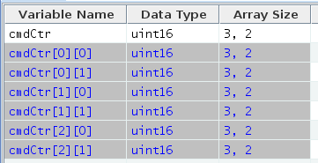

*array members*

*array definition*

1. Example array display

Note that the variable name, data type, and array size are grayed out and cannot be altered in the array member rows; however, individual values may be assigned to a member for the other columns in the table. The exception is the bit length column – an array definition or member cannot be assigned a bit length. To change the array member names or data type make the change to the array definition row; the member rows are changed as well. Changing the array definition row’s array size value increases or decreases the member rows as needed, and clearing the array size cell removes all of the member rows for that variable.

The string data type is a special instance of the character base data type. If no array size is specified then the string variable is simply a single character. If an array size is supplied then the first (rightmost) array dimension determines the string length in characters. A string behaves as other array variables except that column values (e.g., description) may not be assigned to array members of the string other than the first one (i.e., one ending with an array index of zero). Arrays of string variables are allowed, as with other data types.

If a data type cell references a structure then the specific instance of the structure table it represents can be opened by double-clicking the right mouse button while the mouse pointer is positioned over the data type cell. The table is opened in its own tab in the same editor window (see paragraph 4.9.3.2 for more information on the table editor). If this is attempted on a structure reference in a prototype table, and the prototype table is itself referenced in another structure table, then the dialog in Figure 4 is displayed, indicating that the prototype of the selected structure, and not a specific instance, was opened (‘*a_structure_table*‘ and ‘*a_child_table*‘ in the figure are replaced by the prototype and child table names respectively). Once a structure is referenced by another one it is no longer a root structure table, and therefore can’t have its own child tables, only those that are part of the hierarchy of the root structure to which the structure’s prototype belongs.

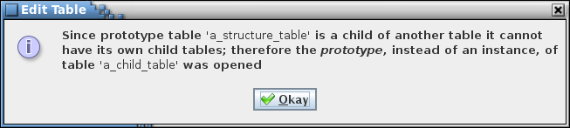

1. Example dialog

As mentioned above, a child table inherits the data values of its prototype table. If a child table’s data value is edited it overrides the inherited value, producing a “custom” value for the child. Even if the child’s prototype values are subsequently changed the child retains its “custom” values. Special action must be taken to remove the child’s custom value and have it use the prototype value – see paragraph 4.9.3.2.2.8.2.

The user may create other table types that also represent a structure table. If a table contains the default structure input data types then the table is treated as a structure table.

#### Command tables

Command tables contain CFS command information. Certain columns are inherent to command tables and must be present for the table to be recognized as a command table. The default names for these columns are “Command Name”, “Command Code”, and “Command Argument”. The column names can be changed if desired; it’s the columns’ input type that identifies the column (see paragraph 4.7 for more information on input types). Therefore, a command table must include columns with the “Command name”, “Command code”, and “Command argument” input types. A description column (“Description) is automatically included for command tables; this additional column can be altered, or even deleted. Only a single command name and command code column is allowed per table type definition. Columns containing other command information can be added at the user’s discretion. Table 3 shows the default command column names and the corresponding input types.

|  |  |
| --- | --- |
| **Default Column Name** | **Input Type** |
| Command Name | Command name1 |
| Command Code | Command code1 |
| Description | Description |
| Command Argument | Command argument1 |

1 *A table must contain this input type to be identified as a command*

1. Command column names and input data types

See paragraph 4.9.3.10 for details on defining columns for a table type definition.

Each row in a command table defines a separate, unique command. Each command may have zero or more arguments associated with it. When the command is sent, the arguments are used to determine the action taken (e.g., enabling or inhibiting a spacecraft function, setting a fan speed, etc.). In CCDD each argument is simply a variable within a structure table. The path to the command’s argument structure is entered in the command’s **Command Argument** column. This connects each variable in the argument structure with the command. For example, a command that references an argument structure containing three variables has three arguments.

In the table editor, selecting a command argument column cell displays a drop down menu. The menu items are the paths to those structures that contain the variables that represent command arguments. A structure appears in the menu if it’s based on a command argument reference table type; i.e., the table type has the **Structure represents command arguments** check box selected (see paragraph 4.9.3.10). The path to each of these structures’ child structures are also included in the menu. More than one command can use the same argument structure reference.

Argument structure references can be handled in two ways. An argument structure can be a root structure or it can be the immediate child of a root structure (descendants of child structures are not eligible). If a root structure is chosen as the command’s argument structure then all commands that use this structure as the command’s argument structure must use the same argument variable information (minimum, maximum, enumeration, etc.). However, if a child of a root structure is used as the command argument reference then multiple references can use the same prototype structure as the data type. The basic structure elements (variable name, data type, array size, and bit length) are the same for every instance of the prototype. Since each reference constitutes a separate instance of that prototype structure, each instance’s argument variable information (minimum, maximum, enumeration, etc.) is unique to that instance. Figure 5 shows the relationship between the command table’s argument structure references, optional argument root structure table(s), and the argument structure table(s).

**Command Table**

Cmd 1 Arg Struct Ref

**.**

**.**

**.**

Cmd *n* Arg Struct Ref

Argument Structure *n*

Arg Root

Struct

Arg Root

Struct

Argument Structure 1

1. Command to argument relation

#### Enum tables

Enum tables are very simple tables, only 1 required column, that are only really meant to store the names of the various enums that make up an enum structure. For example, in the table below we have an enum structure written in C.



1. Enum Structure

This structure could be stored in a table of type Enum as shown below.

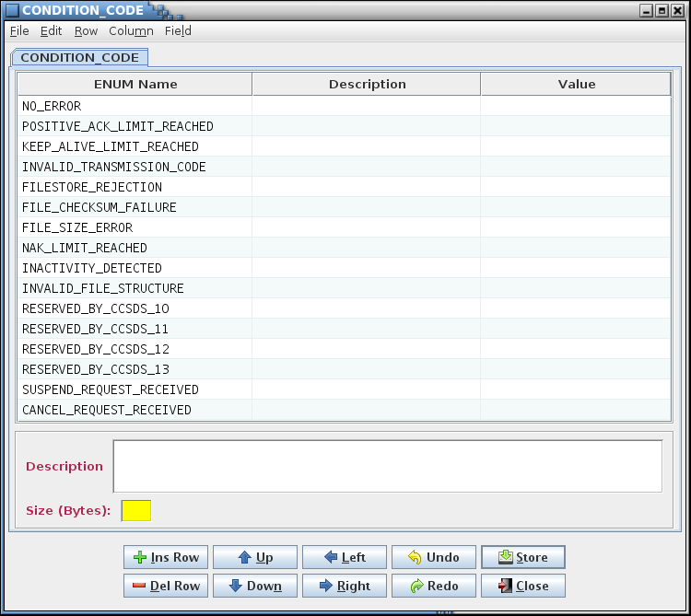

1. Enum table representing enum structure in figure 6

Enum tables also contain a ‘Value’ column that allows a user to specify a specific value for each enum if they wish. There is also a ‘Size (Bytes)’ data field that allows a user to specify the size of the structure. This is important for the accuracy of CCDD when it comes to scheduling, data access methods that report sizes and etc.

### Table groups

Data tables can be assigned to user-defined groups (see paragraph 4.9.3.9 for details on assigning tables to a group). These groups are a method of relating tables to each other. For example, all of the tables for a specific CFS application or subsystem can be assigned to a group. The groups are used in filtering the table tree (see paragraph 4.5.3 concerning tree filtering). A group can also be associated with a script (see paragraph 4.9.5.1 concerning script associations). A table can be assigned to more than one group, or to none. The application scheduler uses the groups designated as CFS applications when producing the scheduler table (see paragraph 4.9.3.9 for details on designating a group as an application, and paragraph 4.9.4.3). Groups can also be assigned data fields. If a group is specified as representing a CFS application a number of data fields are automatically assigned (these can be edited, removed, or additional fields added as desired). See paragraph 4.6 for more details on data fields.

### Table tree

The table tree displays the data tables using a tree representation. Depending on the operation (e.g., Edit, Rename, etc.) there are one or two top level branches in the tree. The first, labeled *Prototypes*, is an alphabetical arrangement of the prototype tables. Since it displays prototypes only it is a single level in depth (not including any filtering; see below). The second top level branch that may be displayed, *Parents & Children*, shows the root tables and, if applicable, their children as sub-branches, and the children of those tables as further sub-branches, etc. See Figure 8 and Figure 9.

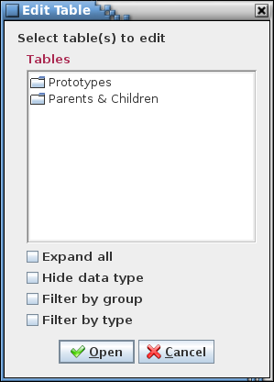

1. Table tree

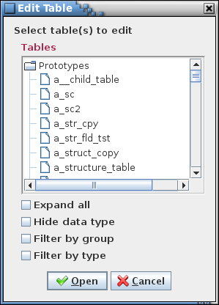 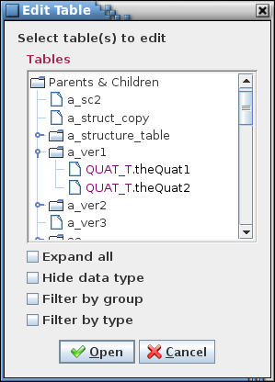

1. Table tree expansion

Selecting the symbol beside a branch in the tree causes that branch to expand (if collapsed) or to collapse (if expanded). Selection can be made with the mouse pointer, or by using the tab key and up/down arrows to highlight the branch’s name, then pressing the right arrow to expand or left arrow to collapse the branch. Positioning the mouse pointer over a branch name and double left-clicking toggles between expanded and collapsed view for that branch. Selecting one or more branches and pressing Ctrl-E causes the selected branches and all of their child branches to expand (if collapsed) or collapse (if expanded). The first branch selected determines if any other selected branches are expanded or collapsed. Hovering the mouse over an item in the tree displays a pop-up tool tip showing the description of the item (if it has one; for a table this is the text from the table’s description field; see Figure 39).

Below the tree are one or more check boxes. The **Expand all** check box is available for every tree; selecting this check box causes all of the tree branches to be displayed. Clearing the check box collapses all of the branches down to the initial level.

The names displayed in the tree for structure and primitive variables are in the format *data type.variable name* (see paragraph 4.5.3.1). For structure variables the data type is the name of the structure defining the variable; for primitive variables (e.g., integers, floats) the data type is the name of the primitive. Color is used to highlight the data type. The **Hide data type** check box appears with table trees that display structure and primitive variables. When unchecked, the tree displays the variables in the full format as described. When check, the data type portion of the name is not displayed.

The remaining check boxes are used to filter the tree contents. There are two filter methods, **by groups** and **by types**. Depending on the operation one, both, or neither of these check boxes may be available.

If the **Filter by group** check box is selected then sub-branches are inserted at the level below the *Prototypes* and *Parents & Children* branches. These sub-branches are the groups defined by the user (see paragraphs Figure 5 and 4.9.3.9). Tables belonging to the group are displayed as sub-branches of the group branch. A special group, labeled “*All tables*”, appears in the tree below the user-defined group sub-branches. The “*All tables*” group is an automatically defined group that displays all tables, including those that are not a member of a group, so that every table is still available for selection in the table tree while the group filter is applied. Deselecting the check box removes the group branches.

If the **Filter by type** check box is selected then sub-branches are inserted at the level below the *Prototypes* and *Parents & Children* branches. These sub-branches are the table types: structure, command, and any others defined by the user (see paragraphs 4.5.1 and 4.9.3.10). Tables of a given type are displayed as sub-branches of the table type branch. In other words, all of the Structure type tables appear under a *Structure* branch, all Command type tables under a *Command* branch, and so on for each defined table type. Deselecting the check box removes the type branches.

Both the group and type filters may be applied simultaneously. The branches are first divided by group. Each group is then sub-divided by table type.

#### Variable tree

Another form of the table tree is the variable tree. The variable tree displays only the project’s structure tables. These are displayed in the same manner as in the table tree, except that the variables belonging to the structure tables are also shown as branches of their parent structure. Variable trees are used where selection of variables is required; e.g., in the links manager (paragraph 4.9.4.1) and the telemetry scheduler (paragraph 4.9.4.2). Like the table tree, variable trees allow filtering by group.

Variable names are displayed in the tree in the format:

<*data type*>.<*variable name*[*[array size][…]*]>[*:bit length*]

Examples: float.bq[1], uint16.faultBits:12

The node icons used in the variable tree indicate if the variable is a bit-wise variable or not (i.e., has a bit length assigned), if the variable is bit-packed with one or more variables, and if the variable belongs to a link (see Table 4). Paragraph 4.5.5 provides details on bit-packed variables.

|  |  |
| --- | --- |
| **Icon** | **Variable type** |
|  | Non-bit-wise variable |
|  | Linked non-bit-wise variable |
|  | Bit-wise variable |
|  | Linked bit-wise variable |
|  | Packed bit-wise variable |
|  | Linked and packed bit-wise variable |

1. Variable tree icons

### Data types

The structure, command and enum tables, and possibly and user-defined table types, contain data type columns. This column is used to set the data type for the referenced parameter (e.g., structure variable or command argument). The data type is either a primitive type, a reference to a structure, or a pointer.

Each primitive data type is derived from one of five base data types: signed integer, unsigned integer, floating point, character, and pointer. The base type, along with the size in bytes, determines the characteristics and usage of the data type. For example, a bit length can be assigned to a variable only if its data type has an integer base type (signed or unsigned), and the bit length is less than or equal to the data type’s size (in bits).

A project database is automatically provided with a number of primitive data types. These can be altered or deleted. The default primitive types are shown in Table 5.

|  |  |  |  |
| --- | --- | --- | --- |
| **Data Type Name** | **C-Language**  **Data Type** | **Number of Bytes** | **Base Type** |
| int8_t | signed char | 1 | signed integer |
| int16_t | signed short int | 2 | signed integer |
| int32_t | signed int | 4 | signed integer |
| int64_t | signed long int | 8 | signed integer |
| uint8_t | unsigned char | 1 | unsigned integer |
| uint16_t | unsigned short int | 2 | unsigned integer |
| uint32_t | unsigned int | 4 | unsigned integer |
| uint64_t | unsigned long int | 8 | unsigned integer |
| float | float | 4 | floating point |
| double | double | 8 | floating point |
| char | char | 1 | character |
| string | char (array) | >1 | character |
| address | void * | 4 | pointer |
| ‘User assigned name’ | structure | ‘User assigned’ | structure |
| ‘User assigned name’ | enum | ‘User assigned’ | enum |

1. Default primitive data types

A data type with a base type of ‘character’ is considered a string if the byte size is set to greater than 1. The byte size value in this case is otherwise unused by the application. The application treats a string as an array of characters. An array of data type ‘string’ is treated specially by the application. See paragraph 4.5.1.1 for details.

To the application a pointer represents an address and the actual data type and C type names are irrelevant. However, the application does allow creation of pointers with distinctive names. This is useful, such as in a generated header file to create typedef statements for subsequent use in assigning data types to variables (versus using the void * data type and type casting each variable appropriately). The application allows creation of any number of pointer data types.

In a data table, when a data type column cell is selected it displays a drop down menu showing the data types. The data types available depend on the usage. In general, in a structure table the data types include primitive types and the names of structures that are not referenced in the hierarchy of the structure being edited (this prevents creating a circular reference). If the structure variable has a bit length or enumeration value then the data types available are limited to primitive types with an integer base type (signed or unsigned). For a command argument only primitive types are displayed, and if the argument has an enumeration value then the data types are limited to primitive types that have an integer base type (signed or unsigned).

The data type manager (paragraph 4.9.3.11) is used to create, modify, and delete the primitive data types.

The ‘structure’ and ‘enum’ data types are quite unique. It is possible for both of these types to be defined with a table within the database, but in some situations a user may not wish to define a table in order to assign a variable within any given table a data type of ‘enum’ or ‘structure’. For example, many projects may be using libraries which contain structures that they do not wish to store in their database. This gives them the opertunity to create a data type to represent those structures and assign it a value for the size. This way CCDD knows how big the structure is and is aware that it is not defined within the database.

### Bit fields

Variables with an integer (signed or unsigned) data type may be assigned as bit fields. A bit field is identified by having a value entered in the structure data table’s **Bit Length** column. Variables with bit lengths specified that are co-located in the table and have the same data type are assumed to be packed together; i.e., these variables occupy the same byte or bytes. The number of variables and bits that are packed is based on the data type’s byte size and the bit length of each variable. The bits representing a variable must be contained within a single data type’s set of bits. For example, a *uint16* is two bytes, or 16 bits, so bit field variables totaling 16 or fewer bits are packed. If three variables of type *uint16* are co-located, with bit lengths of 2, 12, and 5, then the first two variables are packed together (2 + 12 < 16), and the third variable occupies its own pair of bytes since its 5 bits won’t fit within the first packed pair’s 2 unused bits.

Bit-packed variables must have the same telemetry downlink rate. Since the variables are packed together they are downlinked together, even if only a subset of the variables is desired. The table editor accounts for bit-packing by enforcing a common rate among variables that are packed together. In other words, it changes the rates, if needed, of packed variables so that they match. The check for, and update to, a common rate takes place each time an edit is made to the table. In order to prevent two variables from being packed together a padding variable must be added between them with the appropriate bit length to ensure the two variables no longer fit within the bit size of the variables’ data type.

When transferring variables, such as between trees in the link manager or between the variable tree and messages in the telemetry manager, those that are packed together are automatically moved as a unit, even if not explicitly selected.

### Enumerations

Enumerations allow associating a text label with an integer value, and optionally other attributes. Enumerations are useful, for example, in displays, since descriptive label text can be substituted for an ambiguous numeric value.

The format for an enumeration is as follows:

<*1st enum value*> <*value/label separator*> <*1st enum label*> [<*value/label separator*> <*other 1st enum attributes*>]

[<pair separator> <*2nd enum value*> <*value/label separator*> < *2nd enum label*> [<*value/label separator*> <*other 2nd enum attributes*>]][[<*pair separator*>…] [<*pair separator*> <*nth enum value*> <*value/label separator*> < *nth enum label*> [<*value/label separator*> <*other nth enum attributes*>]]]

The enumeration value/label and pair separator characters are at the discretion of the user. The application detects these characters automatically.

The label can contain multiple attributes (e.g., color, limit, etc.) – use the value/label separator character to delineate each attribute. Below is an example of an enumeration with three possible values (0, 1, and 2):

0 | Off | red, 1 | On | green, 2 | Standby | yellow

In this example the enumerated values 0, 1, and 2 correspond to the labels “Off”, “On”, and “Standby” and the colors “red”, “green”, and “yellow” respectively. The value/label separator is the “|” character, and the pair separator is the comma (“,”). Any spaces and/or tabs bounding the separator characters are ignored.

The structure tables contain an enumeration column by default. The enumeration’s integer value is the value of the parameter described in the same row of the table (the variable name for a structure table). The enumeration parameter’s data type must be an integer type (signed or unsigned). The structure table editor enforces this constraint by not allowing text to be entered into an enumeration cell for which the associated data type is not an integer, and by only displaying integer types in the data type cell if the associated enumeration cell is not blank. Data type and enumeration column associations are determined by their respective input type designation (see paragraph 4.7) and are paired based on their order in the table’s type definition. The EDS and XTCE XML conversions (see paragraphs 4.9.3.8.2 and 4.9.3.8.3) also check that the data type is valid for an enumeration, generating an error message if an enumeration is associated with a non-integer data type.

### Macros

A macro is a text string used to represent a number or text. Once defined, a macro can be used to replace part or all of the contents of a data table cell. This allows a commonly used string of text to be defined once, then used in as many tables and table cells as desired. If the text subsequently needs to be altered then only the macro’s definition need be changed, instead of having to locate and change each table cell where the text is found. An example for such usage would be an enumeration used in multiple cells and/or tables.

Macros are created and their values set or altered using the macro editor, described in paragraph 4.9.3.12. A macro name, when entered into a cell, must be bounded on either side by a pair of ‘#’ characters (##, with no intervening spaces) in order for the macro to be recognized. Text that’s entered into a cell bounded by the macro delimiters is only recognized as a macro if the macro is defined. If the macro isn’t recognized then the characters are treated as any other text string. If the macro is subsequently defined the cell automatically recognizes the text string as a macro. Macros can also be entered using the **Insert macro** command in the table editor; see paragraph 4.9.3.2.2.6.

A special type of macro is the *sizeof(data type)* call. The *sizeof()* call returns the size in bytes of the specified primitive or structure data type. A macro may be used in the *sizeof()* call as log as it evaluates to a primitive or structure data type. If the data type is unrecognized then an error dialog is displayed. *sizeof()* can be used in the same locations as a macro. The macro identifier characters (##) are not used with the *sizeof()* call.

Multiple macros can be inserted into a cell. However, a macro can’t be inserted within another macro (the macro into which the second macro is inserted is no longer recognized as a macro in this case).

Text containing a macro and/or sizeof() call is evaluated as a mathematical expression if the resulting expansion of the macro(s) and *sizeof()* call(s) in the text is in a valid expression format. Mathematical expressions may contain numbers (including floating point values), the operators ‘+’ (addition or sign, based on context), - (subtraction or sign, based on context), ‘*’ (multiplication), ‘/’ (division), ‘&’ (bit-wise AND), ‘|’ (bit-wise OR), ‘<<’ (left bit shift), ‘>>’ (right bit shift), parentheses (‘(‘ and ‘)’) for nesting expressions, and spaces (which are ignored). If the expression is invalid due to an attempt to divide by zero or use of a negative right operand for a bit shift then the expression is treated simply as a text string.

As an example assume two macros are defined, MACRO_A with a value of “2” and MACRO_B with a value of “3”. The text “(##MACRO_A## + 4) / ##MACRO_B”, when the macros are expanded, is “(2 + 4) / 3”. Since this is a valid mathematical expression the resulting text is “2” since (2 + 4) / 3 = 2. Multiple expressions can exist in the same text if each is separated from the other by a comma (,). For example, the text “#MACRO_A, sizeof(float) * 3” when expanded is “2, 4 * 3” (using the value for MACRO_A stated previously and assuming a float is 4 bytes). Each portion of the text, when separated at the comma, is a valid mathematical expression, so the resulting text is “2, 12”. This format is useful when setting the array size for a multi-dimensional array variable.

If the mouse pointer is hovered over a cell containing a macro a tool tip pop up appears displaying the contents of the cell with each macro name replaced by its value. All of the macros in a data table can be temporarily replaced by their corresponding values using the **Show macros** command in the table editor; see paragraph 4.9.3.2.2.7.

When a table’s data is retrieved for use in a script or via the web server the option exists to retain the macro names in place of the macro values. See paragraph and 4.9.1.6 and the CCDD Developers Guide for details. An example of use for this is when creating C header files, where a #define statement is used to set a constant that determines array variable size(s). The macro name can be used to set the #define constant’s name and value. In the array definition(s) the macro name is retained instead of the using the value so that the #define constant determines the array size (note that the macro delimiter characters must be removed in this example).

## Data Fields

Data fields are input fields created by the user for entering information associated with the component to which the field belongs. The fields are assigned names and an input type that constrains the values that can be entered into the field. Data fields can be associated with a project’s data tables, groups, and to the project as a whole.

A data field can be used to enter a piece of information for a data table that doesn’t fit with a table’s row and column format. An example is a message identification (ID) number for a root structure table – the message ID applies to the entire table, not a specific row within it. A column could be added for information such as the message ID, but having the same value repeated for each row is both wasteful in storage as well as prone to errors (if every value doesn’t match). Any number of data fields (including none) can be associated with each table.

Default data fields may be assigned to a table type. Every table of that type automatically inherits an instance of its type’s fields. This inheritance is strictly enforced so that adding, deleting, or modifying the default field also affects the inherited fields.

Fields can also be assigned to individual tables. There is no requirement for the tables to have the same fields (other than those inherited from the table’s type as mentioned above).

Similarly, table groups can be assigned data fields. For example, a group can be created that consists of all of the tables for a specific CFS application, so that the group represents the application. Applications have data associated with them that isn’t appropriate for storage in a table, such as the application schedule rate or execution time. In this case a data field can be assigned to the group to hold the information. Groups designated as CFS applications are automatically assigned certain data fields; see paragraph 4.9.3.9.

Some data associated with a project is applicable to the entire project. Examples include the project’s name and description, or the number of central processing units (CPUs) supported. For these cases the project-level data fields are appropriate. Paragraph 4.9.3.15 provides information on adding data fields at the project level.

### Data field editor

This section provides details on use of the data field editor (Figure 10). See paragraph 4.9.3.10.4.1 for information regarding adding default data fields to table types, paragraph 4.9.3.2.5.1 for information on adding fields to a particular table, paragraph 4.9.3.9 for information on adding group fields, and paragraph 4.9.3.15 for information on adding project-level fields. In each case the editor operation is the same.

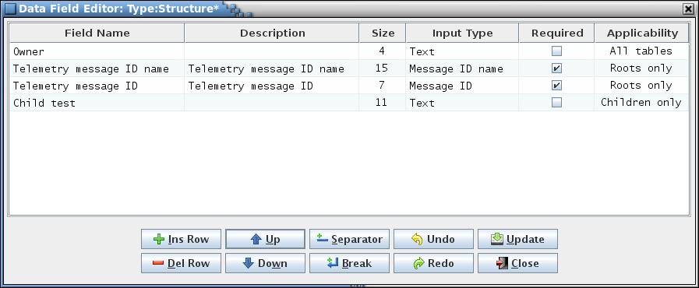

1. Data field editor

There are five or six columns in the field editor (depending on context):

**Field Name** This is the name of the data field. The name can be of any length and can contain letters, numerals, and punctuation characters. When the data field is displayed the field name is the label shown immediately to the left of the input field that is used to contain the field’s value. The field name is also used if the data field is referenced from a script (see the CCDD Developers Guide). The field name is required.

**Description** The field description is use to describe the content of the data field. The description appears as tool tip text whenever the mouse pointer hovers over the field in a table, group, or table type editor. HTML tags may be entered to provide formatting for the displayed tool tip text. This column may remain blank.

**Size** The field size defines the width, in characters, of the data field’s input text field. Due to padding and font differences, the actual field width may appear slightly larger. The size must be a positive integer, and is required. If a boolean input type or one with selection items is used in the **Input Type** column then the size is ignored; a boolean field is displayed as a check box, and the longest selection item determines the combo box width for a field with selection items.

**Input Type** The field input type constrains the type of value entered into the data field’s input text field. If the value entered into the data field doesn’t conform to field’s specified input type then a warning message dialog is displayed and the field reverts to its previous value. The input types are selectable from the combo box pull-down menu that appears when a cell in the Input Type column is selected. See paragraph 4.7 for information on the available input types. A field with a boolean input type is displayed as a check box. The input type defaults to “text.”

**Required** The **Required** column displays a check box, initially unselected. Selecting the check box indicates that the field is required. When the field is displayed in the table or table editor the input text field is highlighted in yellow as long as the field’s input text field value is empty. The application does not enforce the user to input data into the fields marked “required”; the highlighting is used merely as a reminder that the field value is considered necessary and should be filled. A boolean (check box) data field does not display the highlighting.

**Applicability** This column only appears when assigning default data fields in the table type editor for a structure table type, or when editing the fields for a prototype or root structure table.

If the data field editor is invoked from the table type editor then it allows defining fields that are propagated to new and existing structure tables. Select the applicability for a field from the combo box pull down menu that appears when the applicability cell is selected. *All tables* indicates that the field will be added to all structure tables (root and child tables), *Roots only* implies that only root tables have the field added, and *Children only* means that only child tables have the field added. The default is *All tables*.

If the data field editor is invoked from a prototype or root structure table then all fields assigned to the table, regardless of the applicability setting, are displayed in the editor. For example, if the table has both *Roots only* and *Children only* fields assigned then only one of these types is displayed in the table’s editor since a table can only be a root or a child, but not both. However, a table can change from a root to a child, and vice versa; when this happens the types of fields that are displayed are changed to match. The field editor displays all of the fields, whether applicable or not, so that these can be altered by the user.

The order that the rows appear in the field editor determines the order of appearance in the project field editor, table editor, group manager, or table type editor. Field definition rows may be rearranged as desired by first selecting a cell in one or more rows, then pressing the **Up** or **Down** buttons to move the selected row relative to the ones not selected. The editor columns can be sorted as described in paragraph 4.4; however, the sorted order does not dictate the field display order.

Line separators and line breaks may be inserted as rows using the **Separator** and **Break** buttons respectively. Without these breaks the data fields, when displayed in a table, group manager, or table type editor, are arranged end to end, wrapping to the next line when the width of the editor is reached. The line break forces the next data field to the next row regardless of the editor width constraint. The line separator does the same, except that a dividing line is drawn between the rows where the separator is inserted. These breaks can be used to aid in grouping related data fields.

The field editor button commands are described below:

**Ins Row** The editor is initially empty unless the table editor, group manager, or table type editor from which it’s invoked has any previously defined fields. To add a field first select the **Ins Row** button; a new field definition row is inserted into the editor. Additional rows can be added in the same manner. The insertion point is dependent on the currently selected row in the editor; if no row is selected then the new row is added at the bottom. The empty row has the Field Name and Size columns highlighted in yellow. The highlighting indicates that these columns are required and must have values assigned.

**Del Row** One or more field definition rows may be deleted by first selecting a cell in the target row(s), then pressing the **Del Row** button. The selection of multiple rows is constrained to contiguous rows; i.e., rows cannot be skipped.

**Up** The order that the rows appear in the field editor determines the order of appearance in the table editor, group manager, or table type editor. Field definition rows may be rearranged as desired by first selecting a cell in one or more rows, then pressing the **Up** button to move the selected row(s) up a row relative to the ones not selected.

**Down** Similar to the **Up** button action, except that selected row(s) are moved down a row relative to the ones not selected.

**Separator** Inserts a line separator below the currently selected field’s row.

**Break** Inserts a line breakbelow the currently selected field’s row.

**Undo** Undoes the last action performed (typing, paste, insert, delete, redo, etc.).

**Redo** Reverses the last action undone (typing, paste, insert, delete, redo, etc.).

**Update** Applies the data field definitions currently displayed in the field editor to the table editor, group manager, or table type editor from which the field editor was invoked. Any existing fields that are in the table editor, group manager, or table type editor are deleted and replaced by the new definitions. However, these changes are not stored in the database – this is only accomplished when the **Store** button in the table editor, group manager, or table type editor is selected.

**Close** Closes the field editor window. If any changes made have not been applied using the **Update** button then a dialog appears allowing the user to confirm discarding the updates or to cancel closing the editor.

## Input Types

Data table columns and data fields are assigned an input type in the table type editor (see paragraph 4.9.3.10) and the data field editor (see paragraph 4.6.1) respectively. The input type constrains the type of value entered into a data table cell or data field. Leading and trailing white space characters (spaces, tabs, etc.) are ignored and eliminated when the text is formatted (except for the two Text input types that specifically preserve these characters; spaces between characters in a text string are always retained). Leading plus (+) signs and zeroes are allowed for non-negative integer and floating point values, but are ignored and eliminated.

Some input types constrain the allowable values to one or more selection items (the **Variable reference** type, for example, and custom input types defined by the user that are provided a selection item list). The list items are displayed in a drop down menu in the table cell or data field. An empty cell/field is an allowable entry for input types with selection items and a blank item is automatically prepended to the list. These cells and fields use an item matching feature that allows for quickly pruning the selection item list based on the characters entered into the field or cell. As the user enters text those list items not matching the text are removed from the list. Wildcard characters are allowed. A ‘?’ matches a single character and a ‘*’ matches one or more characters. The matching operation assumes a ‘*’ is at the end of the entered text. Matching is case sensitive. For example, given the list below, if the match criteria entered is ‘*az’ then the first four items constitute a match, whereas the remaining two items do not.

az

azq

a,az,b[0]

a,az,b[1]

b,Az

b,a,z

A blank item is always retained as the first item in the list. If editing ends (e.g., by selecting another field or cell) then the first item in the list that matches the current match text is entered into the field/cell. If no item in the list matches the match text then the field/cell is blanked. The match text can be used to reduce the number of items in the list, then the mouse or keyboard (i.e., arrow keys) used to select an item from the list.

Customized input types may be defined using the input type editor; see paragraph 4.9.3.12.

In the table type or data field editor select the row in the **Input Type** column corresponding to the data table column or data field. A combo box pull down menu appears with the input types, both default and custom, listed in alphabetical order. The default input types are:

**Alphanumeric** This type allows letters, numerals, and underscore characters. A numeral may not begin the text string. Alphanumeric text is appropriate for variable names.

**Alphanumeric (multi)** Allows multiple **Alphanumeric** inputs, separated by one or more white space character(s).

**Array index** Special format used to designate the array size column. Allows one or more integer values (each greater than 0), separated by commas. For the array size column each value represents an array dimension size (e.g., if the array size is 2, 3, 4 then the associated array size is defined by *arrayName*[2][3][4]).

**Bit length** Special format used to designate the structure table bit length column. This type has the same constraints as the **Positive integer** type.

**Boolean** A check box is used to represent data table cells and data fields of this type.

**Command argument** Displays a drop down menu containing all of the command argument structures as determined by the structure table type **Structure represents command arguments** check box selection. See paragraph 4.9.3.10.

**Command code** Special format used to designate the command table command code column. This type has the same constraints as the **Hexadecimal** type.

**Command name** Special format used to designate the command table command name column. This type has the same constraints as the **Alphanumeric** type.

**Command reference** Displays a drop down menu containing information for every command in the project (name, code, argument variables, and command table). Only a command from the list, or no selection, is allowed. The Alt-Shift-M key can be used in a table cell or data field to display a similar pop-up menu from which the command reference information can be selected for insertion into the cell or field (see Appendix E.1). If a command’s name, code, or argument variable is changed then any table cell or data field using this input type and referencing the command is automatically updated with the change (if a command is deleted then all references to it are blanked).

The Alt-Shift-C key can be used in a table cell or data field to display a similar pop-up menu from which the command reference information can be selected for insertion into the cell or field (see Appendix E.1). However, subsequent changes to a command name, code, or argument variable are not automatically updated for references inserted in this manner.

**Description** Special format used to designate a description column. This type has the same constraints as the **Text** type.

**Enumeration** Special format used to designate a column containing enumerated values. This type allows letters, numerals, and punctuation characters.

**Floating point** This type allows floating point values to be entered; i.e., values with decimal components in the form “#.###” (e.g., 3.14).

**Hexadecimal** This type allows only hexadecimal digits to be entered (0 – 9, A – F, and a – f). The hexadecimal digits may optionally be preceded by “0x”.

**Hexadecimal range** Allows one or two **Hexadecimal** values. If two values are entered they must be separated by a hyphen (-).

**Integer** The integer data type allows input of any integer value: positive, negative, or zero.

**Integer > 1** Only integer values greater than 1 are allowed for this type.

**Maximum** Special format used to designate a column containing maximum values. This type allows boolean, integer, floating point, and hexadecimal values depending on the data type associated with it. If the associated data type is missing or blank then the maximum value cell is blanked and cannot be edited. The maximum column is automatically paired with a minimum column (if present); if multiple minimum columns are present then pairing is done in order of column appearance in the table type definition. When paired the minimum value is constrained to be less than or equal to the maximum value.

**Message name & ID**Used to designate a table column or data field as representing a telemetry or command message name and ID. The contents must be in the format *[<message name>] [<message ID>]*. The field may be blank, contain only the message name, contain only the message ID, or contain the message name and ID (examples: GNC_NOOP_MID 0x1234 or 0xa001). The constraints for the message name are identical to the **Alphanumeric** type. The constraints for the message ID are identical to the **Hexadecimal** type, except that the ‘#’ character may be appended to the ID number. This character flags the message ID as being protected from overwriting by the automatic message ID assignment command. Assigning this type to a table column or data field enables the application to recognize the information as representing a message name and ID; see paragraph 4.9.3.14.3 for more information on how this input type is used.

**Message reference** This type causes a combo box pull down menu to appear when the table cell or data field is selected. The menu contains all of the currently defined message ID names, associated message ID numbers, and the message owners (table, group, or telemetry scheduler) in the format *<message name> (ID: <message ID>, owner: <owner name>*. The Alt-Shift-M key can be used in a table cell or data field to display a similar pop-up menu from which the message reference information can be selected for insertion into the cell or field (see Appendix E.1). If a message’s name, ID, or owner is changed then any table cell or data field using this input type and referencing the message is automatically updated with the change (if a message is deleted then all references to it are blanked).

The Alt-Shift-M key can be used in a table cell or data field to display a similar pop-up menu from which the message reference information can be selected for insertion into the cell or field (see Appendix E.1). However, subsequent changes to a message name, ID, or owner are not automatically updated for references inserted in this manner.

**Minimum** Special format used to designate a column containing minimum values. This type allows boolean, integer, floating point, and hexadecimal values depending on the data type associated with it. If the associated data type is missing or blank then the minimum value cell is blanked and cannot be edited. The minimum column is automatically paired with a maximum column (if present); if multiple maximum columns are present then pairing is done in order of column appearance in the table type definition. When paired the minimum value is constrained to be less than or equal to the maximum value.

**Negative float**Similar to the **Floating point** type, except that only negative values are allowed.

**Negative integer**Similar to the **Integer** type, except that only negative integer values are allowed.

**Non-negative float** Similar to the **Floating point** type, except that only zero or negative values are allowed.

**Non-negative integer** Similar to the **Integer** type, except that only zero or negative values are allowed.

**Non-zero hexadecimal** Similar to the **Hexadecimal** type, except that a value of zero (0x0) is excluded.

**Number** Identical to the floating point type, except that a trailing ‘.0’ isn’t added for integer values.

**Positive float** Similar to the **Floating point** type, except that only positive, non-zero values are allowed.

**Positive integer** Similar to the **Integer** type, except that only positive, non-zero integers are allowed.

**Primitive** This type causes a combo box pull down menu to appear when the cell is selected. The menu contains all of the primitive data types. This selection is not available in the data field editor.

**Primitive & Structure** This type causes a combo box pull down menu to appear when the cell is selected. The menu contains all of the primitive data types along with the names of all the prototype structure tables. This is primarily for use in defining the **Data Type** column in structure tables but can be used elsewhere. This selection is not available in the data field editor.

**Rate** Special format used to designate telemetry sample rate columns. Allows positive integer values and values in the form “1 / #” where *#* is a positive integer value.

**Text** This type allows letters, numerals, and punctuation characters. **Text** is the default data type.

**Text (multi-line)** This type allows letters, numerals, punctuation, and new line characters, the latter allowing for multiple lines of text in a data field. The field initially displays as a single row, but the number of rows increases as new line characters are entered. This type behaves identically to **Text** if used as a table column’s input type.

**Text (spaces)** Identical to the **Text** type except that leading and trailing white space characters are preserved.

**Text (multi-line, spaces)** Identical to the **Text (multi-line)** type except that leading and trailing white space characters are preserved. This type behaves identically to **Text (spaces)** if used as a table column’s input type.

**Units** Special format used to designate a column containing units (e.g., degrees F, rpm, m/s). This type has the same constraints as the **Text** type.

**Variable name** Special format used to designate a variable name column. This type has the same constraints as the **Alphanumeric** type.

**Variable path** This is a special format valid only in a structure table type definition. If a column in the table is assigned this type then the table’s path is combined with the variable name and data type to produce the variable’s full path. The column can be edited, in which case the manually entered value overrides the automatically generated path. The characters that separate each structure reference in the path, and the data types and variable names, and whether or not the data type is displayed, are set using the **Search variables** dialog; see paragraph 4.9.3.17.

**Variable reference** Displays a drop down menu containing every structure and variable in the project. Only a structure or variable name from the list, or no selection, is allowed. If a variable’s name, data type, or path is changed then any table cell or data field using this input type and referencing the variable is automatically updated with the change (if a variable is deleted then all references to it are blanked).

The Alt-Shift-V key can be used in a table cell or data field to display a similar pop-up menu from which the variable reference information can be selected for insertion into the cell or field (see Appendix E.1). However, subsequent changes to a variable name, data type, or path are not automatically updated for references inserted in this manner.

**XML: Application ID** Name of the variable in the telemetry and command header structure tables that contains the application ID. This type has the same constraints as the **Alphanumeric** type. Used during XML import and export to determine the location from which to retrieve or where to store the application ID.

**XML: Command Header** Name of the structure table representing the command header. This type has the same constraints as the **Alphanumeric** type. Used during XML import and export to indicate the command header table.

**XML: Function Code** Name of the variable in the command header structure table that contains the command function code. This type has the same constraints as the **Alphanumeric** type. Used during XML import and export to determine the location from which to retrieve or where to store the command function code.

**XML: Telemetry Header** Name of the structure table representing the telemetry header. This type has the same constraints as the **Alphanumeric** type. Used during XML import and export to indicate the telemetry header table.

## Data Streams

CCDD supports the definition and use of multiple data streams. In this context a data stream refers to an uplink/downlink path; for example, serial, Ethernet, radio, etc. Each data stream has its own set of rate parameters (see paragraph 4.9.4.4). Addition of a stream is accomplished by adding a new sample rate column to a structure table definition (see paragraph 4.9.3.10 for information on altering a table type). A rate column is designated by assigning the column an input type of ‘Rate’ (see paragraph 4.7 for information on input types). A telemetry parameter can be assigned a rate in each of the defined data streams. The link manager (paragraph 4.9.4.1) allows linking telemetry parameters for allocation in the downlink messages. These linkages are specific to a data stream. The data stream can be assigned a name different from its associated rate column name in the rate parameter dialog (paragraph 4.9.4.4).

## Command Menu

The following paragraphs describe the main application window’s menu commands.

### File

The **File** menu provides selections for connecting to the database, altering the database connection properties, reading, printing, and searching the application logs, enabling the web server, updating the application’s overall appearance, and exiting the program.

#### Select user

When the **Select user** command is issued, if any table editor or the table type editor is open and has unsaved changes then a confirmation dialog first appears, allowing the user to choose whether to discard the unsaved changes and continue with the user change, or to cancel the user change. If there are no unsaved changes or if the user confirms discarding the changes then the editors are closed and the **Select User** dialog is displayed. The dialog allows entering the user name and/or user password. The appearance of the dialog is dependent on whether or not a connection is currently established with the PostgreSQL server. If no connection exists then the dialog appears as in Figure 11, and both the user and user password must be entered. If a connection to the server does exist (i.e., if changing to another user from one already connected to the server) then the dialog appears similar to that in Figure 12. For this case the user text field is replaced by radio buttons providing an alphabetized list of the users registered in the PostgreSQL server.

Select or type in a user name and, if required by the server, provide the password in the **Password** field, then select the **Okay** button. An attempt is then made to establish a connection as the indicated user with the most recently selected or open project’s database. If a project’s database is open when the user is changed and the newly selected user does not have access privileges to this project then the database is closed. If the user name and password combination aren’t recognized by the PostgreSQl server then the dialog reappears with a message displayed below the password field indicating the credentials are invalid. Select the **Cancel** button to exit the dialog without changing the user.

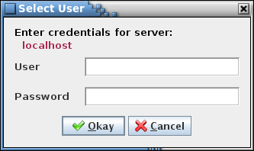

1. Select User dialog (no server connection)

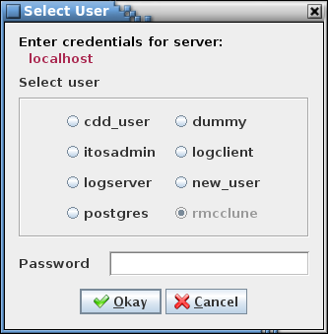

1. Select User dialog (server connected)

#### Database server

The **Database server** command is used to set the PostgreSQL database connection properties. When the command is issued, if any table editor or the table type editor is open and has unsaved changes then a confirmation dialog first appears, allowing the user to choose whether to discard the unsaved changes and continue with the server change, or to cancel the server change. If there are no unsaved changes or if the user confirms discarding the changes then the editors are closed and the **Database Server** dialog is displayed (see Figure 13). The dialog allows entering the PostgreSQL server host name and server port number, and to enable or disable secure sockets layer (SSL) authentication.

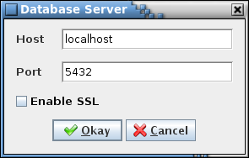

1. Database server dialog

The dialog allows selection of a PostgreSQL server on the local or a remote host. Enter the server host name and the server port number, set the **Enable SSL** check box appropriate to the target connection’s encryption requirements, and then select the **Okay** button. The host text field uses auto-completion to fill in the host string. The previous 30 host names are remembered by default, including those from previous sessions (the number of remembered host names can be changed via the Preferences dialog). If the host field is empty then the default host name, localhost, is used. The default port number for the PostgreSQL server is 5432. An attempt is then made to establish a connection to the server on the new host as the current user. Select the **Cancel** button to exit the dialog without changing the database server properties.

The SSL selection must match that of the target or else the connection will not be established. *Note: When SSL is enabled no certificate validation is performed by the JDBC driver.*

#### Read log

The **Read log** command causes the **Open Event Log** file selection dialog to be displayed. Navigate to the location of the desired CCDD event log file, highlight it using the mouse or keyboard controls, and select **Open** to open the log in a window similar to the main program window. The log file names are in the format CCDD-*YYYYMMDD-hhmmss*.log, where *YYYYMMDD* is the year, month, and day, and *hhmmss* is the hour, minute, and second when the log was created. Select **Cancel** to close the file selection dialog without opening a log file. See paragraph 4.2 for details on the event log columns and filter selections. The log window may be resized. The **Search** button displays the event log search dialog (see paragraph 4.9.1.5); the log can be searched for a user-specified text string. Select the **Print** button to open a printer selection dialog in order to print a copy of the log to the selected printer. Select **Close** to close the log window.

#### Print log

The **Print log** command causes a dialog to appear allowing selection of a printer in order to print a copy of the current session’s event log; i.e., the log displayed in the main application window.

#### Search log

The **Search log** dialog provides a means of searching the current session’s event log for a specified text string (see Figure 14).

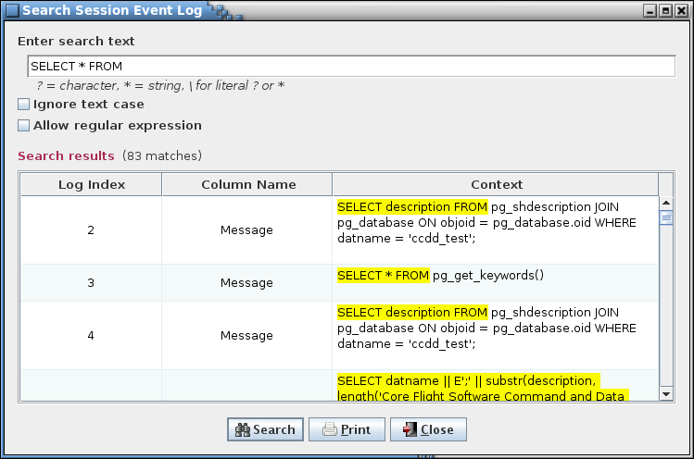

1. Search event log dialog

Enter the search text in the input field and select the **Search** button. The search results are displayed in the table at the bottom of the search dialog. The first column, **Log Index**, shows the log entry’s index number where a match is found. The second column, **Column Name**, provides the column where the match occurs in the event log. The last column, **Context**, displays the string from log entry containing the search text, with the search text highlighted. The full length of the log message text is searched (and displayed, if a match is found), even if the message is truncated in the event log due to length restrictions. Pressing the Ctrl-F key sequence while the main application window has the focus also displays the event log search dialog.

The search text field uses auto-completion to fill in the search string. The previous search strings (those for the event log, tables, and scripts) are remembered, including those from previous sessions. The number of remembered search strings can be changed via the Preferences dalog, and defaults to 30. Case sensitivity for auto-completion is based on the **Ignore text case** check box selection state.

The input text can be changed and the **Search** button pressed again to initiate another search of the log. The search results can be output to a file or printer by selecting the **Print** button. To exit the search dialog select the **Close** button.

The search criteria can be adjusted by use of the check boxes below the search text. Case sensitivity for the search is governed by the **Ignore text case** check box.

If the **Allow regular expression** check box is not checked then the search text is matched as typed in the search text field. The search text may contain one or more wild card characters. A label, giving a brief explanation for the wild cards, is displayed underneath the search text field. A question mark (?) in the search string will match any single character (example: the search string *a?c* matches *abc*, *a c*, and *a&c*, but not *ac*). An asterisk (*) matches one or more characters (example: *a*c* matches *abc*, *a_b_c*, and *a:123c*, but not *ac*). In order to search for a wild card character the character must be preceded by a backslash (\) character (example: *a\?c* matches *a?c* but not *abc*).

The **Allow regular expression** check box, when checked, allows the use of a regular expression to define the search pattern in the search text field. The wild card label is removed when a regular expression is allowed. A regular expression can be formulated to find multiple matching conditions (for example, the search for **a.c** would match any string that has a single character between the characters ‘a’ and ‘c’). Information regarding the use of regular expressions is beyond the scope of this document; however, resources and tutorials can be found online.

#### Web server

The embedded web server allows web-based applications access to a project’s data. The web server must be started before any requests are made. If the application is running the **Enable server** command (paragraph 4.9.1.6.1) is used to start and stop the server. The server is disabled by default. Command line options are available to allow the server to be started at program start-up, with or without the GUI enabled. See Table 1 for the web server command line arguments.

All requests are directed to the currently open project database. The query format is:

*host*:*port*/*component*<?*attribute*<=*name*>>

The *host* name is the network name or IP address on which the CCDD application, with the web server active, is operating (‘localhost’ if active on the same machine as the requesting application). The *port* number is the port to which the server is assigned to listen (the default is 7070; this can be changed via command line command or menu option). The *component*, *attribute*, and *name* portions of the request determine the data returned. Data for tables, groups, applications, and the telemetry and application scheduler is available. Data may be requested for a single table, group, or application, or for all of the given component. Lists containing the names of all tables, groups, or applications can be requested. Table 6 contains the recognized *component*, *attribute*, and *name* combinations.

The data is returned to the requesting application in JSON “*key*”:”*value*” pair format per the **Output** column in Table 6. For the initial request the user is prompted for a valid PostgreSQL server user name and password. Additionally, this user must have read access to the project open in the CCDD application hosting the web server.

If a table contains macro references then the table values default to replacing the macro names with the corresponding macro values, as defined in the macro editor (see paragraphs 4.5.7 and 4.9.3.12 for more information relating to macros). Requests can be made to return the table data with the macro names displayed in place of the macro values by appending **;macro** (or **;macros** – either is case insensitive) at the end of the *name* portion of the request, or at the end of the *attribute* portion if there is no *name* portion. For example, the request *table?=;macro* returns the table data for all tables with the macro names displayed, and the request *telemetry?;macros* returns the telemetry information for all tables with the macro names displayed in those JSON “*key*”:”*value*” pairs that are taken directly from table cells.

Variable paths, formatted as single strings, can be requested as part of a structure table’s data (see paragraph 4.9.3.17 for more information on variable paths). The variable paths are attached to the table data as an additional column named “Variable Path”. The format for returning the paths is similar to the *variable* command (see Table 6):

;path<s><,<*variable path member separator character(s)*>,<*hide data types flag (*true *or* false*)*>,<*data type and variable name separator character(s)*>>

If the variable path member separator character(s), hide data type flag, and data type and variable name separator character(s) are not provided then the default values – “_”, false, and ”_”, respectively – are used. The command is case insensitive and must be placed at the end of the *name* portion of the request, or at the end of the *attribute* portion if there is no *name* portion. It may be used in conjunction with the **macro** command described above. For example, the request:

*table?data=;path,”_”,”false”,”.”*

would convert the variable path *rootStruct,parentStruct.structVar,int.primVar* to *rootStruct_parentStruct.structVar_int.primVar*, and the request:

*table?data=;path,”_”,true,”_”*

would convert the variable path *rootStruct,parentStruct.structVar,int.primVar* to *rootStruct_structVar_primVar*.

| **Request** | | | **Returned Information** | **Output1,2** |
| --- | --- | --- | --- | --- |
| **Component** | **Attribute** | **Name** |
| table | all *(or blank)* | <*table name*> | Type, description, size (if a structure), data, and data fields for the specified data table (*table name* is case insensitive), or for all tables if *table name* is omitted | {"Table Name":"*table* *name*","Table Type":"*type*","Table Description":"*description*","Table Size":*size*,"Table Data":[{"*first row column name*":"*first* row *column value*",<,"*first row next column name:*"*first row next column value*{"*second row column name*":"*second* row *column value*",<,"*second row next column name:*"*second row next column value*"<,…>>}<,…>],"Data Field":[{"Field Name":"*field name*","Description":"*field description*","Size":"*field character length*","Input Type":"*input data type*","Required":"true *or* false","Applicability":"*field applicability*","Value":"*field value*"}<,*next field’s data*…>]} |
| data | <*table name*> | Data for the specified data table (*table name* is case insensitive), or for all tables if *table name* is omitted | {"Table Name":"*table name*","Table Data":[{"*first row column name*":"*first* row *column value*",<,"*first row next column name:*"*first row next column value*{"*second row column name*":"*second* row *column value*",<,"*second row next column name:*"*second row next column value*"<,…>>}<,…>]} |
| description | <*table name*> | Description for the specified table (*table name* is case insensitive), or for all tables if *table name* is omitted | {"Table Name":"*table name*","Table Description":"*description*"} |
| fields | <*table name*> | Data field information for the specified table (*table name* is case insensitive), or for all tables if *table name* is omitted | {"Table Name":"*table name*","Data Field":[{"Field Name":"*field name*","Description":"*field description*","Size":"*field character length*","Input Type":"*input data type*","Required":"true *or* false","Applicability":"*field applicability*","Value":"*field value*"}<,*next field’s data*…>]} |
| names | <*table type*> | Names of all tables of the specified table type (*table name* is case insensitive), or for all table types if *table type* is omitted | {"Table Type":"*table* *type*", "Table Names":["*table name*"<,"*next table name*"<,…>>]} |
| size | <*table name*> | Size (in bytes) for the specified structure table (*table name* is case insensitive), or for all tables if *table name* is omitted | {"Table Name":"*table name*","Byte Size":*size*} |
| search | <*search text*>,<*ignore case (*true *or* false*)*>, <*allow regular expression (*true *or* false*)*>,<*data table cells only (*true *or* false*)*><,*search table column names*> | Search for the specified text in the project database tables. Set the *ignore case* flag to true to ignore case when matching the text (defaults to *false* if not provided).  If the *allow regular expression* flag is not set to *true* then the search text is matched as is text (defaults to *false* if not provided). The search text may contain one or more wild card characters. A question mark (?) in the search string will match any single character (example: the search string *a?c* matches *abc*, *a c*, and *a&c*, but not *ac*). An asterisk (*) matches one or more characters (example: *a*c* matches *abc*, *a_b_c*, and *a:123c*, but not *ac*). In order to search for a wild card character the character must be preceded by a backslash (\) character (example: *a\?c* matches *a?c* but not *abc*).  If the *allow regular expression* flag is set to *true* a regular expression is allowed to define the search pattern in the search text. A regular expression can be formulated to find multiple matching conditions (for example, the search for **a.c** would match any string that has a single character between the characters ‘a’ and ‘c’). Information regarding the use of regular expressions is beyond the scope of this document; however, resources and tutorials can be found online.  Set the *data table cells only* flag to return only those matches within the data table cells (otherwise matches in the internal tables are returned as well; defaults to false if not provided). Optionally constrain the search to specific data table columns by appending a comma-separated list of column names (the names are case sensitive) | [{"Table / Object":"*table name*","Location":"*location within table*","Context":"*table cell contents containing the matching search text*"}<,…>] |
| proto_table | *Same requests as for* table *above, except only table information for prototype tables is returned* | | | |
| root_table | *Same requests as for* table *above, except only table information for root tables is returned* | | | |
| instance_table | *Same requests as for* table *above, except only table information for instance tables is returned* | | | |
| group | all *(or blank)* | <*group name*> | Description, application status, associated table(s), and data field(s) for the specified group, or for all groups if *group name* is omitted | {"Group Name":"*group* *name*","Group Description":"*description*","Group Is Application", " true *or* false","Group Table":["*table name*"<,"*next table name*<,…>>"],"Group Data Field": [{"Field Name":"*field name*","Description":"*field description*","Size":"*field character length*","Input Type":"*input data type*","Required":"true *or* false","Applicability":"*field applicability*","Value":"*field value*"}<,*next field’s data*…>]} |
| tables | <*group name*> | Table(s) associated with the specified group (*group name* is case sensitive), or for all groups if *group name* is omitted | {"Group Name":"*group* *name*","Group Table":["*table name*"<,"*next table name*<,…>>"]} |
| description | <*group name*> | Description for the specified group (*group name* is case sensitive), or for all groups if *group name* is omitted | {"Group Name":"*group name*","Group Description":"*group* *description*"} |
| fields | <*group name*> | Data field information for the specified group (*group name* is case sensitive), or for all groups if *group name* is omitted | {"Group Name":"*group* *name*","Group Data Field": [{"Field Name":"*field name*","Description":"*field description*","Size":"*field character length*","Input Type":"*input data type*","Required":"true *or* false","Applicability":"*field applicability*","Value":"*field value*"}<,*next field’s data*…>]} |
| names |  | Names of all groups | {"Group Names":["*first group name*"<,"*second group name*"<,"…">>]} |
| application | *Same requests as for* group *above, except only group information for groups representing a CFS application is returned* | | | |
| scheduler | telemetry | <*data stream name*>,  <*header size (bytes)*>,  <*message ID name data field name*>,  <*optimize flag (*true *or* false*)*> | Telemetry scheduler's copy table entries for the specified data stream | {"Stream Name":"*stream name*","Header Size":"*size*","Optimized":"true *or* false","Copy Table":[{"Input Message ID":"*input ID*","Input Offset":"*input byte offset*","Output Message ID":"*output ID*","Output Offset":"out*put byte offset*","Number of Bytes":"*output size in bytes*","Root Table":"*root table name*","Variable Path":"*variable path*"}<,*next row*<,…>>]} |
| application | schedule | Application scheduler's schedule definition table entries | {"Schedule Definition Table":[{"MessageIndex":"*wake-up message name*","Type":"SCH_ACTIVITY_SEND_MSG","EnableState":"SCH_ENABLED","Frequency":"1","Remainder":"0","GroupData":"*schedule group name*"} *or* {"MessageIndex":"0","Type":"0","EnableState":"SCH_UNUSED","Frequency":"0","Remainder":"0","GroupData":"SCH_GROUP_NONE"}<,*next row*,<,…>]} |
| message | Application scheduler's message definition table entries | {"Message Definition Table":[{"Command ID #*row number*":"SCH_UNUSED_MID *or* *wake-up message name*, 0xC000, 0x0001, 0x0000"}<,*next row*,<,…>]} |
| variable | <*variable path + name*> or blank | <*variable path member separator character(s)*>,  <*hide data types flag (*true *or* false*)*>,  <*data type and variable name separator character(s)*> | The variable path and name in the format used by the application paired with the converted path and name (dependent on the input parameters). If no variable path and name is supplied then every variable in the project along with its converted form is returned | {"*variable path and name (application format)*":"*variable path and name (user-specified format)*"[,…]} |
| telemetry | <<*group name*>, <*data stream name*>, <*sample rate*>> |  | Structure table name, variable name, data type, data stream information, enumeration information, and all other data associated with the variable for the telemetered variables in the structure tables belonging to the specified group (or application), or for all structure tables if *group name* is omitted. Filters can be specified for the data stream name and/or the sample rate so that only those telemetered variables matching the filter(s) are returned | {"Structure Table Name":"*table name from which the variable is taken*","Variable Name":"*variable name*","Data Type":"*variable’s data type*","Data Streams":[{"Stream Name":"*first* *stream’s name*","Sample Rate":"*variable’s sample rate in this stream*"}<,*next stream’s data*<,…>>],"Enumerations":[{"Enumeration Name":"first enumeration’s name","Enumeration Value":"*first enumeration’s value*"}<,*next enumeration’s data*<,…>>]} |
| command | all *(or blank)* | <*group name*> | Command table name, command name, command code, command description, and for each of the command’s arguments the argument name, data type, enumeration, minimum value, maximum value, and any other argument data, for the commands in the command tables belonging to the specified group (or application), or for all command tables if *group name* is omitted | {"Command Table Name":"*table name from which the command is taken*","*command name column name*":"*command name*", "*command code column name*":"*command code*",<"*command description column name*":"*command description*">,"Arguments":[{"*first argument’s name column name*":"*first argument’s name*","*first argument’s data type column name*":"*first argument’s data type*","*first argument’s enumeration column name*":"*first argument’s enumeration*","*first argument’s minimum value column name*":"*first argument’s minimum value*","*first argument’s maximum value column name*":"*first argument’s maximum value*"<,*first argument’s other column data*>}<,*next argument’s data*<,…>>]} |
| table_type |  |  | Table type definitions | {"Table Type Definition":[{"Column Name":,"*type name*"," Description":"*type description*","Input Type":"input data type","Unique":"true *or* false","Required":"true *or* false","Enable if Structure":"true *or* false","Enable if Pointer":"true *or* false"}]} |
| input_type |  |  | User-defined input type definitions | {"Input Type Definition":[{"Type Name":"*input type name*","Description":"*input type description*","RegEx Match":"*regular expression constraining the entered values*","Selection Items":"*list of text strings from which to select, separated by line feed characters*","Value Format":"*value format option:* Text*,* Array*,* Boolean*,* Float*,* Integer*, or* Hexadecimal"}<,*next input type definition*<,…>>]} |
| data_type |  |  | Data type definitions | {"Data Type Definition":[{"Type Name":"*user-defined name*","C Name":"*C-language name*","Size":"*size in bytes*","Base Type":"*base data type*"}<,*next data type definition*<,…>>]} |
| macro |  |  | Macro definitions | {"Macro Definition": ":[{"Macro Name":"*macro name*","Value":"*macro value*"}<,*next macro definition*<,…>>]} |
| message_id |  |  | Message ID owners, names, and values | {"Message ID Owner, Name, and Value": [{"Owner":"*message ID owner*","Message ID Name":"*message ID name*","Message ID":"*message ID value*"}<,*next message ID*<,…>>]} |
| project_info |  |  | Get the active project's information (name, database name, description, lock status, current user name, project owner name, and project data fields) | {"Project":"*project name*","Database":"*database name*","Description":"*project description*","Status":"locked *or* unlocked","User":"*user name*","Owner":"*owner name*","Project Data Field":[ {"Field Name":"*field name*","Description":"*field description*","Size":"*field character length*","Input Type":"*input data type*","Required":"true *or* false","Applicability":"*field applicability*","Value":"*field value*"}<,*next field’s data*…>]} |
| authenticate | *user name* | *user password* | Determine if the specified user credentials are valid for the currently open project database | true *if the credentials are valid;* false *otherwise* |
| shutdown |  |  | Close the web server and project database, and exit the CCDD application |  |

1. *Only those JSON “*key*”:”*value*” pairs that are members of a JSON array (i.e., that are enclosed by brackets ([]) in the output) have their original order preserved; other pairs may appear in any order**.*
2. *If* Name *is omitted in a* table*,* proto_table*,* root_table*,* instance_table*,* group*, or* application *request then a JSON array is returned in the format* [<*first output*><,*second output*<,…>>]*, with each array member representing a table, group, or application.*
3. Web data access commands

##### Enable server

Selecting the **Enable server** command toggles between starting and stopping the web server. When enabled, the web server allows CCDD to respond to web-based queries. When disabled, the server ignores web queries.

##### Select port

The **Select port** command displays a dialog (Figure 15) that allows selection of a port number for the embedded web server. Enter the server port number, then select the **Okay** button. If the web server is active then it’s automatically restarted using the new port number. Select the **Cancel** button to exit the dialog without changing the server port.

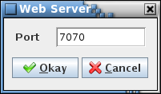

1. Web Server dialog

#### Preferences

The **Preferences** command displays the **Preferences** dialog (Figure 16), which allows altering the application’s display characteristics. This includes choosing the “look and feel” (L&F), fonts, colors, sizes, and spacing values applied to the program’s GUI components. The dialog has a separate tab for each of the selection types. Once updates to the preferences are completed press the **Close** button to exit the dialog. The preference changes are saved so that the updated characteristics are used when the application is opened again. See Appendix E.2 for details on the stored preferences.

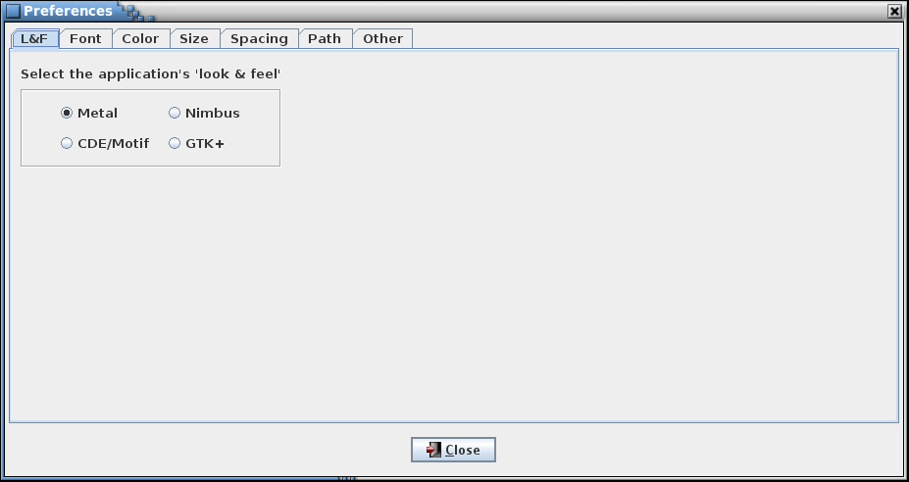

1. Preferences dialog; look and feel preferences

##### L&F

The L&F can be changed via the **L&F** tab (Figure 16). L&Fs change the shape and color scheme of the graphical components (see Figure 17), though the basic layout remains the same. The default is “Metal”, the standard L&F provided with Java. The list of L&F selections displayed in the dialog is dependent on the available L&Fs loaded on the host machine. When the radio button associated with the desired L&F is selected the **Preferences** dialog, main application window, and any other open CCDD windows are immediately redrawn to reflect the L&F chosen.

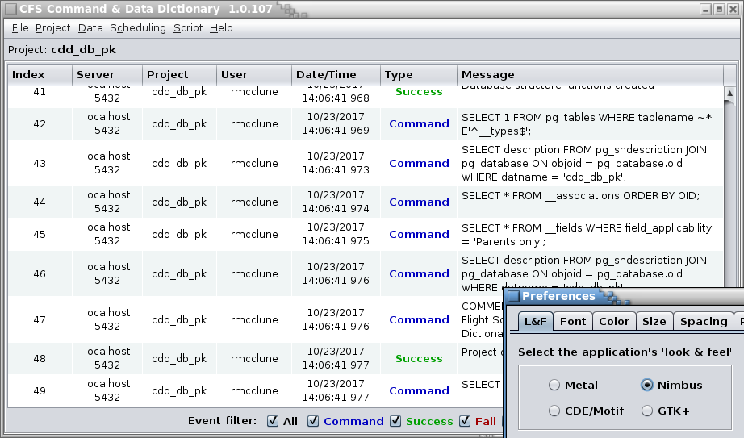 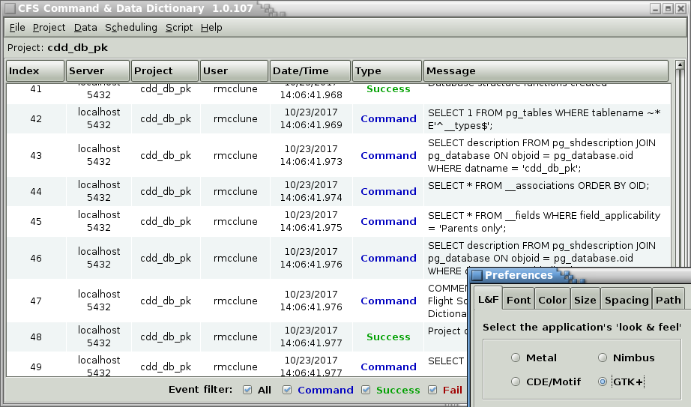

1. Example look and feel differences

##### Font

The **Font** tab displays the selection controls for the various fonts used in the application and an overall font scaling factor (Figure 18).

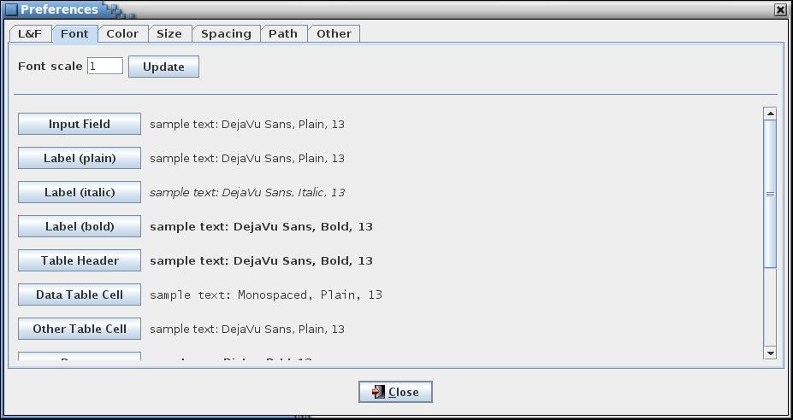

1. Font preferences

Each font is represented by a button with a sample of the font’s text beside it. Hovering the mouse pointer over the font button displays a tool tip describing the font’s use in more detail. To alter a font press its associated button – a font selection dialog appears (Figure 19). The font, style, and size are selected from the lists; the Sample field displays a sample of text using the chosen font settings. Select **Update** to change the selected font. The font change is implemented immediately in all of the application’s open windows. Select **Default** to use the font’s default settings. Press the **Close** button to exit the font selection dialog.

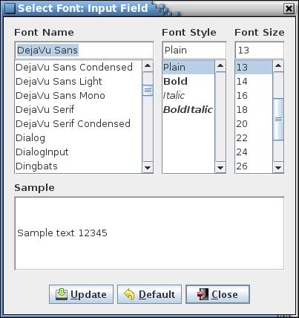

1. Font selection dialog

The **Font scale** input field allows a scale factor to be entered. Scaling provides a quick method for increasing or decreasing the font sizes (this is useful for high DPI displays, which are not well supported by Java in Linux). The scale factor must be a value between 0.1 and 25 (inclusive). When the **Update** button is pressed all of the application’s fonts are adjusted immediately by multiplying the scale factor by the font’s current size. Note that the font size values displayed in the **Preferences** dialog and stored in the program preferences are unchanged. The scale factor is stored in the program preferences and is applied whenever the application is opened.

##### Color

The **Color** tab displays the selection controls for the various colors used in the application (Figure 20).

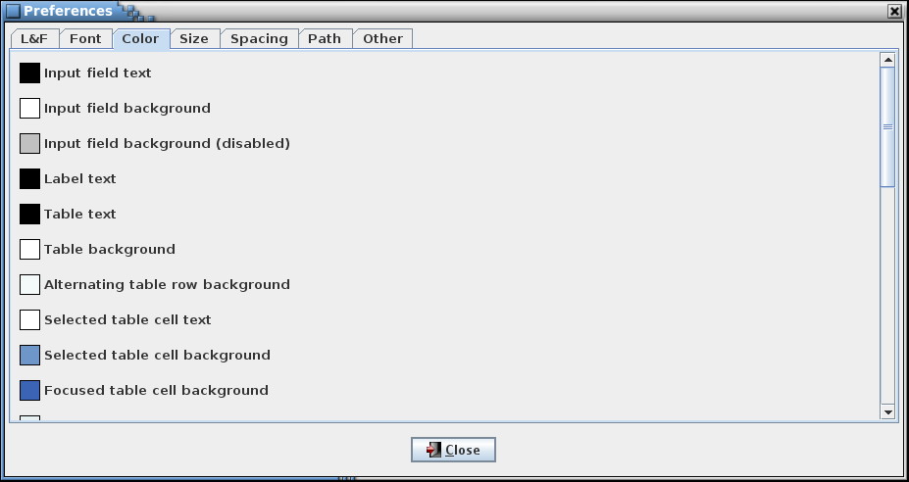

1. Color preferences

Each color is represented by a color box with a description beside it. Hovering the mouse pointer over the color box or description displays a tool tip describing the color’s use in more detail. To alter a color select its associated box – a color selection dialog appears (Figure 21). The actual appearance of the color selection dialog varies based on the chosen L&F. However, the basic color selection for each is the same – use the mouse to operation alter the color parameters via the dialog’s buttons, sliders, wheels, input fields, etc. Select **Update** to change the selected color. The color change is implemented immediately in all of the application’s open windows. Select **Default** to use the color’s default settings. Press the **Close** button to exit the color selection dialog.

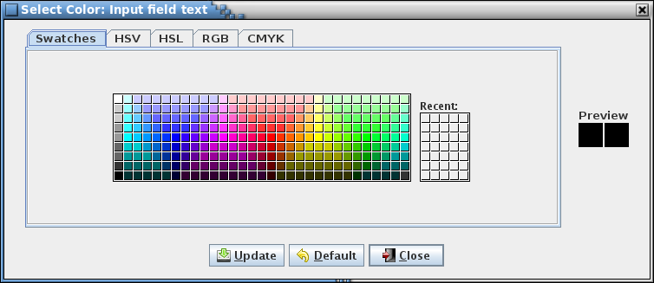

1. Color selection dialog

##### Size

The **Size** tab displays the selection controls for the various size values used in the application (Figure 22). This also include timeout settings for connecting to the postgreSQL server, and for database reposnse and query execution.

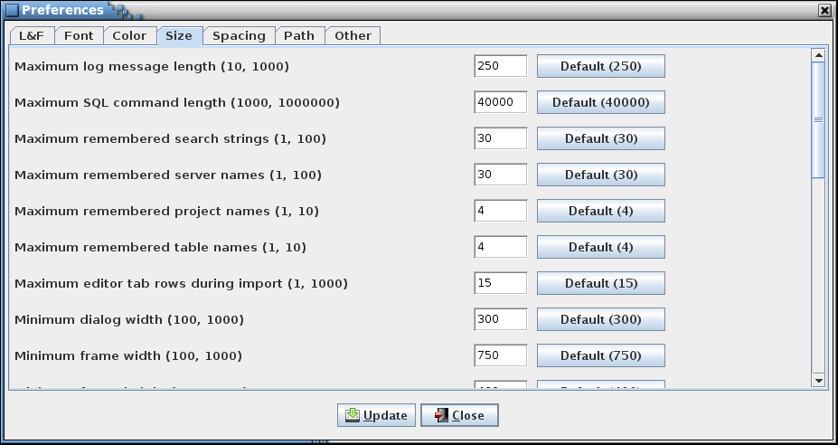

1. Size preferences

Each size value is represented by an input field with a description and default value button on either side of it. Hovering the mouse pointer over the description or input field displays a tool tip describing the size value’s use in more detail. The description includes the minimum and maximum values allowed. To alter a size value enter a valid value into its associated input field. Selecting the size value’s associated **Default** button (which displays the default value) enters the size value’s default value into the input field. Select **Update** to implement the altered size value(s). Although size changes are implemented immediately, these are not apparent until the size value is used (e.g., the log message length applies to event messages subsequently logged).

##### Spacing

The **Spacing** tab displays the selection controls for the various spacing values used in the application (Figure 23).

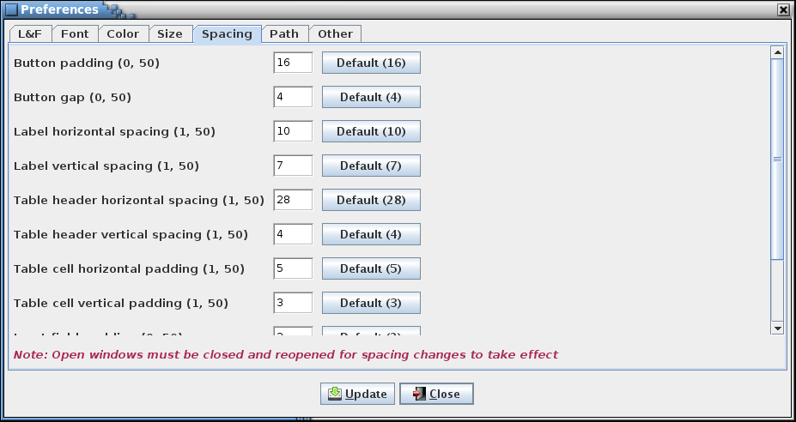

1. Spacing preferences

Each spacing value is represented by an input field with a description and default value button on either side of it. Hovering the mouse pointer over the description or input field displays a tool tip describing the spacing value’s use in more detail. The description includes the minimum and maximum values allowed. To alter a spacing value enter a valid value into its associated input field. Selecting the spacing value’s associated **Default** button (which displays the default value) enters the spacing value’s default value into the input field. Select **Update** to implement the altered spacing value(s). As indicated by the note at the bottom of the dialog changes to spacing values are not applied to the application’s open windows. These must be closed and reopened to use the updated values. Since this includes the main window, the application must be restarted in order for the spacing values to affect it.

##### Path

The **Path** tab displays the selection controls for the various folder paths used in the application (Figure 24).

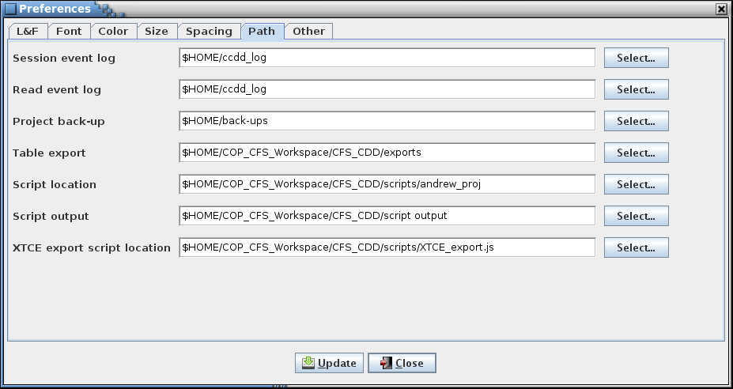

1. Path preferences

Each path is represented by an input field with a description and path selection button on either side of it. Hovering the mouse pointer over the description or input field displays a tool tip describing the path’s use in more detail. To alter a path either enter it into its associated input field or press its **Select…** button to display a folder chooser dialog; once selected in the dialog the path appears in the input field. Select **Update** to implement the altered path(s). Paths can be absolute or relative. Relative paths are based on the folder in which the application is executed. Note that path selection in other dialogs (for example, the **Script Manager** or **Open Event Log** dialogs) updates the respective path if changed in the dialog. Path selection via command line argument also updates the path preference.

The **Script output** path is a special case. It does not directly affect the output location of files generated by scripts. Instead, a script may obtain the **Script output** path via an access method (see the CCDD Developers Guide) and use it to set the location of any output files(s).

##### Other

The **Other** tab displays program preferences that don’t conform to those in the other tabs (Figure 25).

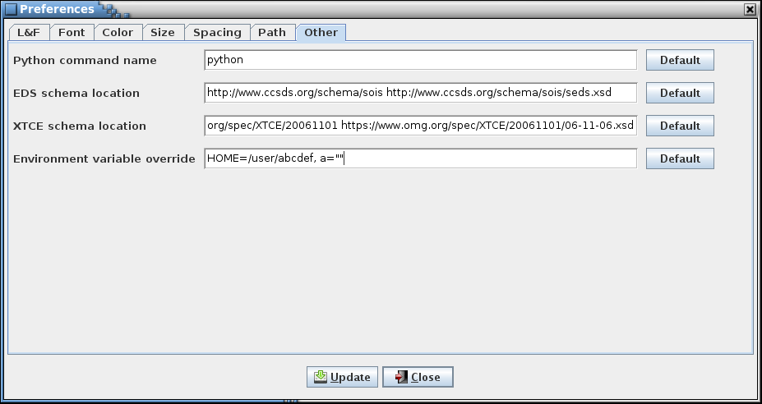

1. Other settings

Each setting is represented by an input field with a description and default selection button on either side of it. Hovering the mouse pointer over the description or input field displays a tool tip describing the setting’s use in more detail. To alter a setting value enter a valid value into its associated input field. Selecting the setting’s associated **Default** button enters the setting’s default value into the input field. Select **Update** to store the altered setting value(s).

#### Exit

Choosing the **Exit** command displays a dialog so that the user can confirm whether or not to exit the application. Select **Okay** to exit CCDD. If there are unsaved changes to a table editor or the table type editor then the user is queried whether or not to continue. If **Okay** is selected the open editors are closed (any unsaved changes are discarded), the main application window is closed, and the application exits. Select **Cancel** to close the dialog without exiting the application.

### Project

The **Project** menu contains commands for interacting with the project databases.

Each project has a locked/unlocked status flag. This flag is checked by the application when attempting to access a project. Project access is required for the **Open**, **New**, **Rename**, **Copy**, and **Delete** commands described in this section. If the flag indicates the project is unlocked the command proceeds. If the flag indicates the project is locked, the project access is denied and the specified operation is terminated. Access failure results in display of a database error dialog and the failure is written to the event log. The lock status is set to “locked” for an open project database. When the project database is closed (e.g., when exiting the CCDD application) the flag is set to “unlocked”. Abnormal termination of the CCDD application can result in a project database retaining a locked status. The **Unlock** command (paragraph 4.9.2.9) allows clearing a project’s lock status.

*Note: In the project dialogs below, only those project databases for which the current user is allowed access are displayed.*

#### Open

Selecting the **Open** command results in a dialog being displayed that shows the CCDD project databases, along with their descriptions, that are available in the PostgreSQL server (see Figure 26). The currently open project database is shown selected and grayed out. Other projects that are open in another instance of the CCDD application are also grayed out and have their associated radio button disabled. Select a project’s radio button and then the **Open** button to open the selected project’s database. The currently open project is first closed, along with any open table or table type editors. If the editors have any unsaved changes then a confirmation dialog appears, allowing the user to choose whether to continue with the project change, discarding the unsaved changes, or to cancel the project change. Select **Cancel** to allow the currently opened project to remain open.

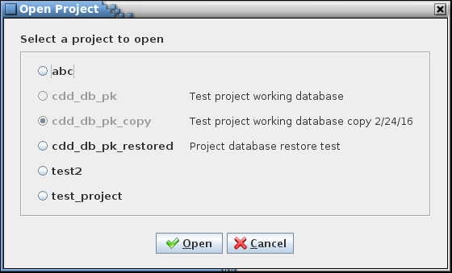

1. Select Project dialog

#### Close

When the **Close** command is selected the currently open project database is closed, along with any open data table or table type editors. If the editors have any unsaved changes then a confirmation dialog appears, allowing the user to choose whether to discard the unsaved changes and continue with closing the project, or to cancel closing the project.

#### New

The **Create Project** dialog (see Figure 27) appears when the **New** command is chosen, which allows creation of a new CCDD project database. A project owner must be selected from the list of available roles stored in the server (the curernt user is selected by default), and a name supplied for the new project. Optionally, a description can be entered for the project.

The choice of owner should take into account the number of users that require access to the project’s database. If only a single user needs access then that user can be selected as the owner. If multiple users need access then a group role should be created and this role assigned as the owner. All users requiring access would then need to be made members of this group role. Note that any user with super user status can access the project’s database regardless of the owner. See paragraph 4.2 for further information regarding setup of the PostgreSQL server.

The project name can contain any character except a semi-colon (;). The project name is used to create the project’s PostgreSQL database name. To meet the PostgreSQL naming constraints all letters are changed to lower case, any non-alphanumeric characters are converted to underscores, and an underscore is prepended to the resulting name if it begins with a numeral. If the resulting database name length exceeds 63 characters (the maximum allowed by PostgreSQL) then the name is truncated to the maximum length. The project and derived database names must be unique; these may not be the same as another project/database name existing in the server. The description can contain any character and, optionally, can be formatted using HTML tags.

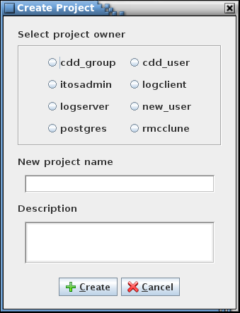

1. Create Project dialog

#### Rename

When the **Rename** command is selected the **Rename Project** dialog is displayed (see Figure 28). This dialog allows an existing project to be renamed, its description to be altered, or both. When one of the radio buttons representing a project’s database is selected the name and description appear in the fields below the radio button panel. Projects that are open in another instance of the CCDD application cannot be renamed and are grayed out with their radio button disabled. Only a project’s administrator may rename a project, so radio buttons for projects for which the user is not an administrator are also disabled. See paragraph 4.9.2.3 for constraints on the project name and description. When the **Rename** button is selected the project and description are updated. If the currently open project is renamed any open table editors are closed; if an editor has unstored changes then a dialog first appears allowing the user to confirm discarding the changes or canceling the rename operation. Note that this dialog can, if desired, be used to alter only the project’s description (the description can also be edited using the **Manage project fields** command in the **Data** menu; see paragraph 4.9.3.15). Selecting the **Cancel** button closes the dialog without making any alterations.

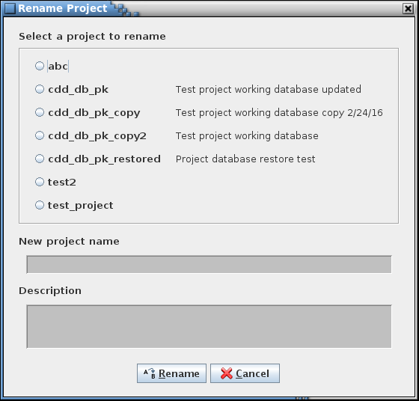

1. Rename Project dialog

#### Copy

When the **Copy** command selected the **Copy Project** dialog is displayed (see Figure 29). This dialog allows an existing project’s database to be copied. Only a project’s administrator may copy a project – the radio buttons for those projects which the user does not have administrator access are disabled. The exception is that a user with read/write access may copy the currently open project. When one of the radio buttons representing a project is selected the name and description appear in the fields below the radio button panel. The project name has the text “_copy” automatically appended, though the copy’s name and description can be altered as desired. See paragraph 4.9.2.3 for constraints on the project name and description. The **Append date and time to project name** check box, if selected, replaces the text “_copy” with the current date (year, month, and day) and time (hours, minutes, and seconds) stamp. Deselecting the check box removes the data and time stamp and appends the text “_copy” again. When the **Copy** button is selected, if an editor has unstored changes then a dialog first appears allowing the user to confirm discarding the changes or canceling the copy operation. If there are no unstored changes, or if the changes are discarded, then the selected project’s database is copied, using the copy name and description. Selecting the **Cancel** button closes the dialog without making a copy.

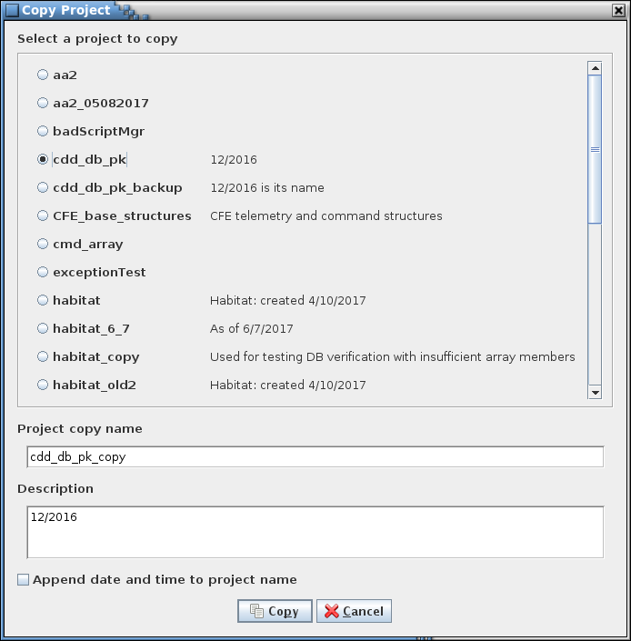

1. Copy Project dialog

#### Delete

The **Delete** command allows one or more project databases to be deleted. The **Delete Project(s)** dialog (Figure 30) appears when the command is issued. Projects that are open, in this or another instance of the CCDD application, cannot be deleted and are grayed out with their associated radio button disabled. Only a project’s administrator may delete a project, so radio buttons for projects for which the user is not an administrator are also disabled. After selecting a project (or projects) to delete, selecting the **Delete** button removes the project database(s) from the server. Selecting the **Cancel** button exits the dialog without deleting any projects. If **Delete** is selected a confirmation dialog is displayed for each selected project; selecting **Okay** continues with the delete operation for that project, and **Cancel** ignores the indicated project and does not delete it.

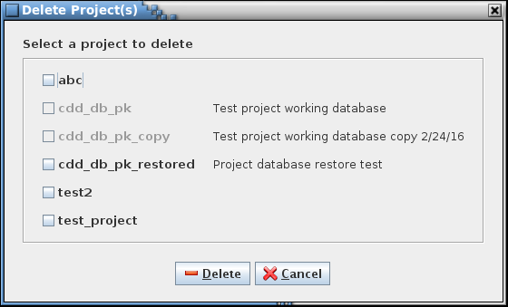

1. Delete Project dialog

#### Backup

The **Backup** command allows a user with read/write or administrator access to create a backup of the currently open project’s database. A file selection dialog is displayed for choosing the location and name of the backup file (Figure 31). The backup file extension is ‘.dbu’. The **Append date and time to file name** check box, if selected, appends the current date (year, month, and day) and time (hours, minutes, and seconds) stamp to the file name. Deselecting the check box removes the data and time stamp. Select the **Backup** button to proceed. If the file selected already exists an overwrite confirmation dialog appears. The backup file is created using the PostgreSQL *pg_dump* command. This produces a PostgreSQL script file, in plain ASCII text, that has all of the commands necessary to create the project’s database as it currently exists. The backup file makes it easy to transfer the database between servers and platforms. The **Restore** command, detailed in paragraph 4.9.2.8, uses the file generated by the **Backup** command to recreate a project’s database. Selecting the **Cancel** button exits the dialog without creating a backup.

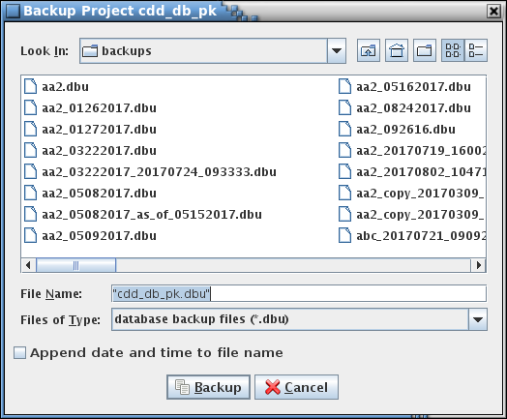

1. Backup Project dialog

#### Restore

The **Restore** allows the user to restore an entire database using a .dbu file, .json file(s) or .csv file(s).

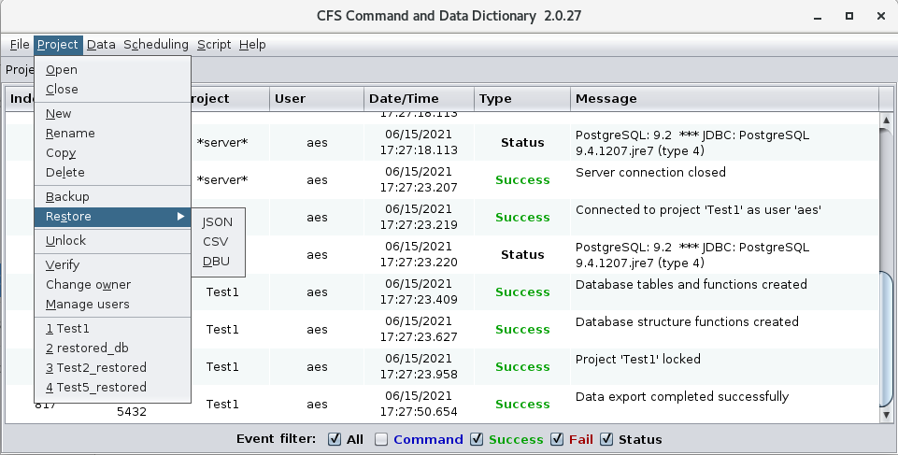

The **DBU Restore** command allows (re)creating a project’s database on a server using a PostgreSQL script file created using the **Backup** command (see paragraph 4.9.2.7). Using the dialog that appears, navigate to the desired backup file, select it, and press the **Restore** button; the project database recorded in the script file is restored to the server. The name of the restored database is its original name with “_restored” appended.

The **JSON Restore** and the **CSV Restore** command allows (re)creating a project’s database on a server using a single JSON/CSV file or multiple JSON/CSV files. Only one file type may be used for a single restore though. Using the dialog that appears, navigate to the desired file or directory, select it, and press the **Restore** button; the project database recorded in the file(s) is restored to the server. The name of the restored database will be the same as the database that was used to create the file(s) or it will be the default “restored_db” name. If using the command line a name can be provided by the user.

If the name of the restored project’s database would match that of an existing database then a sequence number is appended to the restored database’s name. For example, if the database *abc* is restored and the database *abc_restore* already exists then the database is restored as *abc_restore1*; if *abc_restore1* already exists then *abc_restore2* is used, and so on until an unused name is found.

The owner of this new database is changed from the original owner to the current user (i.e., the user performing the restore operation). If desired, the owner can be changed using the **Change owner** command (see paragraph 4.9.2.11).

#### Unlock

The **Unlock** command allows the locked status to be changed to “unlock” for a project database. This command is intended to be used to remove a lock from a project that remains locked after abnormal termination of the CCDD application. The **Unlock Project(s)** dialog (Figure 32) appears when the command is issued. Though all projects are displayed, only those that are locked have their associated check box enabled.

The locked/unlocked status is displayed beside the project database name along with the name(s) of the user(s) that have active connections to the project. A project is shown as “Current” if opened by the current instance of the CCDD application and is shown as “in use by” the current user. “Locked” is displayed if a project is in use by another instance of the CCDD application or was open when the application terminated abnormally. “Unlocked” indicates that no other instance of the CCDD application has the project open. Other applications may have active connections to the project (e.g., the PostgreSQL command line interface application, psql). The users for these non-CCDD connections are also shown in the “in use by” list. Referring to Figure 32, project *abc* is unlocked with no active connections, project *cdd_db_pk* is open by user *new_user* in this instance of the CCDD application, project *test2* is not open by CCDD but does have an active connection from another application by user *rmcclune*, and project *test_project* is open by user *new_user* in another instance of CCDD.

After selecting a project (or projects) to unlock, selecting the **Unlock** button unlocks the project database(s). Selecting the **Cancel** button exits the dialog without altering the project lock statuses.

***Warning****: Removing a project’s lock allows concurrent access to the project from more than one instance of the CCDD application. This may produce unexpected results or corruption of the project database if the multiple instances make updates to the update.*

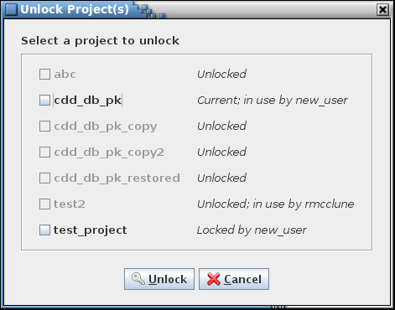

1. Unlock Project(s) dialog

#### Verify

The **Verify** command performs a consistency check on the currently open project database. This check ensures that the project’s data tables are consistent with the table type definitions and that the information within a table is valid. Errors in the tables should not arise from interactions with the CCDD application. However, changes to the project’s database from another application (e.g., psql) or using a version of the CCDD application that differs from the one used to create the project could result in the introduction and flagging of errors. The user is alerted to any potential problems and, where possible, is given the option to make corrections to the project’s tables, ignore the problem and continue the check, or to cancel the check. There are three areas of verification performed, described in the following paragraphs. No changes are made to the project database until the user selects and confirms applying the updates at the end of the check. Since the project database can be altered by the verification it is recommended that the project be backed up or copied prior to allowing any updates to the database.

The *internal table check* verifies the project database’s internal tables. These tables are for use by the CCDD application and are not directly viewable or editable by the user from within the application. The verification checks that the tables contain the expected number of columns and that the columns have the expected names and data types. Extraneous internal tables – tables with names conforming to the internal table naming scheme – are also detected; these tables can be created by the application’s automatic update feature and can be ignored.

The *path reference check* verifies that the table and variable references in the internal tables are valid. Many of the internal tables store references to tables, and in the case of structure tables the table reference can include one or more child tables and associated variable names. When changes made to a table the references in the internal tables are updated as well. If any table or variable references no longer exist these references can be removed upon confirmation by the user.

The *table type check* compares each data table to its table type definition, verifying that the number of columns, column names, and column order match. Each data table is checked to see if its type matches one of the defined table types, and if so, that it contains only those columns defined for that type. If updating is confirmed then missing columns are added (devoid of data) and extra columns are eliminated (including the data in them). If the table’s type is not defined then the entire table is deleted, along with its contents, when the update is applied. If the internal data type of the column doesn’t match the expected one then the column data type is corrected with no loss of the column’s data.

The *table data* *check* performs a check of the data within each table. In doing so it opens and inspects each data table and can generate a considerable number of database queries as is evidenced in the event log. Depending on the number of tables and the amount of data within them this operation can take a while. Each data value is checked to ensure it isn’t null (empty cells in a data table contain blanks instead of nulls) and that it is compatible with the input type as defined in the table’s type definition (e.g., no alphabetical characters in an integer cell). A check is made that each row in the table contains a row index (these indices are hidden from display in the table editor), that the row indices begin at 1, and there are no gaps in the index values. For structure tables containing array variables the check looks for missing array definitions (i.e., an array member without a corresponding array definition) and missing members (e.g., an array with an array size of 3 having only two members). Any columns in the table marked as unique (via the table type manager) are checked for duplicate values. If a duplicate is found and updating is confirmed then the value is replaced with a blank.

Note that certain inconsistencies may prevent a complete check of a project. For example, if a column is missing from a data table then the table’s data can’t be loaded (an error dialog is displayed) and checked until the missing column is added at the end of the verification check. For this case the column should be allowed to be added during the first verification check, then a second verification performed so that the data within the affected table is checked. Inconsistencies ignored during the table data verification section may lead to subsequent inconsistency detection that otherwise wouldn’t exist. An example would be ignoring a missing array definition when multiple array members are present – an issue is raised for each array member if the missing definition is ignored, whereas if updated the subsequent missing definition warnings won’t occur.

While the check is being conducted a dialog appears (Figure 33) showing the verification progress. This dialog allows halting the verification by pressing the **Halt** button. No changes are made to the project database if the **Halt** button is pressed.

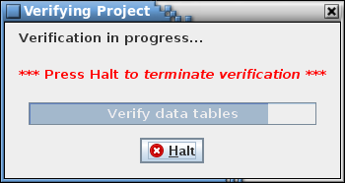

1. Verification and termination dialog

When the verification steps are complete, if any issues are detected then a dialog appears detailing the issues and the corrective action to be taken (Figure 34). Only users with administrative privileges (see paragraph 4.2.5) are allowed to implement the corrective actions (the **Okay** button is disabled for other users). After selecting the check box(es) in the **Corrective** **Action** column (or using the **Select all** check box to toggle selection of all of the issues), selecting **Okay** applies the corrective action(s) to the project database to address the issues flagged to be updated. If unchecked issues remain after corrected the selected ones then the dialog reappears, showing the uncorrected issues. The process of selecting issues to correct and selecting **Okay** can then be repeated, if desired. Selecting **Print** allows outputting the list to a printer. Selecting **Cancel** exits the verification check dialog.

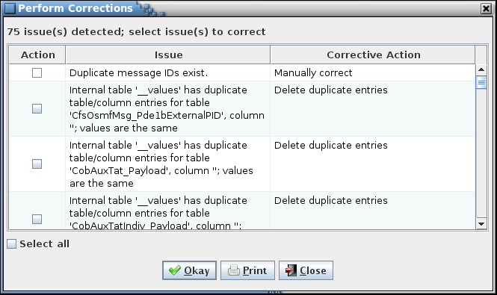

1. Example Perform Corrections dialog

#### Change owner

The Change Project Owner dialog (Figure 35) allows a project’s owner to be changed.

A project is selected from the radio button group in the upper portion of the dialog. The project’s current owner os display to the right of the project name. A project name is displayed grayed out and is disabled for selection if the current user doesn’t have administrative privileges for that project. A new owner is selected from the radio button group in the lower portion of the dialog. Once a project and new owner are chosen select the **Change Owner** button to change the project’s owner. Selecting **Cancel** exits the dialog without making any changes.

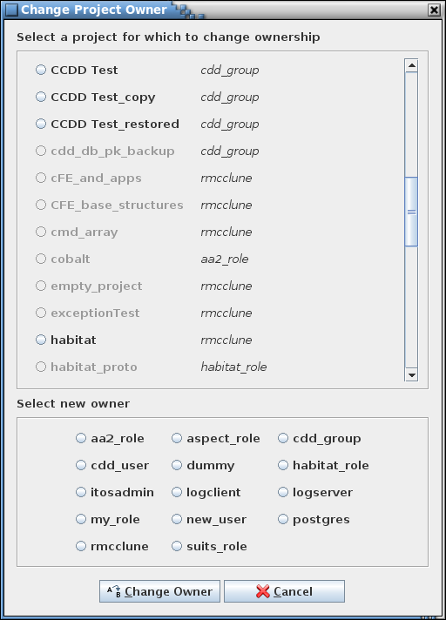

1. Change Project Owner dialog

#### Manage users

The Manage User Access Level dialog (Figure 36) provides a means to assign the level of access for each user of the current project. This command is enabled only for users with ‘Admin’ level access (see below). The creator of a project database is automatically granted administrator privileges. A user belonging to the project, but not explicitly assigned an access level, is granted ‘Read Only’ privileges.

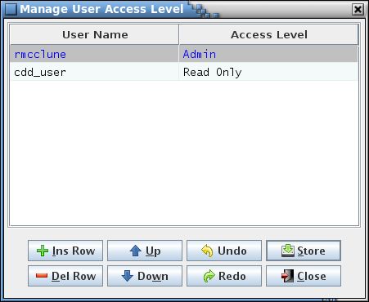

1. Manage User Access Level dialog

The editor column descriptions are as follows:

**User Name** This cell, when selected, displays a drop down menu containing all users registered in the PostgreSQL server. The current user is excluded from the list since a user can’t change their own access level.

**Acess Level** This cell, when selected, displays a drop down menu containing the available access levels. These capabilities allowed by these levels are as follows:

**Admin** In addition to the Read/Write access capabilities described below, the **Manage users** command is enabled so that the user may grant, alter, or remove a user’s access to the project. Also, any issues detected during project verification (paragraph 4.9.2.10) may only be implemented by an administrator.

**Read/Write** The user has full read/write access to the project database. All command menu and editor capabilities are enabled, except for the **Manage users** command. However, project verification updates may only be implemented by an administrator.

**Read Only** The user has full read access to the project database, but all commands that can alter the database data are disabled. This doesn’t prevent the user from altering the contents of any of the editors, but such changes are not persistent.

Each row in the table defines a user access level assignment. The rows can be sorted by selecting the column headers, as with other table editors in the application. Every assignment requires a value in the **User Name** and **Access Level** columns. The assignment for the current user is grayed out and can’t be altered; only another user with administrative privileges can change or delete the current user.

The button commands are described below:

**Ins Row** Inserts an empty row below the currently selected cell’s row. If cells in multiple rows are selected then the new row is inserted below the lowest one. If no cell is selected then the new row is inserted at the end of the table.

**Del Row** Deletes the row associated with each currently selected cell. If cells in multiple rows are selected then each of the rows is deleted. If no row is selected then this has no effect. The row containing the current user’s access level (Admin by definition) cannot be deleted.

**Up** Move the row(s) of the currently selected cell(s) up one row relative to the remaining rows. The order of the access level assignments in the editor has no effect on program operation. The capability to arrange the rows is solely for the user to group the users as desired.

**Down** Move the row(s) of the currently selected cell(s) down one row relative to the remaining rows. The order of the access level assignments in the editor has no effect on program operation. The capability to arrange the rows is solely for the user to group the users as desired.

**Undo** Undoes the last action performed (typing, paste, insert, delete, redo, etc.).

**Redo** Reverses the last action undone (typing, paste, insert, delete, undo, etc.).

**Store** Stores the changes made to user access levels into the database.

**Close** Closes the user access level manager window. If any changes have not been stored then a dialog appears allowing the user to confirm discarding the updates or to cancel closing the dialog.

#### Recently opened project(s)

The remaining commands in the Project menu are the names of the most recently opened projects. Selecting one of these items opens the specified project. Note that the attempt to open the project is made in the currently attached PostgreSQL server.

### Data

The **Data** menu has the commands for manipulating the data tables that contain a project’s data.

#### New table(s)

The **New Table** command allows creation of a new data table. This command is enabled only for a user with read/write or administrator access. The **New Table** dialog (Figure 37) displays the defined table types and input fields for the table name and its description.

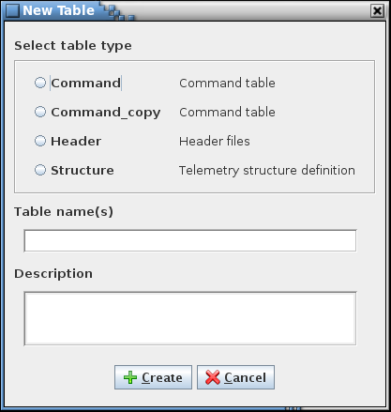

1. New Table dialog

A table type must be selected along with a valid table name. The description is optional and can be added or altered later using the table editor. Table names must be unique within a project. Though upper and lower case characters may be used, the name must still be unique if all of the characters are forced to lower case. The name must begin with a character or underscore (_) and can only contain characters, numerals, and underscores. Name length is constrained by PostgreSQL to a maximum of 63 characters. Also, the name may not match a primitive data type (e.g., double, or int8 or begin with a pair of underscores (this is used to designate internal tables created by the CCDD application). A warning dialog appears if any constraint is violated.

Multiple tables of the same type may be created by entering more than one name in the table name field with each name separated by a comma. The new tables created in this manner share the description entered in the description field (if any). The descriptions can be added or altered later using the table editor.

Selecting **Create** causes the table(s) to be created and stored in the database. Each table created has the columns defined by the selected table type and initially has no rows. If the type chosen has default data fields, then the new table inherits these fields and their default values. The new table(s) can then be opened using the **Edit** command (see paragraph 4.9.3.2).

#### Edit table(s)

The **Edit table(s)** command displays the data table selection dialog (Figure 38).



1. Edit Table dialog

The selection dialog has a table tree (see paragraph 4.5.3) from which one or more tables are selected for editing. Pressing the **Open** button opens the selected table(s) in a table editor (see Figure 39 for an example). Positioning the mouse pointer over a table name in the tree and double right-clicking can also be used to open the selected table. The **Cancel** button closes the table selection dialog without opening a table.

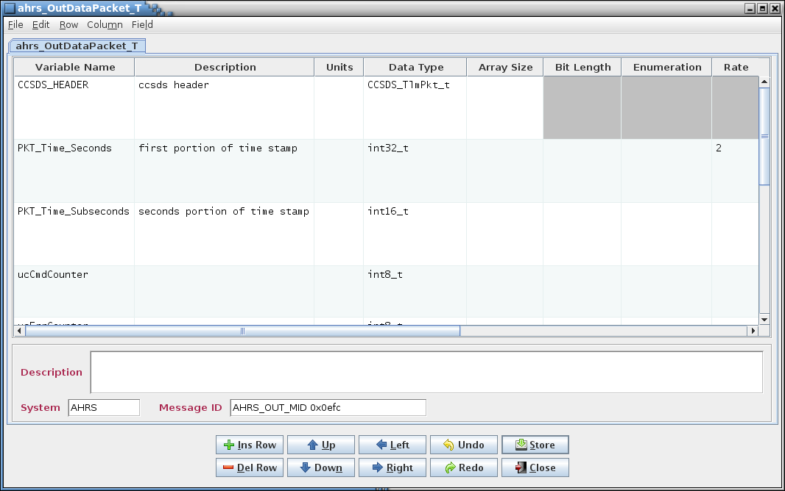

*Data field(s)*

*Description*

*Split pane*

*Table tab(s)*

*Buttons*

*Menu bar*

*Table data*

1. Example table editor

The table editor provides the means by which data is added to, altered, or removed from a data table. The editor is divided into six main sections.

**Menu bar** The first section is the menu bar, which contains the commands, described in the following paragraphs, for manipulating the table contents.

**Table tab(s)** The second section has one or more tabbed panes, each representing a data table’s contents. The tab names indicate the table to which the tab applies. A prototype or root table shows only the prototype/root name. For a structure table’s child table the tab displays a name in the format *root : structure.variable* where *root* is this table’s root table name, *structure* is the name of the prototype structure represented by this table, and *variable* is the variable name that references this child table in the child’s immediate parent structure. An asterisk beside the table name in the tab indicates that a change has been made to the table that hasn’t been stored in the project database. Hovering the mouse pointer over the tab name produces a pop-up tool tip showing the table’s type, root table, and complete structure and variable path.

**Table data** The columns displayed in the tabbed pane’s table are determined by the table type of the table being edited. The table columns can be sorted and repositioned as described in paragraph 4.4; however, the sorted order does not dictate the actual table data row order. See paragraph 4.9.3.2.4 for the menu commands for repositioning the columns. If the column order change is stored in the database then it is restored when the table is reopened. Column ordering is preserved separately for each user.

**Split pane** If the mouse pointer is hovered in the space between the table and the description field the pointer turns into a double-headed vertical arrow. Pressing and holding the mouse buttonis a control that allows sizing the portion of the editor for the table and the remainder for displaying the description and data fields.

**Description** This section contains the table description. The description is initially empty (unless set when the table was first created). The text entered here is used as a tool tip when the mouse pointer hovers over the table’s name in the table tree. Letter, numeral, and punctuation characters may be entered. Additionally, HTML tags can be inserted to provide additional formatting to the tool tip text.

**Data field(s)** This section displays any data field(s) assigned to the table. See paragraph 4.6 for details concerning data field creation.

**Buttons** The remaining section has a series of buttons that perform some of the more commonly used commands. Certain buttons may be disabled depending on the table displayed in the editor. The buttons are as follows:

**Ins Row** Inserts a new row in the table. See paragraph 4.9.3.2.3.1.

**Del Row** Deletes the selected row(s) from the table. See paragraph 4.9.3.2.3.2.

**Up** Moves the selected row(s) up one row. See paragraph 4.9.3.2.3.3

**Down** Moves the selected row(s) down one row. See paragraph 4.9.3.2.3.4.

**Left** Moves the selected column(s) left one column. See paragraph 4.9.3.2.4.1

**Right** Moves the selected column(s) right one column. See paragraph 4.9.3.2.4.2.

**Undo** Undoes the last action performed (typing, paste, insert, delete, redo, etc.).

**Redo** Reverses the last action undone (typing, paste, insert, delete, redo, etc.).

**Store** Stores the currently displayed table’s contents (cell data, description, and data fields) in the database. See paragraph 4.9.3.2.1.3.

**Close** Closes the currently displayed table’s editor. See paragraph 4.9.3.2.1.8.

The following paragraphs provide details on the commands available in the table editor menu bar.

##### File menu

###### Edit table(s)

The **Edit table(s)** command displays the Edit Table dialog (Figure 38). The table(s) opened from this dialog appear in the current table editor under their own tabs.

###### Edit prototype

If the currently displayed table in the editor is a child table then issuing the **Edit prototype** command opens the child’s prototype table in the current table editor under its own tab.

###### Store current

The **Store current** command stores the currently displayed table’s contents, including the table’s cell data, description, data fields, row order, and column order, into the database if changes have been made since the table was opened or since the last store operation. This command is enabled only for a user with read/write or administrator access. If no changes have been made then no action is taken; otherwise a confirmation dialog appears allowing the user to choose between continuing with the store operation and canceling it.

###### Store all

Selecting the **Store all** command is similar to the **Store current** command (paragraph 4.9.3.2.1.3) except that all tables in the table editor are stored to the database if changes have been made. This command is enabled only for a user with read/write or administrator access. A confirmation dialog appears allowing the user to choose between continuing with the store operation and canceling it.

###### Import data

The **Import data** command provides a means of inserting data and/or data fields from a CSV, EDS XML, JSON, or XTCE XML formatted file into the table currently displayed in the table editor. The import file may contain information for multiple tables, but only the data (and fields for CSV and JSON imports) for the first table defined in the file are imported. When you click **Import data** you will be given 4 options which are JSON, CSV, XTCE or EDS. A dialog appears (Figure 40) allowing the user to choose the import file based on file format. The **Export table** and **Export table(s)** commands produce files compatible with the import command; see paragraphs 4.9.3.2.1.6 and 4.9.3.8; Appendix C contains details on the file formats.

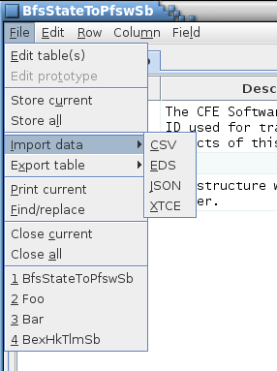

1. Import data and fields into an existing table dialog

Figure 39 depicts the options explained below.

The **Overwrite existing table data** check box, if selected, causes the imported data to overwrite all existing data and fields for JSON and CSV. For XTCE and EDS it will only replace all data.

The **Append Data** check box, if selected will append any new data rows or fields that are defined within the imported data to the currently existing data. Any imported data rows or fields that share names with currently existing data rows or fields will be reported and ignored.

The **Ignore all import file errors** check box, if selected, automatically ignores any errors detected in the import file and continues to process the file, if possible. This check box is only applicable to CSV and JSON formatted files.

The **Keep all existing data fields option** is a checkbox that will only appear if you are importing an XTCE or EDS file. These files can not store any data field information so this option if provided to give the user a choice to keep all existing fields if they wish.

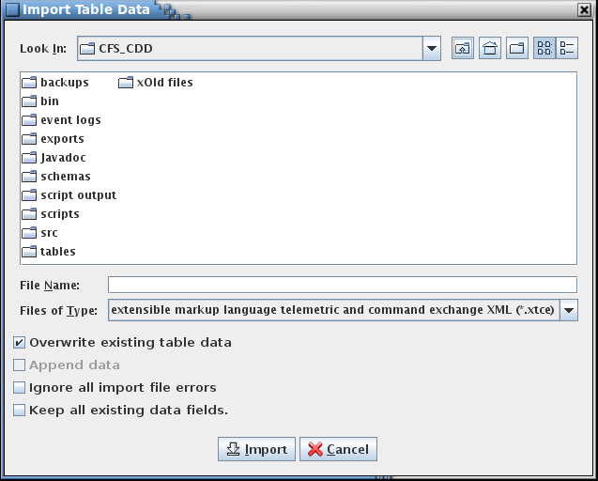

1. Import options

For CSV and JSON imports the data type and macro definitions in the import file, if present, are ignored. The table type definitions are evaluated in the event the table from which the data is imported is otherwise undefined. If a column name is missing in the table type definition a dialog appears alerting the user to the error. The user can elect to ignore this table type definition and continue with the import, ignore any remaining table type errors in this import file and continue, or cancel the import. Following the import any table type additions are removed.

For CSV and JSON imports the column names in the import file associated with the row data are compared to those in the table’s table type definition columns in order to insert the cell values into the proper column. If the column name associated with a cell value isn’t recognized as one belonging to the table’s table type definition then that cell value is ignored and a dialog appears alerting the user to the discrepancy. The user can elect to ignore the unrecognized column name and continue with the import, ignore any remaining unrecognized column names in this import file and continue, or cancel the import. For EDS AND XTCE imports the data is placed in the structure or command table based on the table’s table type definition column input types (for example, a variable name is placed in the column with the **Variable name** input type, regardless of its position in the table).

###### Export table

The **Export table** command provides a means of outputting the current table’s definition to a file in CSV, EDS, JSON, or XTCE format. This is equivalent to the **Export table(s)** command in the main window’s **Data** menu - see paragraph 4.9.3.8 for details. The dialog that appears when is similar to that for the **Export table(s)** command, except there is no table tree.

###### Print current

The **Print current** command outputs the currently displayed table to a printer or file selected by the user from the printer dialog that appears. The table’s data fields are also output on a separate page.

###### Find/replace

Selecting the **Find/replace** command causes a find and replace dialog to be displayed (see Figure 42). This dialog allows searching for matching text in the currently active table editor and optionally replacing the matching text with the specified text. The dialog remains on top of the table editor dialog. If the editor dialog has multiple tabs, then when another tab is selected the search criteria are applied to the new active table editor. If a window other than that for the table editor dialog or search dialog is selected the search dialog is hidden; the dialog becomes visible again when the table editor dialog is selected. Pressing the Ctrl-F key sequence while the table editor dialog window has the focus also displays the search dialog.

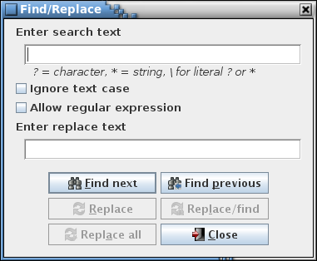

1. Data table search and replace dialog

Case sensitivity for the search is governed by the **Ignore text case** check box.

If the **Allow regular expression** check box is not checked then the search text is matched as typed in the search text field. The search text may contain one or more wild card characters. A label, giving a brief explanation for the wild cards, is displayed underneath the search text field. A question mark (?) in the search string will match any single character (example: the search string *a?c* matches *abc*, *a c*, and *a&c*, but not *ac*). An asterisk (*) matches one or more characters (example: *a*c* matches *abc*, *a_b_c*, and *a:123c*, but not *ac*). In order to search for a wild card character the character must be preceded by a backslash (\) character (example: *a\?c* matches *a?c* but not *abc*).

The **Allow regular expression** check box, when checked, allows the use of a regular expression to define the search pattern in the search text field. The wild card label is removed when a regular expression is allowed. A regular expression can be formulated to find multiple matching conditions (for example, the search for **a.c** would match any string that has a single character between the characters ‘a’ and ‘c’). Information regarding the use of regular expressions is beyond the scope of this document; however, resources and tutorials can be found online.

Enter the search text in the input field and select the **Find next** or **Find previous** button. Any matching text in the table is highlighted and the total number of matches, including multiple matches in a single cell, is displayed beside the search text field’s label. If the search text field is empty and the **Find next** or **Find previous** button is pressed, or if the search dialog is closed, then any search match highlighting is removed.

The search text field uses auto-completion to fill in the search string. The previous search strings (those for the event log, table, and script) are remembered, including those from previous sessions. The number of remembered search strings can be changed via the Preferences dalog, and defaults to 30. Case sensitivity for auto-completion is based on the **Ignore text case** check box selection state.

If the table contains one or more instances of the search text then the search dialog’s **Find previous** and **Find next** buttons are enabled. These buttons cause the table cell selection to move from the currently selected cell to the previous or next cell containing a search match, wrapping to the end or beginning of the table if needed. The table scrolls, and for a structure table array members are expanded, if necessary for the selected cell’s row to be visible.

The text matched by the search may be replaced with the text entered into the **Enter replace text** field. Selecting the **Replace** button replaces the currently selected match text with the replacement text. The **Replace/find** button performs the same action, but the selectes the next matching instance. Selecting **Replace all** replaces all the matching search text instances with the replacement text.

The input text can be changed and the **Find next** or **Find previous** button pressed again to initiate another search. To exit the find and replace dialog select the **Close** button.

###### Close current

The **Close current** command closes the currently displayed table’s editor tab. If this is the last table in the editor then the editor window is also closed. If any changes to the table’s data, description, data fields, row order, or column order have been made, but not stored in the database, then a confirmation dialog appears allowing the user to choose between continuing with the close operation, discarding the changes, or canceling it, keeping the table editor open.

###### Close all

The **Close all** command performs a similar operation to the **Close current** command (paragraph 4.9.3.2.1.8) except all tables in the editor are closed as well as the editor. For unstored changes in any of the tables, only a single confirmation dialog appears; if confirmed, the changes in all tables in the editor are discarded.

##### Edit menu

###### Copy

The **Copy** command places the contents of the highlighted cell(s) into the operating system’s clipboard. This information can then be pasted into another table cell or input field within the application, or into applications other than CCDD. The Ctrl-C keys perform the same operation.

###### Paste

The Paste command places the contents of the operating system’s clipboard into one or more table cells, if a cell is selected, or into an input field if a field is selected. The paste location within the table is determined by the leftmost and uppermost highlighted cell. The paste operation behaves as if the user is typing each cell value sequentially, including validation of the cell’s contents. The rows and columns of the copied cells are then placed into the editor beginning at this location and extending down and to the right. The existing cell contents is overwritten; however, if the cell is protected (e.g., an array member variable name) the cell and the value that would have been pasted are skipped, and the paste operation continues with the next cell. If insufficient columns exist for the pasted data then the excess column data is ignored. Extra rows are inserted at the bottom of the table to provide room for data that would be placed below the editor’s last row. See paragraph 4.9.3.2.2.3 on inserting copied data without overwriting the existing cell contents.

If data from multiple cells is pasted into an input field then content from each cell is concatenated, separated by a space, and the result is pasted into the field. The Ctrl-V keys perform the same operation.

###### Pasting and array variable data

When pasting array variables or over existing array variables the visibility of the array members affects how the pasted data is handled (see paragraph 4.9.3.2.3.5 for details on expanding and collapsing arrays). If the arrays are collapsed then the paste data is assumed to not include any array member cell data. Array definition cells are allowed; the array members are created/removed as needed, but pasting continues in the next row following the last member of the array. If the arrays are expanded then the paste data is assumed to contain data for any array members within the pasted cells.

###### Insert

The **Insert** command behaves similarly to the **Paste** command (paragraph 4.9.3.2.2.2) except that no editor data is overwritten. Instead, rows are inserted, beginning at the row above the upper- and leftmost highlighted cell, to accommodate the pasted values. The Ctrl-I keys perform the same operation.

###### Undo

The **Undo** command performs the same action as the **Undo** button. The command undoes the last action performed (typing, paste, insert, delete, redo, etc.) in the currently displayed table editor. The Ctrl-Z keys perform the same operation.

###### Redo

The **Redo** command performs the same action as the **Redo** button. The command reverses the last action undone (typing, paste, insert, delete, redo, etc.) in the currently displayed table editor. The Ctrl-Y keys perform the same operation.

###### Insert macro

The **Insert macro** command provides a convenient means to insert a macro into a table cell. Editing must first be initiated in the cell. Position the text cursor within the cell at the point where the macro is to be inserted, or select any existing text the macro is to replace, then select the **Insert Macro** command. A pop-up list appears displaying all macros with values that are consistent with the input type of the cell being edited (see Figure 43; see paragraph 4.7 for information on input types). Use the mouse or keyboard to highlight the macro to insert. If the mouse pointer is hovered over a macro name in the pop up a tool tip pop up appears displaying the macro’s value. Once the desired macro is highlighted either press the left mouse button or the Enter key. The macro name is inserted into the table cell, replacing any selected text, bounded by the macro delimiter characters (##), and highlighted to aid in distinguishing it from the non-macro text (see Figure 43). Press the Escape key to remove the macro pop up dialog without inserting a macro.

The Ctrl-M keys can be used in place of the **Insert macro** command. While editing a cell, position the text cursor or highlight one or more characters to be replaced, then press Ctrl-M. The pop-up list appears as described above.

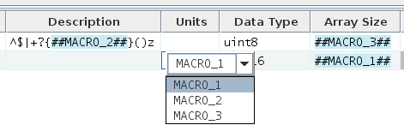

1. Example of macro name display and pop-up dialog in a data table

###### Show macros

The **Show macros** command, when checked, temporarily replaces every macro with its corresponding value in each table of the editor dialog. No editing of the table may take place while the command is selected (all tables cells are grayed out and most of the editor menu commands and buttons are disabled). Deselecting the **Show macros** command restores the macros and enables normal editing and commands.

Pressing Ctrl-Shift-M produces a similar effect, causing the currently selected table to display all cells containing a macro to replace the macro with its value; releasing the Ctrl-Shift-M keys restores the macro names in the cells.

###### Clear selected

The **Clear selected** sub-menu contains commands for replacing the contents of the selected cell(s) in the currently displayed table.

###### With blanks

The **With blanks** command replaces the values in the selected cell(s) with a blank. Pressing the Delete key performs the same action.

###### With prototype

The **With prototype** command is only available if the table editor is displaying a child table. This command replaces the value in selected cell(s) with the contents of the corresponding cell in the table’s prototype table. Pressing the Shift-Delete keys performs the same action. A special indicator flag (Ø) is prepended to the cell value and highlighted (see Figure 44 for an example). If the table changes are stored or the cell is subsequently edited this indicator is removed.



1. Special indicator flag example

##### Row menu

###### Insert row

The **Insert row** command performs the same action as the **Ins Row** button. The command causes an empty row to be inserted below the currently selected cell’s row. If cells in multiple rows are selected then the new row is inserted below the lowest one. If no cell is selected then the new row is inserted at the end of the table. The Insert key performs the same operation.

A row may not be inserted within an array. If an array definition or member cell is selected then the new row is inserted below the last array member.

###### Delete row(s)

The **Delete row(s)** command performs the same action as the **Del Row** button. This command deletes the row associated with each currently selected cell. If cells in multiple rows are selected then each of the rows is deleted. If no row is selected then this command has no effect. The Delete key performs the same operation.

A row may not be removed from within an array. If an array definition or member cell is selected then the entire array – definition and members – is deleted.

###### Move up

The **Move up** command performs the same action as the **Up** button. This command causes the row(s) of the currently selected cell(s) to move up one row relative to the remaining rows. Only prototype tables may have their rows reordered; reordering the prototype’s rows affects the row ordering for all tables based on the prototype. Reordering the rows is recognized as a table change and is preserved in the database via use of the **Store** command (menu or button).

Arrays cannot be split by use of the **Move up** command. If an array definition or member cell is selected then the array moves up as a unit.

###### Move down

The **Move down** command performs the same action as the **Down** button. This causes the row(s) of the currently selected cell(s) to move down one row relative to the remaining rows. Only prototype tables may have their rows reordered; reordering the prototype’s rows affects the row ordering for all tables based on the prototype. Reordering the rows is recognized as a table change and is preserved in the database via use of the **Store** command (menu or button).

Arrays cannot be split by use of the **Move down** command. If an array definition or member cell is selected then the array moves down as a unit.

###### Expand arrays

The **Expand arrays** command is only available for those tables containing a column with an input type of “Array index” (e.g., the **Array Size** column in the default **Structure** table type). This command toggles display of array members in the table. When enabled, each array member is displayed in its own row in the table beneath the array’s definition row. When disabled, the array members are hidden, though the array’s definition row continues to be displayed. Array member visibility can also be toggled by positioning the mouse pointer over any cell in the array size column (except the column header) and double right-clicking.

###### Array overwrite

The **Array overwrite** command is a sub-menu with three mutually exclusive selections: **Overwrite all**, **Overwrite empty**, and **Overwrite none**. The selection governs pasting of data into array member cells already containing values. **Overwrite all**, the default, overwrites any existing values with the pasted values. **Overwrite empty** only pastes values into cells that are currently empty; paste values are discarded if the target cell is occupied. **Overwrite none** prevents pasting values into array member cells.

##### Column menu

###### Move left

Issuing the **Move left** command moves the column(s) of the selected cell(s) to the left one column relative to the remaining columns. Reordering the columns is recognized as a table change and is preserved in the database separately for each user via use of the **Store** command (menu or button).

###### Move right

Issuing the **Move right** command moves the column(s) of the selected cell(s) to the right one column relative to the remaining columns. Reordering the columns is recognized as a table change and is preserved in the database separately for each user via use of the **Store** command (menu or button).

###### Reset order

The **Reset order** command restores the column order for the currently displayed table to the default order. The default order is established by the order of the column definitions in the table type editor for the table’s type.

###### Fix column

The **Fix column** command causes a duplicate of the table’s first column to appear at the left side of the table. When the table is scrolled horizontally the fixed column remains in place. When the table is scrolled vertically the fixed column’s rows scroll to stay synchronized with the table. If another column is dragged into the first column position then the contents of the fixed column is replaced by the new first column. The fixed column width can be resized using the same method as for the table’s columns, and resizing the original column’s width affects the fixed column’s width. Selecting the **Fix column** command while the fixed column is visible causes the fixed column to disappear.

##### Field menu

###### Manage fields

The **Manage fields** command allows the user to create, alter, and delete data fields for the table represented by the active table editor tab. See paragraph 4.6 for information regarding data fields and use of the data field editor.

Fields that are inherited from the table’s type definition are displayed with a gray background, indicating that these cannot be changed or removed. Default fields can only be altered in the table’s table type editor (see paragraph 4.9.3.10.4.1).

The fields manipulated by the field editor are displayed below the table editor table and description when the **Update** button is pressed. After the field editor is closed values can be entered into the data fields. The table editor’s **Store** button or command must be used to store the changes in the project database and apply them to the table.

###### Clear values

The **Clear values** command clears the contents of all of the currently displayed table’s data fields. A confirmation dialog is first displayed. Selecting **Okay** causes all of the data field values to be blanked. Selecting **Cancel** exits the dialog without affecting the data field values.

#### Recent

This sub-menu contains the names (with paths) of the most recently opened tables. Selecting one of these items opens the specified table. Note that the attempt to open the table is made in the currently open project.

#### Rename table

The **Rename table** command allows a prototype data table to be renamed. This command is enabled only for a user with read/write or administrator access. Child tables cannot be renamed using this dialog. Child tables are instances of a prototype table assigned as a variable, so a child table’s name is a combination of its prototype table name and the variable name in its parent table’s prototype. Therefore, child table names can only be altered by changing the name of the child table’s prototype table, or changing the name of the variable representing the child table in its parent table’s prototype table.

The **Rename Table** dialog (Figure 45) appears, displaying a table tree showing the prototype tables and input fields for providing the selected table’s new name and description. See paragraph 4.5.3 for details on the table tree. A table is first selected from the tree; the table name and description (if any) appear in the input fields. After altering the name and description fields as desired the **Rename** button is selected to change the table’s name and description. See paragraph 4.9.3.1 for details on table name constraints. The new name and description are immediately reflected in all parent and child tables, including those appearing in open table editors. The description is optional and can be added or altered later using the table editor. Select the **Cancel** button to exit the dialog without making a change to a table name.

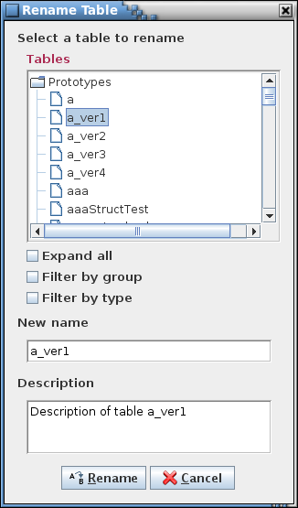

1. Rename Table dialog

#### Copy table

The **Copy table** command allows a prototype data table to be copied. This command is enabled only for a user with read/write or administrator access. The **Copy Table** dialog (Figure 46) appears, displaying a table tree showing the prototype tables and input fields for providing the name and description of the selected table’s copy. See paragraph 4.5.3 for details on the table tree. A table is first selected from the tree; the table name appears in the input field with “_copy” appended and its description, if any, appears in the description field. After altering the name and description fields as desired the **Copy** button is selected to create the table’s copy. See paragraph 4.9.3.1 for details on table name constraints. The description is optional and can be added or altered later using the table editor. Select the **Cancel** button to exit the dialog without copying a table.

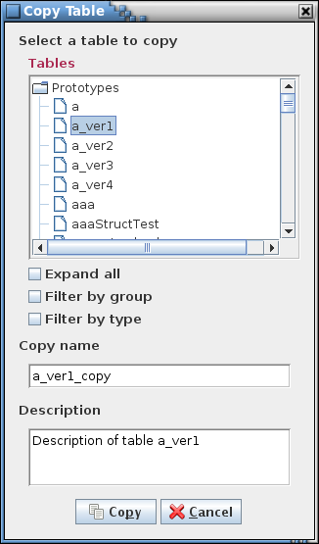

1. Copy Table dialog

#### Delete table(s)

The **Delete table** command allows one or more prototype tables to be deleted. This command is enabled only for a user with read/write or administrator access. The **Delete Table** dialog (Figure 47) appears, displaying a table tree showing the prototype tables. See paragraph 4.5.3 for details on the table tree. After one or more tables is selected from the tree the **Delete** button is selected to delete the table(s). A confirmation dialog appears and if **Okay** is selected all instances of the deleted table, both parent and child tables, are deleted from the project database, including those appearing in open table editors. Select the **Cancel** button to exit the dialog without deleting a table.

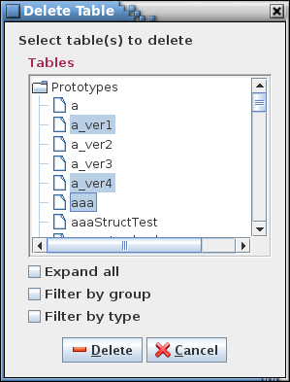

1. Delete Table dialog

#### Import data

The **Import data** command allows importing information from CSV, EDS, JSON, XTCE and C-Header formatted files in order to create tables, data fields, data types, input types, and/or macros in the project database. This command is enabled only for a user with read/write or administrator access. CSV and JSON import files can contain information for tables of any type (structure, command, and other user-defined types), table type definitions, data type definitions, user-defined input type definitions, macro definitions, reserved message IDs, group definitions, script associations, telemetry scheduler data, application scheduler data, and variable paths. EDS and XTCE XML import files are restricted in the information contained, so only basic information for structure and command tables can be imported from files in these formats. When the command is selected a dialog appears allowing the user to choose the location of the import file(s) (see Figure 48, Figure 49, Figure 50, Figure 51, and Figure 52).

Each import dialog, shown in the following sections, differs in options and inputs. The common features are described in the following paragraphs. Featires specific to an import format are described in the format’s section below.

The **Replace existing tables** check box allows the user to choose whether to replace any existing tables that share the same name with a table being imported; all data in the existing table is first removed, then the new table data is imported. If selected, the **Append existing data fields** check box is enabled, which indicates if replaced tables that have data fields should have those existing fields appended to those being imported or not. If this check box is selected then the **Use existing field if duplicate** check box is enabled, which determines whether to use the existing data field or the imported one in the event that the data fields have the same name.

The check box, **Backup project before importing**, determines if a backup of the project database is created prior to continuing with the import operation.

The **Open editor for each imported table** check box, if selected, causes a table editor dialog to be opened, and a table editor displayed for each table imported from the file. If a large number of tables is imported, then multiple table editor dialogs may be created, based on the number of rows of tabs taken up by the table names in the dialog. The maximum number of tab rows is user-adjustable via the **Preferences** dialog (see paragraph 4.9.1.7.4); the default is 15.

The **Ignore all import file errors** check box, if selected, automatically ignores any errors detected in the import file and continues to process the file, if possible.

More information regarding the permissible formats for the import file are described in Appendix C.

When a structure table is imported, if it has a variable with a data type that is a reference to another structure and the prototype for this child structure doesn’t already exist in the project and isn’t defined in the import file(s), then the prototype table is created. This auto-generated prototype is a copy of the child structure; i.e., it’s created using the same structure table type definition as the child structure and contains all of the table data in the child (it does not include the child’s data fields).

##### CSV

The **Importing an entire database** check box allows the user to indicate if an entire database is being imported. Once this option is selected the **Replace existing tables, Replace existing groups,** and **Delete undefined tables** options are automatically selected and grayed out since these three options are required when importing an entire database.Do not select this option if importing individual files into an existing database as it will result in a loss of data and require a restore.

The **Replace existing data types** check box allows the user to choose whether or not to replace the definition of any existing data type with the same name with the data type as defined in the import file. If the check box isn’t selected and the data type definition in the import file differs from an existing data type then the import operation is terminated.

The **Replace existing macro values** check box allows the user to choose whether or not to replace the values of any existing instances of a macro that shares the same name with a new macro as defined in the import file. The new macro value must be valid for the existing instances or else the import is stopped. If the check box isn’t selected and the value of a macro in the import file differs from an existing macro then the user is given the choice of stopping the import, or continuing and retaining the existing macro values.

The **Replace existing groups** check box allows the user to choose whether to replace the definitions of any existing groups with the same name with the group as defined in the import file. If the check box isn’t selected and the group definition in the import file differs from an existing group (other than the group’s description) then the user is given the choice of stopping the import, or continuing and retaining the existing group definitions.

The **Replace existing associations** check box allows the user to choose whether or not to replace the definition of any existing association with the same name with the association as defined in the import file. If the check box isn’t selected and the association definition in the import file differs from an existing association then the user is given the choice of stopping the import, or continuing and retaining the existing association definitions.

The **Delete undefined tables** check box, if checked, causes any tables in the current project that are not defined in the import file(s) to be deleted from the database.

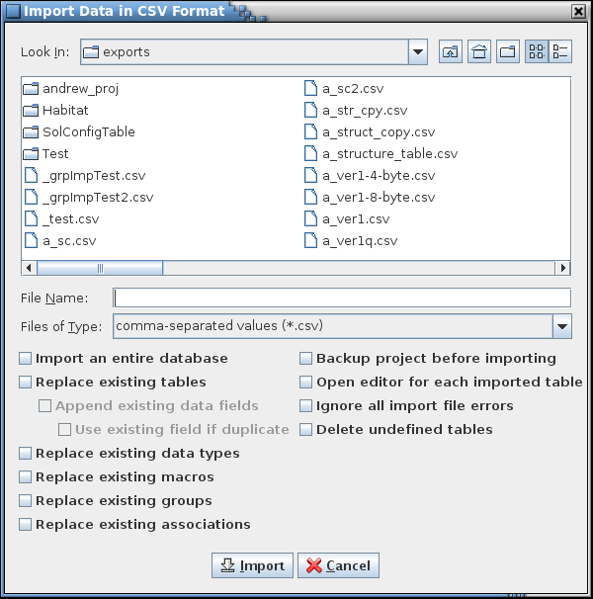

1. CSV import dialog

##### EDS

There are no EDS-specific check boxes.

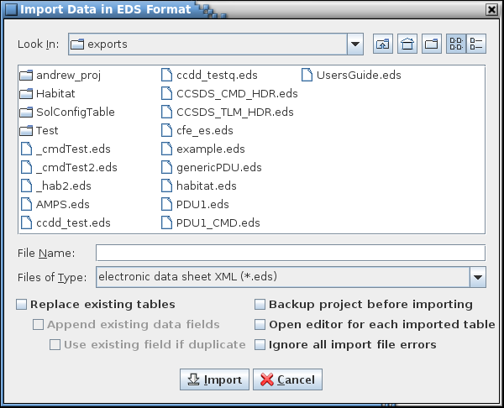

1. EDS import dialog

##### JSON

The description for the JSON-specific check boxes are the same as those for the CSV import dialog. See paragraph 4.9.3.7.1.

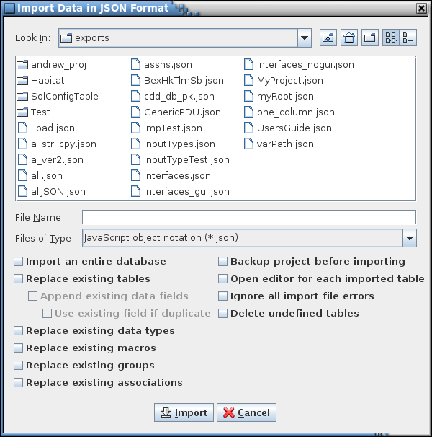

1. JSON import dialog

##### XTCE

There are no XTCE-specific check boxes.

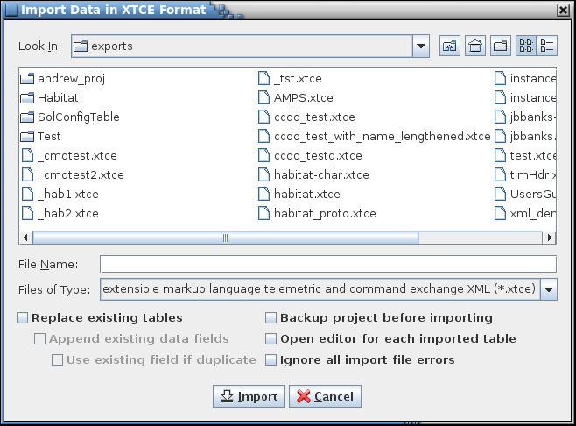

1. XTCE import dialog

##### C header

Data can be imported directly from C header files. The specified file(s) are scanned for “#define”, "struct", and "typedef struct" definitions; any other content in the file(s) is ignored. The information is used to create a CSV file which is then imported into the current project. Comments associated with the structures or variables are preserved. #define statements, and macro values or formulae for a variable's array size or bit length, are converted to CCDD macros. However, if the macro is not defined in the header file the value of the macro is set to "2". The user may use the macro editor to update the macro’s value. Note that the default macro value can lead to import errors if a macro formula used as an array size evaluates to less that 2 (array size must be >= 2). If a non-structure data type that is not defined in the database is used for a variable then a data type by that name is created. The user may use the data type editor to alter the data type’s characteristics.

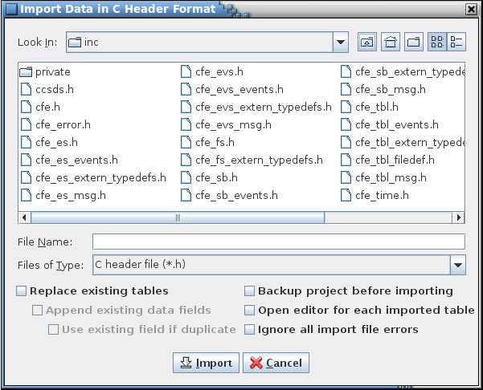

1. C header import dialog

##### Importing table types

When importing from EDS or XTCE XML formatted files a single structure and/or a single command table type is created on which all of the structure and command tables are based. The table type definition names are ‘Structure’ and ‘Command’ with with ‘EDS_’ or ‘XTCE_’ prepended and are guaranteed to be unique (a numeral is appended to the table type definition name as needed to differentiate the new type from an existing one).

CVS and JSON formatted files must either use a table type definition already defined in the target project database, or contain a definition for each type of table imported. If a table type present in the import file has the same name as one already present in the project and no tables of this table type already exist in the project then the existing table type is replaced by the one defined in the import file. However, if tables do exist of the conflicting type then the existing and imported column definitions must match (other than for the column descriptions), otherwise an error dialog appears (if the error is ignored then this table type definition is skipped). Note that any tables in the import file using the conflicting type won’t be imported. Three options are available to overcome the table type collision: (1) change the existing type’s name, (2) change the type’s name in the import file (including any references in any table definitions using it), or (3) alter the existing table type to match the imported type (adding, removing, or altering the column definitions as needed). Once the changes are made the import can be performed again.

When importing a table type column definition the inputs are expected in the same order as they appear in the table type editor (see Figure 59). If the number of inputs is fewer or more than those expected, or the column name is blank, then an error dialog appears; if the error is ignored then this table type definition is skipped. If the input type is blank then it defaults to ‘Text’, but if the input type is present and isn’t one recognized by the application (see paragraph 4.7) a warning error dialog appears; if the error is ignored then the input type ‘Text’ is used. The inputs representing the check box columns evaluate to ‘true’ if the input is ‘true’ (case insensitive); otherwise ‘false’ is used, regardless of the actual value supplied.

##### Importing data fields

When importing from EDS and XTCE XML formatted files certain data fields are created if the information is present in the import file. These fields are the application (or message) ID for root structure tables and command tables, and the system path for each table (root or instance).

When importing a data field definition from a CSV or JSON formatted file the inputs are expected in the same order as they appear in the data field editor (see Figure 10). This includes an input for the “Applicability Type”, even if the data field isn’t associated with a structure table type definition. An additional input containing the field’s value is expected as the last input. If the number of inputs is fewer or more than those expected, or the field name is blank, then an error dialog appears; if the error is ignored then this data field is skipped. If the input type is blank then it defaults to ‘Text’, but if the input type is present and isn’t one of the recognized ones a warning dialog appears; if the error is ignored then the input type ‘Text’ is used. The input representing the check box column evaluates to ‘true’ if the input is ‘true’ (case insensitive); otherwise ‘false’ is used, regardless of the actual value supplied. If the applicability type is blank then it defaults to ‘All tables’, but if the applicability type is present and isn’t one of the recognized ones a warning dialog appears; if the error is ignored then the applicability type ‘All tables’ is used.

#### Export data

The **Export data** commands allow outputting a project’s data table information in one of four formats: CSV, JSON, EDS XML, and XTCE XML. The CSV and JSON formats can include information for table date, data fields, table type definitions, data type definitions, user-defined input type definitions, macro definitions, reserved message IDs, project fields, group definitions, script associations, telemetry scheduler, application scheduler and/or variable paths. This allows these formats to exchange detailed project information with another CCDD project. The XML and EDS formats only export a subset of the information that appears in the project’s structure and command data tables.

Each export dialog, shown in the following sections, differs in options and inputs. The common features are as follows. At the top of the dialog is a table tree for selecting the tables to export; below the tree are the various tree filters – see paragraph 4.5.3 for more details. The dialog includes an input field for specifying the export path or file. The CSV and JSON formats allow for storing the output either combined into a single file or with each table in its own file based on the selection of the radio buttons (**Store in** a **Single File** or **Multiple files**). The EDS and XTCE output is to a single file only. The output file name or path must be entered in the export file/path field, or selected from the file chooser dialog that appears when the **Select…** button is pressed. For multiple tables with output to individual files the file names are automatically assigned based on the table names. If an output file already exists then the table isn’t exported unless the **Overwrite existing file(s)** check box is selected or the user confirms overwriting each file (via a dialog that appears during the export operation).

The dialogs for the EDS and XTCE exports contain a pair of radio buttons, **Endianess Big** and **Little**, that are used to determine the flags set in the export file that indicate if the data is in big or little endian format. If little endianness is selected then the check box **Headers are big endian** is enabled. If selected, the telemetry and command header table variables are flagged as big endian (as an example, the CFS CCSDS headers are always big endian). This check box is selected by default.

The following inputs allow for modifying what other information is included in the export file and only apply to CSV and JSON exports. When the **Substitute macro values for macro names** check box is selected the table cells containing macro references have the references replaced with the corresponding macro value. If the **All table type definitions** check box is selected then all of the table type definitions are included in the output; otherwise only the table type definitions for the selected tables are included. If the **All data type definitions** check box is selected then all of the data type definitions are included in the output; otherwise only the data type definitions used in the selected tables are included. If the **All user-defined input type definitions** check box is selected then all of the user-defined input type definitions are included in the output; otherwise only the user-defined input type definitions used in the selected tables, table data fields, table type column definitions, table type data fields, and group data fields are included. If the **All macro definitions** check box is selected then all of the macro definitions are included in the output; otherwise only the macro definitions used in the selected tables are included. The **Reserved message IDs** check box, when checked, causes the message IDs in the reserved message ID editor (see paragraph 4.9.3.14.2) to be exported. If the **Project data fields** check box is selected then all of the project-level data field definitions are included in the output. If the **Group definitions and data fields** check box is selected then all groups and their associated data fields are included in the output. If the **Script associations** check box is selected then all of the script associations are included in the output. If the **Tlm scheduler** check box is selected then the telemetry scheduler information is included in the output. If the **App scheduler** check box is selected then the application scheduler information is included in the output. If the **Variable paths** check box is selected then the variable path, in both application and user-defined formats, for each variable is included in the output (if one or more tables is selected then only variables in these tables output). The separator fields and **Hide data types** check box become active when the **Variable paths** check box is selected. These inputs behave identically to the corresponding ones described in paragraph 4.9.3.18. An **Export full database** check box has been included as well that will mark **All table type definitions, All user-defined input type definitions, All data type definitions, All macro definitions, Group definitions and data fields, Script associtaions, Tlm scheduler** and **App scheduler** as checked and fade them out so that they can not be unchecked. This is because all of this data is needed for a full export. An example of this is shown below in figure 48. When the **Export full database** option is selected the **Clean target directory** checkbox is enabled. This checkbox allows the user to decide if they would like to delete all contents in the target directory before starting the export. The **Build information** check box, if selected, causes build-specific information (creation date, CCDD version, project name, host, user information, and endianess (if applicable)) to be included in the exported file(s).

The column data in an exported table file may be imported into an existing table using the **Import data** command (paragraph 4.9.3.2.1.5). The **Import table(s)** command (paragraph 4.9.3.7) imports the entire contents of the export file into the current project, creating tables, table type definitions, and data field definitions (and data type definitions, macros, reserved message IDs, project fields, groups, script associations, telemetry scheduler data, application scheduler data and variable paths in the case of CSV and JSON formatted files) as described in the file. Details on the allowable formats of the export file are described in Appendix C.

##### CSV

The **Export table(s) - CSV** command allows exporting one or more selected tables in CSV format. See Appendix C.1 for details on the file format.

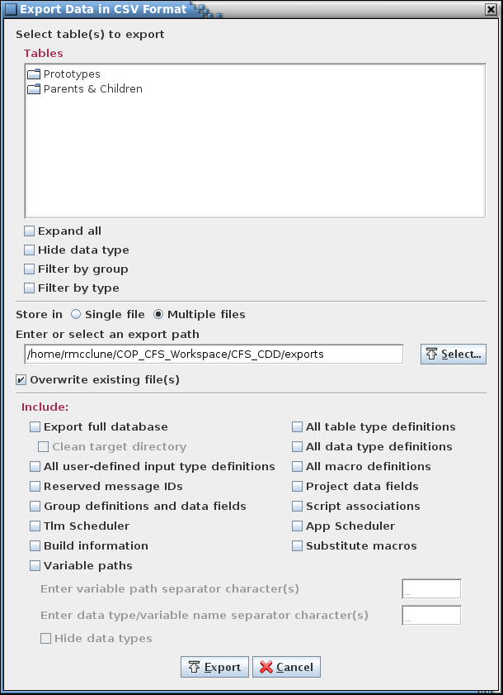

1. CSV export dialog

##### EDS

The **Export table(s) - EDS** command allows outputting one or more selected tables in EDS XML format. Only certain data for structure and command tables is exported; other table types are ignored. Any macros are expanded in the exported data. See Appendix C.2 for details on the file format.

Four special project-level data fields are utilized by the EDS format (see paragraph 4.9.3.15 for information on assigning project-level fields). These fields are described in Table 7. The names of the fields can be whatever the user desires; the input types determine how the fields are used during the export process. The telemetry and command header table names indicate which tables represent the telemetry and command header structures, respectively. All root structure tables reference a single telemetry header in the export file, and all command tables reference a single command header in the export file. If a field is missing or its contents is empty the export is still performed, but certain data may be missing. For example, without the header fields or the application ID and function code fields the export operation can’t determine where to place the ID and function code values in the export file, so these values are ignored. The contents of the four data fields are stored as device metadata in the export file. Application ID and command function code use default values if not specified in the data fields.

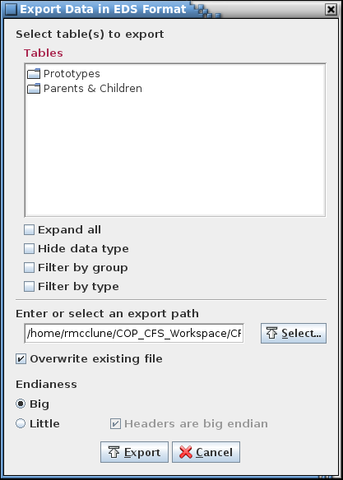

1. EDS export dialog

|  |  |
| --- | --- |
| **Input Type** | **Description** |
| XML: Application ID | Name of the variable containing the application ID in the structure tables representing the telemetry and command headers |
| XML: Command Header | Name of the structure table representing the command header |
| XML: Function Code | Name of the variable containing the command function code in the structure table representing the command header |
| XML: Telemetry Header | Name of the structure table representing the telemetry header |

1. XML special data fields

##### JSON

The **Export table(s) - JSON** command allows outputting one or more selected tables in JSON format. See Appendix C.3 for details on the file format.

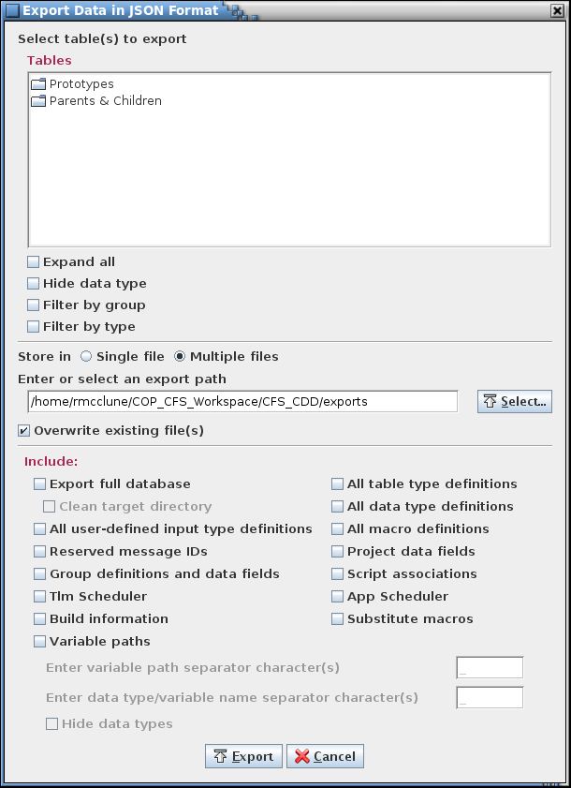

1. JSON export dialog

##### XTCE

The **Export table(s) - XTCE** command allows outputting one or more selected tables in XTCE XML format. Only certain data for structure and command tables is exported; other table types are ignored. Any macros are expanded in the exported data.

The **Use external methods** check box, when checked, indicates that the script, named in the **Enter script file name** input field, is used to perform some or all of the XTCE conversion. The process is identical to performing the export operation via script association (see the CCDD Developers Guide for details on modifying the XTCE conversion via a script). However, not all of the script data access methods are available when using the external methods feature from the export dialog – any method referencing the table names, rows, table data, etc. is not accessible.

The XTCE dialog has additional inputs for defining certain XTCE attributes and classification levels that are used when constructing the output file. Default values are provided, but can be changed as desired. The attributes are used to construct the XML **Header** elements. See Appendix C.4 for details on the file format.

Four special project-level data fields are utilized by the XTCE format (see paragraph 4.9.3.15 for information on assigning project-level fields). These fields are described in Table 7. The names of the fields can be whatever the user desires; the input types determine how the fields are used during the export process. The telemetry and command header table names indicate which tables represent the telemetry and command header structures, respectively. All root structure tables reference a single telemetry header in the export file, and all command tables reference a single command header in the export file. The command tables all reference a single command header in the export file. If a field is missing or its contents is empty the export is still performed, but certain data may be missing. For example, without the header fields or the application ID and function code fields the export operation can’t determine where to place the ID and function code values in the export file, so these values are ignored. The contents of the four data fields are stored as ancillary data in the root system in the export file. Application ID and command function code use default values if not specified in the data fields.

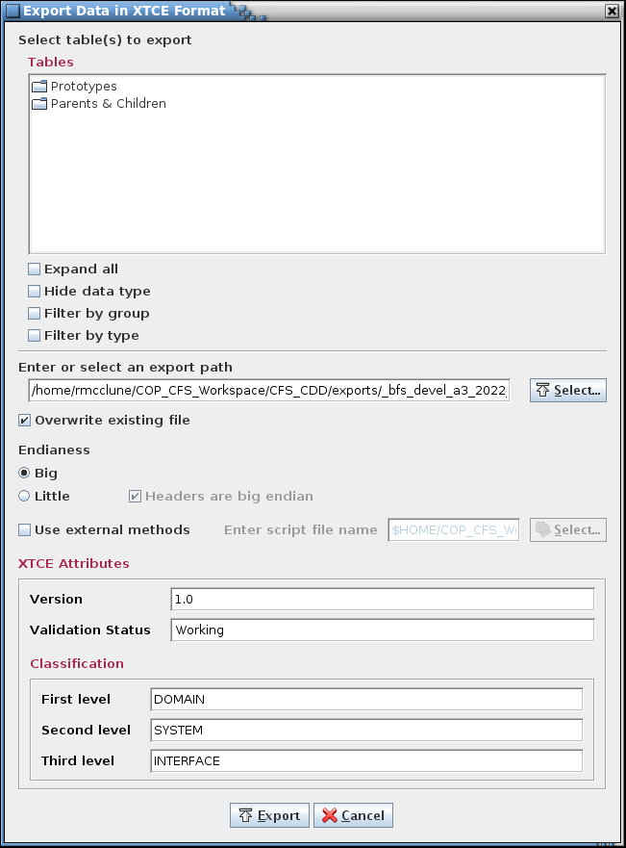

1. XTCE export dialog

#### Manage groups

The **Manage groups** command allows data tables to be assigned to user-defined groups. These groups can be used to filter the tables in the table trees used in other dialogs, making it easier to locate tables that are related (e.g., by a vehicle subsystem or CFS application). Groups can be added, altered, or deleted. When the command is selected a dialog similar to that in Figure 57 appears.

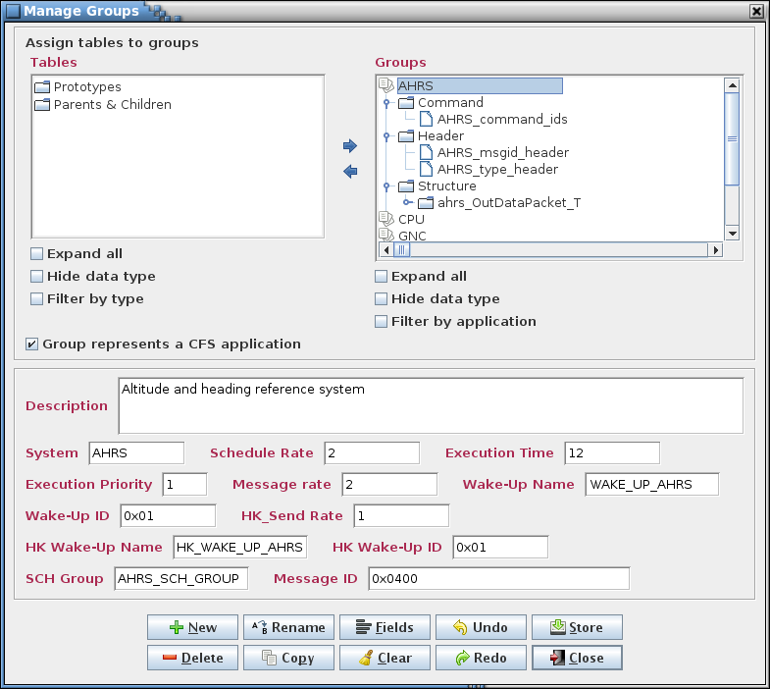

1. Manage Groups dialog

The upper left of the dialog contains a table tree (under the **Tables** heading). The upper right shows the groups and their trees (under the **Groups** heading). Both trees have the **Expand all** and **Hide data type** check boxes (see paragraph 4.5.3 for further details). The **Groups** tree has an additional filter, **Filter by application**, which causes the groups to be divided into two sub-trees, **Application** and **Other**. The **Application** sub-tree displays only those groups that represent a CFS application (see below for more details), and the **Other** sub-tree shows the remaining groups. Note that the individual groups are always filtered by table type (see paragraph 4.5.3 for further details). If no the group contains no tables of a particular table type then that table type is not displayed.

In between the tree panes are arrows for moving tables in and out of the group(s). Each tree also has one or more check boxes, to expand/collapse the tree and to filter the tree information. Below the trees is a check box for indicating that the group represents a CFS application and an input field for adding a description for the group. This description is used as text for a tool tip that appears in the table trees whenever the mouse pointer hovers over a group name.

The space separating the table and group trees delineates a split pane control that is used to resize these panels relative to one another. Position the mouse pointer between the two tree panels and when the pointer changes to a double-headed arrow press and hold the left mouse button. Space permitting, the adjoining panes can be resized by moving the mouse pointer left or right. Release the mouse button to exit resizing.

If a variable is selected in the **Tables** tree then every group to which it belongs is selected automatically in the **Groups** tree. If multiple tables are selected in the **Tables** tree then any selected groups are deselected. Selecting a non-grouped table deselects any highlighted group in the **Groups** tree.

To create a group select the **New** button and provide a group name and description in the input dialog that appears (Figure 58). The group name may not be blank, nor is the name allowed to match that of an existing group (including the automatically supplied group’s name, ‘All tables’, which does not appear in the **Groups** tree). The group name may contain alphanumeric, spaces, and punctuation characters; there is no length constraint. If the **Group represents a CFS application** check box is selected then the group is automatically assigned a number of data fields appropriate for a CFS application (the fields may be altered using the **Fields** button after the group is created; a group’s classification as a CFS application can be altered later – see below). These fields are **Schedule Rate**, **Execution Time**, **Execution Priority**, **Message Rate**, **Wake-Up Name**, **Wake-Up ID**, **HK Send Rate**, **HK Wake-Up Name**, **HK Wake-Up ID**, and **SCH Group**. The contents of these fields is used when populating the scheduler table created with the application scheduler (paragraph 4.9.4.3). If **Okay** is selected the new group’s name appears in the group tree.

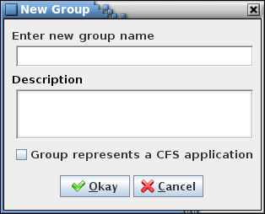

1. New Group dialog

To add tables to a group select the group in the **Groups** tree using the mouse or keyboard. Then, in the **Tables** tree, expand the tree as needed and select one or more tables using the mouse or keyboard. Multiple tables can be selected simultaneously by holding the Ctrl or Shift keys down when making a selection. Selecting a structure table automatically includes its child tables (and their children, etc.). Choosing a child table automatically includes its parent table, and its parent’s parent, etc., up to the root table, but does not include any of its siblings (i.e., tables having the same parent and at the same tree level as the chosen table). Finally, select the right arrow button in the center of the dialog. The table(s) chosen appear in the selected group, and the group’s tree is expanded to show the table(s) added. Note that the table hierarchy for prototype and root tables in the group tree is based on the order in which the tables are assigned to the group, not the order the tables appear in the table tree. More tables can be assigned to the group as described above.

To remove tables from a group expand the group’s tree and select the table(s) to remove using the mouse or keyboard. Then select the left arrow button in the center of the dialog to delete the tables from the group. A table’s children (and their children, etc.) are removed along with the chosen table.

To delete a group, first select it in the **Groups** tree, then select the **Delete** button. Multiple groups can be removed simultaneously if desired by highlighting them while using the Shift or Ctrl keys.

To rename a group, select a single group from the **Groups** tree, then press the **Rename** button. An input dialog appears with the name of the selected group in the input field. Alter the name as desired and select **Okay** to change the group’s name. The renamed group name may not be blank, nor is the name allowed to match that of an existing group. Select **Cancel** to exit the input dialog without affecting the group’s name.

To copy a group and its member tables, select a single group from the **Groups** tree, then press the **Copy** button. An input dialog appears with the name of the selected group in the input field with the text “_copy” appended. Alter the name as desired and select **Okay** to create a copy of the selected group. The copy has all of the tables assigned to it that are assigned to the original. The group name of the copy may not be blank, nor is the name allowed to match that of an existing group. Select **Cancel** to exit the input dialog without copying the group.

Data fields (see paragraph 4.6) may be assigned to a group. A group must first be selected in the **Groups** tree; this enables the **Fields** and **Clear** buttons. Select **Fields** to display the data field editor (see paragraph 4.6.1 for details on it use) for the currently selected group. Once a field is created it can have a value assigned, and the values for existing fields may be altered if desired. The data field values for the currently selected group can be cleared by selecting the **Clear** button.

A group’s description can be added or changed by first selecting the group in the **Groups** tree. The current description for the group appears in the **Description** input field. The description can then be changed as desired.

When a group is selected a check box appears above the description field allowing the group’s classification as a CFS application to be changed. If checked a number of default fields are automatically added below the description field, unless these fields are already present. Deselecting the check box does not remove these fields.

Changes made in the group manager (group additions or deletions, table assignments, data field updates, or changes to descriptions) are stored in the database only when the **Store** button is pressed. If changes have been made a confirmation dialog first appears. Select **Okay** to store the updates; select **Cancel** to exit the confirmation dialog without altering the database.

Select the **Close** button to exit the group manager dialog. If there are any unsaved group changes a dialog appears requesting confirmation to discard the changes. Select **Okay** to exit the group manager, losing any unsaved changes. Select **Cancel** to return to the group manager dialog.

Note that subsequent alteration of a structure table variable affects the group(s) for which the table is a member. If the table has a variable added that has a structure as its data type (that is, it’s a child structure) the group(s) are *not* automatically populated with the new child member(s). However, if a variable name is changed then every group referencing the table has the affected member updated to reflect the new variable name. If a variable is deleted or its data type is changed then any group referencing the table as a member has that member removed.

The group manager button commands are summarized below:

**New** Create a new group.

**Delete** Delete the selected group(s).

**Rename** Rename the selected group.

**Copy** Create a copy of the selected group, including its member tables and data fields.

**Fields** Invokes the data field editor in order to create, alter, and delete data fields for the selected group.

**Clear** Replace the values in all data fields with blanks and deselect any check box data field for the selected group.

**Undo** Undoes the last action performed (table assignment, typing, paste, insert, delete, redo, etc.) on the selected group.

**Redo** Reverses the last action undone (table assignment, typing, paste, insert, delete, undo, etc.) on the selected group.

**Store** Stores the changes made to the groups in the group manager into the project database.

**Close** Closes the group manager window. If any changes have not been stored then a dialog appears allowing the user to confirm discarding the updates or to cancel closing the dialog.

#### Manage table types

The **Manage table types** command opens the table type editor (Figure 59).

 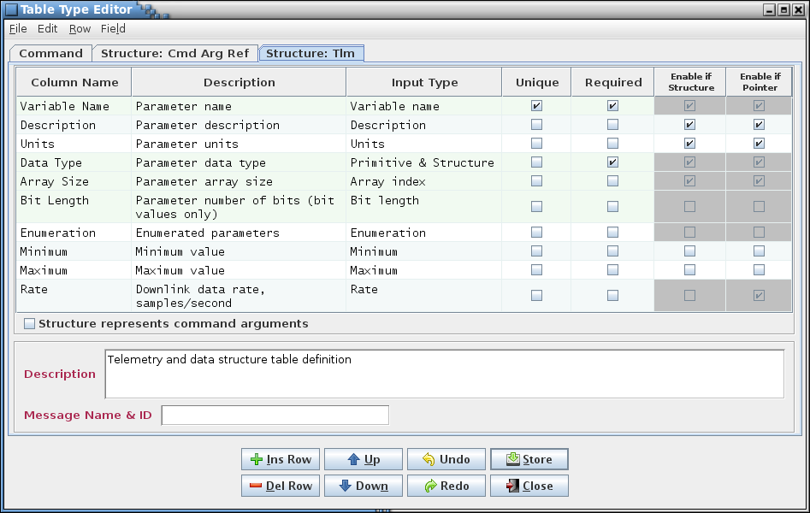

*Argument*

*Buttons*

*Data field(s)*

*Split pane*

*Column definitions*

*Type tab(s)*

*Menu bar*

1. Table type editor

The table type editor provides the means by which the columns are defined for each table type (for example, structure and command tables). The editor is divided into six main sections.

**Menu bar** The first section is the menu bar, which contains the commands, described in the following paragraphs, for manipulating the table contents.

**Type tab(s)** The second section has one or more tabbed panes, each representing a table type’s contents. The tab names indicate the table type to which the tab applies. An asterisk beside the table type name in the tab indicates that a change has been made to the type that hasn’t been stored in the project database. Hovering the mouse pointer over the tab name produces a pop-up tool tip showing the table type’s description (also displayed in the type’s description field, described below).

**Column definitions** The columns displayed in the tabbed pane’s table are determined by the table type of the table being edited. The table columns can be sorted and repositioned as described in paragraph 4.4; however, the sorted order does not dictate the actual table data row order. See paragraph 4.9.3.2.4 for the menu commands for repositioning the columns. If the column order change is stored in the database then it is restored when the table is reopened. Column ordering is preserved separately for each user.

**Argument** This check box only appears when the table type represents a structure (see paragraph 4.5.1.1). If checked, then tables created from this type are considered as containing command argument references. Only structure variables in these tables appear in a command table’s command argument column drop down menu.

**Split pane** If the mouse pointer is hovered in the space between the table and the description field the pointer turns into a double-headed vertical arrow. Pressing and holding the mouse buttonis a control that allows sizing the portion of the editor for the table and the remainder for displaying the description and data fields.

**Description** This section contains the table type description. The description is initially empty. The text entered here is used as a tool tip when the mouse pointer hovers over the table type’s editor tab. Letter, numeral, and punctuation characters may be entered. Additionally, HTML tags can be inserted to provide additional formatting to the tool tip text.

**Data field(s)** This section displays any data field(s) assigned to the table type. See paragraph 4.64.6 for details concerning data field creation.

**Buttons** The button commands mirror commands available in the editor menu bar and provide an easy method of accessing the commonly used editor commands. The button commands are described below:

**Ins Row** Insertsan empty row below the currently selected cell’s row. If no cell is selected then the new row is inserted at the end of the table.

**Del Row** Deletes the row associated with each currently selected cell. If no row is selected then this has no effect.

**Up** Move the row(s) of the currently selected cell(s) up one row. This affects the order of the columns of new instances of this table type; it does not affect existing tables of this type. The displayed column order can be changed for each individual table in the table editor (see paragraph 4.9.3.2.4).

**Down** Move the row(s) of the currently selected cell(s) down one row. This affects the order of the columns of new instances of this table type; it does not affect existing tables of this type. Column order can be changed for each individual table in the table editor (see paragraph 4.9.3.2.4).

**Undo** Undoes the last action performed (typing, paste, insert, delete, redo, etc.).

**Redo** Reverses the last action undone (typing, paste, insert, delete, undo, etc.).

**Store** Stores the changes made to the currently displayed tab in the table type editor (not those in the other tabs) in the database. See paragraph 4.9.3.10.1.5 for further details.

**Close** Closes the table type editor window. If any changes for any of the tabs have not been stored then a dialog appears allowing the user to confirm discarding the updates or to cancel closing the editor.

The menu bar has commands associated with the table type editor; the commands are described in subsequent paragraphs. The buttons, described in detail below, represent some of the more commonly used commands; each has a counterpart in the menu bar. Each type tab represents one of defined table types. As a default this includes the Structure and Command types. Any types created by the user also appear. The tabs are arranged in alphabetical order. Selecting the tab causes the editor to display the information for the selected table type.

Each row in the editor is a definition of a column that appears in each table of this type. The order of the column definitions determines the initial column order when the table is first displayed. The editor columns can be sorted and repositioned as described in paragraph 4.4. Note that sorting the columns using the header does not affect the column order of tables created using the type. The displayed column order can be changed for each individual table in the table editor (see paragraph 4.9.3.2.4).

Editor cells that are grayed out cannot be changed. Selections in a columns definition can preclude other selections. For example, since only integer data types are valid for an enumeration, columns with an enumeration input type can’t have a data type that’s a structure and the **Enable if Structure** check box is disabled.

Column definition rows are highlighted when the all of the column definitions necessary to define a structure or command table are present and the column definition is one of these rows. In Figure 59 the column definitions for the variable name, data type, array size, bit length, enumeration, and rate are highlighted since these are the ones required to define a table representing a structure. If any one of these column definitions is removed then this highlighting is removed for all of the rows. The highlighting serves to indicate that the minimum column definitions are present to define the table type.

The editor column descriptions are as follows:

**Column Name** When a table of this type is displayed, this is the name that’s displayed in the table’s header for the column defined on this row of the editor. The column name is limited to no more than 63 characters (due to PostgreSQL limitation). Note that the column name used within the database is converted if needed to one that meets PostgreSQL syntax constraints: any character that is not a letter, numeral, or underscore is converted to an underscore; any uppercase letter is converted to lowercase; if the name begins with a numeral then an underscore is prepended

**Description** This text is displayed as a tool tip whenever the mouse pointer hovers over this column’s name in the table’s header.

**Input Type** The input type constrains the type of value entered into the table cells for this column. If the value entered into the cell doesn’t conform to the column’s specified input type then a warning message dialog is displayed and the cell reverts to its previous value. The input types are selectable from the combo box pull-down menu that appears when a cell in the **Input Type** column is selected. See paragraph 4.7 for information on the available input types.

**Unique** This check box, if selected, indicates that each cell’s data value must be unique within this column. If a duplicate value is entered into a cell then a warning message dialog is displayed and the cell reverts to its previous value.

**Required** This check box, if selected, indicates that the cell in this column requires a value. This causes the cell to be highlighted in yellow if it is empty. This does not force the user to populate the highlighted cell prior to saving changes to the table, but simply serves as a reminder that the information in this cell is considered important (for example, necessary to a script).

**Enable if Structure** This check box, if selected, indicates that the cells in this column allow input when the same row’s data type column contains a structure reference. If the check box isn’t selected then whenever a structure is selected as the data type the table’s cell is grayed out and its value is blanked. *Note: This editor column only appears when the table type contains all column definitions necessary to represent a structure.*

**Enable if Pointer** This check box, if selected, indicates that the cells in this column allows input when the same row’s data type column contains a pointer reference. If the check box isn’t selected then whenever a pointer is selected as the data type the table’s cell is grayed out and its value is blanked. *Note: This editor column only appears when the table type contains all column definitions necessary to represent a structure.*

##### File menu

###### New type

The **New type** command allows the user to create a new table type. This command is enabled only for a user with read/write or administrator access. A dialog appears with an input field for entering the new type’s name (Figure 60). The three radio buttons allow automatically populating the new type with those columns that are required for a structure or command table type; selecting **None** results in a table type with no columns defined. Select **Create** to create the new type, which is opened in the table type editor. The editor can then be used to populate the table type with column definitions and edit any that were automatically added, and afterwards new tables of this type may be created and edited. Select **Cancel** to exit the dialog without creating a new table type.

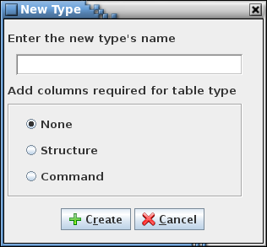

1. New table type dialog

###### Copy type

The **Copy type** command is used to create a new table type from an existing one, including all of its column definitions and default data fields. This command is enabled only for a user with read/write or administrator access. The active tab in the table type editor determines which type is to be copied, so the intended tab must be selected prior to executing the copy command. A dialog appears with an input field for entering the name of the table type’s copy. The name of the selected type is displayed with “_copy” appended. After altering the name as desired, select **Copy** to create a copy of the type. Select **Cancel** to exit the dialog without creating a copy.

###### Rename type

The **Rename type** command is used to rename an existing table type. This command is enabled only for a user with read/write or administrator access. The active tab in the table type editor determines which type is to be renamed, so the intended tab must be selected prior to executing the rename command. A dialog appears with an input field for entering the new name for the table type. The name of the selected type is automatically displayed. After altering the name as desired, select **Rename** to rename the table type. All tables of the renamed type are changed to reference the new table type name. Select **Cancel** to exit the dialog without renaming the table type.

###### Delete type

The **Delete type** command deletes an existing table type. This command is enabled only for a user with read/write or administrator access. The active tab in the table type editor determines which type is to be deleted, so the intended tab must be selected prior to executing the delete command. A confirmation dialog appears. Selecting **Delete** removes the table type *and* *all tables of the deleted type from the project database*. Select **Cancel** to exit the dialog without deleting the table type or any tables.

###### Store current

The **Store current** command performs the identical action to the **Store** button. This command is enabled only for a user with read/write or administrator access. The command stores the changes made to the currently displayed tab in the table type editor (not those in the other tabs) in the project database. Afterwards, any table created using this table type inherits the type’s columns and data fields.

All existing tables of this type, including those in any open table editors, are updated immediately with the column and data field changes. New data fields are added to existing tables; however, deleted data fields are not removed from existing tables. Changes to data field values are applied based on the **Overwrite values** check box described in paragraph 4.9.3.10.4.3.

A confirmation dialog appears allowing the user to choose between continuing with the store operation and canceling it.

###### Store all

The **Store all** command is similar to the **Store current** command described above, except that it stores the changes made to all the table type editor tabs in the project database. This command is enabled only for a user with read/write or administrator access. All existing tables of the affected type(s), including those in any open table editors, are updated immediately with the changes. A confirmation dialog appears allowing the user to choose between continuing with the store operation and canceling it.

###### Print current

The **Print current** command prints the contents of the currently displayed tab to be sent to a printer. A dialog first appears allowing the user to select the printer (or file) and adjust the page setup. Selecting **Print** causes the editor contents, including the data fields (if any), to be output to the selected printer (or file). Selecting **Cancel** removes the print dialog without printing the table type editor contents.

###### Find/replace

Selecting the **Find/replace** command causes a find and replace dialog to be displayed. The behavior of this dialog is identical to that for the table editor dialog except that the search is confined to the currently displayed table type editor. See paragraph 4.9.3.2.1.8 for details on use of the find and replace dialog.

###### Close

The **Close** command performs the identical action to the **Close** button. The command closes the table type editor window. If any changes for any of the tabs have not been stored then a dialog appears allowing the user to confirm discarding the updates or to cancel closing the editor.

##### Edit menu

###### Copy

The **Copy** command places the contents of the highlighted cell(s) into the operating system’s clipboard. This information can then be pasted into another cell or input field in the application, or into applications other than CCDD. The Ctrl-C keys perform the same operation.

###### Paste

The **Paste** command places the contents of the operating system’s clipboard into the editor. The paste location is determined by the leftmost and uppermost highlighted cell. The rows and columns of the copied cells are placed into the editor beginning at this location and extending down and to the right, overwriting the existing data in the cells. If insufficient columns exist for the pasted data then the excess column information is ignored. Extra rows are inserted at the bottom of the table to provide room for data that would be placed below the editor’s last row. See paragraph 4.9.3.10.2.3 on inserting copied data without overwriting the existing cell contents. The Ctrl-V keys perform the same operation.

###### Insert

The **Insert** command behaves similarly to the **Paste** command (paragraph 4.9.3.10.2.2) except that no editor data is overwritten. Instead, rows are inserted, beginning at the row below the upper- and leftmost highlighted cell, to accommodate the pasted values. The Ctrl-I keys perform the same operation.

###### Undo

The **Undo** command performs the same action as the **Undo** button. The command undoes the last action performed (typing, paste, insert, delete, redo, etc.) in the currently displayed table type editor. The Ctrl-Z keys perform the same operation.

###### Redo

The **Redo** command performs the same action as the **Redo** button. The command reverses the last action undone (typing, paste, insert, delete, redo, etc.) in the currently displayed table type editor. The Ctrl-Y keys perform the same operation.

###### Clear data

The **Clear data** command empties all of the currently displayed editor’s cells.

##### Row menu

###### Insert row

The **Insert row** command performs the same action as the **Ins Row** button. The command causes an empty row to be inserted below the currently selected cell’s row. If cells in multiple rows are selected then the new row is inserted below the lowest one. If no cell is selected then the new row is inserted at the end of the table. The Insert key performs the same operation.

###### Delete row(s)

The **Delete row(s)** command performs the same action as the **Del Row** button. This command deletes the row associated with each currently selected cell. If cells in multiple rows are selected then each of the rows is deleted. If no row is selected then this command has no effect. The Delete key performs the same operation.

###### Move up

The **Move up** command performs the same action as the **Up** button. This command causes the row(s) of the currently selected cell(s) to move up one row relative to the remaining rows. Since each row is a column definition, this affects the order of the columns of new instances of this table type; it does not affect existing tables of this type. Column order can be changed for each individual table in the table editor (see paragraphs 4.9.3.2 and 4.9.3.2.4).

###### Move down

The **Move down** command performs the same action as the **Down** button. This causes the row(s) of the currently selected cell(s) to move down one row relative to the remaining rows. Since each row is a column definition, this affects the order of the columns of new instances of this table type; it does not affect existing tables of this type. Column order can be changed for each individual table in the table editor (see paragraphs 4.9.3.2 and 4.9.3.2.4).

##### Field menu

###### Manage fields

The **Manage fields** command allows the user to create, alter, and delete default data fields for the type represented by the active table type editor tab. See paragraph 4.6 for information regarding data fields and use of the data field editor. Default fields are inherited by all tables of this type. Default fields may only be added, modified, and deleted via the table type editor’s field editor; the inherited fields appear in a table’s field editor but editing (other than positioning the field) is disabled. Inherited fields may have their own individual values.

The fields manipulated by the field editor are displayed below the table type editor table and description when the **Update** button is pressed. The table type editor’s **Store** button or command must be used to store the changes in the database and apply them to the tables. The structure table data field editor allows the user to assign fields to only parent or child structure tables, or to all structure tables.

After the field editor is closed values can be entered into the data fields; these become default values for the fields in the tables of this type. When the field updates are stored all tables of the affected table type are updated to match the default fields (field(s) added, modified, and/or deleted). Any open table editors are updated as needed. Any tables of this type that are subsequently created automatically inherit the default fields. If an existing table already has a field of the same name then the existing field’s name is altered (by adding one or more trailing underscores) so that a field with a duplicate name isn’t created. Propagation of the default field’s value is governed by the state of the **Overwrite values** sub-menu radio button selection; see paragraph 4.9.3.10.4.3.

###### Clear values

The **Clear values** command clears the contents of all of the currently displayed editor’s data fields. A confirmation dialog is first displayed. Selecting **Okay** causes all of the data field values to be blanked. Selecting **Cancel** exits the dialog without affected the data field values.

###### Overwrite values

The **Overwrite values** sub-menu selections determine how the default field values are applied to the inherited fields when the table type editor **Store** button is selected. The default setting is **None**.

###### All

If the **All** radio button is selected then all table fields inherited from this default field have their contents replaced with the value in the type editor data field.

###### If same

If the **If same** radio button is selected then only those table fields inherited from this default field with a value matching the default’s original value have their contents replaced with the value in the type editor data field.

###### If empty

If the **If empty** radio button is selected then only those table fields inherited from this default field with a blank value have their contents replaced with the value in the type editor data field.

###### None

If the **None** radio button is selected then the field value changes are not applied to table fields inherited from this default field.

#### Manage data types

The Data Type Editor (Figure 61) provides a means of creating, modifying, and deleting primitive data type definitions (see paragraph 4.5.4 for more information on data types). When a project database is first created the primitive data types default to those shown in Table 5.

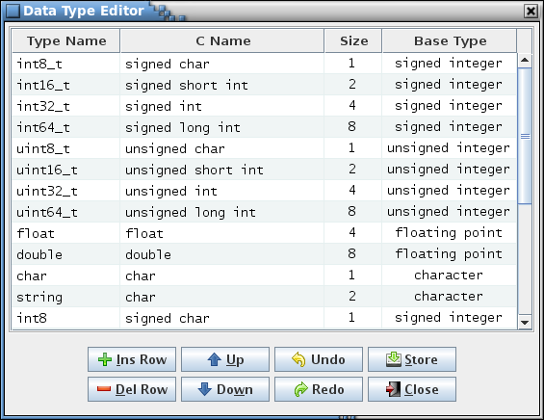

1. Data Type Editor dialog

The editor column descriptions are as follows:

**Type Name** The type name is the text that represents the data type in a data table cell. Data type names must adhere to C-language naming conventions; i.e., begin with an alphabetic or underscore character, followed by alphabetic, numeric, or underscore characters. The data type names are case sensitive and must be unique. If the type name is left blank then the text in the C Name column determines the data type name displayed in the data table cell.

**C Name** The C name is the C-language equivalent of the data type and may contain spaces. It is available to scripts and web applications (for example, a script can create a header file of typedef statements using the type name and C name combinations). One or more trailing asterisks are allowed if the corresponding base type is ‘pointer’. The C name is used as the data type in a data table cell if the corresponding type name is blank.

**Size** Size, in bytes, occupied by this data type. The size must be an integer greater than 0.

**Base Type** The data type’s base type: signed integer, unsigned integer, floating point, character, or pointer. The base type and the size determine how the data type is handled by the application.

Each row in the table is a data type definition. The **Type Name** or **C Name** columns determine the data type displayed in the data type column drop down menus. At least one of these columns must contain text. The type name is used if it isn’t blank. If the type name is blank then the C type name is used as the data type name. Valid values must be entered in the **Size** and **Base Type** columns for every definition. The rows can be sorted by selecting the column headers, as with other table editors in the application.

If a pointer base type is selected then an asterisk (*) is automatically appended to the C name (unless the cell is empty). Conversely, if the base type is changed from a pointer to something else then any trailing asterisk(s) in the C name is automatically removed. A pointer to a pointer (or a pointer to a pointer to a pointer, etc.) can be indicated by appending the requisite number of asterisks. Below is an example of creating a pointer to a structure named **myStruct**:

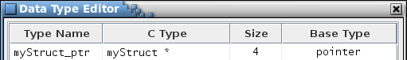

1. Example pointer to a structure data type

As an aid to creating a data type that represents a pointer to a structure a pop-up list of alphabetically arranged prototype structure table names can be displayed from which a structure name can be selected. This pop-up is displayed by pressing Ctrl-S and is only available when editing a cell in the **Type Name** or **C Type** column and if the **Base Type** column for the edited row is blank or a pointer. Use the mouse or keyboard to highlight the structure name to insert. Once the desired structure name is highlighted either press the left mouse button or the Enter key. The structure name is inserted into the table cell, replacing any selected text (Figure 63). Press the Escape key to remove the structure name pop up dialog without inserting a structure name.

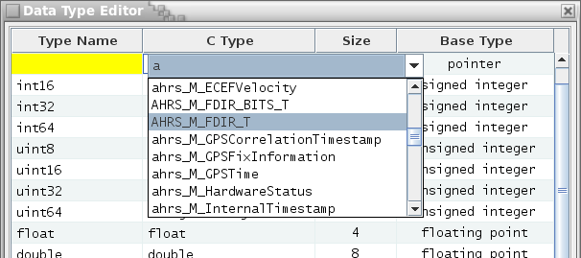

1. Structure name pop-up

If a data type is currently in use in a data table then the size and base type may be constrained by the values in other columns on the same row of the affected table. For example, if a data type is a 2-byte integer and is used in a data table where the parameter is assigned a bit length of 10 bits then the data type size can’t be changed to a single byte since a single byte’s 8 bits is insufficient for the 10-bit parameter. The instance where the bit length exceeds the desired size must first be altered before the size can be updated. If an invalid size or base type is entered a dialog appears indicating the tables where the inconsistency exists, and the table cell reverts to its previous value.

The button commands are described below:

**Ins Row** Inserts an empty row below the currently selected cell’s row. If cells in multiple rows are selected then the new row is inserted below the lowest one. If no cell is selected then the new row is inserted at the end of the table.

**Del Row** Deletes the row associated with each currently selected cell. If cells in multiple rows are selected then each of the rows is deleted. If no row is selected then this has no effect. A data type cannot be deleted if it is currently used in a table; all references must be removed before the data type can be deleted.

**Up** Move the row(s) of the currently selected cell(s) up one row relative to the remaining rows. The order of the data type definitions in the editor has no effect on data type usage, though it does determine the order of the types in the data type combo box lists. The capability to arrange the rows is solely for the user to group the data types as desired.

**Down** Move the row(s) of the currently selected cell(s) down one row relative to the remaining rows. The order of the data type definitions in the editor has no effect on data type usage, though it does determine the order of the types in the data type combo box lists. The capability to arrange the rows is solely for the user to group the data types as desired.

**Undo** Undoes the last action performed (typing, paste, insert, delete, redo, etc.).

**Redo** Reverses the last action undone (typing, paste, insert, delete, undo, etc.).

**Store** Stores the changes made to data type definitions in the data type editor into the project database. All tables are updated with the changes, including any tables currently open in a table editor.

**Close** Closes the data type editor window. If any changes have not been stored then a dialog appears allowing the user to confirm discarding the updates or to cancel closing the editor.

#### Manage input types

The Input Type Editor (Figure 64) provides a means of creating, modifying, and deleting custom input type definitions (see paragraph 4.7 for more information on input types). These input types can then be applied to data table columns via the table type editor (see paragraph 4.9.3.10) and to data fields via the data field editor (see paragraph 4.6.1), the same as with the default input types.

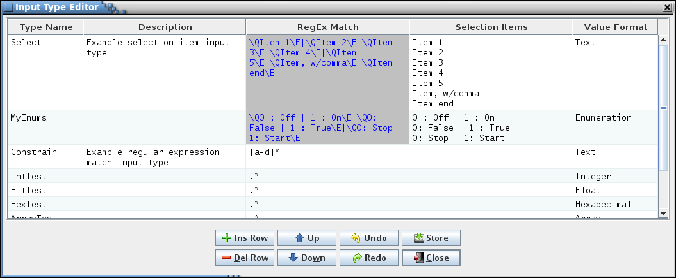

1. Input Type Editor dialog

The editor column descriptions are as follows:

**Type Name** The input type name is the text that appears in the table type and data field editors’ **Input Type** column drop down menus. Input type names are case insensitive and must be unique (this includes the default input type names in paragraph 4.7).

**Description** The input type’s description.

**RegEx Match** This is the regular expression used to constrain the values entered into a data table cell of data field of this input type. Editing of the **RegEx Match** column is disabled if the **Selection Items** cell isn’t blank.

**Selection Items** If the data table cell or data field is constrained to specific text strings then these strings can be entered into this column. The items must be separated by line feed characters (use **Alt-Enter** to insert a line feed). Data table cells and data fields using this input type display a drop down menu displaying these selection items from which to choose. If the **Selection Items** column isn’t empty then editing of the **Regex Match** column is disabled. The **RegEx Match** is automatically populated with the regular expression that constrains the input type to the selection items and the **Value Format** selections are altered. Deleting the contents of the **Selection Items** cell restores the ability to edit the **Regex Match** and **Value Format** columns, but leaves their contents untouched.

**Value Format** When selected, a drop down menu appears displaying various format options. The options available depend on whether or not the **Selection Items** column is empty. If empty, the value format applies the specified formatting to a value entered in a data table cell or data field. The following describes the result of applying the value formats to the entered text (note that if the format isn’t applicable to the values allowed by the input type’s regular expression then the format is ignored and the text is unchanged):

**Text** No formatting is applied; the text remains unchanged. This is the default format.

**Array** This format expects one or more numerals, separated commas. The spaces (if any) and commas between the numbers are replaced by “, “. This is the same formatting used for array sizes.

**Boolean** The table cell or data field is treated as a boolean and is displayed as a check box. The **RegEx Match** column value is changed to the regular expression matching a boolean value.

**Float** The text is formatted as a floating point value in the form #.#. Leading zeroes and excess trailing zeroes in the decimal portion are removed.

**Hexadecimal** The text is formatted as a hexadecimal number. “0x” is prepended if not already present.

**Integer** The text is formatted as an integer value. Leading zeroes and decimal values are removed.

**Number** The text is formatted as a floating point value in the form #.#. If the value is an integer then the decimal and trailing zero is removed.

If the **Selection Items** column isn’t empty the the **Value Format** options are changed to the ones shown below. These options do not reformat the selection items; instead they define how the cells or fields using this input type are handled by the program, such as for the script data access methods, or when parsing table data during EDS and XTCE XML exports and imports. For example, the script data access methods that return enumeration column values will consider a column with the **Enumeration** value format as an enumeration column.

**Text** No special treatment is performed for the selection items. This is the default format.

**Enumeration** The selection items are treated as if the input type is an enumeration. This is useful if the project requires a number of common enumerations that are used frequently throughout the tables. This input type allows the user to quickly choose from the acceptable enumerations.

**Minimum** The selection items are treated as if the input type is a minimum value. In a maximum value column is present then the value in this column selected from the list must be less than or equal to the maximum value.

**Maximum** The selection items are treated as if the input type is a maximum value. In a minimum value column is present then the value in this column selected from the list must be greater than or equal to the minimum value.

Each row in the table is an input type definition. The rows can be sorted by selecting the column headers, as with other table editors in the application. Every definition requires a value in the **Type Name**, **RegEx Match**, and **Value Format** columns; the remaining column may be blank. If an input type is currently in use in a data table or data field then the input type cannot be deleted; if attempted a dialog appears indicating the tables and fields using the input type. If the regular expression or selection item names are changed then a check is made against all of the tables and fields using the input type. If the table cell or data field value no longer conforms to the regular expression then the value in the cell or field is blanked.

The button commands are described below:

**Ins Row** Inserts an empty row below the currently selected cell’s row. If cells in multiple rows are selected then the new row is inserted below the lowest one. If no cell is selected then the new row is inserted at the end of the table.

**Del Row** Deletes the row associated with each currently selected cell. If cells in multiple rows are selected then each of the rows is deleted. If no row is selected then this has no effect. An input type cannot be deleted if it is currently used in a table; all references must be removed before the input type can be deleted.

**Up** Move the row(s) of the currently selected cell(s) up one row relative to the remaining rows. The order of the input type definitions in the editor has no effect on input type usage. The capability to arrange the rows is solely for the user to group the input types as desired.

**Down** Move the row(s) of the currently selected cell(s) down one row relative to the remaining rows. The order of the input type definitions in the editor has no effect on input type usage. The capability to arrange the rows is solely for the user to group the input types as desired.

**Undo** Undoes the last action performed (typing, paste, insert, delete, redo, etc.).

**Redo** Reverses the last action undone (typing, paste, insert, delete, undo, etc.).

**Store** Stores the changes made to input type names, descriptions, regular expression match strings, format types, or selection items in the input type editor into the database. All tables are updated with the changes, including any tables currently open in a table editor.

**Close** Closes the input type editor window. If any changes have not been stored then a dialog appears allowing the user to confirm discarding the updates or to cancel closing the editor.

#### Manage macros

The Macro Editor (Figure 65) provides a means of creating, modifying, and deleting macro definitions (see paragraph 4.5.7 for more information on macros).

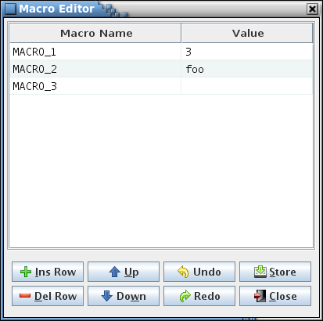

1. Macro Editor dialog

The editor column descriptions are as follows:

**Macro Name** The macro name is the text that represents the macro’s value in a data table or macro editor cell (the macro name is delimited by pairs of ‘#’ characters and highlighted in the cell). Macro names are case insensitive and must be unique.

**Value** The macro value is the text that the macro name represents.

Each row in the table is a macro definition. The rows can be sorted by selecting the column headers, as with other table editors in the application. Every definition requires a name, but the value may be blank. If a macro is currently in use in a table then the macro value is constrained by the input type of the column(s) in which the macro is referenced. For example, if a macro is inserted into a column of input type “Array index” then the macro’s value can be blank or must evaluate to a number (or a series of numbers separated by commas), as required by the array index input type. If an invalid value is entered a dialog appears indicating the tables where the inconsistency exists, and the editor cell reverts to its previous value.

Macro values can reference other macros. Any macros referenced in a macro value are highlighted. Each macro in the macro’s value, when the macro is expanded, is replaced by its value. Circular macro references are not allowed (i.e., a macro references itself in its value); if detected a warning dialog is displayed and the cell contents reverts to its previous value.

Macro values can also use the *sizeof(data type)* call. Any *sizeof()* calls in the macro value are highlighted similar to macro references. When expanded the *sizeof()* call is replaced by the size in bytes of the specified primitive or structure data type.

While editing a macro value cell, the Ctrl-M keys can be used to display a pop-up list of macros for insertion into the value. Position the text cursor or highlight one or more characters to be replaced, then press Ctrl-M. The pop-up list appears as shown in Figure 66.

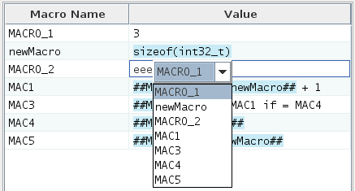

1. Example of macro name selection pop-up dialog in a macro value cell

Pressing Ctrl-Shift-M temporarily replaces every macro with its corresponding value in the macro editor **Values** column. Releasing the Ctrl-Shift-M keys restores the macro names in the cells.

The button commands are described below:

**Ins Row** Inserts an empty row below the currently selected cell’s row. If cells in multiple rows are selected then the new row is inserted below the lowest one. If no cell is selected then the new row is inserted at the end of the table.

**Del Row** Deletes the row associated with each currently selected cell. If cells in multiple rows are selected then each of the rows is deleted. If no row is selected then this has no effect. A macro cannot be deleted if it is currently used in a table; all references must be removed before the macro can be deleted.

**Up** Move the row(s) of the currently selected cell(s) up one row relative to the remaining rows. The order of the macro definitions in the editor has no effect on macro usage. The capability to arrange the rows is solely for the user to group the macros as desired.

**Down** Move the row(s) of the currently selected cell(s) down one row relative to the remaining rows. The order of the macro definitions in the editor has no effect on macro usage. The capability to arrange the rows is solely for the user to group the macros as desired.

**Undo** Undoes the last action performed (typing, paste, insert, delete, redo, etc.).

**Redo** Reverses the last action undone (typing, paste, insert, delete, undo, etc.).

**Store** Stores the changes made to macro names or values in the macro editor into the database. All tables are updated with the changes, including any tables currently open in a table editor.

**Close** Closes the macro editor window. If any changes have not been stored then a dialog appears allowing the user to confirm discarding the updates or to cancel closing the editor.

#### Message IDs

**Message IDs** is a sub-menu of commands relating to message ID names and numbers, described in the following paragraphs.

##### Assign IDs

The **Assign IDs** command provides a method for automatically assigning a unique message ID number to table cells and data fields having an input type of ‘Message ID’ (see paragraph 4.7). This command is enabled only for a user with read/write or administrator access. Telemetry message IDs are assigned in the telemetry scheduler (see paragraph 4.9.4.2).

Automatic assignment can be limited to any tables the user desires. Simply select the tables you wish to have IDs assigned to from the table tree. If you wish to assign IDs to groups that represent a CFS application then select the Group tab. Figure 63 and 64 show what the Msg ID and Group tabs look like.

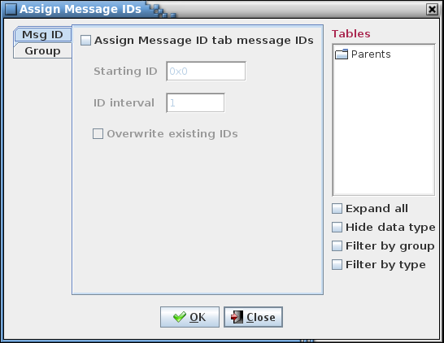

1. Assign Message IDs dialog

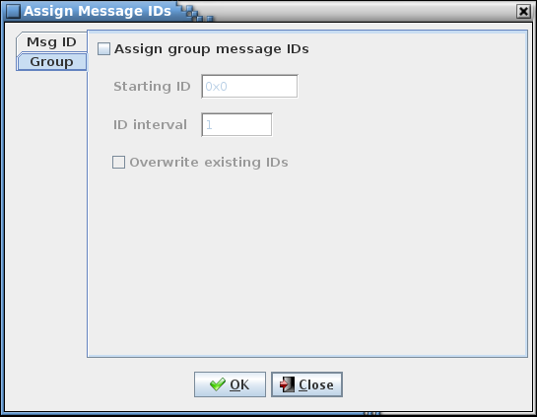

1. Assign Group Message IDs dialog

For each tab there are two check boxes and two input fields. The first check box is used to determine if the message IDs associated with the selected tab are to be updated. For the MSG ID tab this affects both table cells and data fields, and for the Group tab this affects only group data fields. If this check box is unchecked the remaining fields are disabled and ignored. The first input field is the starting ID number, in hexadecimal (the ‘0x’ preceding the number is optional). The second field is the ID interval which is used to calculate the next ID value in the sequence - the default is 1; any positive integer value is valid. The final check box determines whether or not existing table/group message ID numbers are updated or left as is. When checked, existing message IDs are replaced unless the ID is flagged as protected. Message IDs are protected if a ‘#’ character is appended to the ID value (example: ox1234#).

When **Okay** is pressed the selected tables or groups will have their data fields checked to determine if they have a column(s) or data field(s) with the input type of ‘Message ID.’ If so, then the column/field value is assigned a message ID number. IDs are assigned beginning with the starting ID number, and with each subsequent ID number equal to the previous number plus the interval value. Table column message IDs are assigned (for all tables) before message ID data fields. Macros are allowed in the table columns representing message IDs; however, the auto-assignment process will overwrite the macros with message ID values if the overwrite check box is selected for the table’s type. An ID is skipped if it is listed in the reserved message ID list (see 4.9.3.14.2), assigned to table columns and/or data fields for a table type that doesn’t have the overwrite check box selected, assigned to a group data field (unless the Group overwrite check box is selected), or assigned to telemetry messages in the telemetry scheduler (see paragraph 4.9.4.2). If the overwrite check box isn’t selected then the values for any existing message ID data fields are also skipped in order to avoid duplicate ID values. This action also updates the project database and the message ID number columns and/or data fields for any open table editors. Select **Cancel** to exit the dialog without altering the message ID values.

##### Reserve IDs

The editor dialog shown in Figure 69 to appears when the **Reserve message IDs** command is selected. This dialog allows message IDs, either singly or as ranges, to be flagged as reserved. This means that when automatic assignment of message IDs is performed (see paragraphs 4.9.3.14.1 and 4.9.4.2) the message IDs in the reserved table are skipped.

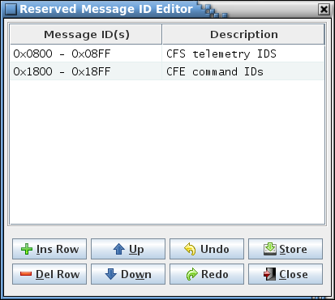

1. Reserved Message ID Editor dialog

The editor column descriptions are as follows:

**Message ID(s)** This column can contain a single hexadecimal number, optionally prepended with “0x”, or a range of IDs consisting of two hexadecimal numbers separated by a hyphen (-). If a range is entered the second number must be greater than the first. Message IDs are not allowed to be duplicated in the table. This includes IDs falling within an existing range or overlapping of two ranges.

**Description** This column can be used to describe the ID or ID range. It may remain empty.

Each row in the table is a reserved message ID definition. Every definition requires a message ID or ID range, but the description may be blank. If an invalid or duplicate value is entered a dialog appears indicating the problem, and the editor cell reverts to its previous value. The rows can be sorted by selecting the column headers, as with other table editors in the application.

The button commands are described below:

**Ins Row** Inserts an empty row below the currently selected cell’s row. If cells in multiple rows are selected then the new row is inserted below the lowest one. If no cell is selected then the new row is inserted at the end of the table.

**Del Row** Deletes the row associated with each currently selected cell. If cells in multiple rows are selected then each of the rows is deleted. If no row is selected then this has no effect.

**Up** Move the row(s) of the currently selected cell(s) up one row relative to the remaining rows. The order of the reserved message ID definitions in the editor has no effect on ID usage. The capability to arrange the rows is solely for the user to group the IDs as desired.

**Down** Move the row(s) of the currently selected cell(s) down one row relative to the remaining rows. The order of the reserved message ID definitions in the editor has no effect on ID usage. The capability to arrange the rows is solely for the user to group the IDs as desired.

**Undo** Undoes the last action performed (typing, paste, insert, delete, redo, etc.).

**Redo** Reverses the last action undone (typing, paste, insert, delete, undo, etc.).

**Store** Stores the changes made to reserved message IDs or description in the reserved message ID editor into the project database.

**Close** Closes the reserved message ID editor window. If any changes have not been stored then a dialog appears allowing the user to confirm discarding the updates or to cancel closing the editor.

##### Show all IDs

The **Show all IDs** command displays a table showing all of the message IDs in a project along with their corresponding message names and the entity (table or group) in which the message name and ID are found. Figure 70 is an example of the table produced by the command. For a table cell or data field containing a message name and ID to be recognized as such it must have the input type **Message name & ID** (see paragraph 4.7 for more information on input types). If a message name or message ID appears more than once in the table then the cells containing the duplicate entries are highlighted as shown in Figure 70.

A script data access method, *getMessageOwnersIDsAndNames*, is provided that returns the same information as is produced by this command; see the reference in the CCDD Developers Guide for details.

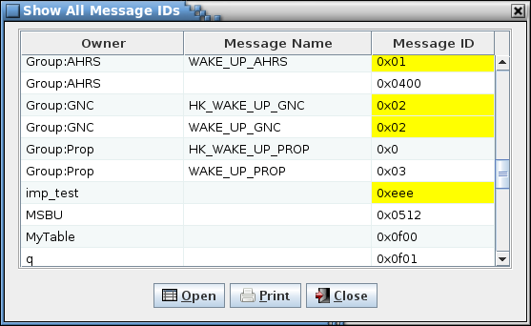

1. Example Show all IDS dialog

If one or more cells is selected and the **Open** button is pressed then the table(s) associated with the selected cell(s) are opened in a table editor. A row is ignored if it contains a message ID belonging to a group or telemetry message.

Selecting the **Print** button opens a printer selection dialog in order to print a copy of the table to the selected printer or file. Selecting **Close** closes the message ID dialog.

##### Find duplicates

The **Find duplicates** command searches the project database table cells, data fields, and telemetry messages for message ID values used more than once, and displays a dialog showing these IDs and where they are located (see the example dialog in Figure 71). If no duplicate message ID exists the dialog’s table is empty.

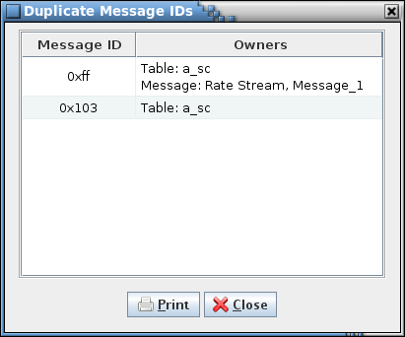

1. Example Duplicate Message IDs dialog

The **Message ID** column shows the duplicated ID as a hexadecimal value; the table is sorted based on the ID value. The **Owners** column displays the location(s) where the message ID is referenced – this can be a table cell or data field (table path and name is preceded by “Table:”), or telemetry message (message data stream and message name is preceded by “Message:”). The rows can be sorted by selecting the column headers, as with other tables in the application. Column order can be changed by dragging a column to a new position.

Selecting **Print** causes the dialog contents to be output to the selected printer (or file). Selecting **Close** closes the duplicate message IDs dialog.

#### Manage project fields

The **Manage project fields** command causes the project data field manager dialog, shown in Figure 72, to appear. Data fields (see paragraph 4.6) may be associated with a project, similar to how they can be associated with specific data tables and groups. The project’s description can also be edited via this dialog (the description can also be edited using the **Rename** command in the **Project** menu; see paragraph 4.9.2.4).

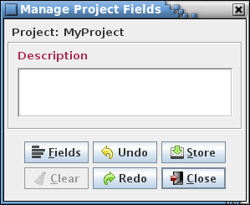

1. Project data field management dialog

The **Description** field appears by default and cannot be deleted. This field is enabled only for a user with administrator access. The **Fields** button causes the data field editor (see paragraph 4.6.1 for details on it use) to appear; data fields can be added, modified, or removed via this editor.

The project data field manager button commands are summarized below:

**Fields** Invokes the data field editor in order to create, alter, and delete data fields for the project.

**Clear** Replace the values in all data fields with blanks and deselect any check box data field for the project.

**Undo** Undoes the last action performed (typing, paste, insert, delete, redo, etc.) in the manager dialog.

**Redo** Reverses the last action undone (typing, paste, insert, delete, undo, etc.) in the manager dialog.

**Store** Stores the changes made to the project description and data fields in the manager dialog into the project database.

**Close** Closes the project data field manager window. If any changes have not been stored then a dialog appears allowing the user to confirm discarding the updates or to cancel closing the dialog.

#### Show/edit fields

The purpose of the **Show/edit fields** command is to provide a means of displaying, editing, and removing data fields for one or more data tables and/or groups via a single editor (as opposed to displaying the data fields for a specific owner table in a table editor or group in the group manager). Selecting the **Show/edit fields** command produces a dialog displaying a table tree and a set of check boxes, one for each unique data field name currently in use by the project’s data tables. See Figure 73 for an example; if no tables exist or no data fields are currently assigned then a warning dialog appears instead indicating there is nothing to display.

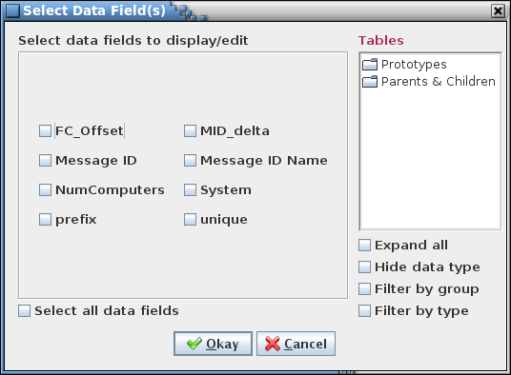

1. Example Select Data Field(s) dialog

The user chooses the field(s) to display/edit by selecting the field’s associated check box. The **Select all data fields** check box is used to alternately select and deselect all of the data field check boxes. The fields can be filtered by selecting one or more tables from the table tree – only the selected fields in the selected tables are displayed in the editor. Selection of a header node in the table tree (e.g., ‘Parents & Children’, or a group name if group filtering is enabled) selects all tables under that header. If no tables are selected then no filtering occurs and the selected data field(s) are displayed for any table. Selecting the **Okay** button opens the data field editor, while the **Cancel** button closes the dialog without opening the editor. An example of the editor dialog that appears is shown in Figure 74.

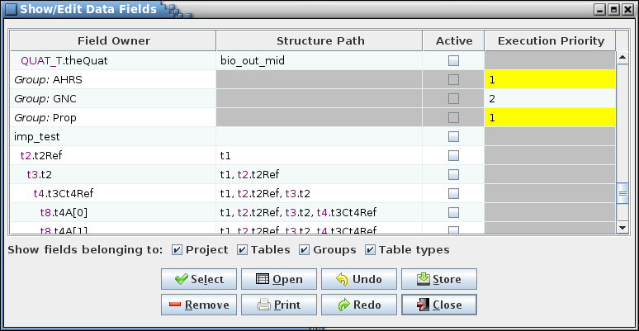

1. Example Show/Edit Data Fields dialog

The first column, **Field Owner**, displays the data field owner. For a top-level structure table or non-structure table this is the table’s name. For a child table the child’s prototype and instance (or variable) name are displayed in the format *prototype*.*instance*, and are indented by an amount based on the number of levels the child is from its root structure. Project-level fields display “*Project:*” as the field owner. Fields that belong to a group display the group’s name with “*Group:*” prepended, and default data fields (those belonging to a table type definition) display the table type name prepended with “*Type:*”.

The second column, **Structure Path**, displays the structure path for child tables, listing each prototype and instance pair in the child structure’s path leading back to its root structure. The root structure is shown first, then each subsequent child prototype and instance in the path. If the field owner is not a child structure then the structure path is this row has a gray background. The column is not displayed if there is no child structure table field owner in any row of the editor. For example, note the row in Figure 74 for the table “ahrs_M_BeaconedTimestamp.beaconedTimestamp”. Since its **Structure Path** column is not empty, the table is a child structure. Working upwards from the bottom of the list, “beaconedTimestamp” is a child of the structure “ahrs_M_OutData” (a structure that is of prototype “ahrs_M_OutData_T”), which in turn is a child of the root structure “ahrs_OutDataPacket_T”.

The remaining columns in the editor show the contents of the data fields chosen in the selection dialog. A cell with a gray background indicates that the associated table does not have the data field indicated by the cell’s column; these cells may not be edited. A yellow background means that another cell or cells in the same column has an identical, non-blank value. The rows can be sorted by selecting the column headers, as with other table editors in the application. Column order can be changed by dragging a column to a new position.

Below the editor table are a number of filter check boxes that determine the type(s) of data fields displayed in the table. All of the filters are initially selected. The filters are as follows:

**Project** Display the project-level data fields (see paragraph 4.9.3.15).

**Tables** Display data fields belonging to the data tables (see paragraph 4.9.3.2.5.1).

**Groups** Display group data fields (see paragraph 4.9.3.9).

**Table types** Display the default data fields; those belonging to a table type definition (see paragraph 4.9.3.10.4.1).

The data fields to display can be changed by pressing the **Select** button, causing the initial data field selection dialog to reappear. However, if there is an unstored change or field marked for removal a confirmation dialog appears first, allowing the user to choose between continuing with the selection operation and discarding the changes, or canceling it and retaining the current selection with its unstored changes. The current selection state of the data field type filter check boxes is retained when the newly selected fields are displayed.

Data field values can be altered or the entire field removed via the editor. To change a field’s valuehighlight the cell and press the Enter key, or double left-click the mouse while the pointer is over the cell. The data type constraints set when the field was created (e.g., hexadecimal or positive integer) are enforced for the new field values. To remove a field entirely select the field using the mouse and press the **Remove** button. The field’s background is displayed in red to indicate it is marked for removal. Multiple fields can be selected for removal. Selecting a marked field and pressing **Remove** again unmarks the field for removal, and the background color returns to normal. Note that changing the value for a table type (default) field does not propagate the value to the data fields for tables of this type (the effect is the same as if the field value overwrite state is set to **None**; see paragraph 4.9.3.10.4.3.4). If a default field is removed then all of the inherited fields derived from it are removed as well.

If one or more cells is selected and the **Open** button is pressed then the table(s) associated with the selected cell(s) are opened in a table editor. A row is ignored if it contains a data field belonging to a group or table type.

Selecting the **Print** button opens a printer selection dialog in order to print a copy of the editor table to the selected printer or file.

Unstored data field edits and removal selections can be undone by pressing the **Undo** button. Changes are undone in the order they were input. The Ctrl-Z key sequence performs the identical function. Conversely, undone changes can be reentered by pressing the **Redo** button or by the Ctrl-Y key sequence.

The **Store** button must be pressed to update the project’s database with the data field value changes and removals. A confirmation dialog appears allowing the user to choose between continuing with the store operation and canceling it.

Selecting **Close** closes the data field editor dialog. If a change has been made to a data field that hasn’t been stored in the project database, or there are one or more fields marked for removal then a confirmation dialog appears allowing the user to choose between continuing with the close operation and discarding the changes, or canceling it and keeping the editor open.

#### Padding

The **Padding** command causes a dialog to be displayed (Figure 75) that provides for adding or removing padding variables from the structure tables to properly byte align the structure variables. This command is enabled only for a user with read/write or administrator access. The dialog’s table tree displays the prototype structure tables. One or more tables must be selected before adjusting the padding. Selecting the **Prototypes** node in the table tree selects all structure tables.

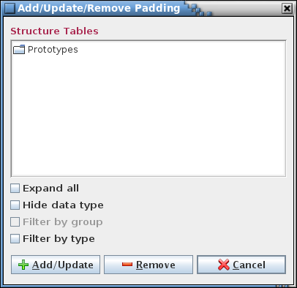

1. Padding adjustment dialog

The padding adjustment button commands are summarized below:

**Add/Update** Inserts padding variables into the selected prototype structure tables as needed to align the variables based on the size of the largest element within the structure (including any referenced child structures). The padding variables are of data type *char* and are represented as a single variable or an array of variables (if needed for multiple, consecutive padding). The exception for the data type is that padding variables added to “fill out” the unused bits for a bit-wise variable or series of bit-packed variables has the same data type as the bit-wise variable(s). The padding variable names are in the format *pad#__* (where *#* is one or more numerals). Padding variables are highlighted in the structure tables; see Figure 76. These variable rows may be manually edited as with any other row – added, altered, or removed – but are only recognized as the automatically inserted variety if they conform to the aforementioned name and data type constraints. If any data table has unstored changes a confirmation dialog appears allowing the user to choose between continuing with the padding add/update operation (losing the unstored changes) and canceling it (allowing the changes to be stored).

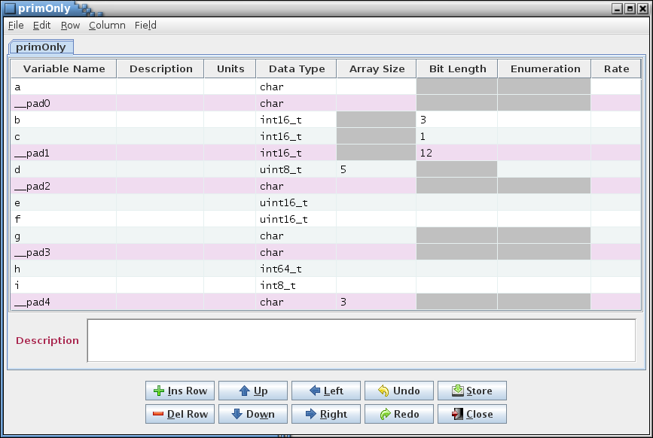

1. Structure table showing highlighted padding variables

**Remove** Causes all padding variables to be removed from the selected prototype structure tables. Only variables conforming to the name and data type constraints outlined in the description of the **Add/Update** button are recognized as padding variables. If any data table has unstored changes a confirmation dialog appears allowing the user to choose between continuing with the padding removal operation (losing the unstored changes) and canceling it (allowing the changes to be stored).

**Close** Closes the padding adjustment dialog.

While the padding is being added/updated or removed a dialog appears (Figure 77) showing the adjustment progress. This dialog allows halting padding adjustment by pressing the **Halt** button. Padding may be altered in the project database for some of the structures depending on when in the adjustment process the **Halt** button is pressed.

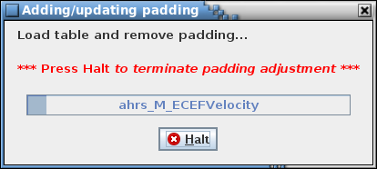

1. Example padding adjustment progress/cancellation dialog

#### Show variables

The **Show variables** command causes a dialog to appear that displays the variable paths and names, in alphabetical order, for tables representing structures in the project database (see Figure 78 for an example). The variables displayed can be filtered by a matching text string and/or by selecting one or more tables in the **Structure Tables** tree.

To filter by a text string enter the filter text in the input field and select the **Update** button. Any variables with matching text are displayed in the **Variables** table. The matching text is highlighted and the total number of matches, including multiple matches in a single variable, is displayed beside the **Variables** table label. Matches are only made within the individual *data type<*.*variable name>* sections of the variable’s path. For example, if the variable with the path *a,b.c* is searched for *a* or *b.c* then a match occurs, whereas a search for *a,b* does not constitute a match. Additionally. the **Structures & Variables** tree is collapsed and any node containing the filter text is expanded and the matching text highlighted (other nodes that are expanded due to sharing the same level as a matching node are grayed out).

The filter text field uses auto-completion to fill in the filter string. The previous filter strings are remembered, including those from previous sessions. The number of remembered filter strings can be changed via the Preferences dalog, and defaults to 30. Case sensitivity for auto-completion is based on the **Ignore text case** check box selection state.

The filter behavior can be adjusted by use of the check boxes below the filter text field. Case sensitivity for a match is governed by the **Ignore text case** check box.

If the **Allow regular expression** check box is not checked then the filter text is matched as diplayed in the text field. The filter text may contain one or more wild card characters. A label, giving a brief explanation for the wild cards, is displayed underneath the filter text field. A question mark (?) in the filter string will match any single character (example: the search string *a?c* matches *abc*, *a c*, and *a&c*, but not *ac*). An asterisk (*) matches one or more characters (example: *a*c* matches *abc*, *a_b_c*, and *a:123c*, but not *ac*). In order to filter for a wild card character the character must be preceded by a backslash (\) character (example: *a\?c* matches *a?c* but not *abc*).

The **Allow regular expression** check box, when checked, allows the use of a regular expression to define the filter pattern in the filter text field. The wild card label is removed when a regular expression is allowed. A regular expression can be formulated to find multiple matching conditions (for example, the search for **a.c** would match any string that has a single character between the characters ‘a’ and ‘c’). Information regarding the use of regular expressions is beyond the scope of this document; however, resources and tutorials can be found online.

Changing the filter and pressing the **Update** button updates the table and tree to match the new filter conditions; clearing the filter and pressing **Update** causes all variables to again be displayed.

The **Structures & Variables** tree can be used to filter the variables displayed in the table. Select one or more structures in the tree and press the **Update** button. Only variables for the selected structure(s) and that match the current filter are displayed. Selection of a header node in the tree (e.g., ‘Parents & Children’, or a group name if group filtering is enabled) selects all structures under that header. If no structure or header node is selected in the tree then all variables in the project are displayed that match the current filter.

The paths and names in the **Variables** tables are shown in two formats. The **Application Format** column shows the format used within the application:

*rootTable*

[,*structureDataType1*.*structureVariableName1*

[,*structureDataType2*.*structureVariableName2*

[,...]]],

*primitiveDataType*.*variableName*[*[arrayIndex]*]

The variable path and name is a combination of the structure’s root table, ancestor structure(s) (if any), and the variable data type and name. This combination is unique for each variable defined in the project database. Note that any macro embedded in a variable name is replaced by its corresponding value before being displayed in the dialog.

The **User Format** column shows the path and name based on the user inputs. The **Enter variable path separator character(s)** text field allows entering the character(s) that are used to replace the commas that separate each variable in the variable path. The **Enter data type/variable name separator character(s)** text field allows entering the character(s) that are used to replace the periods that separate the data types and variable names. The **Hide data types** check box, if selected, causes the data types (structure and primitive) to be removed from the path, along with the periods that separate the data types from the variable names. The data type/variable name separator field is disabled and ignored for this case. Array member indices are altered by replacing the left bracket ([) with an underscore (_) and removing the right bracket (]). The **User Format** column values are identical to that returned by the script data access method call:

getFullVariableName(“*variable path + name*”, path_*separator*, *hide_data_types, type_and_name_separator*)

To change the User Format variable names enter the separator character(s) and set the data type check box, then press the **Show** button. The **User Format** column updates to display the variables in the new format. The **Save** button outputs the variables in the table (both formats) to a user-specified file. The **Store** button stores the separators and show/hide data type state as a program preference so that these are restored if the dialog is closed and reopened. Additionally, this sets the separators used in displaying the variable path column; any open tables displaying a column with the variable path input data type are automatically updated.

To exit the **Show** **Variables** dialog select the **Close** button.

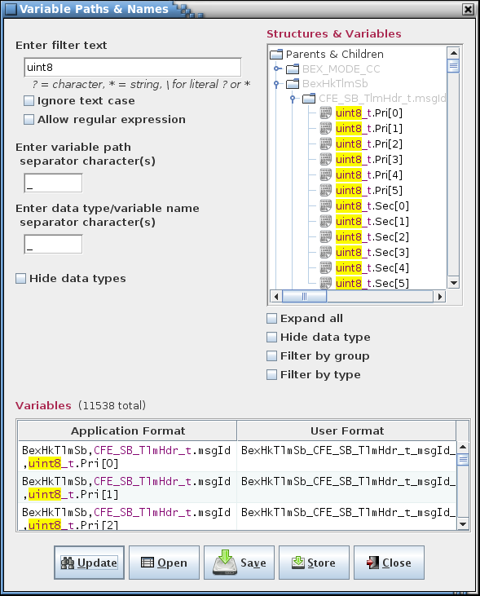

1. Example variable paths & names dialog

#### Show commands

The **Show commands** command causes a dialog to appear that displays information for commands defined in the project database (see Figure 79 for an example). The command information is displayed in alphabetical order based on the command name. The commands displayed can be constrained by selecting one or more tables in the table tree. Only commands for the selected tables are displayed. Selection of a header node in the table tree (e.g., ‘Commands’, or a group name if group filtering is enabled) selects all tables under that header. If no table or header node is selected in the tree then all commands in the project are displayed. The number of commands matching the constraints is displayed beside the command information table’s label.

The **Command Name**, **Command Code**, and **Command Table** columns show the command’s name, code, and table respectively. The **Command Argument(s)** column displays the names of the command’s argument variables (if any).

Initially all commands are displayed. Select or deselect tables in the table tree and press the **Show** button to update the displayed commands. If one or more rows is selected then pressing the **Open** button opens the command table(s) referenced in the **Command Table** column for the selected rows. The **Print** button outputs the table to a user-specified printer or file. Select the **Close** button to exit the dialog.

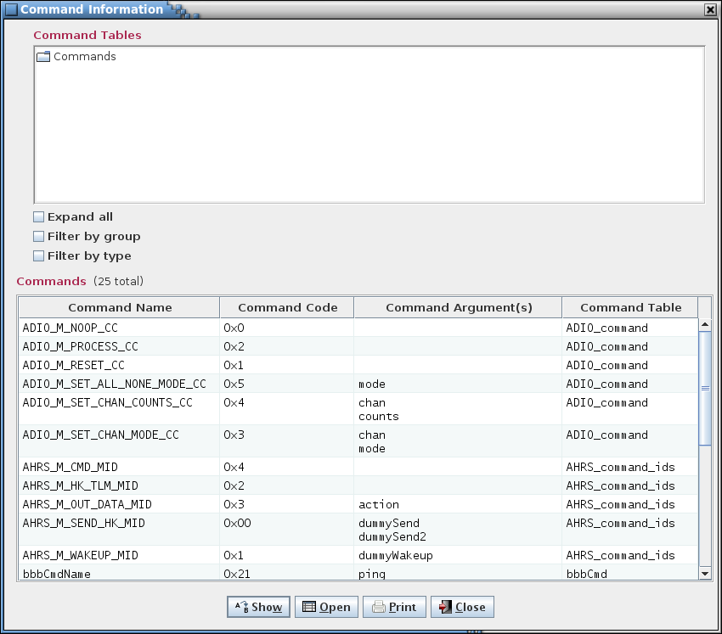

1. Example command information dialog

#### Search tables

The **Search tables** dialog provides a means of searching the project database data and internal tables for a specified text string (see Figure 80). The dialog is divided into three sections: search criteria (upper left), table filter tree (upper right), and search results table (lower). The vertical line separating the search criteria and and the table filter selection section delineates a split pane control that is used to resize these panels relative to one another. Position the mouse pointer over the separator line and when the pointer changes to a double-headed arrow press and hold the left mouse button. Space permitting, the adjoining panes can be resized by moving the mouse pointer left or right. Release the mouse button to exit resizing. The line that separates the results table section from the sections above is also a split pane control and operates in a similar manner.

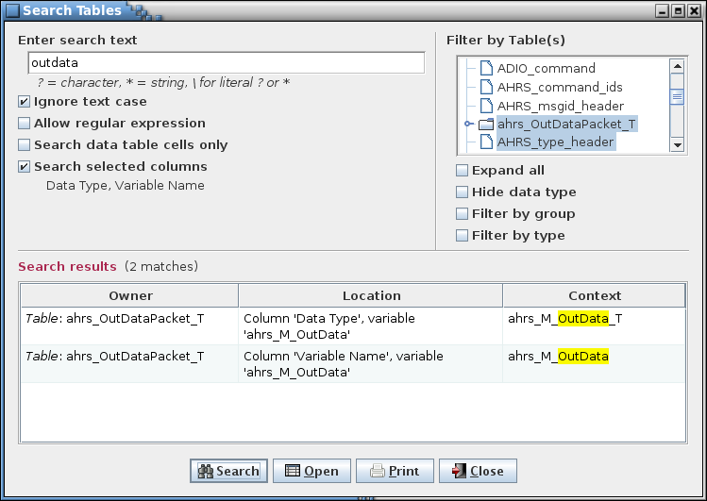

1. Search tables dialog

Enter the search text in the input field and select the **Search** button. The search results are displayed in the dialog’s **Search results** table. The number of results is displayed beside the results table’s label. The first column, **Owner**, shows the name of the data table or data object (table type definition, data field, group, script association, link, telemetry message, or scheduler entry) where a match is found. The second column, **Location**, describes the location of the match in the table/object. For a table the location is the column name in the table. A data object location depends on the type of object. For a data field this can be the field name, description, etc., whereas for a group or link this can be one of the tables or variables belonging to the group/link. The last column, **Context**, displays the string from the table or object containing the search text, with the search text highlighted.

The search text field uses auto-completion to fill in the search string. The previous search strings (those for the event log, table, and script) are remembered, including those from previous sessions. The number of remembered search strings can be changed via the Preferences dalog, and defaults to 30. Case sensitivity for auto-completion is based on the **Ignore text case** check box selection state.

The input text can be changed and the **Search** button pressed again to initiate another search of the tables. If one or more cells is selected and the **Open** button is pressed then the table(s) associated with the selected cells are opened in a table editor. A row is ignored if it contains a reference to other than a table or table data field. The search results can be output to a file or printer by selecting the **Print** button. To exit the search dialog select the **Close** button.

The search criteria can be adjusted by use of the check boxes below the search text field and the table filter tree. Case sensitivity for the search is governed by the **Ignore text case** check box.

If the **Allow regular expression** check box is not checked then the search text is matched as typed in the search text field. The search text may contain one or more wild card characters. A label, giving a brief explanation for the wild cards, is displayed underneath the search text field. A question mark (?) in the search string will match any single character (example: the search string *a?c* matches *abc*, *a c*, and *a&c*, but not *ac*). An asterisk (*) matches one or more characters (example: *a*c* matches *abc*, *a_b_c*, and *a:123c*, but not *ac*). In order to search for a wild card character the character must be preceded by a backslash (\) character (example: *a\?c* matches *a?c* but not *abc*).

The **Allow regular expression** check box, when checked, allows the use of a regular expression to define the search pattern in the search text field. The wild card label is removed when a regular expression is allowed. A regular expression can be formulated to find multiple matching conditions (for example, the search for **a.c** would match any string that has a single character between the characters ‘a’ and ‘c’). Information regarding the use of regular expressions is beyond the scope of this document; however, resources and tutorials can be found online.

The **Search data table cells only** check box, if selected, only displays matches found within the project database’s data table cells and ignores those in the internal tables (see Appendix E.4; data table cell values stored in the custom values tables are included in the search).

The **Search selected columns** check box, if selected, causes the **Select Column(s)** dialog, shown in Figure 81, to appear. One or more column check boxes can be selected, then the **Okay** button pressed (or press Cancel to exit the selection dialog without changing the column selection criteria). If one or more columns are chosen then these column names are displayed underneath the **Search selected columns** check box. When the search is performed only the selected columns are checked for matching text. Deselecting all of the check boxes restores the search to all columns.

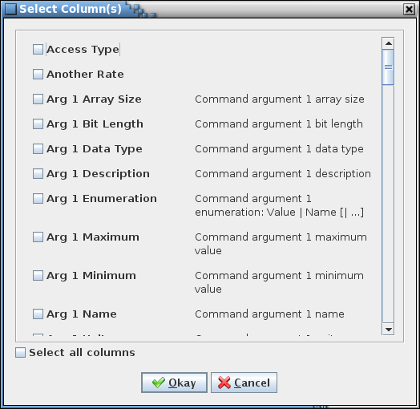

1. Select Column(s) dialog

The search can be constrained by selecting one or more tables in the filter table tree. Only matches in the selected tables are reported. Selection of a header node in the table tree (e.g., ‘Parents & Children’, or a group name if group filtering is enabled) selects all tables under that header. If no table or header node is selected in the tree then all tables are searched.

#### Search variables

The **Search variables** dialog, shown in Figure 82, provides a means of locating project variables by matching some portion or all of the variable’s name.

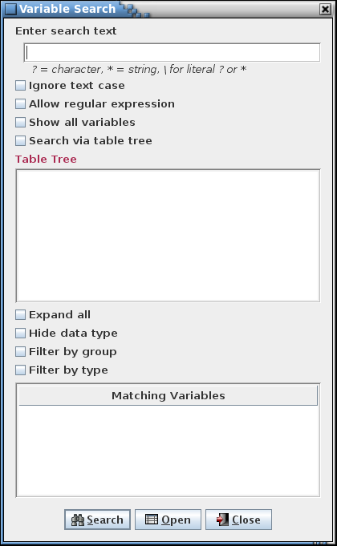

1. Variable search dialog

Enter the search text in the input field and select the **Search** button. Any variables with matching text are displayed in the **Matching Variables** tree and table. The matching text is highlighted and the total number of matches, including multiple matches in a single variable, is displayed beside the search text field’s label. Matches are only made within the individual *data type<*.*variable name>* sections of the variable’s path. For example, if the variable with the path *a,b.c* is searched for *a* or *b.c* then a match occurs, whereas a search for *a,b* does not constitute a match.

Initially the **Matching Variables** tree and table are empty. The tree and table are also emptied if the search text field is empty and the **Search** button is pressed.

The search text field uses auto-completion to fill in the search string. The previous search strings (those for the event log, table, and script) are remembered, including those from previous sessions. The number of remembered search strings can be changed via the Preferences dalog, and defaults to 30. Case sensitivity for auto-completion is based on the **Ignore text case** check box selection state.

The search text can be changed and the **Search** button pressed again to initiate another search. To exit the **Variable search** dialog select the **Close** button.

The search criteria can be adjusted by use of the check boxes below the search text. Case sensitivity for the search is governed by the **Ignore text case** check box.

If the **Allow regular expression** check box is not checked then the search text is matched as typed in the search text field. The search text may contain one or more wild card characters. A label, giving a brief explanation for the wild cards, is displayed underneath the search text field. A question mark (?) in the search string will match any single character (example: the search string *a?c* matches *abc*, *a c*, and *a&c*, but not *ac*). An asterisk (*) matches one or more characters (example: *a*c* matches *abc*, *a_b_c*, and *a:123c*, but not *ac*). In order to search for a wild card character the character must be preceded by a backslash (\) character (example: *a\?c* matches *a?c* but not *abc*).

The **Allow regular expression** check box, when checked, allows the use of a regular expression to define the search pattern in the search text field. The wild card label is removed when a regular expression is allowed. A regular expression can be formulated to find multiple matching conditions (for example, the search for **a.c** would match any string that has a single character between the characters ‘a’ and ‘c’). Information regarding the use of regular expressions is beyond the scope of this document; however, resources and tutorials can be found online.

The **Show all variables** check box displays the variable paths and names, in alphabetical order, for all tables representing structures in the project database. This option does not use the **search field**, **ignore text case** check box, **Allow regular expression** check box or the **Search via table tree** checkbox. For this reason all of those options are disabled to prevent confusion. An example of this is shown below in figure 79.

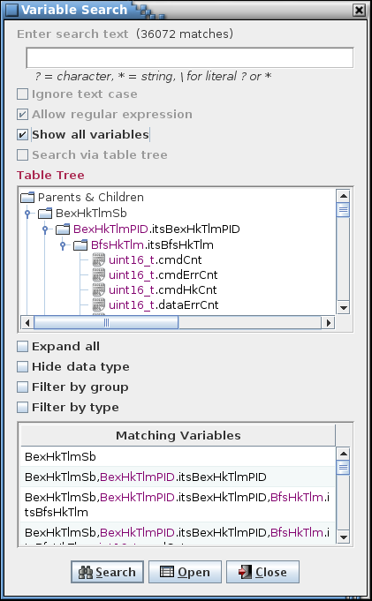

1. Example of Show all variables

The **Seach via table tree** checkbox allows the displayed variables to be constrained by selecting one or more tables in the table tree. Only variables for the selected tables are displayed. Selection of a header node in the table tree (e.g., ‘Parents & Children’, or a group name if group filtering is enabled) selects all tables under that header. If no table or header node is selected in the tree then all variables in the project are displayed. The number of variables matching the constraints is displayed beside the variable table’s label. An example is shown below in figure 80.

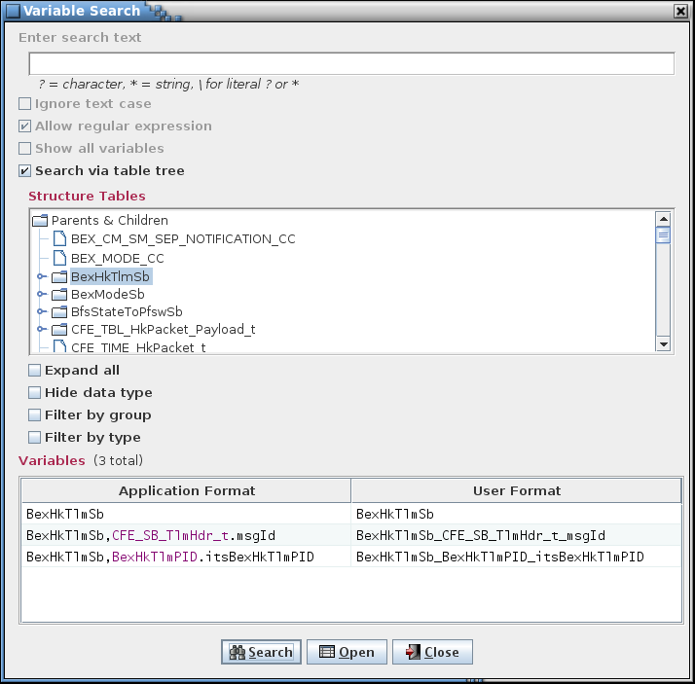

1. Search via table tree example

The paths and names are shown in two formats. The **Application Format** column shows the format used within the application:

*rootTable*

[,*structureDataType1*.*structureVariableName1*

[,*structureDataType2*.*structureVariableName2*

[,...]]],

*primitiveDataType*.*variableName*[*[arrayIndex]*]

The variable path and name is a combination of the structure’s root table, ancestor structure(s) (if any), and the variable data type and name. This combination is unique for each variable defined in the project database. Note that any macro embedded in a variable name is replaced by its corresponding value before being displayed in the dialog.

### Scheduling

The scheduling commands are used to create and manage the information required to schedule telemetry downlink and application execution.

#### Manage links

The **Manage links** command opens the Manage Links dialog (Figure 85). This command is disabled if no rate columns are defined. The link manager allows the user to create telemetry parameter linkages. These are simply groupings, selected by the user, of telemetry parameters (i.e., variables in the structures) with the same sample rate. The link information is used when assigning variables to telemetry messages in the telemetry scheduler (paragraph 4.9.4.2) to force the linked variables to be contained within the same message(s). The linkages created are specific to the data stream to which the linkage belongs. In other words, variables that are linked in one data stream do not have to be linked in another data stream.

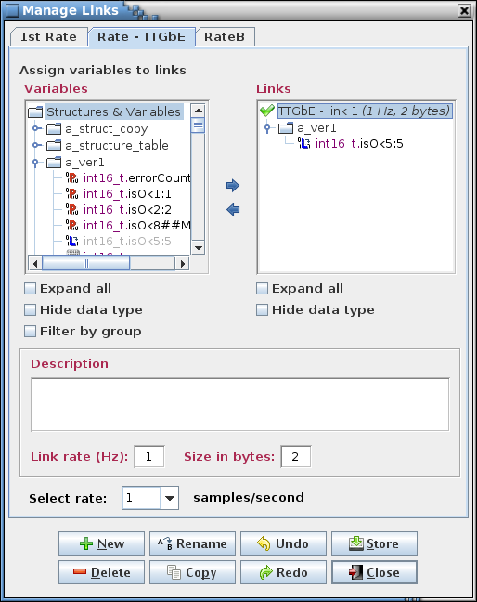

1. Manage Links dialog

The dialog’s components are as follows. Along the top are the tabs that allow selection of the data stream in which to create, alter, or delete linkages. The upper left displays a tree showing structures and their members (under the heading **Variables**), both child structures and primitive variable types. The variables that are displayed in the tree are determined by the rate chosen from the **Select rate** combo box pull down menu near the bottom of the dialog. Rate values are grayed out and can’t be selected if there is no variable that has that rate assigned. In the upper right is a tree showing the links and their member variables (under the heading **Links**). Between the trees are left and right arrows for adding or removing a variable from a link. Each tree also has one or more check boxes, to expand/collapse the tree and to filter the tree information. Below the trees is an input field for providing a description of a link. Underneath this is the link rate, in samples per second, and the total size in bytes of the link, which is the sum of the byte sizes of the variables assigned to the link. The description, rate, and size fields are active when a single link is selected in the link tree.

The space separating the variable and link trees delineates a split pane control that is used to resize these panels relative to one another. Position the mouse pointer between the two tree panels and when the pointer changes to a double-headed arrow press and hold the left mouse button. Space permitting, the adjoining panes can be resized by moving the mouse pointer left or right. Release the mouse button to exit resizing.

In the link tree, displayed in parentheses next to each link name, are that link’s rate and size in bytes (the same information that appears below the description field when this link is selected). A link’s rate must match the selected sample rate (or the link must have no variables assigned) in order for it to be assigned variables from the variable tree. A check mark () beside the link name indicates that the link can be assigned variables from the variable tree, and a red X () is displayed if the link is incompatible with the selected sample rate (the tree text is also grayed out for incompatible links).

A variable may not be assigned to more than one link for a given data stream. Once assigned to a link the variable still appears in the variable tree but it is disabled (grayed out and not selectable). When a variable is removed from a link it becomes enabled again in the variable tree. Once an entire structure’s complement of variables is assigned the structure itself it disabled in the variable tree, and if all structures are assigned then the **Structures & Variables** tree node itself is disabled.

If a variable is selected in the **Variables** tree then the link to which it belongs is selected automatically in the **Links** tree. Since linked variables are disabled in the **Variables** tree the variable isn’t highlighted when selected. Selecting a non-linked variable deselects any highlighted link in the **Links** tree.

To create a link select the **New** button and provide a link name and, optionally, a description, in the input dialog that appears (Figure 86). The description can be altered later in the main dialog. The new link name appears in the link tree. The link name may not be blank, nor is the name allowed to match that of an existing link in the selected data stream. The link name may contain alphanumeric, space, and punctuation characters. There is no constraint on the length of the name.

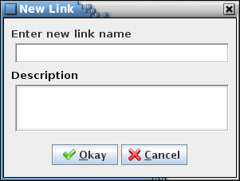

1. New Link dialog

To add variables to a link select the link in the link tree using the mouse or keyboard. Expand the variable tree as needed and select one or more variables using the mouse or keyboard. Multiple variables can be selected simultaneously by holding the Ctrl or Shift keys down when making a selection. Selecting a structure automatically includes its child structures (and their children, etc.), and all variables associated with the structure(s). Choosing a child structure automatically includes its parent structure, and its parent’s parent, etc., up to its root structure, but does not include any of its sibling variables (i.e., a variable having the same parent structure and at the same tree level as the chosen variable). The exception is if the selected variable is bit-packed with one or more variables; in this case all of the packed variables are automatically included (see paragraph 4.5.5). Finally, select the right arrow button in the center of the dialog. The variable(s) chosen appear in the selected link, and the link’s tree is expanded to show the variable(s) added. Note that the variable hierarchy is preserved in the link’s tree. More variables can be assigned to the link as described above.

To remove structures or variables from a link expand the link’s tree and select the structure(s) and/or variable(s) to remove using the mouse or keyboard. Then select the left arrow button in the center of the dialog to delete the structure(s) or variable(s) from the link. A structure’s children (and their children, etc.) and variables are removed along with the chosen structure. If a bit-packed variable is removed then all other variables packed together with it are removed as well, even if not explicitly selected.

To delete a link, first select it in the link tree, then select the **Delete** button. Multiple links can be removed simultaneously if desired by highlighting them while using the Shift or Ctrl keys.

To rename a link, select a single link from the link tree, then press the **Rename** button. An input dialog appears with the name of the selected link in the input field. Alter the name as desired and select **Okay** to change the link’s name. The renamed link name may not be blank, nor is the name allowed to match that of an existing link in the current data stream. Select **Cancel** to exit the input dialog without affecting the link’s name.

A link, including its description, variable structure(s) and variable(s), can be copied from one data stream to another. First select one or more links from the link tree to be copied, then press the **Copy** button. A dialog appears (Figure 87) with the name(s) of the selected link(s) in the link name text field. Below the link name field is an array of check boxes, one for each of the project’s data stream names. The current data stream is grayed out and can’t be selected (recall that a variable may belong to only one link in a given data stream). Select one or more data streams to which the link (or links) is to be copied. Press the **Copy** button to copy the link(s) to the selected data stream(s). Select **Cancel** to exit the copy dialog without copying the link.

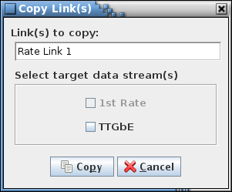

1. Copy Link(s) dialog

If the targeted data stream doesn’t support the link’s sample rate or the link name already exists in the stream then the link isn’t copied to that stream. If a variable’s sample rate differs between the copied stream and the target stream, or if the variable is unavailable in the target stream (i.e., the structure containing the variable doesn’t have the rate column corresponding to the target data stream) then the variable isn’t copied. For these cases a dialog is displayed indicating which link(s) or link member variable(s) could not be copied to which stream(s) and the reason for the failure(s) (see example in Figure 88). The **Print** button allows outputting the coy failure table to the selected printer or file. The **Close** button exits the copy failure dialog.

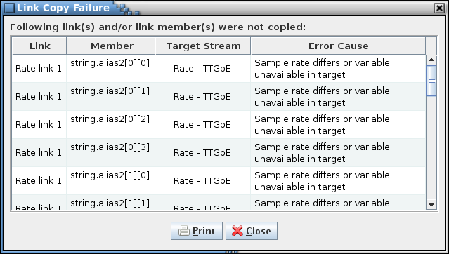

1. Example link copy failure dialog

A link’s description can be added or changed by first selecting the link in the link tree. The current description for the link appears in the **Description** input field. The description can then be changed as desired.

Changes to the links (descriptions and member variables) for all data streams are stored in the project database only when the **Store** button is pressed. If changes have been made a confirmation dialog first appears. Select **Okay** to store the updates; select **Cancel** to exit the confirmation dialog without altering the project database.

Select the **Close** button to exit the link manager dialog. If there are any unsaved link changes in any of the data streams a dialog appears requesting confirmation to discard the changes. Select **Okay** to exit the link manager, losing any unsaved changes. Select **Cancel** to return to the link manager dialog.

The link manager button commands are summarized below:

**New** Create a new link.

**Delete** Delete the selected link(s).

**Rename** Rename the selected link.

**Copy** Copy the selected link, including its member tables, so another data stream.

**Undo** Undoes the last action performed (table assignment, typing, paste, insert, delete, redo, etc.) on the selected link.

**Redo** Reverses the last action undone (table assignment, typing, paste, insert, delete, undo, etc.) on the selected link.

**Store** Stores the changes made to the links in the link manager into the project database.

**Close** Closes the link manager window. If any changes have not been stored then a dialog appears allowing the user to confirm discarding the updates or to cancel closing the editor.

#### Telemetry

The **Telemetry** command opens the Telemetry Scheduler dialog (Figure 89). This command is disabled if no rate columns are defined. The telemetry scheduler is used to assign a project’s variables to telemetry messages. The message information can be used to build a CFS housekeeping “copy table” (for example, by using the copy table script provided with the CCDD application). The available messages are determined by the rate parameters. These parameters can be altered in the Rate Parameters dialog (see paragraph 4.9.4.4). Before the telemetry scheduler can be used the following must be done:

* Adjust the rate parameters to establish the correct boundaries for handling the project’s telemetry
* Assign rates to the variables to be downlinked in the Edit Table dialog (see paragraph 4.9.3.2)
* (*Optional*) Assign variables that are desired to be sent down in the same message to a link using the link manager (see paragraph 4.9.4.1)

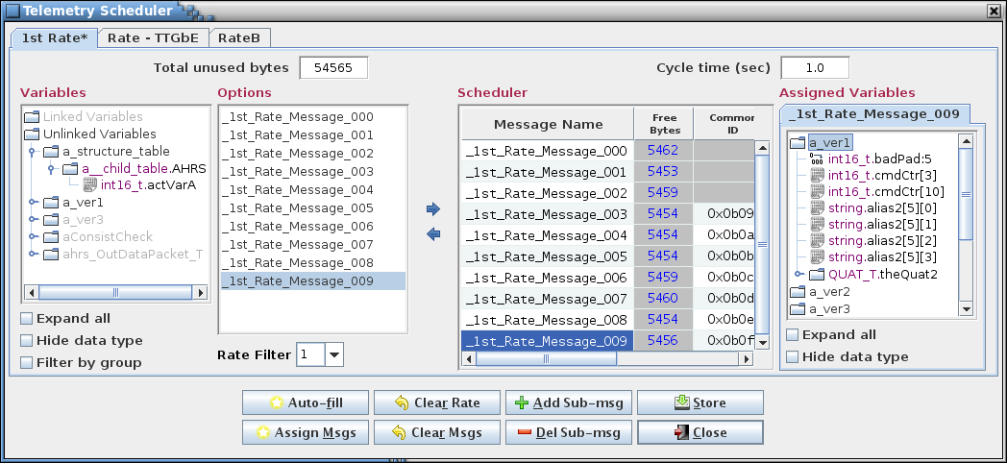

1. Telemetry Scheduler dialog

The Telemetry Scheduler dialog is composed of number of components. Along the top are tabs for each defined data stream (see paragraph 4.8). Each stream has its own variable rates and message assignments. Selecting a tab displays the dialog components associated with that data stream. At the top left is displayed the total number of bytes remaining to be assigned. This value is equal to the maximum bytes per second (from the Rate Parameters dialog) minus the size in bytes of all the variables assigned to messages. At the upper right is the cycle time which is the amount of time it will take for the messages to repeat; e.g., a cycle time of 2 seconds means that each message in the table will be sent down at least once every 2 seconds.

The **Variables** tree, at the left of the dialog, displays in tree format the variables available for downlink. Only variables assigned a rate are displayed in the variable tree. The tree is separated into two sections: **Linked Variables** and **Unlinked Variables**. **Linked Variables** displays the links per the currently selected data stream and rate filter. Each link contains the variables assigned to the link via the link manager. **Unlinked Variables** displays all the variables with a rate matching the selected rate filter. Variables assigned to a link are also displayed, but are grayed out and cannot be selected. Beneath the variable tree are two check boxes that are used to expand the tree or filter it by group.

To the right of the **Variables** tree is the **Options** list. Thislist displays the available options, based on the selected rate filter, for assignment of the variables to the messages. For example, if the rate filter is set to 5 and there are 10 available messages then the options displayed are “Option 1: Messages 1, 3, 5, 7, 9” and “Option 2: Messages 2, 4, 6, 8, 10” (assuming the cycle time is one second).

The **Rate Filter**, just below the **Options** list, is a pull down list of the data stream’s available rates. The selected rate is used to filter the **Variables** tree and the **Options** list. Rate values are grayed out and can’t be selected if there is no variable in the data stream that has that rate assigned. The variable tree only displays variables that have a rate that matches the selected rate filter value. The user can change the rate filter at any time to make the **Variables** tree and **Options** list update.

The **Scheduler** table, located on the right of the **Options** list, contains a table with every available message. The scheduler table has at least three columns: the **Message** column, which displays the message name; the **Bytes** column, which displays the remaining bytes for each message; the **ID** column, which display the message’s ID value. Extra columns, labeled **Sub 1**, **Sub 2**, etc. are added if any message has a sub-message; for messages without the specified sub-message the column is grayed out. The **Bytes** column is updated as variables are added or removed from the message. A negative number indicates that the message is over assigned (i.e., insufficient bytes available to contain the assigned variables); the **Message** column is displayed in red in this case. The message names and the ID (and sub ID) values can be edited in the **Scheduler** table, or can be automatically assigned in the Assign Telemetry Messages dialog called via the **Assign Msgs** button.

The **Assigned** **Variables** tree, located to the right of the **Scheduler** table, shows the variables assigned to the most recently selected message in the **Scheduler** table.

In between the **Options** list and **Scheduler** table are two arrow buttons. The right arrow button assigns one or more variables to a message. The assignment process is described below. The left arrow button **r**emoves one or more variables from a message. The removal process is described below.

The **Variables**, **Options**, **Scheduler**, and **Assigned Variables** portions of the telemetry scheduler can be resized. Position the mouse pointer between adjoining panes and when the pointer changes to a double-headed arrow press and hold the left mouse button. Space permitting, the adjoining panes can be resized by moving the mouse pointer left or right. Release the mouse button to exit resizing.

At the bottom of the telemetry scheduler dialog is the button panel. The button functions are as follows:

**Auto-fill** Assigns all the variables in the variable tree that are not yet assigned to messages. Auto-fill does this optimally so each message is filled as evenly as possible. During the auto-fill operation a progress/cancellation dialog appears (Figure 90). Pressing the dialog’s **Halt** button stops the auto-fill operation; however, any variable assignments made up to that point are retained.

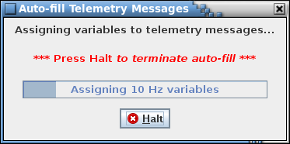

1. Telemetry message auto-fill progress/cancellation dialog

If auto-fill is successful then all the variables are assigned to an appropriate message. If auto-fill is unable to assign every variable (due to insufficient room or no available option) it displays a dialog indicating how many variables are left unassigned.

**Assign Msgs** Opens the Assign Telemetry Messages dialog (Figure 91). This dialog provides a means for assigning message names and/or message IDs to all messages and sub-messages based on a pattern, starting value, and interval value.

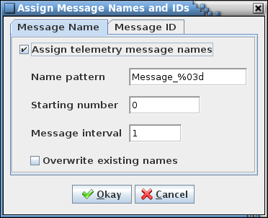

1. Assign telemetry message names and IDs dialog

To assign message names the **Assign telemetry message names** check box under the **Message name** tab must be selected. A pattern for the names is entered in the **Name pattern** input field. This pattern must adhere to alphanumeric naming constraints (see paragraph 4.7) except that it also must contain a single ‘%<0#>d’ format string somewhere after the first character. The format string is replaced with a sequence number when the names are assigned. The optional ‘0#’, where ‘#’ represents one or more digits, provides a means of padding the sequence number with leading zeroes so as to bring its length to # digits. The first message name uses the pattern and the **Starting number** field value; the **Message interval** value is added to the previous message’s number for each subsequent message name. For example, with the values as shown in Figure 91 the message names are “Message_001”, “Message_002”, “Message_003”, etc., until all messages are named.

To assign message IDs the **Assign telemetry message IDs** check box under the **Message ID** tab must be selected. The **Starting ID** field is the starting ID number, in hexadecimal. The **ID interval** field is the interval used to calculate the next ID value in the sequence - the default is 1; any positive integer value is valid. The **Overwrite existing IDs** check box determines whether or not messages with an existing ID number are updated or left as is. The IDs are assigned beginning with the starting ID number and with each subsequent ID number equal to the previous number plus the interval value. Message IDs in the reserved message ID list (see 4.9.3.14.2) and IDs already assigned to message ID data fields for structure and command tables are automatically skipped when assigning IDs to the telemetry messages.

When **Okay** is selected the message names and/or IDs, based on the check box states, are assigned to the messages in the **Options** list and **Scheduler** table. Press **Cancel** to exit the dialog without changing the message names or IDs. Note that he telemetry scheduler’s **Store** button must be used to update the messages in the project database. The names and/or IDs are assigned to the current data stream; the process must be repeated for each data stream. Avoid using the identical message ID name pattern for different streams since this can lead to duplicate output message ID names when creating the housekeeping copy table.

**Clear Rate** Removes all message and sub-message variable assignments for variables with a rate matching the currently selected rate filter.

**Clear Msgs** Removes all message and sub-message variable assignments.

**Add Sub-msg** Adds a sub-message to the message currently selected in the **Scheduler** table. Any number of sub-messages may be added. Adding a sub-message removes all of a message’s sub-message variable assignments. This is done since the number of sub-messages affects the rate at which a sub-message is sent.

**Del Sub-msg** Removes the currently selected sub-message in the **Scheduler** table. Deleting a sub-message removes all sub-message variable assignments for that message. This is done since the number of sub-messages affects the rate at which a sub-message is sent.

**Store** Stores the telemetry scheduler data in the project database. Any changes not stored before closing the telemetry scheduler dialog are lost.

**Close** Closes the telemetry scheduler dialog. If there are any unsaved changes in any of the data streams a dialog appears requesting confirmation to discard the changes. Select **Okay** to exit the telemetry scheduler, losing any unsaved changes. Select **Cancel** to return to the telemetry scheduler dialog.

If a variable is selected in the **Variables** tree then every message to which it belongs is selected automatically in the **Scheduler** table, including sub-messages. The first message to which the variable belongs sets the tab in the **Assigned Variables** tree. The option corresponding to the message selection is highlighted in the **Options** list. Since assigned variables are disabled in the **Variables** tree the variable isn’t highlighted when selected. Choosing a non-assigned variable in the **Variables** tree does not change the option and message selections.

The following describes the process to manually assign a variable to a message. First, one or more variables and/or links are selected in the **Variables** tree. A grayed out variable, structure, or link indicates that it is already assigned and can’t be selected (linked variables also appear in the unlinked portion of the variable tree, but are grayed out and can’t be assigned individually). After selecting one or more variables an option is chosen from the **Options** list. To aid in deciding which option to choose, the **Scheduler** table temporarily updates the **Bytes** column for the option’s message(s), displaying the message size if that option is chosen. Also, the text of the **Message** column changes to either green, signifying there is enough room in the message for the variable(s), or red, signifying there is insufficient room. Changing which option is selected resets any of the temporary changes and updates the message(s) based on the new option. This allows the user to evaluate each option before selecting a choice. After deciding on an option, pressing the dialog’s right arrow button assigns the selected variable(s) to each message in the selected option. Adding a linked or bit-packed variable also adds the variables associated with it; i.e., all members of the link are added, and all other variables bit-packed with the selected variable are added. Once a variable is assigned to a message it is grayed out in the **Variables** tree so it can’t be assigned more than once.

A variable or variables can be removed manually from the messages and sub-messages. First a message or sub-message is selected (either in the **Scheduler** table or the **Assigned Variables** tree), which causes the **Assigned Variables** tree to display the variables for the selected (sub-)message. The user selects from the tree one or more of the variables or structures that are to be removed and then presses the dialog’s left arrow button. The selected variable(s) is removed from the message(s) to which it is assigned. Removing a linked or bit-packed variable also removes the variables associated with it; i.e., all members of the link are removed, and all other variables bit-packed with the selected variable are removed. Any de-assigned variable is no longer grayed out in the **Variables** tree to signify it is available to be re-assigned.

#### Applications

The **Applications** command displays the Application Scheduler dialog (Figure 92). The application scheduler is used to schedule the execution frequency and order of a project’s applications. The data created from the application scheduler is used to create scheduler tables for the project. The schedule table is used by the CFS scheduler application (SCH) to determine when to execute the project’s applications (demonstration scripts are provided that create the scheduler tables). The available time slots for when an application can be executed are determined by the application parameters that can be altered in the application parameters dialog (see paragraph 4.9.4.5). Before the application scheduler can be used the following must be done:

* Set the application parameters to establish the correct boundaries
* Create applications using the **Group Manager** dialog (see paragraph 4.9.3.9)

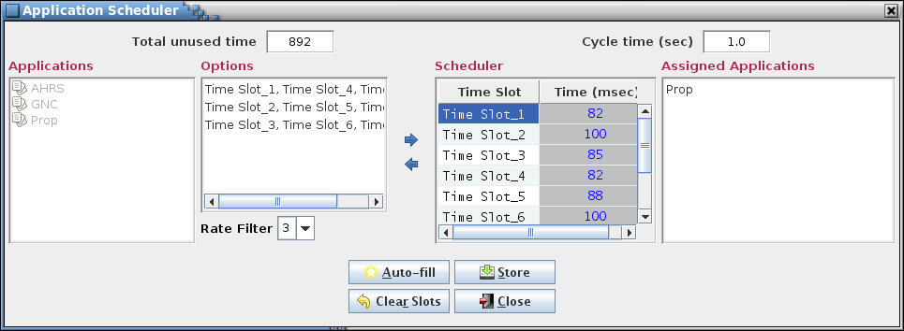

1. Application Scheduler dialog

The application scheduler dialog is composed of multiple components. At the top left is displayed the total number of milliseconds remaining to be assigned. At the upper right is the cycle time which is amount of time it will take for the schedule to repeat; e.g., a cycle time of 2 seconds means that the schedule table will be executed once every 2 seconds.

The **Applications** tree, at the left of the dialog, displays all the available applications to be scheduled. Any application that has already been assigned or has an execution rate that does not match the rate filter is grayed out and cannot be selected.

To the right of the **Applications** tree is the **Options** list. Thislist displays the available options, based on the selected rate filter, for assignment of the applications to the time slots. For example, if the rate filter is set to 1 and forty time slots are available then the options will be “Option1: TimeSlot_1”, “Option2: TimeSlot_2”, “Option3: TimeSlot_3”, etc. for all forty time slots (assuming the cycle time is one second).

The **Rate Filter**, which is located below the **Options** list, contains a drop-down list of all the available execution rates. Changing the rate causes the **Applications** tree to gray out any applications that are not at the selected rate, and the **Options** list changes to display options for the newly selected rate.

The **Scheduler** table, which is located to the right of the **Options** list, is a table of all available time slots. The **Time Slot** column displays the time slots and the **Time (msec)** column displays the remaining available time for that time slot (in milliseconds). The available time decreases as applications are added to that time slot and increase if an application is removed. If the available time ever becomes negative (i.e., the sum of the assigned applications’ execution times exceeds the maximum available for a time slot) then the time slot’s text changes to red.

The **Assigned Applications** list, located to the right of the **Scheduler** table, displays the application(s) assigned to the currently selected time slot. If multiple time slots are selected only the first selected time slot’s applications are displayed. This allows the user a quick way to view the applications currently assigned to a time slot.

In between the **Options** list and **Scheduler** table are two arrow buttons. The right arrow button is used to assign one or more applications to a time slot. The left arrow button **r**emoves one or more applications from a time slot. The assignment and removal processes are described below.

The **Applications**, **Options**, **Scheduler**, and **Assigned Applications** portions of the application scheduler can be resized. Position the mouse pointer between adjoining panes and when the pointer changes to a double-headed arrow press and hold the left mouse button. Space permitting, the adjoining panes can be resized by moving the mouse pointer left or right. Release the mouse button to exit resizing.

At the bottom of the application scheduler dialog is the button panel. The button functions are as follows:

**Auto-fill** Assigns all the applications in the application tree that are not yet assigned to time slots. Auto-fill does this optimally so each slot is filled as evenly as possible. During the auto-fill operation a progress/cancellation dialog appears (Figure 93). Pressing the dialog’s **Halt** button stops the auto-fill operation; however, any application assignments made up to that point are retained.

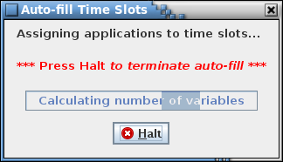

1. Application time slot auto-fill progress/cancellation dialog

If auto-fill is successful then all the applications are assigned to a time slot. If auto-fill is unable to assign every application (due to insufficient room or no available option) it displays a dialog indicating how many applications are left unassigned.

**Clear Slots** Removes all application time slot assignments.

**Store** Stores the application scheduler data in the project database. Any changes not stored before closing the application scheduler dialog are lost.

**Close** Closes the application scheduler dialog. If there are any unsaved changes a dialog appears requesting confirmation to discard the changes. Select **Okay** to exit the application scheduler, losing any unsaved changes. Select **Cancel** to return to the application scheduler dialog.

The following describes the process to manually assign an application to a time slot. First, one or more applications are selected in the **Applications** tree. A grayed-out application indicates that it is already assigned or doesn’t have the same rate as that shown in the **Rate Filter**, and can’t be selected. After selecting one or more applications an option is chosen from the **Options** list. To aid in deciding which option to choose, the **Scheduler** table temporarily subtracts the application run time(s) from the **Time (msec)** column for the selected option’s time slot(s), displaying the time remaining if that option is chosen. Also, the text of the **Time Slot** column changes to either green, signifying there is enough room in the slot for the application(s), or red, signifying there is insufficient room. Changing which option is selected resets any of the temporary changes and updates the time slot(s) based on the new option. This allows evaluation each option before committing to a choice. After deciding on an option, pressing the dialog’s right arrow button assigns the selected applications(s) to each time slot in the selected option. Once an application is assigned to a time slot it is grayed out in the **Applications** tree so it can’t be assigned more than once.

An application or applications can be removed manually from the time slot(s). First a time slot is selected in the **Scheduler** table; this causes the **Assigned Applications** list to display the applications for the selected slot. Select from the list one or more of the applications that are to be removed and then press the dialog’s left arrow button. The selected application(s) is removed from the slots to which it is assigned. Any de-assigned application is no longer grayed out in the **Applications** tree, signifying it is available to be re-assigned.

#### Rate parameters

The **Rate parameters** command displays the dialog shown in Figure 94. This command is disabled if no rate columns are defined.

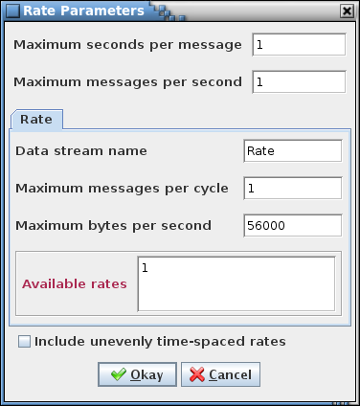

1. Rate Parameters dialog

This dialog is used to set the bounds for the sample rates for each defined data stream (see paragraph 4.8) and from these generate the selections in the drop down menu for the rate column(s) in the data tables, the link manager (see paragraph 4.9.4.1), and the telemetry scheduler (see paragraph 4.9.4.2). These parameters also define the total number of messages and maximum message size. Each of these parameters must be a positive, non-zero integer value. The first two parameters, maximum seconds per message and maximum messages per second, are common to all data streams, while the remaining parameters are assigned by data stream. A data stream is selected via the tabs, which reflect the rate column names, in the center of the dialog. The definitions of these values are as follows:

**Maximum seconds per message** The slowest period, in seconds, that a message is downlinked. Example: If 5 is entered then 5 seconds per sample is the slowest rate allowed to be selected as the rate for a telemetered value. All rates between this and 1 second/sample that are multiples of the period are added to the rate list. Rates slower than 1 sample per second are displayed in the format “1/#” where # is the number of seconds between samples.

**Maximum messages per second** Maximum number of telemetry messages that can be downlinked in a single second. For a cycle time of one second this value is the same as the **Maximum messages per cycle** value.

**Data stream name** This value is specific for a data stream. This is a user-defined alternate name to associate with the rate column and is used in the link manager and telemetry scheduler for the tab name (if no data stream name is entered the rate column name is used instead). The script access methods use the data stream name.

**Maximum messages per cycle** This value is specific for a data stream. This value is the number of telemetry messages that are downlinked during a single cycle through the message list. For a cycle time of one second this value is the same as the **Maximum messages per second** value.

**Maximum bytes per second** This value is specific for a data stream. This is the maximum number of bytes that can be downlinked during a single second.

The **Available rates** field displays the rates that are available based on the input values.

The evenly time-spaced sub-second rates are calculated using the above values. For example, given a maximum messages per cycle of 10 and a maximum messages per second of 10 then only rate values that are a factor of 10 – i.e., 1, 2, 5, and 10 samples per second – are available. The check box labeled **Include unevenly time-spaced rates**, when checked,causes the remaining, unevenly time-spaced rates to be included in the list of rates (in the example this is all values between 1 and 10 – i.e., 1, 2, 3, 4, 5, 6, 7, 8, 9, and 10 samples per second).

#### App parameters

The **App Parameters** command displays the Application Parameters dialog (Figure 95).

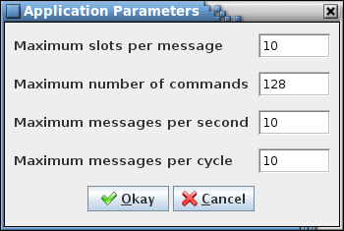

1. Application Parameters dialog

This dialog is used to set parameters for the application scheduler table. The values for **Maximum slots per message** and the **Maximum number of commands** define the boundaries, while the **Maximum messages per second** and the **Maximum messages per cycle** are used for scheduling the applications. Each parameter must be a positive, non-zero integer value. The definitions of these values are as follows:

**Maximum slots per message** The number of slots available in each time slot of the scheduler table**.** If 10 is entered then every time slot will have 10 available slots for an application. The Application Scheduler doesn’t allow a time slot to have more applications assigned to it than this parameter.

**Maximum number of commands** The maximum number of commands that can be created for the scheduler table.

**Maximum messages per second** The maximum number of time slots that are available for an application to be scheduled in a second.

**Maximum messages per cycle** The number of time slots that are executed during a single cycle through the time slot list. For a cycle time of one second this value is the same as the **Maximum messages per second** value.

### Script

The **Script** menu contains commands for associating scripts with data tables and fields, and for executing the stored associations. Scripts are a means of accessing the project data in order to create output files (e.g., C header files or ITOS record files) or otherwise manipulate the data. The script languages supported by the application include JavaScript, Python, Ruby, Groovy, and Scala. Example scripts are provided with the application. These can be modified, or new scripts written as needed by the user. See paragraph the CCDD Developers Guide for more information on the use of scripts to access the table data.

The Manage Script Associations (see paragraph 4.9.5.1) and Execute Script(s) (see paragraph 4.9.5.2) dialogs are mutually exclusive; opening one causes the other, if displayed, to be closed.

#### Manage

The **Manage** command provides the means for associating scripts and data tables. This is required before executing the scripts. The associated scripts and tables can be stored in the project database so that frequently used associations can be quickly executed.

When the command is selected the Manage Script Associations dialog (Figure 96) is displayed. If the Execute Script(s) dialog (see paragraph 4.9.5.2) is currently displayed then it is closed. The dialog is divided into four sections: script selection and association name, table selection, script associations, and command buttons. The vertical line separating the script selection and association name section and the table selection section delineates a split pane control that is used to resize these panels relative to one another. Position the mouse pointer over the separator line and when the pointer changes to a double-headed arrow press and hold the left mouse button. Space permitting, the adjoining panes can be resized by moving the mouse pointer left or right. Release the mouse button to exit resizing. The line that separates the script association table from the sections above is also a split pane control and operates in a similar manner.

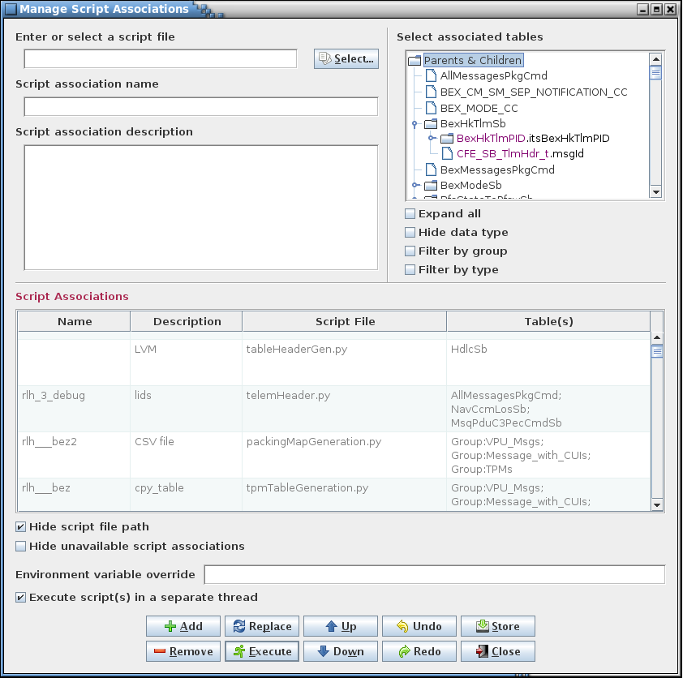

1. Manage Script Associations dialog

The **Script association name** field allows a name to be assigned to an association. The name may not match one already in use by another association and must adhere to the Text input type (see paragraph 4.7). The association name is optional; its purpose is to be used with the command line execute option (see paragraph 4.1) to reference an existing association, in place of typing the script name and table(s).

The **Script association description** field allows a description to be added to an association. The description may remain blank.

The script selection field and **Select…** button are used to select a script file. A script name (with file path) can be typed into the field; alternatively, pressing the **Select…** button displays a file selection dialog from which a script file can be located and selected. Script names must be a valid for use as a file name (e.g., may contain spaces, but not certain special characters, dependent on the operating system, such as a forward slash (/)).

The table tree displays all of the root tables and their child tables (if applicable). The user expands the tree branches and selects one or more tables (see paragraph 4.5.3 for more information on table trees). When a structure table is chosen all of its child tables are automatically included when the script association is executed; therefore the child tables do not have to be explicitly selected when creating the association, and any child nodes that are selected are eliminated from the **Script Associations** table’s **Table(s)** column when the association is added. It makes no difference in what order the tables are selected for assignment since, when loaded for use by the script, the tables are sorted so that the root tables are in alphabetical order and the child tables appear in the order defined by their table type definition.

If the table tree is filtered by group then one or more group names can be selected from the tree for association with the chosen script. When the association is added to the table the group name (prepended with “Group:”) appears in the **Table(s)** column. Any of the group’s member tables that were also selected don’t appear in the table, however. When the script association is executed the group’s current member tables are loaded. This allows the script association to remain unchanged even if tables are added or removed from the group.

The **Script Associations** table displays the script associations that are stored in the project database, plus any that have been added while this dialog is open. Associations are grayed out if the script file doesn’t exist on the local machine or an associated table doesn’t exist in the project database (display of these unavailable associations can be toggled off and on; see the **Hide unavailable script associations** check box description below). These disabled associations can be selected for removal, but can’t be executed. The **Description** column may be edited to add, alter, or remove an association’s description. The **Script File** column displays the association’s script file and file path. Below the table is a check box that allows toggling between hiding and displaying the script file paths; this selection does not affect storing and retrieving the file paths and the check box’s selection state is remembered between sessions. The **Table(s)** column display each table associated with the script in the **Script File** column. Each table is displayed on a single line (space permitting) and includes its full path.

Below the table are two check boxes. The first is **Hide script file path**. When selected the file paths in the association table’s **Script File** column are not displayed. Deselecting the check box restores the paths. The paths are used when executing the associations even if not displayed. The second check box is **Hide unavailable script associations**. When selected the associations in the table that are unavailable, due to a missing script file or table, are not displayed. Deselecting the check box restores any unavailable associations.

Script file paths are allowed to have environment variables within them. When the association is executed any variables in the script path are replaced by their corresponding value in the system environment variable map. The **Environment variable override** field allows the variable values in the system map to be temporarily replaced, or added if the variable doesn’t exist in the map. The format for entries in this field is:

<key1 = value1<,key2 = value2<, …>>>

Each key/value pair must be separated by a comma. A dollar sign ($) can precede the key name, and spaces (except those embedded within a key or value) and double quotes bounding the keys and values are ignored. The contents of this field are stored as a program preference, so the field is automatically populated with the overrides that were last used.

The scripts can be executed within the same thread as the CCDD application. This can result in an increase in execution speed. The drawback is that the GUI freezes during script execution and there is no indication to the user on the progress of the script execution, nor is there a way to stop execution of a script. Running the script(s) in a separate thread allows for stopping script execution as well as provides a progress dialog. Selecting the **Execute script(s) in a separate thread** check box causes script execution to occur in a separate thread.

Script associations may be executed from within this dialog. This is similar to execution of the associations from the Execute Scripts dialog (see paragraph 4.9.5.2) except that in this dialog the associations do not have to be stored in the project database to be executed. This provides a means to create a one-use association for immediate execution. See paragraph 4.9.5.2 for further detail on script execution.

The button commands are described below:

**Add** After entering a name (optional), description (optional), choosing a script file, and (if needed by the script) one or more data tables or groups, selecting the **Add** button creates the script association. The new association is inserted as the first row in the **Script Associations** table (any existing associations are moved down a row) and is automatically selected. A script may be used in more than one association, and a data table or group may be used in any number of associations; however, duplicate associations, i.e., those utilizing the same script, table(s), and group(s), are not added to the list.

A script can be added without associating it with a table or group. This is the case when the script performs actions that do not need data from a specific data table (for an example see the script that creates the housekeeping (HK) copy table).

**Remove** An association may be deleted from the table by selecting it using the mouse or keyboard, then pressing the **Remove** button. Multiple associations may be removed simultaneously by selecting more than one from the list by using the Ctrl or Shift keys.

**Replace** Replace the currently selected association in the **Script Associations** table with the association defined by the currently entered script name, description, script file, and selected table(s).

**Execute** Execute the script associations(s) that are selected in the script associations table (disabled associations are ignored). The application GUI is disabled during script execution in order to prevent possible alteration of the data while a script is accessing it.

**Up** Move the currently selected row(s) up one row relative to the remaining rows. The order of the script associations in the table affects the order in which the associations are executed if multiple associations are chosen to execute. Otherwise the capability to arrange the rows is solely for the user to group the associations as desired. The ordering is preserved when the associations are stored and retrieved from the project database, and can be useful for keeping affiliated associations near one another.

**Down** Move the row(s) of the currently selected cell(s) down one row relative to the remaining rows. The order of the script associations in the table affects the order in which the associations are executed if multiple associations are chosen to execute. Otherwise the capability to arrange the rows is solely for the user to group the associations as desired. The ordering is preserved when the associations are stored and retrieved from the project database, and can be useful for keeping affiliated associations near one another.

**Undo** Undoes the last action performed (add, remove, move up, move down, redo).

**Redo** Reverses the last action undone (add, remove, move up, move down, undo).

**Store** Stores the changes made to script associations in the script association manager into the project database. The order of the associations in the table is preserved. If changes have been made a confirmation dialog first appears. Select **Okay** to store the updates; select **Cancel** to exit the confirmation dialog without altering the database.

**Close** Closes the script association manager window. If there are any unsaved association changes a dialog appears requesting confirmation to discard the changes. Select **Okay** to exit script associations dialog, losing any unsaved changes. Select **Cancel** to return to the Manage Script Associations dialog.

#### Execute

Selecting the **Execute** command causes the Execute Script Association(s) dialog to appear (Figure 97). If the Manage Script Associations dialog (see paragraph 4.9.5.1) is currently open then it is closed unless there are unsaved changes; in this case a dialog appears requesting confirmation to discard the changes. If the user doesn’t elect to discard the changes then the Manage Script Associations dialog remains open and the Execute Script(s) dialog doesn’t appear.

The dialog displays a table of the stored script associations. Associations are grayed out if the script file script file can’t be found in the folder indicated by the path or an associated data table doesn’t exist in the project database (display of these associations can be toggle on and off using the **Hide unavailable script associations** check box). Grayed-out associations can’t be selected for execution. Below the table is a check box that allows toggling between hiding and displaying the script file paths in the **Script File** column. See paragraph 4.9.5.1 for more information on the script associations table.

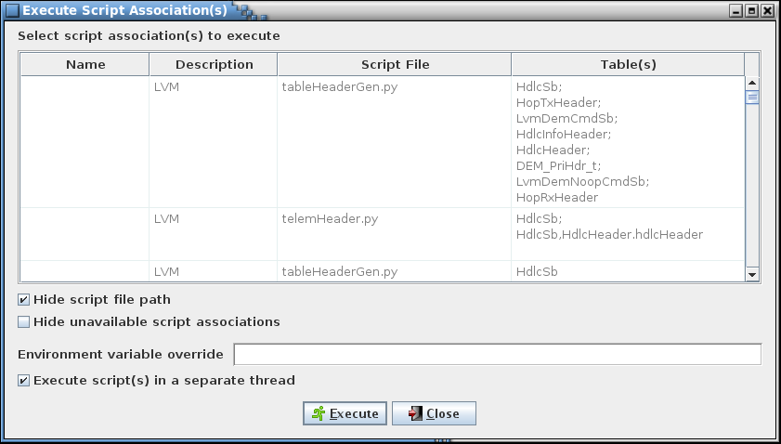

1. Execute Script(s) dialog

Select one or more associations from the table and press the **Execute** button to execute the selected association(s).

The scripts can be executed within the same thread as the CCDD application. This can result in an increase in execution speed. The drawback is that the GUI freezes during script execution and there is no indication to the user on the progress of the script execution, nor is there a way to stop execution of a script. Running the script(s) in a separate thread allows for stopping script execution as well as provides a progress dialog. Selecting the **Execute script(s) in a separate thread** check box causes script execution to occur in a separate thread.

The application GUI is disabled during script execution in order to prevent possible alteration of the data while a script is accessing it. If the script is executed in a separate thread, then while the script is executing the dialog shown in Figure 98 is displayed. Pressing the **Halt** button stops script execution immediately and returns control to the CCDD application – this is necessary, for instance, if the script contains an infinite loop.

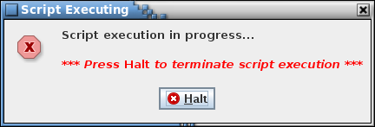

1. Halt script execution dialog

When script execution completes a status message is written to the event log. If script execution is halted the log entry indicates that the scripts failed to execute; however, if multiple scripts are executed it’s possible that one or more successfully completed prior to the action to halt execution. If an error occurs, preventing successful script completion, an error dialog appears indicating that the script(s) failed to execute. The log entry in this case displays the script name(s) and provides details on the cause of the error.

Select the **Close** button to exit the Execute Script(s) dialog.

#### Store

The **Store** command is used to store scripts in the project database. This provides a means of script security and configuration management as well as allow all users, including those at remote sites, to access a common set of script files. This command is enabled only for a user with read/write or administrator access. Selecting the command causes a file selection dialog to appear (Figure 99).

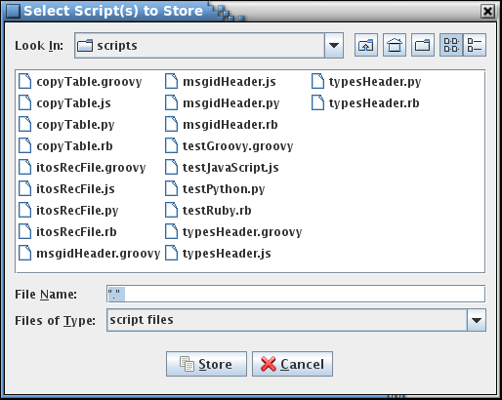

1. Script selection dialog

Only files with extensions supported by the available script engines are shown. However, other files are displayed if “All Files” is selected from the **Files of Type** drop down menu. After selecting one or more files, selecting the **Store** button stores the contents of the files in the project, each as a separate database table. If a script with the same name is already stored in the project database then a confirmation dialog first appears; select **Okay** to continue with the script storage, or **Cancel** to exit the dialog without storing the script. Select the Select Script(s) to Store dialog’s **Cancel** button to exit the dialog without storing any scripts. The **Retrieve** command (see paragraph 4.9.5.4) provides the means for retrieving the stored scripts from the project.

When a file is stored the application first searches it for the first line containing the text “description:”. The search ignores case, so any combination of upper and lower case characters constitutes a match. If found, the remaining text on the same line in the file (sans any leading or trailing white space character(s)) is stored with the file as its description. The description appears alongside the file name in the Retrieve Script(s) dialog (Figure 100). If no match is found then the description text in the dialog is blank.

Note that this command can be used to store any text file in the project database, not only script files.

#### Retrieve

Selecting the **Retrieve** command causes the Retrieve Script(s) dialog to appear (Figure 100). This command allows for extracting scripts (or other text files) that are stored in the project database using the **Store** command (see paragraph 4.9.5.3).

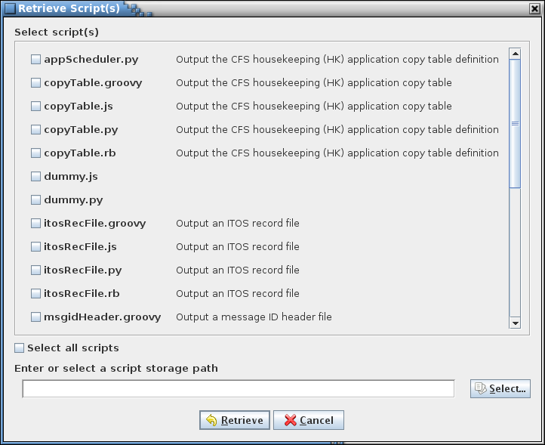

1. Retrieve Script(s) dialog

The dialog displays a list of the stored script (or other text) files. Using the check boxes, select one or more files. The **Select all scripts** check box is used to alternately select and deselect all of the individual script check boxes. Choose a folder in which to save the retrieved file(s), then press the **Retrieve** button to extract a copy of the file(s) from the project into the selected folder. If a file with the same name is already present in the target folder then a confirmation dialog first appears; select **Okay** to continue with the script retrieval, or **Cancel** to exit the dialog without retrieving the script. Select the Retrieve Script(s) dialog’s **Cancel** button to exit the dialog without retrieving any files.

When a file is stored the application first searches it for the first line containing the text “description:”. The search ignores case, so any combination of upper and lower case characters constitutes a match. If found, the remaining text on the same line in the file (sans any leading or trailing white space character(s)) is stored with the file as its description. This is the description that appears alongside the file name in the dialog. If no match is found then the description text in the dialog is blank.

#### Delete

Selecting the **Delete** command causes the Delete Script(s) dialog to appear (Figure 101). This command allows for deleting script (or other text files) stored in the project database using the **Store** command (see paragraph 4.9.5.3). This command is enabled only for a user with read/write or administrator access.

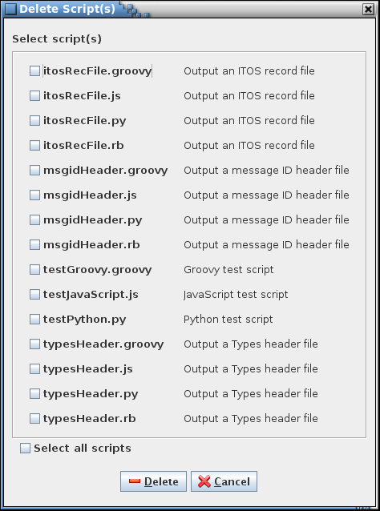

1. Delete Script(s) dialog

The dialog displays a list of the stored script (or other text) files. Using the check boxes, select one or more files. The **Select all scripts** check box is used to alternately select and deselect all of the individual script check boxes. Press the **Delete** button to delete the file(s) from the project. A confirmation dialog first appears; select **Okay** to continue with the script deletion, or **Cancel** to exit the dialog without deleting a script. Select the Delete Script(s) dialog’s **Cancel** button to exit the dialog without deleting any files.

#### Search

The script **Search** dialog provides a means of searching for a specified text string within the scripts stored in the project database (see Figure 102). The dialog is divided into three sections: search criteria (upper left), script filter tree (upper right), and search results table (lower). The vertical line separating the search criteria and and the script filter selection section delineates a split pane control that is used to resize these panels relative to one another. Position the mouse pointer over the separator line and when the pointer changes to a double-headed arrow press and hold the left mouse button. Space permitting, the adjoining panes can be resized by moving the mouse pointer left or right. Release the mouse button to exit resizing. The line that separates the results table section from the sections above is also a split pane control and operates in a similar manner.

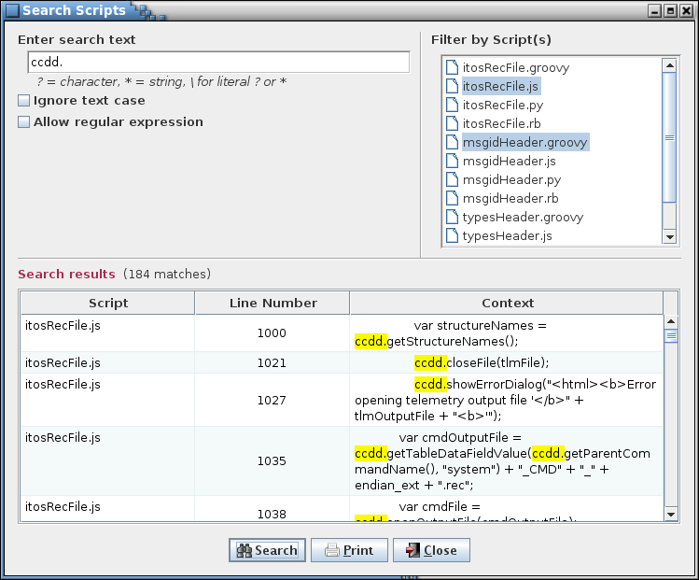

1. Script search dialog

Enter the search text in the input field and select the **Search** button. The search results are displayed in the table at the bottom of the search dialog. The first column, **Script**, shows the name of the script, and the second column, **Line number**, provides the line number in the script where a match is found. The last column, **Context**, displays the line from the script containing the search text, with the search text highlighted. Leading and trailing white space characters are removed from the context cells’ text prior to display.

The search text field uses auto-completion to fill in the search string. The previous search strings (those for the event log, table, and script) are remembered, including those from previous sessions. The number of remembered search strings can be changed via the Preferences dalog, and defaults to 30. Case sensitivity for auto-completion is based on the **Ignore text case** check box selection state.

Another search can be performed by altering the search text and selecting the **Search** button again. The search results can be output to a file or printer by selecting the **Print** button. To exit the search dialog select the **Close** button.

The search criteria can be adjusted by use of the check boxes below the search text field and the script filter tree. Case sensitivity for the search is governed by the **Ignore text case** check box.

If the **Allow regular expression** check box is not checked then the search text is matched as typed in the search text field. The search text may contain one or more wild card characters. A label, giving a brief explanation for the wild cards, is displayed underneath the search text field. A question mark (?) in the search string will match any single character (example: the search string *a?c* matches *abc*, *a c*, and *a&c*, but not *ac*). An asterisk (*) matches one or more characters (example: *a*c* matches *abc*, *a_b_c*, and *a:123c*, but not *ac*). In order to search for a wild card character the character must be preceded by a backslash (\) character (example: *a\?c* matches *a?c* but not *abc*).

The **Allow regular expression** check box, when checked, allows the use of a regular expression to define the search pattern in the search text field. The wild card label is removed when a regular expression is allowed. A regular expression can be formulated to find multiple matching conditions (for example, the search for **a.c** would match any string that has a single character between the characters ‘a’ and ‘c’). Information regarding the use of regular expressions is beyond the scope of this document; however, resources and tutorials can be found online.

The search can be constrained by selecting one or more scripts in the **Stored Scripts** tree. Only matches in the selected scripts are reported. If no script is selected in the tree then all stored scripts are searched.

### Help

#### Guide

The **Guide** command displays a copy of this user’s guide in PDF format. The file CCDD_Users_guide.pdf must be in the same folder in which the CCDD.jar file is located in order for the user’s guide to be opened using this command.

#### About

Selecting the **About** menu item brings up an informational dialog (see Figure 103) providing the application’s version number and date, version numbers for Java, PostgreSQL, JDBC, and Jetty that are in use, and the copyright notice. Also displayed is the list of available scripting languages and associated scripting engines, if any, and their respective version information.

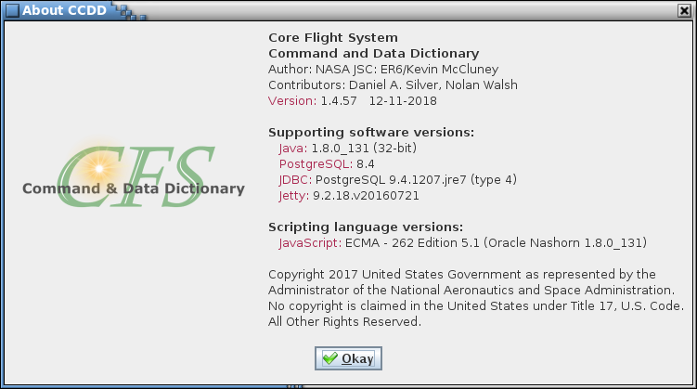

1. About dialog

1. Acronyms

CCDD CFS Command & Data Dictionary

CCSDS Consultative Committee for Space Data Systems

cFE Core Flight Executive

CFS Core Flight System

CPU Central Processing Unit

CSV Comma-Separated Value

DBU Database Backup

DPI Dots Per Inch

EDS Electronic Data Sheet

GUI Graphical User Interface

HK Housekeeping

I/O Input/Output

ID Identifier

ITOS Integrated Test and Operations System

JAR Java Archive

JDBC Java Database Connectivity

JRE Java Runtime Environment

JSON JavaScript Object Notation

JVM Java Virtual Machine

L&F Look and Feel

OID Object Identifier

OS Operating System

PDF Portable Document Format

PNG Portable Network Graphics

SQL Structured Query Language

SSL Secure Sockets Layer

URL Uniform Resource Locator

XML Extensible Markup Language

XTCE XML Telemetric and Command Exchange

1. Definitions

**Array definition** In a structure table, the row where the variable name and array size are specified.

**Array member** In a structure table, the rows following the array definition row (when arrays are expanded) that display the individual variables that belong to the array. The variable name begins with the array definition’s variable name and has the array index, encased in square brackets, appended. The array member rows are displayed in ascending index order, starting with a zero index. The array size column for each member row displays the total number of members in the array.

**Child table** A structure table that is referenced as a data type for a variable in another structure table.

**Data type** A primitive or structure data type; see **Primitive type** and **Structure type**.

**Database** A collection of data within a PostgreSQL server organized as tables. A CCDD *project* is a PostgreSQL database representing the data for a CFS project.

**Encoded type** The byte order for primitive data types composed of two or more bytes. CCDD recognizes four encodings:

*little endian* bytes are store with the least significant byte first.

*big endian* bytes are stores with the least significant byte last.

*little endian, swap* similar to little endian, except that each byte pair is reversed; applies only to integer and unsigned integer data types composed of one or more pairs of bytes.

*big endian, swap* similar to big endian, except that each byte pair is reversed; applies only to integer and unsigned integer data types composed of one or more pairs of bytes.

**Instance table** A structure table that is a child of another structure table (the child’s *parent* table).

**Macro** An alphanumeric string, bounded by special delimiter characters, that can be inserted into a data table cell to represent text defined by the user.

**Parent table** The structure table for which a table is an immediate descendant (child). The parent and root tables are the same if this table is a child of a root table.

**Path** Refers to a table path or variable path.

**Primitive type** A primitive data type is a basic data type (e.g., integer, float), as opposed to a structure, which is a group of primitive and/or structure data types. The primitive data types recognized by the CCDD application can be altered using the Data Type Manager (see paragraphs 4.5.4 and 4.9.3.11).

**Project** Synonymous with the term *database* in this guide except when referring to the PostgreSQL default database, postgres.

**Prototype table** A table created via the **Data** **|** **New table(s)** command, based on one of the table types. Instances of this table are created by using this table as the data type for a variable in a structure table. If this table is not referenced as a child in another table then it is also a root table.

**Regular expression** A special set of characters that defines a pattern for matching all or part of a text string. The search dialogs optionally allow the use of regular expressions in order to tailor a search more specifically (for example, the use of wild card characters). Information regarding the construction and use of regular expressions can be found on the web.

**Root table** The top-level table in the hierarchical table tree; the highest level ancestor of a child table. All non-structure tables and prototype tables not referenced as the data type for a variable in a structure table are root tables.

**Structure type** Data type that references a structure table prototype (the data type name is the structure prototype name).

**Table path** The path to a table beginning with its root table. For a non-structure table or other top-level table the table path is the root table name. For a child structure table the path lists the child’s root table and all intervening ancestor tables and variable names in direct descent to the child table .

**Table type** A table template created using the Table Type Manager (see paragraph 4.9.3.104.9.3.7). Any number of tables may be created of a given table type.

**Variable path** The path to a variable beginning with its root table. For a non-structure table or other top-level table the variable path is the root table name. For a variable in a child structure table the path lists the child’s root table and all intervening variable names in direct descent to the child table (identical to the table path, but without the structure names other than the root’s).

2. Import and Export Format

Examples and descriptions of the CSV, EDS, JSON, and XTCE file formats used when importing and exporting tables are provided in the subsequent sections. For each format the identical project data is used to create the export output. This project data is shown in Figure 104 and Figure 105 (the data tables), Figure 111 and Figure 112 (the table type definitions), and Figure 113 (the data field, data type, and macro definitions).

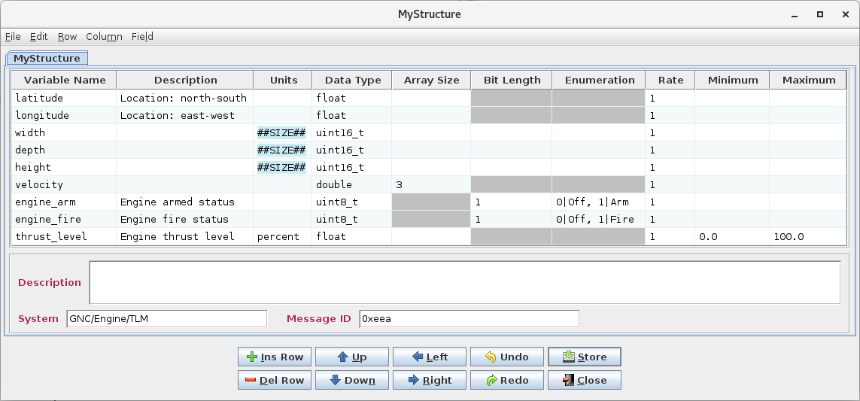

1. Structure table for import/export format examples

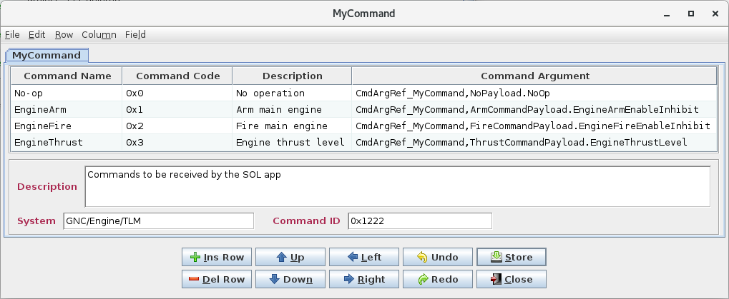

1. Command table for import/export examples

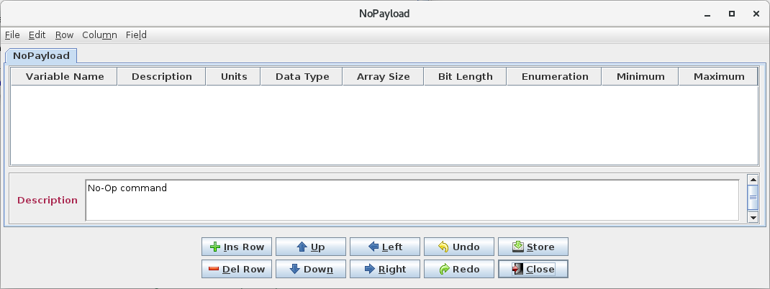

1. No-op command payload structure

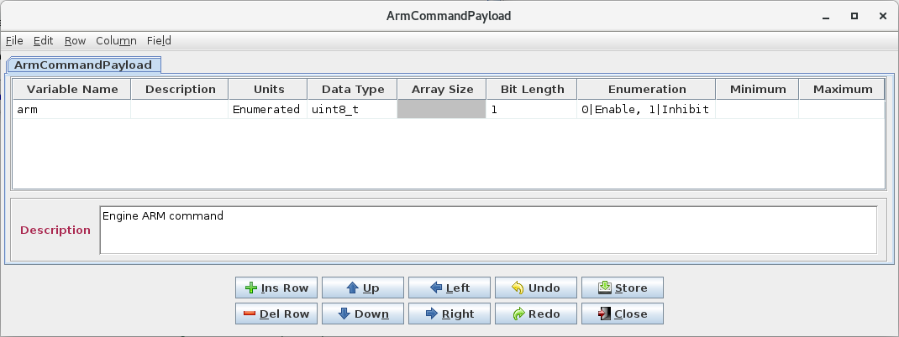

1. Arm command payload structure

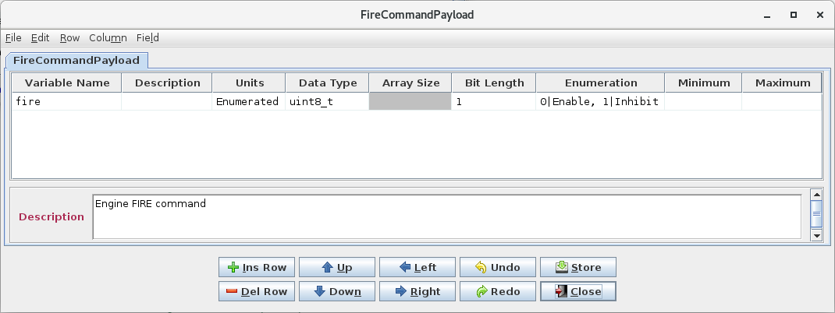

1. Fire command payload structure

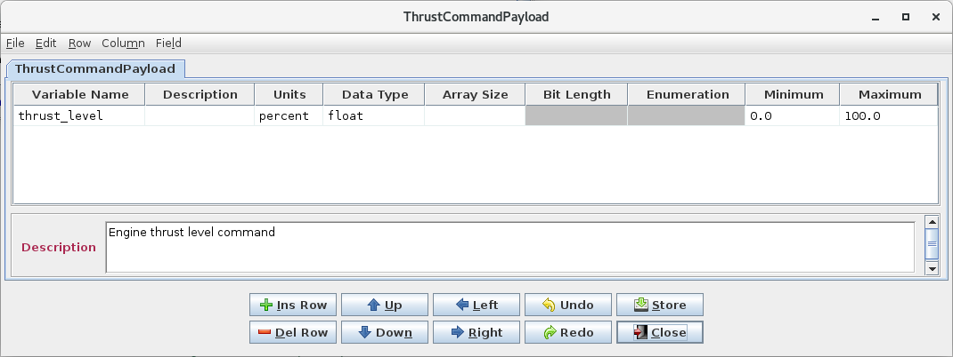

1. Thrust level command payload structure

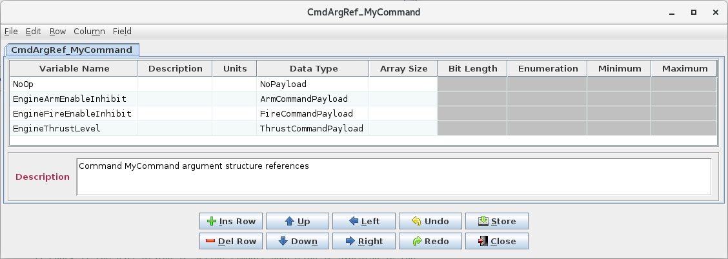

1. Command reference table for import/export examples

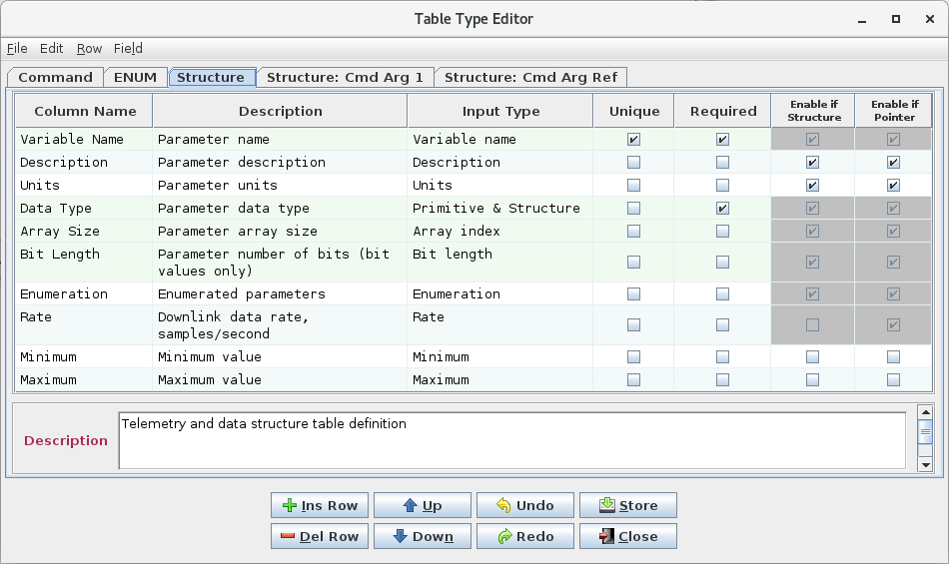

1. Structure table type definition for import/export example

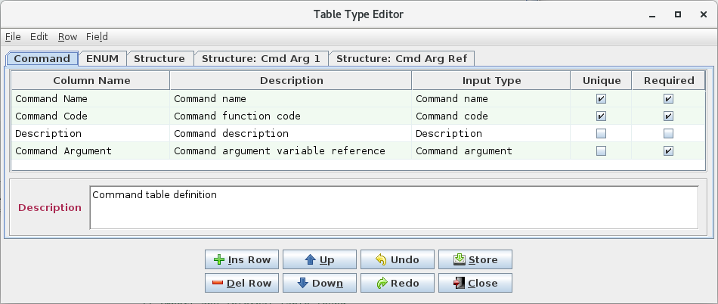

1. Command table type definition for import/export example

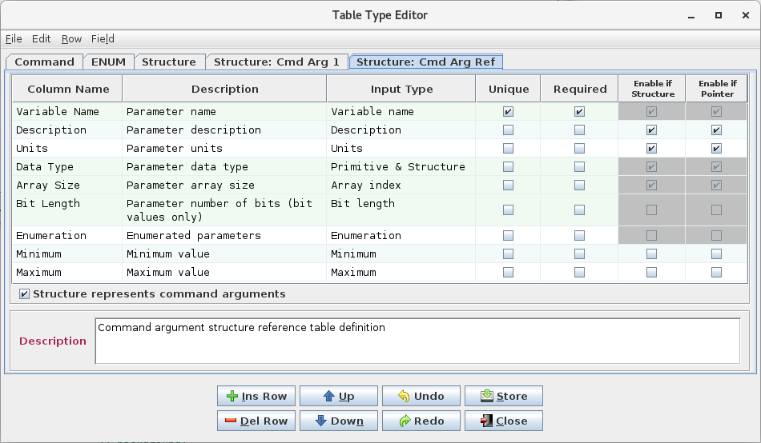

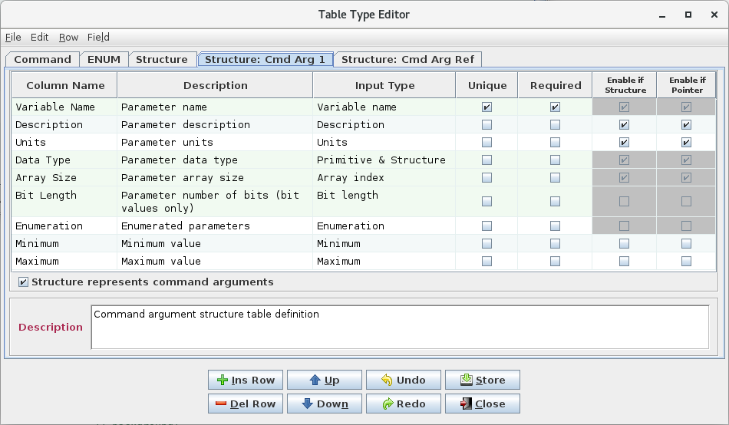

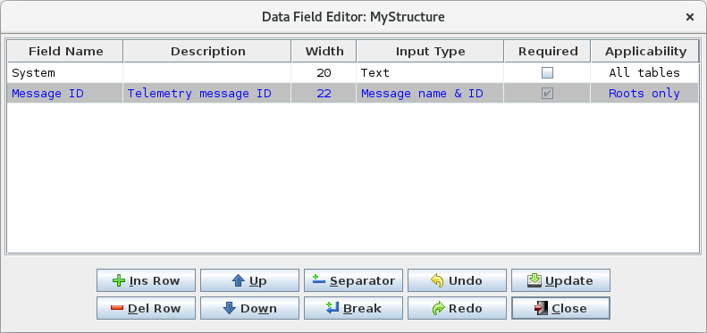

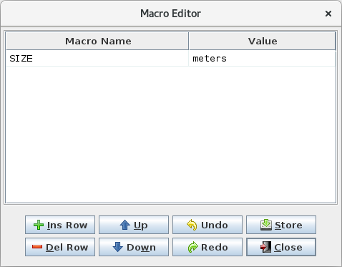

1. Data field and macro definitions for import/export example
2. CSV

The CSV import/export file is divided into nine sections: data type definitions, group definitions, macro definitions, project-level data fields, reserved message IDs, table definitions, table type definitions, variable paths, and script associations. These sections can appear in any order. Not all sections need be present. The table definitions are further sub-divided into table name & type, description, column data, and data field sections. The table type definitiosn are sub-divided into table type and table type data fiels sections. The group definitions are sub-divided into group and group data field sections.

Each section is designated by a tag in the format _*tag*_*name*_. The subsequent row(s) are interpreted based on the last tag name until another tag is detected. The various values in the rows following a tag are separated by commas, with each value enclosed in double quotes in order to preserve quotes and commas in the values.

The name & type tag begins each table definition. Subsequent description, column data, and data field definitions are associated with the table in the most recently defined name & type tag.

Empty rows and rows beginning with a # character are ignored and can be used for section spacing and inserting comments. A ‘#’ character beginning a quoted string is not interpreted as a comment (note that a spreadsheet application, if used to create the CSV file, may automatically surround text intended as a comment in quotes). Extra commas and white space characters appended to a row are ignored. This allows a CSV file generated from a spreadsheet application (which appends trailing commas to ensure that each row has the same number of columns) to be used without further editing.

The tag names and formats for the sections are as follows:

**Data type definition section:**

_data_type_

“*data* *type name*”, “*C type*”, “*size in bytes*”, “*base type*”

… *repeat previous row for each data type definition*

See paragraph 4.9.3.11 for more information on the data type definition components.

**Group definition section:**

_group_

“*group name*”, “*group description*”, “*application status (*true *or* false*)*”, “*table member 1;table member 2;p…*”

_group_data_field_

“*field name*”, “*description*”, “*size in characters*”, “*input type*”, “*required*”, “*applicability*”, “*value*”

… *repeat previous row for each data field associated with the group. Only the “field name” is required; if left blank, default values for “description” (blank), “size in characters” (10), “input type” (Text), “required” (false), and “applicability” (All tables) are used. The “applicability” input is unused by the group definition*

… *repeat above, starting with* _group_*, for each group definition*

See paragraph 4.9.3.9 for more information on group definitions.

**Macro definition section:**

_macro_

“*macro name*”, “*macro value*”

… *repeat previous row for each macro definition*

See paragraph 4.9.3.12 for more information on the macro definition components.

**Project-level data field section:**

_ project_data_field_

“*field name*”, “*description*”, “*size in characters*”, “*input type*”, “*required*”, “*applicability*”, “*value*”

… *repeat previous row for each data field associated with the project. Only the “field name” is required; if left blank, default values for “description” (blank), “size in characters” (10), “input type” (Text), “required” (false), and “applicability” (All tables) are used. The “applicability” input is unused by the project-level fields*

**Reserved message ID section:**

_ reserved_msg_id_

“*message ID (or ID range)*”, “*message ID description*”

… *repeat previous row for each reserved message ID (or ID range)*

See paragraph 4.9.3.14.2 for more information on the reserved message ID components.

**Table definition section:**

_name_type_

“*table path and name*”, “*table type*”<, “*system name*”>

_description_

“*table description*”

_column_data_

“*column 1 name*”, “*column 2 name*”, ….

“*row 1 column 1 value*”, “*row 1 column 2 value*”, …

“*row 2 column 1 value*”, “*row 2 column 2 value*”, …

… *repeat previous row for each row in the table*

_data_field_

“*field name*”, “*description*”, “*size in characters*”, “*input type*”, “*required*”, “*applicability*”, “*value*”

… *repeat previous row for each data field associated with the table. Only the “field name” is required; if left blank, default values for “description” (blank), “size in characters” (10), “input type” (Text), “required” (false), and “applicability” (All tables) are used*

…*repeat above, starting with* _name_type_*, for each table definition*

The system name under _name_type_ is optional; when exporting this is the value of the data field with the **System path** input type (if present), but when importing the value is unused.

If the table represents a structure and an array variable is included in the _column_data_ section then the array’s data must adhere to one of the following criteria:

* Within the pasted data all array variables provide only the array’s definition, but no array members
* Within the pasted data all array variables provide both the array’s definition and all of the array’s members
  + If the array is the last variable in the pasted data then some or all of the members can be omitted. In this case if only some of the array members are provided these must be in sequential numeric order, starting at member [0]

**Table type definition section:**

_table_type_

“*table type name*”, “*table type description*”

“*type name*”, “*type description*”, “*input type*”, “*unique*”, “*required*”, “*structure allowed*”, “*pointer allowed*”

… *repeat previous row for each table type and each type’s column definitions*

_table_type_data_field_

“*field name*”, “*description*”, “*size in characters*”, “*input type*”, “*required*”, “*applicability*”, “*value*”

… *repeat previous row for each data field associated with the table type. Only the “field name” is required; if left blank, default values for “description” (blank), “size in characters” (10), “input type” (Text), “required” (false), and “applicability” (All tables) are used*

See paragraph 4.9.3.10 for more information on the table type definition components.

**Variable path section:**

_variable_path_

“*variable path*”

… *repeat previous row for each variable defined in the project*

The variable path section is optionally created when exporting; this section is ignored when importing. See paragraph 4.9.3.18 for more information regarding variable paths.

**Input type section:**

_input_type_

“*max msgs per time slot*”, “*max msgs per sec*”, “*max msgs per cycle*”, “*number of time slots*”

**Script associations section:**

_script_association_

“*association name*”, “association *description*”, “*script path + name*”, “*association members*”

… *repeat previous row for each script association*

**Telemetry scheduler section:**

TBD

**Application scheduler section:**

_app_sched_

“*max msgs per time slot*”, “*max msgs per sec*”, “*max msgs per cycle*”, “*number of time slots*”

The association group and/or table members must be in the format as described for the command line execute command (see Table 1).

The example tables are shown below as exported in CSV format.

_name_type_

"ArmCommandPayload","Structure: Cmd Arg 1",""

_description_

"Engine ARM command"

_column_data_

"Variable Name","Description","Units","Data Type","Array Size","Bit Length","Enumeration","Minimum","Maximum"

"arm","","Enumerated","uint8_t","","1","0|Enable, 1|Inhibit","",""

_name_type_

"CmdArgRef_MyCommand","Structure: Cmd Arg Ref",""

_description_

"Command MyCommand argument structure references"

_column_data_

"Variable Name","Description","Units","Data Type","Array Size","Bit Length","Enumeration","Minimum","Maximum"

"NoOp","","","NoPayload","","","","",""

"EngineArmEnableInhibit","","","ArmCommandPayload","","","","",""

"EngineFireEnableInhibit","","","FireCommandPayload","","","","",""

"EngineThrustLevel","","","ThrustCommandPayload","","","","",""

_name_type_

"FireCommandPayload","Structure: Cmd Arg 1",""

_description_

"Engine FIRE command"

_column_data_

"Variable Name","Description","Units","Data Type","Array Size","Bit Length","Enumeration","Minimum","Maximum"

"fire","","Enumerated","uint8_t","","1","0|Enable, 1|Inhibit","",""

_name_type_

"MyCommand","Command",""

_description_

"Commands to be received by the SOL app"

_column_data_

"Command Name","Command Code","Description","Command Argument"

"No-op","0x0","No operation","CmdArgRef_MyCommand,NoPayload.NoOp"

"EngineArm","0x1","Arm main engine","CmdArgRef_MyCommand,ArmCommandPayload.EngineArmEnableInhibit"

"EngineFire","0x2","Fire main engine","CmdArgRef_MyCommand,FireCommandPayload.EngineFireEnableInhibit"

"EngineThrust","0x3","Engine thrust level","CmdArgRef_MyCommand,ThrustCommandPayload.EngineThrustLevel"

_data_field_

"field_name","field_description","field_size","field_type","field_required","field_applicability","field_value"

"System","","20","Text","false","All tables","GNC/Engine/TLM"

"Command ID","Command name and ID","15","Message name & ID","true","All tables","0x1222"

_name_type_

"MyStructure","Structure",""

_column_data_

"Variable Name","Description","Units","Data Type","Array Size","Bit Length","Enumeration","Rate","Minimum","Maximum"

"latitude","Location: north-south","","float","","","","1","",""

"longitude","Location: east-west","","float","","","","1","",""

"width","","##SIZE##","uint16_t","","","","1","",""

"depth","","##SIZE##","uint16_t","","","","1","",""

"height","","##SIZE##","uint16_t","","","","1","",""

"velocity","","","double","3","","","1","",""

"velocity[0]","","","double","3","","","1","",""

"velocity[1]","","","double","3","","","1","",""

"velocity[2]","","","double","3","","","1","",""

"engine_arm","Engine armed status","","uint8_t","","1","0|Off, 1|Arm","1","",""

"engine_fire","Engine fire status","","uint8_t","","1","0|Off, 1|Fire","1","",""

"thrust_level","Engine thrust level","percent","float","","","","1","0.0","100.0"

_data_field_

"field_name","field_description","field_size","field_type","field_required","field_applicability","field_value"

"System","","20","Text","false","All tables","GNC/Engine/TLM"

"Message ID","Telemetry message ID","22","Message name & ID","true","Roots only","0xeea"

_name_type_

"NoPayload","Structure: Cmd Arg 1",""

_description_

"No-Op command"

_column_data_

"Variable Name","Description","Units","Data Type","Array Size","Bit Length","Enumeration","Minimum","Maximum"

_name_type_

"ThrustCommandPayload","Structure: Cmd Arg 1",""

_description_

"Engine thrust level command"

_column_data_

"Variable Name","Description","Units","Data Type","Array Size","Bit Length","Enumeration","Minimum","Maximum"

"thrust_level","","percent","float","","","","0.0","100.0"

_name_type_

"CmdArgRef_MyCommand,ArmCommandPayload.EngineArmEnableInhibit","Structure: Cmd Arg 1",""

_description_

"Engine ARM command"

_column_data_

"Variable Name","Description","Units","Data Type","Array Size","Bit Length","Enumeration","Minimum","Maximum"

"arm","","Enumerated","uint8_t","","1","0|Enable, 1|Inhibit","",""

_name_type_

"CmdArgRef_MyCommand,FireCommandPayload.EngineFireEnableInhibit","Structure: Cmd Arg 1",""

_description_

"Engine FIRE command"

_column_data_

"Variable Name","Description","Units","Data Type","Array Size","Bit Length","Enumeration","Minimum","Maximum"

"fire","","Enumerated","uint8_t","","1","0|Enable, 1|Inhibit","",""

_name_type_

"CmdArgRef_MyCommand,ThrustCommandPayload.EngineThrustLevel","Structure: Cmd Arg 1",""

_description_

"Engine thrust level command"

_column_data_

"Variable Name","Description","Units","Data Type","Array Size","Bit Length","Enumeration","Minimum","Maximum"

"thrust_level","","percent","float","","","","0.0","100.0"

_name_type_

"CmdArgRef_MyCommand,NoPayload.NoOp","Structure: Cmd Arg 1",""

_description_

"No-Op command"

_column_data_

"Variable Name","Description","Units","Data Type","Array Size","Bit Length","Enumeration","Minimum","Maximum"

_table_type_

"Command","Command table definition","FALSE"

"Command Name","Command name","Command name","true","true","false","true"

"Command Code","Command function code","Command code","true","true","false","true"

"Description","Command description","Description","false","false","false","true"

"Command Argument","Command argument variable reference","Command argument","false","true","false","false"

_table_type_

"ENUM","ENUM table","FALSE"

"ENUM Name","ENUM name","Variable name","true","true","false","true"

"Description","ENUM description","Description","false","false","true","true"

"Value","ENUM Value","Integer","false","false","false","false"

_table_type_data_field_

"Size (Bytes):","Size of the Enum in bytes","2","Text","true","All tables",""

_table_type_

"Structure","Telemetry and data structure table definition","FALSE"

"Variable Name","Parameter name","Variable name","true","true","true","true"

"Description","Parameter description","Description","false","false","true","true"

"Units","Parameter units","Units","false","false","true","true"

"Data Type","Parameter data type","Primitive & Structure","false","true","true","true"

"Array Size","Parameter array size","Array index","false","false","true","true"

"Bit Length","Parameter number of bits (bit values only)","Bit length","false","false","true","true"

"Enumeration","Enumerated parameters","Enumeration","false","false","true","true"

"Rate","Downlink data rate, samples/second","Rate","false","false","false","true"

"Minimum","Minimum value","Minimum","false","false","false","false"

"Maximum","Maximum value","Maximum","false","false","false","false"

_table_type_data_field_

"Message ID","Telemetry message ID","22","Message name & ID","true","Roots only",""

_table_type_

"Structure: Cmd Arg 1","Command argument structure table definition","TRUE"

"Variable Name","Parameter name","Variable name","true","true","true","true"

"Description","Parameter description","Description","false","false","true","true"

"Units","Parameter units","Units","false","false","true","true"

"Data Type","Parameter data type","Primitive & Structure","false","false","true","true"

"Array Size","Parameter array size","Array index","false","false","true","true"

"Bit Length","Parameter number of bits (bit values only)","Bit length","false","false","false","false"

"Enumeration","Enumerated parameters","Enumeration","false","false","false","false"

"Minimum","Minimum value","Minimum","false","false","false","false"

"Maximum","Maximum value","Maximum","false","false","false","false"

_table_type_

"Structure: Cmd Arg Ref","Command argument structure reference table definition","TRUE"

"Variable Name","Parameter name","Variable name","true","true","true","true"

"Description","Parameter description","Description","false","false","true","true"

"Units","Parameter units","Units","false","false","true","true"

"Data Type","Parameter data type","Primitive & Structure","false","false","true","true"

"Array Size","Parameter array size","Array index","false","false","true","true"

"Bit Length","Parameter number of bits (bit values only)","Bit length","false","false","false","false"

"Enumeration","Enumerated parameters","Enumeration","false","false","false","false"

"Minimum","Minimum value","Minimum","false","false","false","false"

"Maximum","Maximum value","Maximum","false","false","false","false"

_data_type_

"address","void *","4","pointer"

"char","char","1","character"

"double","double","8","floating point"

"float","float","4","floating point"

"int16","signed short int","2","signed integer"

"int16_t","signed short int","2","signed integer"

"int32","signed int","4","signed integer"

"int32_t","signed int","4","signed integer"

"int64","signed long int","8","signed integer"

"int64_t","signed long int","8","signed integer"

"int8","signed char","1","signed integer"

"int8_t","signed char","1","signed integer"

"string","char","2","character"

"uint16","unsigned short int","2","unsigned integer"

"uint16_t","unsigned short int","2","unsigned integer"

"uint32","unsigned int","4","unsigned integer"

"uint32_t","unsigned int","4","unsigned integer"

"uint64","unsigned long int","8","unsigned integer"

"uint64_t","unsigned long int","8","unsigned integer"

"uint8","unsigned char","1","unsigned integer"

"uint8_t","unsigned char","1","unsigned integer"

"","void *","4","pointer"

_macro_

"SIZE","meters"

1. EDS

The **Namespace** *name* field is contructed using the contents of the table’s data field having a **System path** input type (if present) followed by the table’s full path, with all invalid characters (spaces, commas, periods, etc.) converted to underscores (this is a constraint imposed on the *name* field by the EDS schema).

When exporting, the **Namespace** *shortDesciption* field is used to store the original table name with its full path. During importing this field is checked and if it exists and adheres to the constraints for a table path and name then it is used as the table name. If the field doesn’t meet the requirements then the **Namespace** *name* field is used instead. The *name* field isn’t used by default since it is not allowed to contain commas or periods, which are required for a table’s full path.

Each **Namespace** defines a structure or command table. The **Interface** *name* field is set to “Telemetry” for structures, and “Command” for commands; however, the presence of a **ParameterSet** or **CommandSet** in the **Interface** determines how the information is assigned when the file is imported. Both a **ParameterSet** and a **CommandSet** can exist in the same **Namespace**, a condition that can exist if the EDS file is constructed by other means than via the CCDD export operation. Since the **Namespace** fields are used to set the table name, both a **ParameterSet** and a **CommandSet** within the **Namespace** would result in the creation of tables with duplicate names. This is avoided by appending “_tlm” to structure table name and “_cmd” to the command table name for this case.

The original integer data type size for parameters with a bit length is not preserved when exporting in EDS format. The **IntegerDataEncoding** *sizeInBits* field is used to set the bit length; however, there is no field for the overall size. When the file is imported the data type size for a bit-wise parameter is set to the smallest integer into which the number of bits will fit. This can lead to a difference in the original data type sizes which in turn can affect bit-packing.

The **Device** **Metadata** is used to store the telemetry header table name (if defined), the command header table name (if defined), the telemetry and command header table application ID variable name, and the command header command function code variable name. These are defined in project-level data fields (see Table 7). Default values are used for the application ID variable name (“applicationID”) and the command function code variable name (“functionCode”) if these fields are not defined in the project database.

The structure table identified by the project-level data field as the command header is treated specially during conversion. When exported, the structure is converted into a **CommandSet** and stored in the same manner a command table. The **Interface** *abstract* field is set to ‘true’; this is used to indicate that the commands in this **Namespace** are common to the other command tables. When the file is imported the command header information is converted back into a structure.

When exporting, each root table (structure and command) is checked for the existence of data fields with the **Message ID** and **System path** input types. The contents of the field containing a system path is prepended to the table’s path and the result is used to contruct the **Namespace** *name* field (after converting invalid characters to underscores as previously mentioned). When importing the file the data field for the system path is reconstructed from the **Namespace** *name* (the system path is separated from the table name portion using a ‘/’ character; the system path may contain ‘/’ characters as well). If the data field with a **Message ID** input type exists then its contents is used to set the application ID variable in the table’s telemetry or command header in the export file (by setting the **ValueConstraint** *value* field in a **ContainerDataType** within the table’s **DataTypeSet**). When imported, the data field is reconstructed to contain the ID value.

When exporting, the values in the command table’s column with the input type **Command code** are stored in the export file by setting the **ValueConstraint** *value* field (in a **ContainerDataType** within the table’s **DataTypeSet)** to the function code value. When the command table is imported, these values are placed in the table’s command code column.

The table defined using the project-level data field as the command header is stored once in the export file and each command table **Namespace** references this single header definition. Since the telemetry header table is referenced in the root structure tables as a header variable’s data type, each root structure table will have an individual instance of the header contructed in the export file. When importing, a single telemetry header structure table is recreated. The root structure telemetry header variable use this table as the data type reference.

The example tables are shown below as exported in EDS format.

<?xml version="1.0" encoding="UTF-8" standalone="no"?>

<DataSheet xmlns="http://www.ccsds.org/schema/sois/seds" xmlns:xsi="http://www.w3.org/2001/XMLSchema-instance" xsi:schemaLocation="http://www.ccsds.org/schema/sois seds.xsd">

<Device name="example">

<LongDescription>

Author: rmcclune

CCDD Version: 2.0.35 (9-29-2022)

Date: Thu Sep 29 07:46:02 CDT 2022

Project: example

Host: localhost:5432

Endianess: big</LongDescription>

<Metadata>

<MetadataValueSet>

<StringValue name="XML__Application_ID" shortDescription="XML: Application ID" value="applicationID"/>

<StringValue name="XML__Function_Code" shortDescription="XML: Function Code" value="functionCode"/>

</MetadataValueSet>

</Metadata>

</Device>

<Namespace name="ArmCommandPayload" shortDescription="ArmCommandPayload">

<LongDescription>Engine ARM command</LongDescription>

<DataTypeSet>

<ContainerDataType name="ArmCommandPayload_Type">

<EntryList>

<Entry name="arm" type="uint8_t_Type"/>

</EntryList>

</ContainerDataType>

<EnumeratedDataType name="arm_Type">

<IntegerDataEncoding byteOrder="bigEndian" encoding="unsigned" sizeInBits="1"/>

<EnumerationList>

<Enumeration label="Enable" value="0"/>

<Enumeration label="Inhibit" value="1"/>

</EnumerationList>

</EnumeratedDataType>

</DataTypeSet>

<DeclaredInterfaceSet>

<Interface name="Telemetry">

<ParameterSet>

<Parameter name="arm" type="arm_Type"/>

</ParameterSet>

</Interface>

</DeclaredInterfaceSet>

</Namespace>

<Namespace name="CmdArgRef_MyCommand" shortDescription="CmdArgRef_MyCommand">

<LongDescription>Command MyCommand argument structure references</LongDescription>

<DataTypeSet>

<ContainerDataType name="CmdArgRef_MyCommand_Type">

<EntryList>

<Entry name="NoOp" type="NoPayload_Type"/>

<Entry name="EngineArmEnableInhibit" type="ArmCommandPayload_Type"/>

<Entry name="EngineFireEnableInhibit" type="FireCommandPayload_Type"/>

<Entry name="EngineThrustLevel" type="ThrustCommandPayload_Type"/>

</EntryList>

</ContainerDataType>

<ContainerDataType baseType="CmdArgRef_MyCommand_NoPayload_NoOp_Type" name="NoPayload_Type"/>

<ContainerDataType baseType="CmdArgRef_MyCommand_ArmCommandPayload_EngineArmEnableInhibit_Type" name="ArmCommandPayload_Type"/>

<ContainerDataType baseType="CmdArgRef_MyCommand_FireCommandPayload_EngineFireEnableInhibit_Type" name="FireCommandPayload_Type"/>

<ContainerDataType baseType="CmdArgRef_MyCommand_ThrustCommandPayload_EngineThrustLevel_Type" name="ThrustCommandPayload_Type"/>

</DataTypeSet>

<DeclaredInterfaceSet>

<Interface name="Telemetry">

<ParameterSet>

<Parameter name="NoOp" type="NoPayload_Type"/>

<Parameter name="EngineArmEnableInhibit" type="ArmCommandPayload_Type"/>

<Parameter name="EngineFireEnableInhibit" type="FireCommandPayload_Type"/>

<Parameter name="EngineThrustLevel" type="ThrustCommandPayload_Type"/>

</ParameterSet>

</Interface>

</DeclaredInterfaceSet>

</Namespace>

<Namespace name="FireCommandPayload" shortDescription="FireCommandPayload">

<LongDescription>Engine FIRE command</LongDescription>

<DataTypeSet>

<ContainerDataType name="FireCommandPayload_Type">

<EntryList>

<Entry name="fire" type="uint8_t_Type"/>

</EntryList>

</ContainerDataType>

<EnumeratedDataType name="fire_Type">

<IntegerDataEncoding byteOrder="bigEndian" encoding="unsigned" sizeInBits="1"/>

<EnumerationList>

<Enumeration label="Enable" value="0"/>

<Enumeration label="Inhibit" value="1"/>

</EnumerationList>

</EnumeratedDataType>

</DataTypeSet>

<DeclaredInterfaceSet>

<Interface name="Telemetry">

<ParameterSet>

<Parameter name="fire" type="fire_Type"/>

</ParameterSet>

</Interface>

</DeclaredInterfaceSet>

</Namespace>

<Namespace name="MyCommand" shortDescription="MyCommand">

<LongDescription>Commands to be received by the SOL app</LongDescription>

<DataTypeSet>

<EnumeratedDataType name="arm_Type">

<IntegerDataEncoding byteOrder="bigEndian" encoding="unsigned" sizeInBits="1"/>

<EnumerationList>

<Enumeration label="Enable" value="0"/>

<Enumeration label="Inhibit" value="1"/>

</EnumerationList>

</EnumeratedDataType>

<EnumeratedDataType name="fire_Type">

<IntegerDataEncoding byteOrder="bigEndian" encoding="unsigned" sizeInBits="1"/>

<EnumerationList>

<Enumeration label="Enable" value="0"/>

<Enumeration label="Inhibit" value="1"/>

</EnumerationList>

</EnumeratedDataType>

<FloatDataType name="thrust_level_Type">

<Semantics unit="percent"/>

<FloatDataEncoding byteOrder="bigEndian" encodingAndPrecision="IEEE754_2008_single"/>

<Range>

<PrecisionRange>single</PrecisionRange>

</Range>

</FloatDataType>

</DataTypeSet>

<DeclaredInterfaceSet>

<Interface name="Command">

<CommandSet>

<Command name="No-op">

<LongDescription>No operation</LongDescription>

</Command>

<Command name="EngineArm">

<LongDescription>Arm main engine</LongDescription>

<Argument name="arm" type="arm_Type"/>

</Command>

<Command name="EngineFire">

<LongDescription>Fire main engine</LongDescription>

<Argument name="fire" type="fire_Type"/>

</Command>

<Command name="EngineThrust">

<LongDescription>Engine thrust level</LongDescription>

<Argument name="thrust_level" type="thrust_level_Type">

<ValidRange>

<MinMaxRange max="100.0" min="0.0" rangeType="inclusiveMinInclusiveMax"/>

</ValidRange>

</Argument>

</Command>

</CommandSet>

</Interface>

</DeclaredInterfaceSet>

</Namespace>

<Namespace name="MyStructure" shortDescription="MyStructure">

<DataTypeSet>

<ContainerDataType name="MyStructure_Type">

<EntryList>

<Entry name="latitude" type="float_Type"/>

<Entry name="longitude" type="float_Type"/>

<Entry name="width" type="uint16_t_Type"/>

<Entry name="depth" type="uint16_t_Type"/>

<Entry name="height" type="uint16_t_Type"/>

<Entry name="velocity" type="double_Array"/>

<Entry name="engine_arm" type="uint8_t_Type"/>

<Entry name="engine_fire" type="uint8_t_Type"/>

<Entry name="thrust_level" type="float_Type">

<ValidRange>

<MinMaxRange max="100.0" min="0.0" rangeType="inclusiveMinInclusiveMax"/>

</ValidRange>

</Entry>

</EntryList>

</ContainerDataType>

<FloatDataType name="latitude_Type">

<LongDescription>Location: north-south</LongDescription>

<FloatDataEncoding byteOrder="bigEndian" encodingAndPrecision="IEEE754_2008_single"/>

<Range>

<PrecisionRange>single</PrecisionRange>

</Range>

</FloatDataType>

<FloatDataType name="longitude_Type">

<LongDescription>Location: east-west</LongDescription>

<FloatDataEncoding byteOrder="bigEndian" encodingAndPrecision="IEEE754_2008_single"/>

<Range>

<PrecisionRange>single</PrecisionRange>

</Range>

</FloatDataType>

<IntegerDataType name="width_Type">

<IntegerDataEncoding byteOrder="bigEndian" encoding="unsigned" sizeInBits="16"/>

<Range>

<MinMaxRange rangeType="inclusiveMinInclusiveMax"/>

</Range>

</IntegerDataType>

<IntegerDataType name="depth_Type">

<IntegerDataEncoding byteOrder="bigEndian" encoding="unsigned" sizeInBits="16"/>

<Range>

<MinMaxRange rangeType="inclusiveMinInclusiveMax"/>

</Range>

</IntegerDataType>

<IntegerDataType name="height_Type">

<IntegerDataEncoding byteOrder="bigEndian" encoding="unsigned" sizeInBits="16"/>

<Range>

<MinMaxRange rangeType="inclusiveMinInclusiveMax"/>

</Range>

</IntegerDataType>

<ArrayDataType dataTypeRef="velocity_Type" name="velocity_Array">

<DimensionList>

<Dimension size="3"/>

</DimensionList>

</ArrayDataType>

<FloatDataType name="velocity_Type">

<FloatDataEncoding byteOrder="bigEndian" encodingAndPrecision="IEEE754_2008_double"/>

<Range>

<PrecisionRange>double</PrecisionRange>

</Range>

</FloatDataType>

<EnumeratedDataType name="engine_arm_Type">

<LongDescription>Engine armed status</LongDescription>

<IntegerDataEncoding byteOrder="bigEndian" encoding="unsigned" sizeInBits="1"/>

<EnumerationList>

<Enumeration label="Off" value="0"/>

<Enumeration label="Arm" value="1"/>

</EnumerationList>

</EnumeratedDataType>

<EnumeratedDataType name="engine_fire_Type">

<LongDescription>Engine fire status</LongDescription>

<IntegerDataEncoding byteOrder="bigEndian" encoding="unsigned" sizeInBits="1"/>

<EnumerationList>

<Enumeration label="Off" value="0"/>

<Enumeration label="Fire" value="1"/>

</EnumerationList>

</EnumeratedDataType>

<FloatDataType name="thrust_level_Type">

<LongDescription>Engine thrust level</LongDescription>

<Semantics unit="percent"/>

<FloatDataEncoding byteOrder="bigEndian" encodingAndPrecision="IEEE754_2008_single"/>

<Range>

<PrecisionRange>single</PrecisionRange>

</Range>

</FloatDataType>

</DataTypeSet>

<DeclaredInterfaceSet>

<Interface name="Telemetry">

<ParameterSet>

<Parameter name="latitude" type="latitude_Type">

<LongDescription>Location: north-south</LongDescription>

</Parameter>

<Parameter name="longitude" type="longitude_Type">

<LongDescription>Location: east-west</LongDescription>

</Parameter>

<Parameter name="width" type="width_Type"/>

<Parameter name="depth" type="depth_Type"/>

<Parameter name="height" type="height_Type"/>

<Parameter name="velocity" type="velocity_Array"/>

<Parameter name="engine_arm" type="engine_arm_Type">

<LongDescription>Engine armed status</LongDescription>

</Parameter>

<Parameter name="engine_fire" type="engine_fire_Type">

<LongDescription>Engine fire status</LongDescription>

</Parameter>

<Parameter name="thrust_level" type="thrust_level_Type">

<LongDescription>Engine thrust level</LongDescription>

</Parameter>

</ParameterSet>

</Interface>

</DeclaredInterfaceSet>

</Namespace>

<Namespace name="NoPayload" shortDescription="NoPayload">

<LongDescription>No-Op command</LongDescription>

<DeclaredInterfaceSet>

<Interface name="Telemetry">

<ParameterSet/>

</Interface>

</DeclaredInterfaceSet>

</Namespace>

<Namespace name="ThrustCommandPayload" shortDescription="ThrustCommandPayload">

<LongDescription>Engine thrust level command</LongDescription>

<DataTypeSet>

<ContainerDataType name="ThrustCommandPayload_Type">

<EntryList>

<Entry name="thrust_level" type="float_Type">

<ValidRange>

<MinMaxRange max="100.0" min="0.0" rangeType="inclusiveMinInclusiveMax"/>

</ValidRange>

</Entry>

</EntryList>

</ContainerDataType>

<FloatDataType name="thrust_level_Type">

<Semantics unit="percent"/>

<FloatDataEncoding byteOrder="bigEndian" encodingAndPrecision="IEEE754_2008_single"/>

<Range>

<PrecisionRange>single</PrecisionRange>

</Range>

</FloatDataType>

</DataTypeSet>

<DeclaredInterfaceSet>

<Interface name="Telemetry">

<ParameterSet>

<Parameter name="thrust_level" type="thrust_level_Type"/>

</ParameterSet>

</Interface>

</DeclaredInterfaceSet>

</Namespace>

<Namespace name="CmdArgRef_MyCommand_ArmCommandPayload_EngineArmEnableInhibit" shortDescription="CmdArgRef_MyCommand,ArmCommandPayload.EngineArmEnableInhibit">

<LongDescription>Engine ARM command</LongDescription>

<DataTypeSet>

<ContainerDataType name="CmdArgRef_MyCommand_ArmCommandPayload_EngineArmEnableInhibit_Type">

<EntryList>

<Entry name="arm" type="uint8_t_Type"/>

</EntryList>

</ContainerDataType>

<EnumeratedDataType name="arm_Type">

<IntegerDataEncoding byteOrder="bigEndian" encoding="unsigned" sizeInBits="1"/>

<EnumerationList>

<Enumeration label="Enable" value="0"/>

<Enumeration label="Inhibit" value="1"/>

</EnumerationList>

</EnumeratedDataType>

</DataTypeSet>

<DeclaredInterfaceSet>

<Interface name="Telemetry">

<ParameterSet>

<Parameter name="arm" type="arm_Type"/>

</ParameterSet>

</Interface>

</DeclaredInterfaceSet>

</Namespace>

<Namespace name="CmdArgRef_MyCommand_FireCommandPayload_EngineFireEnableInhibit" shortDescription="CmdArgRef_MyCommand,FireCommandPayload.EngineFireEnableInhibit">

<LongDescription>Engine FIRE command</LongDescription>

<DataTypeSet>

<ContainerDataType name="CmdArgRef_MyCommand_FireCommandPayload_EngineFireEnableInhibit_Type">

<EntryList>

<Entry name="fire" type="uint8_t_Type"/>

</EntryList>

</ContainerDataType>

<EnumeratedDataType name="fire_Type">

<IntegerDataEncoding byteOrder="bigEndian" encoding="unsigned" sizeInBits="1"/>

<EnumerationList>

<Enumeration label="Enable" value="0"/>

<Enumeration label="Inhibit" value="1"/>

</EnumerationList>

</EnumeratedDataType>

</DataTypeSet>

<DeclaredInterfaceSet>

<Interface name="Telemetry">

<ParameterSet>

<Parameter name="fire" type="fire_Type"/>

</ParameterSet>

</Interface>

</DeclaredInterfaceSet>

</Namespace>

<Namespace name="CmdArgRef_MyCommand_ThrustCommandPayload_EngineThrustLevel" shortDescription="CmdArgRef_MyCommand,ThrustCommandPayload.EngineThrustLevel">

<LongDescription>Engine thrust level command</LongDescription>

<DataTypeSet>

<ContainerDataType name="CmdArgRef_MyCommand_ThrustCommandPayload_EngineThrustLevel_Type">

<EntryList>

<Entry name="thrust_level" type="float_Type">

<ValidRange>

<MinMaxRange max="100.0" min="0.0" rangeType="inclusiveMinInclusiveMax"/>

</ValidRange>

</Entry>

</EntryList>

</ContainerDataType>

<FloatDataType name="thrust_level_Type">

<Semantics unit="percent"/>

<FloatDataEncoding byteOrder="bigEndian" encodingAndPrecision="IEEE754_2008_single"/>

<Range>

<PrecisionRange>single</PrecisionRange>

</Range>

</FloatDataType>

</DataTypeSet>

<DeclaredInterfaceSet>

<Interface name="Telemetry">

<ParameterSet>

<Parameter name="thrust_level" type="thrust_level_Type"/>

</ParameterSet>

</Interface>

</DeclaredInterfaceSet>

</Namespace>

<Namespace name="CmdArgRef_MyCommand_NoPayload_NoOp" shortDescription="CmdArgRef_MyCommand,NoPayload.NoOp">

<LongDescription>No-Op command</LongDescription>

<DeclaredInterfaceSet>

<Interface name="Telemetry">

<ParameterSet/>

</Interface>

</DeclaredInterfaceSet>

</Namespace>

</DataSheet>

1. JSON

A JSON object consists of a name/value pair where the value can be a single value or an array containing more name/value pairs. The CCDD JSON export file uses a unique object name for specific portions of the exported data. These object names are described below (these names are a subset of those used in the web server JSON output).

**Application Scheduler** Array of the databases application scheduler information. The information has the following entries: **MaxMsgsPerTimeSlot, MaxMsgsPerSec, MaxMsgsPerCycle** and **NumberOfTimeSlots.**

**Data Field** Array of the table’s data field definitions. Each definition has the following entries: **Value**, **Required** flag, **Description**, **Applicability** type, **Field Name**, **Input Type**, and **Size**.

**Data Type Definition** An array containing an entry for each data type definition. Each definition has the following entries: **Base Type**, **C Name**, **Type Name**, and **Size**.

**File Description** Information on the export file including the creation time and date, project name, database host, and user name.

**Group** An array containing an entry for each group definition. Each definition has the following entries: **Group Name**, **Group Description**, **Group Is Application**, **Group Table**, and **Group Data Field**. The **Group Table** entry is an array of the group’s table members.

**Group Data Field** Array of the group’s data field definitions. Each definition has the following entries: **Value**, **Required** flag, **Description**, **Applicability** type, **Field Name**, **Input Type**, and **Size**.

**Macro Definition** Array containing the macro definitions. Each definition contains the **Macro Name** and **Macro Value**.

**Project Data Field** Array of the project-level data field definitions. Each definition has the following entries: **Value**, **Required** flag, **Description**, **Applicability** type, **Field Name**, **Input Type**, and **Size**.

**Reserved Message ID Definition** Array containing the reserved message ID definitions. Each definition has entries for the **Message ID(s)** and **Description**.

**Script Association** Array containing the script associations. Each association has entries for the association **Name**, **Description**, **Script File**, and **Table(s)**.

**System Name** The value of the table’s data field with the input type of **System path**, if present.

**Table Data** Array containing the table data. Each array entry consists of a column name and its corresponding value. If the table represents a structure and an array variable is included in the _column_data_ section then the array’s data must adhere to one of the following criteria:

* Within the pasted data all array variables provide only the array’s definition, but no array members
* Within the pasted data all array variables provide both the array’s definition and all of the array’s members
  + If the array is the last variable in the pasted data then some or all of the members can be omitted. In this case if only some of the array members are provided these must be in sequential numeric order, starting at member [0].

**Table Definition** Table definition array. Each array entry in the table definition contains the **Table Data**, **Table Name**, **Table Description**, **Table Type**, **System Name**, and **Data Field**(s) for a single table.

**Table Description** Table description.

**Table Name** Table name, including its full path.

**Table Type** Table type name.

**Table Type Column** Array containing the table type column definitions. Each definition contains the **Column Name**, **Description**, **Input Type**, **Required**, **Unique**, **Enable if Structure**, and **Enable if Pointer**.

**Table Type Data Field** Array of the table type’s data field definitions. Each definition has the following entries: **Value**, **Required**, **Description**, **Applicability**, **Field Name**, **Input Type**, and **Size**.

**Table Type Definition** Array containing the table type definitions. Each array entry defines a table type and contains a **Table Type Column** array, **Table Type Name**, **Table Type Description**, and **Table Type Data Field** array.

**Table Type Description** Table type definition description.

**Table Type Name** Table type definition name.

**Telemetry Scheduler TBD**

**Variable Path** Array containing the variable paths. Each entry contains the full variable path in the application’s native format, and the path formatted per the export dialog options.

The example tables are shown below as exported in JSON format.

{

"Table Definition": [

{

"Table Name": "ArmCommandPayload",

"Table Type": "Structure: Cmd Arg 1",

"Table Description": "Engine ARM command",

"Table Data": [

{

"Variable Name": "arm",

"Units": "Enumerated",

"Data Type": "uint8_t",

"Bit Length": "1",

"Enumeration": "0|Enable, 1|Inhibit"

}

]

},

{

"Table Name": "CmdArgRef_MyCommand",

"Table Type": "Structure: Cmd Arg Ref",

"Table Description": "Command MyCommand argument structure references",

"Table Data": [

{

"Variable Name": "NoOp",

"Data Type": "NoPayload"

},

{

"Variable Name": "EngineArmEnableInhibit",

"Data Type": "ArmCommandPayload"

},

{

"Variable Name": "EngineFireEnableInhibit",

"Data Type": "FireCommandPayload"

},

{

"Variable Name": "EngineThrustLevel",

"Data Type": "ThrustCommandPayload"

}

]

},

{

"Table Name": "FireCommandPayload",

"Table Type": "Structure: Cmd Arg 1",

"Table Description": "Engine FIRE command",

"Table Data": [

{

"Variable Name": "fire",

"Units": "Enumerated",

"Data Type": "uint8_t",

"Bit Length": "1",

"Enumeration": "0|Enable, 1|Inhibit"

}

]

},

{

"Table Name": "MyCommand",

"Table Type": "Command",

"Table Description": "Commands to be received by the SOL app",

"Table Data": [

{

"Command Name": "No-op",

"Command Code": "0x0",

"Description": "No operation",

"Command Argument": "CmdArgRef_MyCommand,NoPayload.NoOp"

},

{

"Command Name": "EngineArm",

"Command Code": "0x1",

"Description": "Arm main engine",

"Command Argument": "CmdArgRef_MyCommand,ArmCommandPayload.EngineArmEnableInhibit"

},

{

"Command Name": "EngineFire",

"Command Code": "0x2",

"Description": "Fire main engine",

"Command Argument": "CmdArgRef_MyCommand,FireCommandPayload.EngineFireEnableInhibit"

},

{

"Command Name": "EngineThrust",

"Command Code": "0x3",

"Description": "Engine thrust level",

"Command Argument": "CmdArgRef_MyCommand,ThrustCommandPayload.EngineThrustLevel"

}

],

"Data Field": [

{

"Field Name": "System",

"Description": "",

"Width": 20,

"Input Type": "Text",

"Required": false,

"Applicability": "All tables",

"Value": "GNC/Engine/TLM"

},

{

"Field Name": "Command ID",

"Description": "Command name and ID",

"Width": 15,

"Input Type": "Message name & ID",

"Required": true,

"Applicability": "All tables",

"Value": "0x1222"

}

]

},

{

"Table Name": "MyStructure",

"Table Type": "Structure",

"Table Description": "",

"Table Data": [

{

"Variable Name": "latitude",

"Description": "Location: north-south",

"Data Type": "float",

"Rate": "1"

},

{

"Variable Name": "longitude",

"Description": "Location: east-west",

"Data Type": "float",

"Rate": "1"

},

{

"Variable Name": "width",

"Units": "##SIZE##",

"Data Type": "uint16_t",

"Rate": "1"

},

{

"Variable Name": "depth",

"Units": "##SIZE##",

"Data Type": "uint16_t",

"Rate": "1"

},

{

"Variable Name": "height",

"Units": "##SIZE##",

"Data Type": "uint16_t",

"Rate": "1"

},

{

"Variable Name": "velocity",

"Data Type": "double",

"Array Size": "3",

"Rate": "1"

},

{

"Variable Name": "velocity[0]",

"Data Type": "double",

"Array Size": "3",

"Rate": "1"

},

{

"Variable Name": "velocity[1]",

"Data Type": "double",

"Array Size": "3",

"Rate": "1"

},

{

"Variable Name": "velocity[2]",

"Data Type": "double",

"Array Size": "3",

"Rate": "1"

},

{

"Variable Name": "engine_arm",

"Description": "Engine armed status",

"Data Type": "uint8_t",

"Bit Length": "1",

"Enumeration": "0|Off, 1|Arm",

"Rate": "1"

},

{

"Variable Name": "engine_fire",

"Description": "Engine fire status",

"Data Type": "uint8_t",

"Bit Length": "1",

"Enumeration": "0|Off, 1|Fire",

"Rate": "1"

},

{

"Variable Name": "thrust_level",

"Description": "Engine thrust level",

"Units": "percent",

"Data Type": "float",

"Rate": "1",

"Minimum": "0.0",

"Maximum": "100.0"

}

],

"Data Field": [

{

"Field Name": "System",

"Description": "",

"Width": 20,

"Input Type": "Text",

"Required": false,

"Applicability": "All tables",

"Value": "GNC/Engine/TLM"

},

{

"Field Name": "Message ID",

"Description": "Telemetry message ID",

"Width": 22,

"Input Type": "Message name & ID",

"Required": true,

"Applicability": "Roots only",

"Value": "0xeea"

}

]

},

{

"Table Name": "NoPayload",

"Table Type": "Structure: Cmd Arg 1",

"Table Description": "No-Op command",

"Table Data": []

},

{

"Table Name": "ThrustCommandPayload",

"Table Type": "Structure: Cmd Arg 1",

"Table Description": "Engine thrust level command",

"Table Data": [

{

"Variable Name": "thrust_level",

"Units": "percent",

"Data Type": "float",

"Minimum": "0.0",

"Maximum": "100.0"

}

]

},

{

"Table Name": "CmdArgRef_MyCommand,ArmCommandPayload.EngineArmEnableInhibit",

"Table Type": "Structure: Cmd Arg 1",

"Table Description": "Engine ARM command",

"Table Data": [

{

"Variable Name": "arm",

"Units": "Enumerated",

"Data Type": "uint8_t",

"Bit Length": "1",

"Enumeration": "0|Enable, 1|Inhibit"

}

]

},

{

"Table Name": "CmdArgRef_MyCommand,FireCommandPayload.EngineFireEnableInhibit",

"Table Type": "Structure: Cmd Arg 1",

"Table Description": "Engine FIRE command",

"Table Data": [

{

"Variable Name": "fire",

"Units": "Enumerated",

"Data Type": "uint8_t",

"Bit Length": "1",

"Enumeration": "0|Enable, 1|Inhibit"

}

]

},

{

"Table Name": "CmdArgRef_MyCommand,ThrustCommandPayload.EngineThrustLevel",

"Table Type": "Structure: Cmd Arg 1",

"Table Description": "Engine thrust level command",

"Table Data": [

{

"Variable Name": "thrust_level",

"Units": "percent",

"Data Type": "float",

"Minimum": "0.0",

"Maximum": "100.0"

}

]

},

{

"Table Name": "CmdArgRef_MyCommand,NoPayload.NoOp",

"Table Type": "Structure: Cmd Arg 1",

"Table Description": "No-Op command",

"Table Data": []

}

],

"Table Type Definition": [

{

"Table Type Name": "Command",

"Table Type Description": "Command table definition",

"Table Represents Command Argument": "FALSE",

"Table Type Column": [

{

"Column Name": "Command Name",

"Description": "Command name",

"Input Type": "Command name",

"Unique": true,

"Required": true,

"Enable if Structure": false,

"Enable if Pointer": true

},

{

"Column Name": "Command Code",

"Description": "Command function code",

"Input Type": "Command code",

"Unique": true,

"Required": true,

"Enable if Structure": false,

"Enable if Pointer": true

},

{

"Column Name": "Description",

"Description": "Command description",

"Input Type": "Description",

"Unique": false,

"Required": false,

"Enable if Structure": false,

"Enable if Pointer": true

},

{

"Column Name": "Command Argument",

"Description": "Command argument variable reference",

"Input Type": "Command argument",

"Unique": false,

"Required": true,

"Enable if Structure": false,

"Enable if Pointer": false

}

]

},

{

"Table Type Data Field": [

{

"Field Name": "Size (Bytes):",

"Description": "Size of the Enum in bytes",

"Width": 2,

"Input Type": "Text",

"Required": true,

"Applicability": "All tables",

"Value": ""

}

]

},

{

"Table Type Name": "Structure",

"Table Type Description": "Telemetry and data structure table definition",

"Table Represents Command Argument": "FALSE",

"Table Type Column": [

{

"Column Name": "Variable Name",

"Description": "Parameter name",

"Input Type": "Variable name",

"Unique": true,

"Required": true,

"Enable if Structure": true,

"Enable if Pointer": true

},

{

"Column Name": "Description",

"Description": "Parameter description",

"Input Type": "Description",

"Unique": false,

"Required": false,

"Enable if Structure": true,

"Enable if Pointer": true

},

{

"Column Name": "Units",

"Description": "Parameter units",

"Input Type": "Units",

"Unique": false,

"Required": false,

"Enable if Structure": true,

"Enable if Pointer": true

},

{

"Column Name": "Data Type",

"Description": "Parameter data type",

"Input Type": "Primitive & Structure",

"Unique": false,

"Required": true,

"Enable if Structure": true,

"Enable if Pointer": true

},

{

"Column Name": "Array Size",

"Description": "Parameter array size",

"Input Type": "Array index",

"Unique": false,

"Required": false,

"Enable if Structure": true,

"Enable if Pointer": true

},

{

"Column Name": "Bit Length",

"Description": "Parameter number of bits (bit values only)",

"Input Type": "Bit length",

"Unique": false,

"Required": false,

"Enable if Structure": true,

"Enable if Pointer": true

},

{

"Column Name": "Enumeration",

"Description": "Enumerated parameters",

"Input Type": "Enumeration",

"Unique": false,

"Required": false,

"Enable if Structure": true,

"Enable if Pointer": true

},

{

"Column Name": "Rate",

"Description": "Downlink data rate, samples/second",

"Input Type": "Rate",

"Unique": false,

"Required": false,

"Enable if Structure": false,

"Enable if Pointer": true

},

{

"Column Name": "Minimum",

"Description": "Minimum value",

"Input Type": "Minimum",

"Unique": false,

"Required": false,

"Enable if Structure": false,

"Enable if Pointer": false

},

{

"Column Name": "Maximum",

"Description": "Maximum value",

"Input Type": "Maximum",

"Unique": false,

"Required": false,

"Enable if Structure": false,

"Enable if Pointer": false

}

],

"Table Type Data Field": [

{

"Field Name": "Message ID",

"Description": "Telemetry message ID",

"Width": 22,

"Input Type": "Message name & ID",

"Required": true,

"Applicability": "Roots only",

"Value": ""

}

]

},

{

"Table Type Name": "Structure: Cmd Arg 1",

"Table Type Description": "Command argument structure table definition",

"Table Represents Command Argument": "TRUE",

"Table Type Column": [

{

"Column Name": "Variable Name",

"Description": "Parameter name",

"Input Type": "Variable name",

"Unique": true,

"Required": true,

"Enable if Structure": true,

"Enable if Pointer": true

},

{

"Column Name": "Description",

"Description": "Parameter description",

"Input Type": "Description",

"Unique": false,

"Required": false,

"Enable if Structure": true,

"Enable if Pointer": true

},

{

"Column Name": "Units",

"Description": "Parameter units",

"Input Type": "Units",

"Unique": false,

"Required": false,

"Enable if Structure": true,

"Enable if Pointer": true

},

{

"Column Name": "Data Type",

"Description": "Parameter data type",

"Input Type": "Primitive & Structure",

"Unique": false,

"Required": false,

"Enable if Structure": true,

"Enable if Pointer": true

},

{

"Column Name": "Array Size",

"Description": "Parameter array size",

"Input Type": "Array index",

"Unique": false,

"Required": false,

"Enable if Structure": true,

"Enable if Pointer": true

},

{

"Column Name": "Bit Length",

"Description": "Parameter number of bits (bit values only)",

"Input Type": "Bit length",

"Unique": false,

"Required": false,

"Enable if Structure": false,

"Enable if Pointer": false

},

{

"Column Name": "Enumeration",

"Description": "Enumerated parameters",

"Input Type": "Enumeration",

"Unique": false,

"Required": false,

"Enable if Structure": false,

"Enable if Pointer": false

},

{

"Column Name": "Minimum",

"Description": "Minimum value",

"Input Type": "Minimum",

"Unique": false,

"Required": false,

"Enable if Structure": false,

"Enable if Pointer": false

},

{

"Column Name": "Maximum",

"Description": "Maximum value",

"Input Type": "Maximum",

"Unique": false,

"Required": false,

"Enable if Structure": false,

"Enable if Pointer": false

}

]

},

{

"Table Type Name": "Structure: Cmd Arg Ref",

"Table Type Description": "Command argument structure reference table definition",

"Table Represents Command Argument": "TRUE",

"Table Type Column": [

{

"Column Name": "Variable Name",

"Description": "Parameter name",

"Input Type": "Variable name",

"Unique": true,

"Required": true,

"Enable if Structure": true,

"Enable if Pointer": true

},

{

"Column Name": "Description",

"Description": "Parameter description",

"Input Type": "Description",

"Unique": false,

"Required": false,

"Enable if Structure": true,

"Enable if Pointer": true

},

{

"Column Name": "Units",

"Description": "Parameter units",

"Input Type": "Units",

"Unique": false,

"Required": false,

"Enable if Structure": true,

"Enable if Pointer": true

},

{

"Column Name": "Data Type",

"Description": "Parameter data type",

"Input Type": "Primitive & Structure",

"Unique": false,

"Required": false,

"Enable if Structure": true,

"Enable if Pointer": true

},

{

"Column Name": "Array Size",

"Description": "Parameter array size",

"Input Type": "Array index",

"Unique": false,

"Required": false,

"Enable if Structure": true,

"Enable if Pointer": true

},

{

"Column Name": "Bit Length",

"Description": "Parameter number of bits (bit values only)",

"Input Type": "Bit length",

"Unique": false,

"Required": false,

"Enable if Structure": false,

"Enable if Pointer": false

},

{

"Column Name": "Enumeration",

"Description": "Enumerated parameters",

"Input Type": "Enumeration",

"Unique": false,

"Required": false,

"Enable if Structure": false,

"Enable if Pointer": false

},

{

"Column Name": "Minimum",

"Description": "Minimum value",

"Input Type": "Minimum",

"Unique": false,

"Required": false,

"Enable if Structure": false,

"Enable if Pointer": false

},

{

"Column Name": "Maximum",

"Description": "Maximum value",

"Input Type": "Maximum",

"Unique": false,

"Required": false,

"Enable if Structure": false,

"Enable if Pointer": false

}

]

}

],

"Macro Definition": [

{

"Macro Name": "SIZE",

"Value": "meters"

}

]

}

1. XTCE

The **SpaceSystem** hierarchy is based on the contents of the table’s data field having a **System path** input type (if present) and the table’s full path. The system path is assumed to use the ‘/’ character to define each level of the path. The table name becomes the final level in the hierarchy. For example, the table ‘MyStructure’ has the system path ‘GNC/Power/TLM’ and the table ‘MyCommand’ has the system path ‘GNC/Power/CMD’. The SpaceSystem hierarchy in the export file would be:

<SpaceSystem name="GNC">

<SpaceSystem name="Power">

<SpaceSystem name="TLM">

<SpaceSystem name="MyStructure">

</SpaceSystem>

</SpaceSystem>

<SpaceSystem name="CMD">

<SpaceSystem name="MyCommand">

</SpaceSystem>

</SpaceSystem>

</SpaceSystem>

</SpaceSystem>

Each **SpaceSystem** with **TelemetryMetaData** or **CommandMetaData** defines a structure or command table, respectively. Both a **TelemetryMetaData** and a **CommandMetaData** can exist in the same **SpaceSystem**, a condition that can exist if the XTCE file is constructed by other means than via the CCDD export operation. Since the **SpaceSystem** *name* field is used to set the table name, both a **TelemetryMetaData** and a **CommandMetaData** within the same **SpaceSystem** would result in the creation of tables with duplicate names. This is avoided by appending “_tlm” to structure table name and “_cmd” to the command table name for this case.

The original integer data type size for parameters with a bit length is not preserved when exporting in XTCE format. The **IntegerDataEncoding** *sizeInBits* field is used to set the bit length; however, there is no field for the overall size. The **IntegerDataType** also has a *sizeInBits* field which could be used to store the size of the integer; however, the **EnumeratedDataType** lacks this field. Rather than have one case covered (integers) and the other not (enumerations), and since the convention would be arbitrary (i.e., which *sizeInBits* field contains the integer size and which is the bit length), both are treated the same: when the file is imported the data type size for a bit-wise parameter is set to the smallest integer into which the number of bits will fit. This can lead to a difference in the original data type sizes which in turn can affect bit-packing.

The root space system **AncillaryData** is used to store the telemetry header table name (if defined), the command heard table name (if defined), the telemetry and command header table application ID variable name, and the command header command function code variable name. These are defined in project-level data fields (see Table 7). Default values are used for the application ID variable name (“applicationID”) and the command function code variable name (“functionCode”) if these fields are not defined in the project database.

The structure table identified by the project-level data field as the command header is treated specially during conversion. When exported, the structure is converted into **CommandMetaData** and stored in the same manner a command table. The **MetaCommand** *abstract* field is set to ‘true’; this is used to indicate that the commands in this **SpaceSystem** are common to the other command tables. When the file is imported the command header information is converted back into a structure.

When exporting, each root table (structure and command) is checked for the existence of data fields with the **Message ID** and **System path** input types. The contents of the field containing a system path is used to establish the SpaceSystem hierarchy as described previously. When importing the file the data field for the system path is reconstructed from the **SpaceSystem** *name* fields preceding it in the table’s hierarchy (each **SpaceSystem** *name* is separated by a ‘/’ character). If the data field with a **Message ID** input type exists then its contents is used to set the application ID variable in the table’s telemetry or command header in the export file (by setting the **Comparison** *value* field as a **RestrictionCriteria** within a **SequenceContainer** in a **ContainerSet** within the table’s **TelemetryMetaData** for structure tables, and by setting the **ArgumentAssignment** *argumentValue* field within the **BaseMetaCommand** in the **CommandMetaData** for command tables). When imported, the data field is reconstructed to contain the ID value.

When exporting, the values in the command table’s column with the input type **Command code** are stored in the export file by setting the **ArgumentAssignment** *argumentValue* field within the **BaseMetaCommand** in the **CommandMetaData)** to the function code value. When the command table is imported, these values are placed in the table’s command code column.

The table defined using the project-level data field as the command header is stored once in the export file and each command table **SpaceSystem** references this single header definition. Since the telemetry header table is referenced in the root structure tables as a header variable’s data type, each root structure table will have an individual instance of the header contructed in the export file. When importing, a single telemetry header structure table is recreated. The root structure telemetry header variable use this table as the data type reference.

The example tables are shown below as exported in XTCE format.

<?xml version="1.0" encoding="UTF-8" standalone="no"?>

<SpaceSystem xmlns="http://www.omg.org/space/xtce" xmlns:xsi="http://www.w3.org/2001/XMLSchema-instance" name="example" shortDescription="example" xsi:schemaLocation="http://www.omg.org/spec/XTCE/20061101 06-11-06.xsd">

<AncillaryDataSet>

<AncillaryData name="XML: Application ID">applicationID</AncillaryData>

<AncillaryData name="XML: Function Code">functionCode</AncillaryData>

</AncillaryDataSet>

<Header classification="DOMAIN" date="Wed Sep 28 13:17:58 CDT 2022" validationStatus="Working" version="1.0">

<AuthorSet>

<Author>rmcclune</Author>

</AuthorSet>

<NoteSet>

<Note>Created: Wed Sep 28 13:17:58 CDT 2022</Note>

<Note>CCDD Version: 2.0.35 (9-28-2022)</Note>

<Note>Date: Wed Sep 28 13:17:58 CDT 2022</Note>

<Note>Project: example</Note>

<Note>Host: localhost:5432</Note>

<Note>Endianess: big</Note>

</NoteSet>

</Header>

<SpaceSystem name="ArmCommandPayload" shortDescription="ArmCommandPayload">

<LongDescription>Engine ARM command</LongDescription>

<Header classification="INTERFACE" validationStatus="Working" version="1.0"/>

<TelemetryMetaData>

<ParameterTypeSet>

<EnumeratedParameterType name="arm_Type">

<UnitSet>

<Unit>Enumerated</Unit>

</UnitSet>

<IntegerDataEncoding bitOrder="mostSignificantBitFirst" encoding="unsigned" sizeInBits="1"/>

<EnumerationList>

<Enumeration label="Enable" value="0"/>

<Enumeration label="Inhibit" value="1"/>

</EnumerationList>

</EnumeratedParameterType>

</ParameterTypeSet>

<ParameterSet>

<Parameter name="arm" parameterTypeRef="arm_Type"/>

</ParameterSet>

<ContainerSet>

<SequenceContainer name="ArmCommandPayload">

<EntryList>

<ParameterRefEntry parameterRef="arm"/>

</EntryList>

</SequenceContainer>

</ContainerSet>

</TelemetryMetaData>

</SpaceSystem>

<SpaceSystem name="CmdArgRef_MyCommand" shortDescription="CmdArgRef_MyCommand">

<LongDescription>Command MyCommand argument structure references</LongDescription>

<Header classification="INTERFACE" validationStatus="Working" version="1.0"/>

<TelemetryMetaData>

<ContainerSet>

<SequenceContainer name="CmdArgRef_MyCommand">

<EntryList>

<ContainerRefEntry containerRef="NoPayload_NoOp/NoOp"/>

<ContainerRefEntry containerRef="ArmCommandPayload_EngineArmEnableInhibit/EngineArmEnableInhibit"/>

<ContainerRefEntry containerRef="FireCommandPayload_EngineFireEnableInhibit/EngineFireEnableInhibit"/>

<ContainerRefEntry containerRef="ThrustCommandPayload_EngineThrustLevel/EngineThrustLevel"/>

</EntryList>

</SequenceContainer>

</ContainerSet>

</TelemetryMetaData>

<SpaceSystem name="ArmCommandPayload_EngineArmEnableInhibit" shortDescription="CmdArgRef_MyCommand,ArmCommandPayload.EngineArmEnableInhibit">

<LongDescription>Engine ARM command</LongDescription>

<Header classification="INTERFACE" validationStatus="Working" version="1.0"/>

<TelemetryMetaData>

<ParameterTypeSet>

<EnumeratedParameterType name="arm_Type">

<UnitSet>

<Unit>Enumerated</Unit>

</UnitSet>

<IntegerDataEncoding bitOrder="mostSignificantBitFirst" encoding="unsigned" sizeInBits="1"/>

<EnumerationList>

<Enumeration label="Enable" value="0"/>

<Enumeration label="Inhibit" value="1"/>

</EnumerationList>

</EnumeratedParameterType>

</ParameterTypeSet>

<ParameterSet>

<Parameter name="arm" parameterTypeRef="arm_Type"/>

</ParameterSet>

<ContainerSet>

<SequenceContainer name="EngineArmEnableInhibit">

<EntryList>

<ParameterRefEntry parameterRef="arm"/>

</EntryList>

</SequenceContainer>

</ContainerSet>

</TelemetryMetaData>

</SpaceSystem>

<SpaceSystem name="FireCommandPayload_EngineFireEnableInhibit" shortDescription="CmdArgRef_MyCommand,FireCommandPayload.EngineFireEnableInhibit">

<LongDescription>Engine FIRE command</LongDescription>

<Header classification="INTERFACE" validationStatus="Working" version="1.0"/>

<TelemetryMetaData>

<ParameterTypeSet>

<EnumeratedParameterType name="fire_Type">

<UnitSet>

<Unit>Enumerated</Unit>

</UnitSet>

<IntegerDataEncoding bitOrder="mostSignificantBitFirst" encoding="unsigned" sizeInBits="1"/>

<EnumerationList>

<Enumeration label="Enable" value="0"/>

<Enumeration label="Inhibit" value="1"/>

</EnumerationList>

</EnumeratedParameterType>

</ParameterTypeSet>

<ParameterSet>

<Parameter name="fire" parameterTypeRef="fire_Type"/>

</ParameterSet>

<ContainerSet>

<SequenceContainer name="EngineFireEnableInhibit">

<EntryList>

<ParameterRefEntry parameterRef="fire"/>

</EntryList>

</SequenceContainer>

</ContainerSet>

</TelemetryMetaData>

</SpaceSystem>

<SpaceSystem name="ThrustCommandPayload_EngineThrustLevel" shortDescription="CmdArgRef_MyCommand,ThrustCommandPayload.EngineThrustLevel">

<LongDescription>Engine thrust level command</LongDescription>

<Header classification="INTERFACE" validationStatus="Working" version="1.0"/>

<TelemetryMetaData>

<ParameterTypeSet>

<FloatParameterType name="thrust_level_Type" sizeInBits="32">

<UnitSet>

<Unit>percent</Unit>

</UnitSet>

<FloatDataEncoding encoding="IEEE754_1985" sizeInBits="32"/>

<ValidRange maxInclusive="100.0" minInclusive="0.0"/>

</FloatParameterType>

</ParameterTypeSet>

<ParameterSet>

<Parameter name="thrust_level" parameterTypeRef="thrust_level_Type"/>

</ParameterSet>

<ContainerSet>

<SequenceContainer name="EngineThrustLevel">

<EntryList>

<ParameterRefEntry parameterRef="thrust_level"/>

</EntryList>

</SequenceContainer>

</ContainerSet>

</TelemetryMetaData>

</SpaceSystem>

<SpaceSystem name="NoPayload_NoOp" shortDescription="CmdArgRef_MyCommand,NoPayload.NoOp">

<LongDescription>No-Op command</LongDescription>

<Header classification="INTERFACE" validationStatus="Working" version="1.0"/>

<TelemetryMetaData/>

</SpaceSystem>

</SpaceSystem>

<SpaceSystem name="FireCommandPayload" shortDescription="FireCommandPayload">

<LongDescription>Engine FIRE command</LongDescription>

<Header classification="INTERFACE" validationStatus="Working" version="1.0"/>

<TelemetryMetaData>

<ParameterTypeSet>

<EnumeratedParameterType name="fire_Type">

<UnitSet>

<Unit>Enumerated</Unit>

</UnitSet>

<IntegerDataEncoding bitOrder="mostSignificantBitFirst" encoding="unsigned" sizeInBits="1"/>

<EnumerationList>

<Enumeration label="Enable" value="0"/>

<Enumeration label="Inhibit" value="1"/>

</EnumerationList>

</EnumeratedParameterType>

</ParameterTypeSet>

<ParameterSet>

<Parameter name="fire" parameterTypeRef="fire_Type"/>

</ParameterSet>

<ContainerSet>

<SequenceContainer name="FireCommandPayload">

<EntryList>

<ParameterRefEntry parameterRef="fire"/>

</EntryList>

</SequenceContainer>

</ContainerSet>

</TelemetryMetaData>

</SpaceSystem>

<SpaceSystem name="MyCommand" shortDescription="MyCommand">

<LongDescription>Commands to be received by the SOL app</LongDescription>

<Header classification="INTERFACE" validationStatus="Working" version="1.0"/>

<CommandMetaData>

<ArgumentTypeSet>

<EnumeratedArgumentType name="arm_Type">

<UnitSet>

<Unit>Enumerated</Unit>

</UnitSet>

<IntegerDataEncoding bitOrder="mostSignificantBitFirst" encoding="unsigned" sizeInBits="1"/>

<EnumerationList>

<Enumeration label="Enable" value="0"/>

<Enumeration label="Inhibit" value="1"/>

</EnumerationList>

</EnumeratedArgumentType>

<EnumeratedArgumentType name="fire_Type">

<UnitSet>

<Unit>Enumerated</Unit>

</UnitSet>

<IntegerDataEncoding bitOrder="mostSignificantBitFirst" encoding="unsigned" sizeInBits="1"/>

<EnumerationList>

<Enumeration label="Enable" value="0"/>

<Enumeration label="Inhibit" value="1"/>

</EnumerationList>

</EnumeratedArgumentType>

<FloatArgumentType name="thrust_level_Type" sizeInBits="32">

<UnitSet>

<Unit>percent</Unit>

</UnitSet>

<FloatDataEncoding encoding="IEEE754_1985" sizeInBits="32"/>

<ValidRangeSet>

<ValidRange maxExclusive="100.0" minExclusive="0.0"/>

</ValidRangeSet>

</FloatArgumentType>

</ArgumentTypeSet>

<MetaCommandSet>

<MetaCommand name="No-op">

<LongDescription>No operation</LongDescription>

</MetaCommand>

<MetaCommand name="EngineArm">

<LongDescription>Arm main engine</LongDescription>

<ArgumentList>

<Argument argumentTypeRef="arm_Type" name="arm"/>

</ArgumentList>

<CommandContainer name="EngineArm">

<EntryList>

<ArgumentRefEntry argumentRef="arm"/>

</EntryList>

</CommandContainer>

</MetaCommand>

<MetaCommand name="EngineFire">

<LongDescription>Fire main engine</LongDescription>

<ArgumentList>

<Argument argumentTypeRef="fire_Type" name="fire"/>

</ArgumentList>

<CommandContainer name="EngineFire">

<EntryList>

<ArgumentRefEntry argumentRef="fire"/>

</EntryList>

</CommandContainer>

</MetaCommand>

<MetaCommand name="EngineThrust">

<LongDescription>Engine thrust level</LongDescription>

<ArgumentList>

<Argument argumentTypeRef="thrust_level_Type" name="thrust_level"/>

</ArgumentList>

<CommandContainer name="EngineThrust">

<EntryList>

<ArgumentRefEntry argumentRef="thrust_level"/>

</EntryList>

</CommandContainer>

</MetaCommand>

</MetaCommandSet>

</CommandMetaData>

</SpaceSystem>

<SpaceSystem name="MyStructure" shortDescription="MyStructure">

<Header classification="INTERFACE" validationStatus="Working" version="1.0"/>

<TelemetryMetaData>

<ParameterTypeSet>

<FloatParameterType name="latitude_Type" sizeInBits="32">

<LongDescription>Location: north-south</LongDescription>

<UnitSet/>

<FloatDataEncoding encoding="IEEE754_1985" sizeInBits="32"/>

</FloatParameterType>

<FloatParameterType name="longitude_Type" sizeInBits="32">

<LongDescription>Location: east-west</LongDescription>

<UnitSet/>

<FloatDataEncoding encoding="IEEE754_1985" sizeInBits="32"/>

</FloatParameterType>

<IntegerParameterType name="width_Type" signed="false" sizeInBits="16">

<UnitSet>

<Unit>meters</Unit>

</UnitSet>

<IntegerDataEncoding bitOrder="mostSignificantBitFirst" encoding="unsigned" sizeInBits="16"/>

</IntegerParameterType>

<IntegerParameterType name="depth_Type" signed="false" sizeInBits="16">

<UnitSet>

<Unit>meters</Unit>

</UnitSet>

<IntegerDataEncoding bitOrder="mostSignificantBitFirst" encoding="unsigned" sizeInBits="16"/>

</IntegerParameterType>

<IntegerParameterType name="height_Type" signed="false" sizeInBits="16">

<UnitSet>

<Unit>meters</Unit>

</UnitSet>

<IntegerDataEncoding bitOrder="mostSignificantBitFirst" encoding="unsigned" sizeInBits="16"/>

</IntegerParameterType>

<ArrayParameterType arrayTypeRef="velocity_Type" name="velocity_Array" numberOfDimensions="1"/>

<FloatParameterType name="velocity_Type" sizeInBits="64">

<UnitSet/>

<FloatDataEncoding encoding="IEEE754_1985" sizeInBits="64"/>

</FloatParameterType>

<EnumeratedParameterType name="engine_arm_Type">

<LongDescription>Engine armed status</LongDescription>

<UnitSet/>

<IntegerDataEncoding bitOrder="mostSignificantBitFirst" encoding="unsigned" sizeInBits="1"/>

<EnumerationList>

<Enumeration label="Off" value="0"/>

<Enumeration label="Arm" value="1"/>

</EnumerationList>

</EnumeratedParameterType>

<EnumeratedParameterType name="engine_fire_Type">

<LongDescription>Engine fire status</LongDescription>

<UnitSet/>

<IntegerDataEncoding bitOrder="mostSignificantBitFirst" encoding="unsigned" sizeInBits="1"/>

<EnumerationList>

<Enumeration label="Off" value="0"/>

<Enumeration label="Fire" value="1"/>

</EnumerationList>

</EnumeratedParameterType>

<FloatParameterType name="thrust_level_Type" sizeInBits="32">

<LongDescription>Engine thrust level</LongDescription>

<UnitSet>

<Unit>percent</Unit>

</UnitSet>

<FloatDataEncoding encoding="IEEE754_1985" sizeInBits="32"/>

<ValidRange maxInclusive="100.0" minInclusive="0.0"/>

</FloatParameterType>

</ParameterTypeSet>

<ParameterSet>

<Parameter name="latitude" parameterTypeRef="latitude_Type"/>

<Parameter name="longitude" parameterTypeRef="longitude_Type"/>

<Parameter name="width" parameterTypeRef="width_Type"/>

<Parameter name="depth" parameterTypeRef="depth_Type"/>

<Parameter name="height" parameterTypeRef="height_Type"/>

<Parameter name="velocity" parameterTypeRef="velocity_Array"/>

<Parameter name="engine_arm" parameterTypeRef="engine_arm_Type"/>

<Parameter name="engine_fire" parameterTypeRef="engine_fire_Type"/>

<Parameter name="thrust_level" parameterTypeRef="thrust_level_Type"/>

</ParameterSet>

<ContainerSet>

<SequenceContainer name="MyStructure">

<EntryList>

<ParameterRefEntry parameterRef="latitude"/>

<ParameterRefEntry parameterRef="longitude"/>

<ParameterRefEntry parameterRef="width"/>

<ParameterRefEntry parameterRef="depth"/>

<ParameterRefEntry parameterRef="height"/>

<ArrayParameterRefEntry parameterRef="velocity">

<DimensionList>

<Dimension>

<StartingIndex>

<FixedValue>0</FixedValue>

</StartingIndex>

<EndingIndex>

<FixedValue>2</FixedValue>

</EndingIndex>

</Dimension>

</DimensionList>

</ArrayParameterRefEntry>

<ParameterRefEntry parameterRef="engine_arm"/>

<ParameterRefEntry parameterRef="engine_fire"/>

<ParameterRefEntry parameterRef="thrust_level"/>

</EntryList>

</SequenceContainer>

</ContainerSet>

</TelemetryMetaData>

</SpaceSystem>

<SpaceSystem name="NoPayload" shortDescription="NoPayload">

<LongDescription>No-Op command</LongDescription>

<Header classification="INTERFACE" validationStatus="Working" version="1.0"/>

<TelemetryMetaData/>

</SpaceSystem>

<SpaceSystem name="ThrustCommandPayload" shortDescription="ThrustCommandPayload">

<LongDescription>Engine thrust level command</LongDescription>

<Header classification="INTERFACE" validationStatus="Working" version="1.0"/>

<TelemetryMetaData>

<ParameterTypeSet>

<FloatParameterType name="thrust_level_Type" sizeInBits="32">

<UnitSet>

<Unit>percent</Unit>

</UnitSet>

<FloatDataEncoding encoding="IEEE754_1985" sizeInBits="32"/>

<ValidRange maxInclusive="100.0" minInclusive="0.0"/>

</FloatParameterType>

</ParameterTypeSet>

<ParameterSet>

<Parameter name="thrust_level" parameterTypeRef="thrust_level_Type"/>

</ParameterSet>

<ContainerSet>

<SequenceContainer name="ThrustCommandPayload">

<EntryList>

<ParameterRefEntry parameterRef="thrust_level"/>

</EntryList>

</SequenceContainer>

</ContainerSet>

</TelemetryMetaData>

</SpaceSystem>

</SpaceSystem>

1. Error & Warning Messages

The table below lists all of the error and warning messages, in alphabetical order, that can occur in the CCDD application and the causes. An error message implies that the intended operation cannot be successfully completed. An attempt is automatically made to revert any changes made to the project database in the event an error occurs during a database update. If this reversion is unsuccessful then the database is likely corrupted. A command line error message results in immediate program termination, but for other errors the application continues to run. A warning message indicates that although the operation was unsuccessful the user can effect a change to correct the problem.

| **Type** | **Message** | **Cause** |
| --- | --- | --- |
| Warning | *#* array member row(s) ignored due to missing array definition(s) | The number of rows indicated, *#*, were ignored when pasting data into a table. The cause is that one or more rows in the pasted data represent an array member, but an array definition does not precede the member(s). Include the array definition row when pasting array member information |
| Warning | All application parameters must be entered | An input text field is empty in the application parameter dialog. Enter a valid value in each of the fields |
| Warning | An association with this script and table(s) already exists in the script associations table | A script association using the same script file and data table(s) is already present in the script association table in the script manager |
| Error | An unanticipated error occurred; cause ‘*error cause*’. Error trace: *class name*: *method name*() line *line number*, <*further trace*> | An exception occurred that is not otherwise covered by the error handling routines. The cause is specified by *error cause*, followed by a method trace showing the line where the error occurred and the calls sequence leading to it |
| Warning | Application parameter values must be positive integer values | The value in one or more application parameter dialog input text fields contains a zero, negative, or non-integer value. Enter an integer value greater than or equal to 1 in each of the fields |
| Warning | Association name already in use | The association name entered in the script association manager is already in use by another association. Association names must be unique. Alter the association name to one not in use |
| Warning | At least one data stream must be selected | No target data stream is selected in the link copy dialog when the Okay button is pressed. Choose at least one data stream or press the Cancel button |
| Warning | Auto-fill detected mismatched rates for variable(s) associated with *variable path+name* | The telemetry scheduler auto-fill operation determined that one or more variables that are associated (via bit-packing or string membership) with the variable *variable path+name* do not have the same rate. Open the table containing the specified variable and adjust the rate for the associated variable(s) |
| Warning | Auto-fill unable to assign *number* applications | The application scheduler was unable to assign *number* applications to a time slot |
| Warning | Auto-fill unable to assign *number* variables | The telemetry scheduler was unable to assign *number* variables to an output message |
| Warning | Base data type inconsistent with data type usage in table(s) ‘*table name(s)*’ | The base data type entered in the data type editor’s Base Type column was changed from an integer (signed or unsigned) to a non-integer, and the indicated table(s), *table name(s)*, has a non-empty bit length or enumeration column. The associated data type for a bit length parameter or an enumerated parameter must be an integer. Clear the bit length and enumeration columns for the table(s) referencing this data type and then change the base type |
| Warning | Bit length exceeds the size of the data type in table(s) ‘*table name(s)*’ | The size entered in the data type editor’s Base Type column for an integer base type (signed or unsigned) was reduced and the data type is used with parameters having a bit length specified that exceeds the capacity of the new size. Reduce or clear the bit length for the table(s) referencing this data type and then change the size |
| Warning | Cannot assign application to a time slot | The application scheduler was unable to assign an application to a time slot when the user attempted manual assignment |
| Warning | Cannot assign variable to a message | The telemetry scheduler was unable to assign a variable to an output message when the user attempted manual assignment |
| Error | Cannot change project ‘*project name*’ ownership | The project *project name* owner cannot be changed. Detail on the cause is logged in the event log |
| Warning | Cannot close backup file ‘*backup file name*’ | An error occurred preventing closing the backup file or temporary backup file *backup file name* when restoring a backup file |
| Warning | Cannot close export file ‘*path+file name*’ | The export file failed to close after being written |
| Warning | Cannot close import file ‘*path+file name*’ | The import file failed to close after being read |
| Error | Cannot close project database ‘*database name*’ | An error occurred preventing closing project database *database name*. Detail on the cause is logged in the event log |
| Warning | Cannot close script file ‘*path+file name*’ | The script file failed to close after being read |
| Error | Cannot close server connection | An error occurred preventing closing the PostgreSQL server connection (which is accomplished by closing the connection to the default database, postgres). Detail on the cause is logged in the event log |
| Error | Cannot connect to project ‘*project name*’ | An attempt to connect to the project *project name* database failed. Detail on the cause is logged in the event log. This can occur due to lack of access permission by the user to the database, if the selected project is already open by another instance of the CCDD application, or if the locked status flag remained set due to abnormal application termination |
| Error | Cannot connect to server | An attempt to connect to the PostgreSQL server, (accomplished by connecting to the default database, postgres) failed. Detail on the cause is logged in the event log. This may occur if the postgreSQL server is not running |
| Error | Cannot copy project ‘*project name*’ | An error occurred preventing copying of the project *project name*. Detail on the cause is logged in the event log |
| Error | Cannot copy table ‘*table name*’ | The attempt to copy table *table name* in the project database failed. Detail on the cause is logged in the event log |
| Error | Cannot copy table type ‘*table type*’ | The attempt to copy table type *table type* in the project database failed. Detail on the cause is logged in the event log |
| Warning | Cannot create event log file | The event log file cannot be created. Check that file permissions allow read/write operations to the directory in which the CCDD application was executed |
| Error | Cannot create export file‘*path+file name*’ | The export .csv file *file name* cannot be created in the directory *path*. Check that the file permissions allow the user to write to this directory |
| Error | Cannot create output file ‘*path+file name*’ | The output file *file name* cannot be created in the directory *path*. Check that the file permissions allow the user to write to this directory |
| Error | Cannot create project ‘*project name*’ | An error occurred preventing creation of the project *project name*. Detail on the cause is logged in the event log |
| Error | Cannot create script file ‘*path+file name*’ | The script file *file name* cannot be created in the directory *path*. Check that the file permissions allow the user to write to this directory |
| Error | Cannot create structure functions in project database ‘*database name*’ | The SQL and pgplsql functions related to structure tables cannot be created in the project database *database name*. Detail on the cause is logged in the event log. This can occur due to lack of access permission by the user to the database |
| Error | Cannot create tables ‘*table names*’ | The attempt to create tables *table names* in the project database failed. Detail on the cause is logged in the event log |
| Error | Cannot create tables and functions in project database ‘*database name*’ | The SQL and pgplsql functions and/or the default tables cannot be created in the project database *database name*. Detail on the cause is logged in the event log. This can occur due to lack of access permission by the user to the database |
| Error | Cannot create web server | The attempt to instantiate the embedded Jetty web server failed. Detail on the cause is logged in the event log |
| Warning | Cannot delete data type ‘*data type*’; data type is referenced by table(s) ‘*table name(s)*’ | An attempt was made to delete the data type *data type*, but the data type is in use in the data table(s) *table name(s)*. A data type can’t be removed until all references to it are first eliminated. Remove the data type reference(s) and then delete the data type |
| Warning | Cannot delete input type ‘*input type*’; input type is referenced by table(s) ‘*table name(s)*’ | An attempt was made to delete the input type *input type*, but the input type is in use in the data table(s) *table name(s)*. An input type can’t be removed until all references to it are first eliminated. Remove the input type reference(s) and then delete the input type |
| Warning | Cannot delete macro ‘*macro name*’; macro is referenced by table(s) ‘*table name(s)*’ | An attempt was made to delete the macro *macro name*, but the macro is in use in the data table(s) *table name(s)*. A macro can’t be removed until all references to it are first eliminated. Remove the macro reference(s) and then delete the macro |
| Error | Cannot delete project ‘*project name*’ | An error occurred preventing deletion of the project *project name*. Detail on the cause is logged in the event log |
| Error | Cannot delete table type ‘*table type*’ <and table(s) ‘*table name(s)*’> | The attempt to delete table type *table type* and its associated table(s) *table name(s)*, if any, from the project database failed. Detail on the cause is logged in the event log |
| Error | Cannot delete table(s) ‘*table name(s)*’ | The attempt to delete table(s) *table name(s)* in the project database failed. Detail on the cause is logged in the event log |
| Error | Cannot disable auto-commit | The attempt to disable the auto-commit mode for database changes failed. If this occurs subsequent database transactions are likely to fail. Restart the application; the affected project database may require manual unlocking. Detail on the cause is logged in the event log |
| Error | Cannot execute script ‘*script name*’ using table(s) ‘*table name(s)*’ | An error occurred during execution preparation of the script *script name*. Detail on the cause is logged in the event log |
| Error | Cannot export to file ‘*file name*’: Error in script function ‘*function name*’; cause ‘*error cause*’ | Exporting the Table(s) to file *file name* in XTCE XML format failed due to an error in the external script file function *function name*, used to override the internal method of the same name. Information on the cause is displayed |
| Error | Cannot export to file ‘*file name*’: *IO exception* | Exporting the Table(s) to file *file name* failed due to the I/O exception *IO exception* (the file exists but is a directory rather than a regular file, does not exist but cannot be created, or cannot be opened for any other reason) |
| Error | Cannot export to file ‘*file name*’: *JAXB or Marshal exception* | Exporting the Table(s) to file *file name* in EDS or XTCE XML format failed due to the JAXB or Marshal exception *JAXB or Marshal exception*. |
| Error | Cannot export to file ‘*file name*’: *Script exception* | Exporting the Table(s) to file *file name* in JSON format failed due to the script exception *script exception* (a JavaScript engine executes a script command that parses the output in JSON format for the export file) |
| Error | Cannot import EDS XML from file ‘*file name*’; cause ‘*error cause’* | Importing the table(s) from file *file name* in EDS XML format failed due to the specified cause |
| Error | Cannot import from file ‘*file name*’ into table; Unrecognized file type | Importing the data from file *file name* failed due to the file type not being recognized. The file extension must end in .csv, .xtce, or .eds |
| Error | Cannot import from file ‘*file name*’: Cannot locate file | Importing the data from file *file name* failed due to the file not existing. Check the file path and name |
| Error | Cannot import from file ‘*file name*’: Data field name missing | A data field definition in the import file *file name* is missing the field name. Delete the data field or add the missing name |
| Error | Cannot import from file ‘*file name*’: Data type ‘*data type name*’ base type invalid | The data type definition with name *data type name* in the import file *file name* has an invalid base type. Delete the input type or correct the invalid base type |
| Error | Cannot import from file ‘*file name*’: Data type ‘*data type name*’ size invalid | The data type definition with name *data type name* in the import file *file name* has an invalid size. Delete the input type or correct the invalid size |
| Error | Cannot import from file ‘*file name*’: Data type user and C names missing | A data type definition in the import file *file name* is missing both the user name and C name. Delete the macro or add at least one of the missing names |
| Error | Cannot import from file ‘*file name*’: EDS conversion setup failed; cause ‘*error cause*’ | Importing the data from file *file name* failed during creation of the EDS XML marshaller/unmarshaller due to the specified cause |
| Error | Cannot import from file ‘*file name*’: File format invalid | The selected import CSV-formatted file *file name* is not in the expected format. Correct the import file format or select another file to import |
| Error | Cannot import from file ‘*file name*’: Group name missing | A group definition in the import file *file name* is missing the group name. Delete the group or add the missing name |
| Error | Cannot import from file ‘*file name*’: Imported data type ‘*data type name*’ doesn’t match the existing definition | Importing the data from file *file name* failed due to the data type ‘*data type* *name*’ already existing in the project, but with a different definition than that in the import file. Delete the data type in the project or import file, or adjust the types to match |
| Error | Cannot import from file ‘*file name*’: Imported group ‘*group name*’ doesn’t match the existing definition | Importing the data from file *file name* failed due to the group ‘*group* *name*’ already existing in the project, but with a different definition than that in the import file. Delete the group in the project or import file, or adjust the groups to match |
| Error | Cannot import from file ‘*file name*’: Imported input type ‘*input type* *name*’ doesn’t match the existing definition | Importing the data from file *file name* failed due to the input type ‘*input type* *name*’ already existing in the project, but with a different definition than that in the import file. Delete the input type in the project or import file, or adjust the types to match |
| Error | Cannot import from file ‘*file name*’: Imported macro ‘*macro name*’ doesn’t match the existing definition | Importing the data from file *file name* failed due to the macro ‘*macro* *name*’ already existing in the project, but with a different definition than that in the import file. Delete the macro in the project or import file, or adjust the macros to match |
| Error | Cannot import from file ‘*file name*’: Imported project data field ‘*field name*’ doesn’t match the existing definition | Importing the data from file *file name* failed due to the project data field ‘*field name*’ already existing in the project, but with a different definition than that in the import file. Delete the data field in the project or import file, or adjust the fields to match |
| Error | Cannot import from file ‘*file name*’: Imported table type ‘*table type* *name*’ doesn’t match the existing definition | Importing the data from file *file name* failed due to the table type ‘*table type* *name*’ already existing in the project, but with a different definition than that in the import file. Delete the table type in the project or import file, or adjust the types to match |
| Error | Cannot import from file ‘*file name*’: Input type ‘*input type name*’ format missing | The input type definition with name *input type name* in the import file *file name* is missing the input type format. Delete the input type or add the missing format |
| Error | Cannot import from file ‘*file name*’: Input type ‘*input type name*’ format invalid | The input type definition with name *input type name* in the import file *file name* has an invalid input type format. Delete the input type or correct the invalid format |
| Error | Cannot import from file ‘*file name*’: Input type ‘*input type name*’ regular expression missing | The input type definition with name *input type name* in the import file *file name* is missing the regular expression. Delete the input type or add the missing regular expression |
| Error | Cannot import from file ‘*file name*’: Input type ‘*input type name*’ regular expression invalid; cause ‘*cause’* | The input type definition with name *input type name* in the import file *file name* has an invalid regular expression (the cause of the error is given by *cause*). Delete the input type or correct the invalid regular expression |
| Error | Cannot import from file ‘*file name*’: Input type name missing | An input type definition in the import file *file name* is missing the input type name. Delete the input type or add the missing name |
| Error | Cannot import from file ‘*file name*’: Invalid table path ‘*table path*’ format | Importing the data from file *file name* failed due to the structure or command table path/name *table path* being in the incorrect format |
| Error | Cannot import from file ‘*file name*’: Macro ‘*macro name*’ invalid | The macro definition with name *macro name* in the import file *file name* is invalid. Delete the input type or correct the invalid name |
| Error | Cannot import from file ‘*file name*’: Macro name missing | A macro definition in the import file *file name* is missing the macro name. Delete the macro or add the missing name |
| Error | Cannot import from file ‘*file name*’: No columns match those in the target table | The CSV-formatted import file *file name* has no columns defined that match those in the table to which the file is being imported; no data is added to the table from the file. Check the import file’s column names |
| Error | Cannot import from file ‘*file name*’: Parsing error; cause ‘*error cause*’ | The EDS, JSON, or XTCE import file *file name* contains text that is not in the expected EDS/JSON/XTCE format |
| Error | Cannot import from file ‘*file name*’: Script file name missing | A script association in the import file *file name* is missing the script file name. Delete the association or add the missing name |
| Error | Cannot import from file ‘*file name*’: Table type ‘*table type*’ definition column name missing | Importing the data from file *file name* failed due to the table type definition *table type* is missing the column name. Add the missing column name |
| Error | Cannot import from file ‘*file name*’: Tag information missing | The CSV-formatted import file *path+file name* has no tag (e.g., _description_ or _column_data_) prior to the table information |
| Error | Cannot import from file ‘*file name*’: Too many/few table name and type inputs | The number of inputs following the _name_type_ tag in the the CSV-formatted import file *file name* is incorrect (should be two) |
| Error | Cannot import from file ‘*file name*’: Unknown table type ‘*table type*’ | Importing the data from file *file name* failed due to the table type *table type* not existing in the project or being defined in the import file. Add the missing table type definition to the project or import file |
| Error | Cannot import from file ‘*file name*’: XTCE conversion setup failed; cause ‘*error cause*’ | Importing the data from file *file name* failed during creation of the XTCE XML marshaller/unmarshaller due to the specified cause |
| Error | Cannot import XTCE XML from file ‘*file name*’; cause ‘*error cause’* | Importing the project from file *file name* in XTCE XML format failed due to the specified cause |
| Error | Cannot load data from the custom values table | The attempt to load the table path(s), column name(s), and column value(s) in the custom values table matching the specified column name and column value failed. Detail on the cause is logged in the event log |
| Error | Cannot load internal table ‘*table name*’ | The attempt to load the data from internal table *table name* in the project database failed. Detail on the cause is logged in the event log |
| Error | Cannot load table ‘*table name*’ | The attempt to load the data from table *table name* in the project database failed. Detail on the cause is logged in the event log |
| Error | Cannot load table members | The attempt to load the table and child table relations failed. Detail on the cause is logged in the event log |
| Error | Cannot locate backup file ‘*path+file name*’ | The project database restore file *file name* cannot be found in the specified directory *path* |
| Error | Cannot locate event log file‘*path+file name*’ | The event log file *file name* cannot be found in the directory *path* |
| Error | Cannot modify data in table ‘*table name*’ | The attempt to update the contents of table *table name* in the project database failed. Detail on the cause is logged in the event log |
| Error | Cannot modify project data field(s) | The attempt to update the project description or project-level data field(s). Detail on the cause is logged in the event log |
| Error | Cannot obtain column order for table ‘*table name*’ | The attempt to query the project database for the column order for table *table name*. Detail on the cause is logged in the event log |
| Error | Cannot obtain command information | The attempt to query the project database for the command information failed. This information is used to populate the Command Information dialog and command references input type selection item list. Detail on the cause is logged in the event log |
| Error | Cannot obtain comment for internal table ‘*table name*’ | The attempt to query the project database for the comment on internal table *table name* failed. Detail on the cause is logged in the event log |
| Error | Cannot obtain comment for project database ‘*database name*’ | The comment for the project database *database name* cannot be retrieved. Detail on the cause is logged in the event log |
| Error | Cannot obtain comment for table ‘*table name*’ | The attempt to query the project database for the comment on table *table name* failed. Detail on the cause is logged in the event log |
| Error | Cannot obtain database version number | The database’s version number cannot be obtained. Detail on the cause is logged in the event log |
| Error | Cannot obtain description for table ‘*table name*’ | The attempt to query the project database __values table for the description of the table *table name* failed. Detail on the cause is logged in the event log |
| Error | Cannot obtain JDBC version number | The JDBC version number cannot be obtained. Detail on the cause is logged in the event log |
| Error | Cannot obtain owner for project ‘*project name*’ | The project *project name* owner cannot be obtained. Detail on the cause is logged in the event log |
| Error | Cannot open output file‘*path+file name*’ | The output file *file name* cannot be opened in the directory *path*. Check that the file permissions allow the user to read from this file and directory |
| Error | Cannot read backup file ‘*path+file name*’; cause ‘*error cause*’ | The backup file *file name*, chosen to restore a project database, cannot be read for the reason *error cause*. Check that the file permissions allow the user so read from this file and directory |
| Warning | Cannot read event log file | The event log file cannot be read. Check that user has file read permissions for the file and directory |
| Error | Cannot read import file‘*path+file name*’ | The import .csv file *file name* cannot be read in the directory *path*. Check that the file permissions allow the user so read this file and directory |
| Error | Cannot read script file ‘*path+file name*’ | The script file *file name* cannot be read in the directory *path*. Check that the file permissions allow the user so read this file and directory |
| Error | Cannot register database driver ‘*driver name*’ | An error occurred registering the JDBC database driver *driver name*. This can be caused by setting an invalid server type |
| Error | Cannot release save point | A save point was created prior to executing one or more database commands. Following command execution, releasing the save point failed. Detail on the cause is logged in the event log |
| Error | Cannot rename project ‘*project name*’ | An error occurred preventing renaming of the project *project name*. Detail on the cause is logged in the event log |
| Error | Cannot rename table ‘*table name*’ | The attempt to rename table *table name* in the project database failed. Detail on the cause is logged in the event log |
| Error | Cannot rename table type for table ‘*table name*’ | The attempt to rename the table type for table *table name* in the project database failed. Detail on the cause is logged in the event log |
| Error | Cannot replace existing backup file ‘*path+file name*’ | The project database backup file *file name* already exists in the directory *path*, but cannot be removed so as to be replaced by a new backup file of the same name. Check that the file permissions allow the user to write to this file and directory |
| Error | Cannot replace export file'*path+file name*’ | The export .csv file *file* *name* already exists in the directory *path*, but cannot be removed so as to be replaced by a new file of the same name. Check that the file permissions allow the user to write to this file and directory |
| Error | Cannot replace output file ‘*path+file name*’ | The output file *file* *name* already exists in the directory *path*, but cannot be removed so as to be replaced by a new file of the same name. Check that the file permissions allow the user to write to this file and directory |
| Error | Cannot replace script file'*path+file name*’ | The script file *file* *name* already exists in the directory *path*, but cannot be removed so as to be replaced by a new file of the same name. Check that the file permissions allow the user to write to this file and directory |
| Error | Cannot respond to web server request | An error occurred in writing the output to the output stream for a request for data from the application via the web server. Detail on the cause is logged in the event log |
| Error | Cannot retrieve clipboard values; cause ‘*error* *cause’* | An error occurred in retrieving the values from the clipboard for a paste operation |
| Error | Cannot retrieve *list type* list | An error occurred retrieving the list of data *list type* from the project database. Detail on the cause is logged in the event log. The may be due to database corruption or a database server error |
| Error | Cannot revert changes to project | Following an update error on the current project another error prevented reverting any changes made to the database. Detail on the cause is logged in the event log |
| Error | Cannot set comment for project ‘*project name*’ | The attempt to update the lock status, which is stored in the project database comment, for project ‘*project name*’ failed. Detail on the cause is logged in the event log |
| Error | Cannot store internal table ‘*table name*’ | The attempt to store the data to internal table *table name* in the project database failed. Detail on the cause is logged in the event log |
| Warning | Cannot store program preference values; cause ‘*error cause*’ | The program preference keys could not be stored in the preference storage node due to the cited cause |
| Error | Cannot update comment for table ‘*table name*’ | The attempt to update comment for table *table name* failed. Detail on the cause is logged in the event log |
| Error | Cannot update data fields | The attempt to update the data fields in the internal table (*__fields*) failed. Detail on the cause is logged in the event log |
| Error | Cannot update data types | The attempt to update the data types in a data table or the internal table (*__data_types*) failed. Detail on the cause is logged in the event log |
| Error | Cannot update input types | The attempt to update the input types in a data table or data field or the internal table (*__input_types*) failed. Detail on the cause is logged in the event log |
| Error | Cannot update macros | The attempt to update the macros in a data table or the internal table (*__macros*) failed. Detail on the cause is logged in the event log |
| Error | Cannot update project administrator(s) | The attempt to update the project administrator(s) in the project database comment failed. Detail on the cause is logged in the event log |
| Error | Cannot update table type ‘*type name*’ <and table(s) ‘*table name(s)>*’ | The attempt to update table type *type name* (and tables of that type, *table name(s)*, if any) in the project database failed. Detail on the cause is logged in the event log |
| Warning | Cannot write to event log | The event log file cannot be written. Check that user has file write permissions for the file and directory |
| Error | Cannot write to export file‘*path+file name*’ | An I/O error occurred while writing to the export file *file name* in the directory *path* |
| Error | Cannot write to script file‘*path+file name*’ | An I/O error occurred while writing to the script file *file name* in the directory *path* |
| Warning | Column ‘*column name*’ expects a boolean value | The text pasted into column *column name* is  non-boolean (true/false) and the column only displays boolean (in the form of a check box); the text is ignored |
| Warning | Column name ‘*column name*’ already in use | The column name *column name* is already used in the table type being edited. A different column name must be chosen |
| Warning | Column name ‘*column name*’ already in use (database) | The database converts the column names to one that is valid for use in PostgreSQL. The database form of the column names in the table type being edited must be unique. A different column name must be chosen |
| Warning | Column name ‘*column name*’ already in use (hidden) | The column name *column name* is already used by a hidden column in the table type being edited. A different column name must be chosen |
| Warning | Column name ‘*column name*’ too long (*maximum* characters maximum) | The column name, *column name*, entered into the Column Name column in the table type editor exceeds the maximum allowed (*maximum*). The maximum length for a table name in PostgreSQL is 63 characters. Shorten the name to within the length limit |
| Warning | Data field ‘*field name*’ definition applicability type ‘*applicability type*’ for owner ‘*owner name*’ unrecognized in import file ‘*file name*’; continue? | The applicability type, *applicability type*, referenced in a data field definition with the name *field name* belonging to field owner *owner name* in the import file *file name* is not one of those recognized. Change the input type, or select **Ignore** or **Ignore all** to use the default input type (‘All tables’) |
| Warning | Data field ‘*field name*’ definition input type ‘*input type*’ for owner ‘*owner name*’ unrecognized in import file ‘*file name*’; continue? | The input type, *input type*, referenced in a data field definition with the name *field name* belonging to field owner *owner name* in the import file *file name* is not one of those recognized. Change the input type, or select **Ignore** or **Ignore all** to use the default input type (‘Text’) |
| Warning | Data must be provided for column ‘*column name 1*’ or column ‘*column name 2*’ [row *row number*] | One or both columns *column name 1* and *column name 2* in the data type editor in row *row number* require a value, but both are empty. Enter a value in at least one of the columns |
| Warning | Data must be provided for column ‘*column name*’ [row *row number*] | The column *column name* in the table type, data type, input type, macro, data field, reserved message ID, or access level editor in row *row number* requires a value, but is empty. Enter a value in the column |
| Warning | Data type name already in use | The data type name entered in the data type editor’s User Name column is already in use by another data type. User-defined data type names must be unique. Alter the data type name to one not in use |
| Warning | Data type size must be a positive integer | The value entered for a data type’s size is less than 1 or is not an integer. Enter a valid size value |
| Warning | Database connection parameter(s) missing | One or more or the server connection parameters, server type, server host, or user name, are missing. the **Change user** and **Server properties** commands are used to set these parameters |
| Error | Database query failed | A project database query executed from within a script using the getDatabaseQuery script data access method failed. The script association dialogs can also produce this error. Detail on the cause is logged in the event log |
| Warning | Directory name cannot be selected as the file name | A directory (folder) name is entered as the file name in the export dialog. Select a file and not a directory |
| Warning | Duplicate stream name | A data stream name netered in the rate parameter dialog matches one already in use. Data stream names must be unique |
| Warning | Enumeration ‘*enumeration’* format invalid in table ‘*table name*’; initial non-negative integer or separator character between enumeration value and label missing | One or more of the enumeration definitions in enumeration *enumeration* in table *table name* imported from an EDS or XTCE XML file does not have a non-negative integer as the first enumeration parameter or the character separating the enumeration value and label can’t be identified. EDS and XTCE XML enumerations must be in the format specified in paragraph 0 |
| Warning | Enumeration ‘*enumeration’* format invalid in table ‘*table name*’; separator character between enumerated pairs missing | The character separating each enumerated pair can’t be identified in one or more of the enumeration definitions in enumeration *enumeration* in table *table name* imported from an EDS or XTCE XML file. EDS and XTCE XML enumerations must be in the format specified in paragraph 0 |
| Warning | Environment variable override key ‘*key name*’ has no corresponding value | The environment variable override key *key name* entered in the script manager or script executive dialog doesn’t have a value associated with it. The key/value format is <key1 = value1<,key2 = value2<,…>>> |
| Error | Error obtaining metadata for internal table ‘*table name*’ | An error occurred while attempting to read the metadata for the internal table *table name* during project database verification. The metadata provides information on the table’s columns (number, names, and data types) |
| Error | Error obtaining metadata for table ‘*table name*’ | An error occurred while attempting to read the metadata for the table *table name* during project database verification. The metadata provides information on the table’s columns (number, names, and data types) |
| Error | Error obtaining project database ‘*database name*’ metadata | An error occurred while attempting to read the metadata for project database *database name* during project database verification. The metadata provides information on the number of tables and their names |
| Error | Error verifying project database ‘*database name*’ consistency | An error occurred while perform updates to project database *database name* internal tables during project database verification. Detail on the cause is logged in the event log |
| Command Line Error | Error: *argument* must be >= *minimum* and <= *maximum* | The command line argument *argument* expects a numeric value between the values *minimum* and *maximum*, inclusive |
| Command Line Error | Error: *argument* must be a color name or in the format '0x######' where '#' is a hexadecimal digit | The command line argument *argument* expects a recognized color name from the color map or a hexdecimal value preceded by ‘0x’ |
| Command Line Error | Error: *argument* must be one of the following: *valid inputs* | The command line argument *argument* is provided an argument value that is not one of the valid inputs, *valid inputs*, for this command |
| Command Line Error | Error: *argument* not a number | The command line argument *argument* expects a numeric value which isn’t provided |
| Command Line Error | Error: Cannot import; project ‘*project name*’ is open in another CCDD instance | The import command was executed for a project, *project name*, but this project is already open in another instance of the CCDD application |
| Command Line Error | Error: Delete disabled; user lacks write access for project ‘*project name*’ | The delete command was executed by a user without administrative access for project *project name* |
| Command Line Error | Error: Delete for project ‘*project name*’ disabled; user lacks administrative access | The delete project command was executed by a user without administrative access for the project *project name*. This message is also generated if a project by that name doesn’t exist in the server |
| Command Line Error | Error: Delete project failed; project ‘*project name*’ does not exist | The delete command was executed for a project, *project name*, that doesn’t exist in the server |
| Command Line Error | Error: Import disabled; user lacks write access for project ‘*project name*’ | The import command was executed by a user with read only access for project *project name*. This command is only available to users with read/write or admin access level for the project |
| Command Line Error | Error: mainSize width or height not a number, or too many/few values | The width or height contains a non-numeric (0-9) character, or other than 2 values are given |
| Command Line Error | Error: Missing argument for command ‘*command name*’ | The command *command name* expects an argument immediately following the command but none is provided |
| Command Line Error | Error: Missing export file name and/or table path(s) | The export command is missing the export file name and/or the data table path(s) |
| Command Line Error | Error: Missing import file name | The import command is missing the import file |
| Command Line Error | Error: Missing project name | The create command is missing the required project name argument |
| Command Line Error | Error: Unrecognized command ‘*command name*’ | The command *command name* isn’t a valid command for CCDD |
| Command Line Error | Error: Unrecognized delimiter for command ‘*command name*’ | The command *command name* uses an unrecognized delimiter. Commands must begin with either ‘-‘ or ‘/’ |
| Warning | Field name ‘*field name*’ already in use | The data field *field name* is already in use for this table. Each field within a table must be unique. Alter the field name |
| Warning | Field size must be a positive integer | The value entered for a data field’s size is less than 1 or is not an integer. Enter a valid size value |
| Warning | Field size must be less than or equal to *maximum width* | The value entered for a data field’s size is greater than the maximum allowed, *maximum width* (determined by the program preference value **MaximumDataFieldLength**). The number of characters that can be entered into the field is not limited by this value, only the displayed width of the field. Enter a value less than the maximum |
| Error | File ‘*path+file name*‘ is not a backup file | The file chosen to restore a project database is not in the expected format. The file is either corrupted or the wrong file was chosen |
| Warning | Group name is already in use | The group name entered in the group name text field is already in use by another group or matches the pseudo-group’s name, ‘All tables’. Group names must be unique. Alter the group name to one not in use |
| Warning | Group name must be entered | The group name text field is empty. Enter a valid group name into the text field |
| Warning | ID interval must be a positive integer | The message ID interval value in the Assign Telemetry Messages or Assign Table Message IDs dialog is invalid. Enter a positive integer value |
| Warning | Illegal character(s) in association name | The association name in the script association manager dialog contains one or more illegal characters. Association names must begin with a letter or underscore and contain only letters, numerals, and underscores. Remove the illegal character(s) |
| Warning | Illegal character(s) in data type C type name | The C type name in the data type editor table cell contains one or more illegal characters. C type names can consist of multiple words, separated by one or more spaces, which must begin with a letter or underscore and contain only letters, numerals, and underscores (an ending asterisk is legal if the corresponding base type is ‘pointer’ or blank). Remove the illegal character(s) |
| Warning | Illegal character(s) in data type name | The user data type name in the data type editor table cell contains one or more illegal characters. Data type names must begin with a letter or underscore and contain only letters, numerals, and underscores. Remove the illegal character(s) |
| Warning | Illegal character(s) in macro name | The macro name in the macro editor table cell contains one or more illegal characters. Macro names must begin with a letter or underscore and contain only letters, numerals, and underscores. Remove the illegal character(s) |
| Warning | Illegal character(s) in project name | The project name text field contains one or more semi-colons. Remove the illegal character(s) |
| Warning | Illegal character(s) in table name ‘*table name*’ | The table name text field contains one or more illegal characters. Table names must begin with a letter or underscore and contain only letters, numerals, and underscores. Remove the illegal character(s) |
| Warning | Incorrect number of columns indicated for table '*table name*' in the column order table for user ‘*user name*’ | Detected during project database verification, the number of columns for table *table name* in the internal table __orders doesn’t match the actual number of columns for that table’s type. If updated the column order is reset to the default |
| Warning | Input type name already in use | The input type name entered in the input type editor’s Type Name column is already in use by another input type (this includes the default input types as well). Input type names must be unique. Alter the input type name to one not in use |
| Warning | Input value out of range in table ‘*table name*’ for column ‘*column name*’; must be greater than *minimum* and less than *maximum* | The minimum or maximum value entered in a cell of table *table name* in the column *column name* is outside the minimum and maximum values for an unsigned integer of the data type’s size. Enter a value within the minimum and maximum boundaries |
| Warning | Internal table ‘*table name*’ column ‘*column name*’ data type mismatch (expected: ‘*expected type*’, actual: ‘*actual type*’) | Detected during project database verification, the data type for the column *column name* in the internal table *table name* is found to not be of the type expected for this column (e.g., an integer type is specified while the table shows a text type). If updated the data type is changed to the one expected |
| Warning | Internal table ‘*table name*’ column *column index* name mismatch (expected: ‘*expected name*’, actual: ‘*actual name*’) | Detected during project database verification, the column indicated by its index is found to have a name other than the name expected for this column. If updated the name is changed to the one expected; however, the data in the column may be incorrect as well. For this case deleting the internal table (with loss of its data) may be necessary |
| Warning | Internal table ‘*table name*’ has too many columns | Detected during project database verification, the internal table *table name* is found to have more columns than the number expected. If updated any extra columns are removed |
| Warning | Internal table ‘*table name*’ is missing one or more columns | Detected during project database verification, the internal table *table name* is found to be missing one or more columns. If updated the table is deleted (with loss of its data) |
| Error | Invalid application parameter(s): using the default values instead | The application scheduler parameters stored in the project database internal table (*__app_scheduler*) comment are invalid. Default values replace these parameters. Detail on the cause is logged in the event log |
| Error | Invalid application scheduler applications detected; *number* removed | The application scheduler internal table (*__app_scheduler*) references applications that do not exist in the project database. The *number* invalid application references are removed |
| Warning | Invalid bit length in table ‘*table name*’; bit length exceeds the size of the data type | Either the bit length entered for a parameter in the data table *table name* is larger than the size, in bits, of the associated data type, or the data type changed to a smaller sized integer with a size in bits less than the current bit length. Decrease the bit length or choose a data type containing more bytes |
| Warning | Invalid characters in field ‘*field name*’; characters consistent with input type ‘*input type*‘ expected | The value in the data field *field name* text field contains characters that are inconsistent with the data field’s input type, *input type*. Enter only characters matching the input type or change the input type |
| Warning | Invalid characters in message ID | The message contains an invalid character in the telemetry scheduler Scheduler ID column cell. Enter an ID in hexadecimal format (the leading ‘0x’ is optional) |
| Warning | Invalid characters in message name | The message contains an invalid character in the telemetry scheduler Scheduler Message column cell. Enter a name beginning with an underscore or alphabetical character, and containing only alphanumeric and underscore characters |
| Warning | Invalid characters in separator field(s) | The variable path or data type/variable name separator characters entered in the Variable Path & Names dialog are not valid. The left and right bracket characters ([ and ]) are not allowed. Remove the invalid character(s) from the separator inputs |
| Warning | Invalid characters in table ‘*table name*’ for column ‘*column name*’; characters consistent with input type ‘*input type*‘ expected | The value entered in a cell of table *table name* in the column *column name* does not match the expected input type, *input type*, as specified in the table type definition. Enter only characters matching the input type or change the input type |
| Warning | Invalid data type ‘data type’ is table ‘*table name*’; structure cannot reference itself or an ancestor | The data type pasted into the structure table *table name*’s data type cell matches the name of the structure or one of its ancestor structures. This causes a recursive reference, so isn’t allowed. Change the data type to a valid structure reference or a primitive data type |
| Warning | Invalid export file name | The file name entered in the export dialog is missing or invalid. Enter a valid file name |
| Warning | Invalid input type in table ‘*table name*’ for column ‘*column name*’; input type ‘non-negative integer’ expected | The minimum or maximum value entered in a cell of table *table name* in the column *column name* for an unsigned integer data type is less than zero. Enter a non-negative integer value |
| Warning | Invalid input type in table ‘*table name*’ for column ‘*column name*’; input type ‘integer’ expected | The minimum or maximum value entered in a cell of table *table name* in the column *column name* for an integer data type is not an integer value. Enter an integer value |
| Warning | Invalid input type in table ‘*table name*’ for column ‘*column name*’; input type ‘float’ expected | The minimum or maximum value entered in a cell of table *table name* in the column *column name* for a floating point data type is not a floating point value. Enter a floating point value |
| Warning | Invalid input value in table ‘*table name*’ for column ‘*column name*’; the minimum must be less than or equal to the maximum | In table *table name* in the column *column name*, representing a minimum or maximum value, the minimum value is greater than the maximum value. Alter the minimum ro maximum such that the minimum is less than or equal to the maximum |
| Warning | Invalid input value in table ‘*table name*’ for column ‘*column name*’; command argument names must be unique for a command | The command argument name entered in a cell of table *table name* in the column *column name* has a duplicate elsewhere in that column, and the cell values must be unique, as specified in the table type definition |
| Warning | Invalid input value in table ‘*table name*’ for column ‘*column name*’; data type invalid or unknown in sizeof() call | The data type referenced in a sizeof() call entered in a cell of table *table name* in the column *column name* is either not a recognized primitive data type or structure name, or is a valid structure name but is the prototype of this structure table or one of its child structures, producing a recursive reference. Enter a valid data type name. Use Ctrl-S to display a pop-up dialog that allows selecting from the valid data types |
| Warning | Invalid input value in table ‘*table name*’ for column ‘*column name*’; input value ‘*input value*‘ must be unique | The value, *input value*, entered in a cell of table *table name* in the column *column name* has a duplicate elsewhere in that column, and the cell values must be unique, as specified in the table type definition |
| Warning | Invalid message ID range; lower value must be <= upper value | The upper message ID range value is less than the lower value entered into the reserved message ID dialog. Correct the lower or upper value |
| Warning | Invalid message ID; hexadecimal range expected | The message ID range entered into the reserved message ID dialog doesn’t match the expcted format: *start hexadecimal value* *<*- *end hexadecimal value>*. Enter a valid hexadecimal value or values |
| Error | Invalid rate parameter(s): using the default values instead | The rate parameters stored in the project database internal table (*__tlm_scheduler*) comment are invalid. Default values replace these parameters. Detail on the cause is logged in the event log |
| Warning | Invalid regular expression; cause ‘*cause’* | A project database or script search, or a table editor find/replace operation was attempted using an invalid regular expression (the check box allowing a regular expression must be selected in order for the search text to be evaluated as a regular expression). The reason is indicated by *cause*. Enter a valid regular expression and reattempt the search |
| Warning | Invalid regular expression; cause ‘*error cause*’ | The regular expression entered in the input type editor’s RegEx Match column is invalid for the cause indicated. Correct the regular expression |
| Warning | Invalid variable path in table ‘*table name*’; variable path already in use in another structure | In table *table name* the variable path entered in the column with input type ‘Variable path’ is a duplicate of that entered for another variable (in this or any other structure). The variable path must be unique. Alter the variable path to be unique or use the default path |
| Error | Invalid web server request | The request for data from the CCDD application via the web server is unrecognized; an unknown data stream name, incorrect number of parameters, or incorrect parameter type was passed to the telemetry scheduler request; or an error occurred while attempting to parse the data from the database for the request. Detail on the cause is logged in the event log |
| Warning | Link name is already in use | The link name entered in the link name text field is already in use by another link. Link names must be unique. Alter the link name to one not in use |
| Warning | Link name must be entered | The link name text field is empty. Enter a valid link name into the text field |
| Warning | Macro ‘*macro name*’ contains a recursive reference | The macro value for the macro *macro name* in the macro editor contains a circular reference (a macro references itself). Alter the macro value to remove the circular reference |
| Warning | Macro name is already in use | The macro name entered in the macro editor’s name column is already in use by another macro. Macro names must be unique. Alter the macro name to one not in use |
| Warning | Macro value is not consistent with macro usage in table(s) ‘*table name(s)*’ | The macro value entered in the macro editor’s value column does not match the input type of a column in one or more tables, *table name(s)*, where the macro is used. Alter the macro value to be consistent with the input type in every column for which the macro is referenced |
| Warning | Message ID is already in use | The message ID is a duplicate of another in the telemetry scheduler Scheduler ID column. Enter a unique message name |
| Warning | Message ID(s) already reserved | The message ID range entered into the reserved message ID dialog matches or encompasses an ID already reserved. Correct the range values so that no overlap occurs |
| Warning | Message name is already in use | The message name is a duplicate of another in the telemetry scheduler Scheduler Message column. Enter a unique message name |
| Warning | Message name must be entered | The message name is missing from the telemetry scheduler Scheduler Message column cell. Enter a valid message name |
| Warning | Message name pattern must be in the format: *startText*<0#>d<*endtext*> where *startText* and *endText* consist of alphanumeric characters and/or underscores, *startText* begins with a letter or underscore, and *#* is one or more digits. Note: *0#* and *endText* are optional | The message name pattern in the Assign Telemetry Messages dialog in not in the expected format. The pattern must contain only alphanumeric characters, contain a single ‘#’ character, and begin with either an underscore or alphabetical character. Change the pattern to match the valid format |
| Warning | Message starting number must be an integer >= 0 | The message starting number in the Assign Telemetry Messages dialog is invalid. Enter a positive integer value or zero |
| Warning | Missing or extra data type definition input(s) in import file ‘*file path+name*’; continue? | A datatype definition is missing or has too many inputs in import file *file path+name* |
| Warning | Missing or extra input type definition input(s) in import file ‘*file path+name*’; continue? | An input type definition is missing or has too many inputs in import file *file path+name* |
| Warning | Missing or extra macro definition input(s) in import file ‘*file path+name*’; continue? | A macro definition is missing or has too many inputs in import file *file path+name* |
| Warning | Missing or extra reserved message ID definition input(s) in import file ‘*file path+name*’; continue? | A reserved message ID definition is missing or has too many inputs in import file *file path+name* |
| Warning | Missing table type name in import file ‘*file path+name*’; continue? | A table type definition is missing the table type name in import file *file path+name* |
| Warning | Must enter or select a script | No script is selected when the Add button is pressed in the script association manager dialog. Enter or select a script file |
| Warning | Must select a project to delete | No project is selected from the Delete Project dialog when the Delete button is pressed. Select one or more projects from the dialog or press the Cancel button |
| Warning | Must select a project to open | No project (other than the currently open one) is selected from the Open Project dialog when the Open button is pressed. Select a project from the dialog or press the Cancel button |
| Warning | Must select a project to unlock | No project is selected from the Unlock Project dialog when the Unlock button is pressed. Select a project from the dialog or press the Cancel button |
| Warning | Must select a script location | No folder is selected in which to save the script(s) retrieved from the project when the Retrieve button is pressed in the Retrieve Script dialog. Enter or select a script location, or press the Cancel button |
| Warning | Must select a script to delete | No script is selected from the Delete Script(s) dialog when the Delete button is pressed. Select a script from the dialog or press the Cancel button |
| Warning | Must select a script to retrieve | No script is selected from the Retrieve Script(s) dialog when the Retrieve button is pressed. Select a script from the dialog or press the Cancel button |
| Warning | Must select a script to store | No script is selected from the Store Script(s) dialog when the Store button is pressed. Select a script from the dialog or press the Cancel button |
| Warning | Must select a table from the tree | No table is selected from the table tree when the edit table(s) or delete table(s) dialog **Okay** button is pressed, or when exporting in EDS or XTCE format and the **Export** button is pressed. Select a table from the tree and then attempt the operation, or select the **Cancel** button |
| Warning | Must select a table or at least one include option | No table or include option is selected in the export dialog. At least one is required for the export operation. Select a table and/or include option in the export dialog |
| Warning | Must select an export file name | No export file name is entered in the export dialog. Enter a valid file name |
| Warning | Must select an import file name | No import file name is entered in the import dialog. Enter a valid file name |
| Warning | Must select at least one data field | No data field is selected from the list of fields in the data field table editor selection dialog. Select at least one data field check box |
| Warning | Must select at least one structure table | No table is selected from the structure table tree in the padding dialog. Select at least one table |
| Warning | New project owner must be selected | The project owner selected when changing a project’s ownership matches the project’s current owner. Choose an owner from the radio button list that differs from the project’s current owner |
| Warning | No data field exists | No data field is available to select in the data field table editor selection dialog |
| Warning | No other user exists | An attempt was made to change to another user when no other user exists in the server |
| Warning | No project exists for which user ‘*user name*’ has access | The user *user name* does not have permission to access any of the project databases existing in the server. The user’s permissions must be upgraded or a project database created for which the user has access |
| Warning | No role exists | No user or role exists in the server from which to choose |
| Warning | Password incorrect for user ‘user name’ | The password entered for user *user name* is invalid. Enter the correct password |
| Warning | Platform does not allow key press simulation | Copy, paste, and insert menu commands in the table and table type editors are handled by simulating the equivalent control key presses. The platform on which the application is running does not support this type of simulation. Use the actual key press sequences to perform the desired operation |
| Warning | Problem occurred when setting the look & feel to *look&feel* | An exception occurred while attempting to set the look & feel to the one selected. This can occur if the look & feel is not supported by the platform, or if there is a problem with access to the look & feel information |
| Error | Project ‘*database name*’ restore failed | An error occurred preventing restoring project *project name*. Detail on the cause is logged in the event log |
| Warning | Project ‘*project name*’ has no table type defined | The project database *project name* has no __types internal table or the __types table is empty. Create table types using the table type editor and store these in the project’s database |
| Error | Project ‘*project name*’ backup failed | An error occurred preventing backing up project *project name*. Detail on the cause is logged in the event log |
| Warning | Project ‘*project name*’ has no scripts | The user attempted to retrieve a script from the project database *project name*, but the project does not have any scripts stored in it |
| Warning | Project ‘*project name*’ has no tables | The project database *project name* contains no data tables. Create tables using the **Table** | **New** command |
| Warning | Project and owner must be selected | No project and/or new owner is selected when changing ownership of a project database. Choose a project and owner from the radio button lists |
| Warning | Project must be selected | No project is selected when renaming or copying a project database. Choose a project from the radio button list |
| Warning | Project name already in use | The project (database) name already exists on the server. Choose another name that does not match an existing project’s database |
| Warning | Project name must be entered | The project name text field is empty. Enter a valid project name into the text field |
| Warning | Project owner must be selected | No owner is selected when creating a project database. Choose an owner from the radio button list |
| Warning | Rate parameter values must be positive integers | The value in one or more rate parameter dialog input text fields contains a zero, negative, or non-integer value. Enter an integer value greater than or equal to 1 in each of the fields |
| Warning | Script file name missing | The script file name is missing in the export dialog. A file name must be entered if the check box indicating an external file is used is selected. Enter a valid script file name or deselect the check box |
| Warning | Search text cannot be blank | A project database or script search was attempted without a text string for which to search entered in the search dialog. Enter a text string prior to attempting a search |
| Warning | Server port must be a positive integer | The value entered into the server port field in the web server properties dialog is invalid. Enter a port number (positive integer value) |
| Warning | Server port must be blank or a positive integer | The value entered into the server port field in the PostgreSQL server properties dialog is invalid. Either clear the field or enter a port number (positive integer value) |
| Warning | Starting ID must be in the format *<*0x*>*#, where # is one or more hexadecimal digits | The starting message ID value in the Assign Telemetry Messages or Assign Table Message IDs dialog is invalid. Enter a hexadecimal value. The “0x” prefix is optional |
| Warning | System data field name, version, validation status, and/or classification missing | The Export XTCE dialog system data field name, version, validation status, and/or classification field is empty. Enter a valid value for each missing field |
| Warning | Table ‘*table name*’ column ‘*column name*’ data type is invalid (*data type*) | Detected during project database verification, column *column name* in table *table name* is found to have an invalid data type, *data type*. Updating replaces the data type with that from the table’s type definition |
| Warning | Table ‘*table name*’ column ‘*column name*’ rows *row number 1* and *row number 2* have duplicate values | Detected during project database verification, the values in table *table name* on rows *row number 1* and *row number 2* in column *column name* are found to have the same value when the indicated column for this table’s type is specified to contain only unique values. If updated the value in row *row number 2* is replaced with a blank |
| Warning | Table ‘*table name*’ column name ‘*column name*’ unrecognized in import file ‘*file path+name*’; continue? | The column *column name* for table *table name* in the import file *file path+name* doesn’t not exist in the table type definition |
| Warning | Table ‘*table name*’ contains a recursive reference to ‘*recursion* *table name*’ | The table *table name* has the condition wherein the table *recursion* *table name* contains a reference to itself as a variable or as a variable in one of its child tables (or in one of their child tables, etc.). Remove the recursive table reference |
| Warning | Table ‘*table name*’ has an unknown column (‘*column name*’) | Detected during project database verification, table *table name* is found to have a column *column name* that is not defined for this table’s type. If updated the column is deleted |
| Warning | Table ‘*table name*’ is an unknown type (‘*table type*’) | Detected during project database verification, the table type *table type* specified for table *table name* is not one of the defined table types. If updated the table is deleted |
| Warning | Table ‘*table name*’ is missing column ‘*column name*’ | Detected during project database verification, table *table name* is found to be missing a column *column name* that is defined for this table’s type. If updated the column, with blank values for any rows, is added |
| Warning | Table ‘*table name*’ printing failed; cause ‘*error cause*’ | Output of the table *table name* to a printer or file was unsuccessful due to the cause specified. This can be due to the printer being offline |
| Warning | Table ‘*table name*’ row *row number* column ‘*column name*’ input type mismatch | Detected during project database verification, the value in row *row number*, column *column name* in table *table name* is found to have a value that is inconsistent with the input type specified in this table’s table type for this column (e.g., text in an integer-only cell). If updated the value in the row and column indicated is replaced with a blank |
| Warning | Table ‘*table name*’ row *row number* index mismatch | Detected during project database verification, row *row number* in table *table name* is found to have the wrong row index. Row indices, stored in a hidden column, start at 1 for the first row and increment sequentially for each additional row. If updated the row indices are set to the expected values |
| Warning | Table ‘*table name*’ variable ‘*variable name*’ array member *array index* array size doesn’t match the array definition | Detected during project database verification, in table *table name* the array member *variable name*[*array index*] is found to have a value in the array size column that differs from that in the array’s array definition. If updated the array size for the specified array member is changed to match the array definition |
| Warning | Table ‘*table name*’ variable ‘*variable name*’ array member *array index* data type doesn’t match the array definition | Detected during project database verification, in table *table name* the array member variable name is found to have a value in the data type column that differs from that in the array’s array definition. If updated the data type for the specified array member is changed to match the array definition |
| Warning | Table ‘*table name*’ variable ‘*variable name*’ has an extra array member | Detected during project database verification, in table *table name* the array variable *variable name* is found to have more members than its array size allows. If updated any extra array member rows are deleted |
| Warning | Table ‘*table name*’ variable ‘*variable name*’ is missing array member *array index* | Detected during project database verification, in table *table name* the array variable *variable name* is found to have fewer members than its array size allows. If updated any missing array member rows are added |
| Warning | Table ‘*table name*’ variable ‘*variable name*’ is missing the array definition | Detected during project database verification, in table *table name* the array member variable name is found to have no accompanying array definition. If updated the missing array definition row is added |
| Error | Table export completed with errors | An error occurred when attempting to export one or more tables to a file. A separate error dialog appears describing the specific error; this error appears at the end of the export operation |
| Warning | Table name ‘table name’ cannot begin with ‘__’ | The table name, *table name*, entered into the table name text field begins with a double underscore. The double underscore prefix is reserved for use by the application to designate internal tables in the project database. Alter the table name to meet the table naming constraints |
| Warning | Table name ‘*table name*’ is a duplicate | The table name, *table name*, appears more than once in the list of new table names entered in the table name text field. Table names must be unique. Alter the table name to one not in use |
| Warning | Table name ‘*table name*’ is already in use | The table name, *table name*, entered in the table name text field is already in use by another table. Table names must be unique. Alter the table name to one not in use |
| Warning | Table name ‘*table name*’ matches a primitive data type | The table name, *table name*, entered in the table name text field matches a primitive data type’s name (e.g., uint32, float). Alter the table name to meet the table naming constraints |
| Warning | Table name ‘*table name*’ too long (*maximum* characters maximum) | The table name, *table name*, entered into the table name text field exceeds the maximum allowed (*maximum*). The maximum length for a table name in PostgreSQL is 63 characters. Shorten the name to within the length limit |
| Warning | Table name must be entered | The table name text field is empty. Enter a valid table name into the text field |
| Warning | Table type ‘*table type*’ definition has missing or extra input(s) in import file ‘*file path+name*’; continue? | The table type definition *table type* is missing or has too many inputs in import file *file path+name*. Add the missing inputs or delete the extraneous ones |
| Warning | Table type ‘*table type*’ definition input type ‘*input type name*’ unrecognized in import file ‘*file path+name*’; continue? | The table type definition *table type* references an input type *input type name* that isn’t a recognized input type in import file *file path+name*. Change the input type name to one of those recognized by the application. If the error is ignored then the invalid input type defaults to Text |
| Warning | Table type must be selected | No table type is selected from the list. Select a table type |
| Warning | Table type name is already in use | The table type entered in the table type name text field is already in use by another table type. Table type names must be unique. Alter the table type name to one not in use |
| Warning | Table type name must be entered | The table type name text field is empty. Enter a valid table type name into the text field |
| Warning | Table(s) not exported ‘*table name(s)*’; output file already exists or file I/O error | The table(s) *table name(s)* selected for exportation were skipped due to the output file already existing and the option to overwrite existing files was not selected, or that a file I/O error occurred (for example, insufficient file permission in the target folder) |
| Warning | Table(s) not imported ‘*table name(s)*’; table already exists | The table(s) *table name(s)* selected for importation were skipped due to the table already existing and the option to overwrite existing tables was not selected |
| Warning | Tables of type ‘Structure *or* Command' may not have more than one column with  input type(s): *input type*[, *input type 2*[, …]] | In the table editor for a table type representing a ‘Structure’ or ‘Command’, one or more column definition input types (*input type*[, *input type 2*[, …]]) are used multiple times, but must be unique for this table type (e.g., input type ‘Variable name’ in a structure table). This can occur if these input types are assigned before the table has all the columns necessary to define the table type as a structure or command, then the final input type necessary to make the type a structure/command is assigned. Assign different input types to the affected row(s), or delete these row(s), then assign the input type |
| Warning | The value for ‘*preference name*’ cannot be blank | The value for the size or spacing preference ‘*preference name*’ in the Preferences dialog is empty. Enter a value between the minimum and maximum (inclusive) |
| Warning | The value for ‘*preference name*’ is outside allowable limits | The value for the size or spacing preference ‘*preference name*’ in the Preferences dialog is outside the minimum and maximum range. Enter a value between the minimum and maximum (inclusive) |
| Warning | The value for ‘*preference name*’ must be a positive integer | A negative value was entered for the size or spacing preference ‘*preference name*’ in the Preferences dialog. Enter a value between the minimum and maximum (inclusive) |
| Warning | Unknown input type ‘*text’* | The text *text* pasted into the Table Type Editor’s Input Type column does not match a known input type; the text is ignored |
| Warning | Unknown internal table ‘*table name*’ | Detected during project database verification, the table *table name* is found to have a name that indicates it is an internal table, but it is not one of the recognized internal tables. If updated the table is deleted |
| Warning | Unrecognized association name ‘*association name*’ | The script association name *association name* entered for the command line **execute** command is not a valid association for the current project. Check the association name spelling |
| Warning | User name already in use | The user name selected in the access level manager **User Name** column matches that in another row. Each user may be assigned only one access level. Select another user name from the drop down menu or change the access level for the row that already contains the user name |
| Warning | User name must be entered | The user name field in the database login dialog is empty. Enter a valid user name into the text field. The user name field is only present if a connection to the database server cannot be established; otherwise a list of radio buttons representing the user list is displayed |
| Warning | User’s guide ‘*file name*‘ cannot be opened; cause ‘Desktop class unsupported’ | The CCDD user’s guide file cannot be opened. This is due to the Java Desktop class not being available in the operating system |
| Warning | User’s guide ‘*file name*‘ cannot be opened; cause ‘file I/O error or no application registered to open .pdf files’ | The CCDD user’s guide file cannot be opened. This is due to either a file I/O error or having no application registered in the operating system to open .pdf files (the help file is in PDF format) |
| Warning | User’s guide ‘*file name*‘ cannot be opened; cause ‘file missing’ | The CCDD user’s guide file cannot be opened. This is due to the file not being located in the CCDD start-up folder |
| Error | Web server failed to start | The attempt to start the embedded Jetty web server failed. Detail on the cause is logged in the event log |
| Error | Web server failed to stop | The attempt to stop the embedded Jetty web server failed. Detail on the cause is logged in the event log |

1. Program Notes
2. Key reference

The special keys and their contexts/actions are described below.

**←→↑↓** The left, right, up, and down arrow keys move table cell selection from the currently highlighted cell to the cell to the left, right, above, or below respectively. If the bottom (top) of the table is reached then the down (up) arrow traverses to the next component within the GUI entity as with the Tab (Shift-Tab) key. If in edit mode the left (right) key repositions the text cursor one character to the left (right) of the current cursor position until the left (right) end of the text string is reached; the up and down arrow keys have no effect while in edit mode unless a selection list (drop down menu) is displayed, in which case the up and down arrow keys are used to highlight an item in the list for selection.

**Alt-Enter** If editing a table cell with an input type that supports multiple lines, a line break is inserted into the table cell at the current text insertion point, replacing any selected character(s).

**Alt-Shift-C** When pressed while in edit mode in a data table cell or data field a pop-up list appears showing the project’s command information in the format:

*command name* (code: *command code*, owner: *command table name*, arg: *argument variable name(s)*)

A command’s information can be selected from the pop-up list using the mouse or the arrow keys. Press a mouse button or the Enter key to select the item - the chosen command’s information is inserted into the table cell or data field at the current text insertion point, replacing any selected character(s). Pressing the Escape key removes the pop-up without inserting any characters.

**Alt-Shift-M** When pressed while in edit mode in a data table cell or data field a pop-up list appears showing the project’s message information in the format:

*message name* (ID: *message ID*, owner: *owning entity*)

The owning entity is either a table name, group name (preceded by ‘Group:’, or the telemetry scheduler (preceded by ‘Tlm:”). A message’s information can be selected from the pop-up list using the mouse or the arrow keys. Press a mouse button or the Enter key to select the item - the chosen message’s information is inserted into the table cell or data field at the current text insertion point, replacing any selected character(s). Pressing the Escape key removes the pop-up without inserting any characters.

**Alt-Shift-V** When pressed while in edit mode in a data table cell or data field a pop-up list appears showing the project’s variables, including the full structure path. A variable can be selected from the pop-up list using the mouse or the arrow keys. Press a mouse button or the Enter key to select the item - the chosen variable is inserted into the table cell or data field at the current text insertion point, replacing any selected character(s). Pressing the Escape key removes the pop-up without inserting any characters.

**Ctrl-A** Selects all cells in the table that currently has the focus.

**Ctrl-Delete** Deletes the currently selected row(s).

**Ctrl-C** Copies the contents of the selected table cell(s) to the clipboard buffer.

**Ctrl-E** Expands (if collapsed) or collapses (if expanded) the currently selected table or variable tree node(s). If multiple nodes are selected then the state of the uppermost one determines which action is taken for all of the selected nodes.

**Ctrl-F** Opens the **Search Session Event Log** dialog if pressed while the main application window has the focus (same as selecting the main window **File** | **Search log** command). Opens the table **Search** dialog if pressed while a table or table type editor dialog is open and has the focus (same as selecting editor’s **File** | **Search** command).

**Ctrl-I** Pastes the contents of the clipboard buffer to the table cell(s). New rows are inserted to contain the pasted data.

**Ctrl-M** When pressed while in edit mode in a data table cell or data field a pop-up list appears showing the macro or macros that are allowed in the cell (no pop-up appears if none of the defined macros is appropriate, or if no macros are defined). The chosen macro is inserted into the table cell at the current text insertion point, replacing any selected character(s) and bounded by the macro identifier characters. If editing a data field the chosen macro’s value is inserted into the field at the current text insertion point, replacing any selected character(s).

**Ctrl-Shift-M** Replaces every macro reference and sizeof() call in the current table or macro editor value column with its corresponding text string, evaluated as a mathematical expression if applicable. Releasing the keys restores the macro names.

**Ctrl-S** When pressed while in the edit mode ina data table cell a pop-up list appears displaying the primitive data types and prototype structure names. If the data table represents a structure then only those prototype structures that can be used as a variable data type are displayed. When pressed while in a data field or the macro editor table a pop-up list appears displaying all primitive data types and prototype structure names. When pressed while in the data type editor’s **Type Name** or **C Name** cells, and the corresponding **Base Type** is either blank or ‘pointer’, a pop-up list appears displaying all of the prototype structure names. The chosen data type name is inserted into the table cell.

**Ctrl-V** Pastes the contents of the clipboard buffer to the table cell(s), overwriting the current contents of the cell(s).

**Delete** When not editing a cell deletes the contents of the currently selected table cell(s). If in edit mode the Delete key removes the character immediately to the left of the text cursor.

**End** Changes the table cell selection to the leftmost column. If in edit mode the End key repositions the text cursor to the end of the text in the input cell or field.

**Enter** Enters edit mode when pressed while an editable table cell is selected. If in edit mode then the cell text is entered into the cell (following any validation) and the next editable cell to the right is placed in edit mode (if the rightmost column is reached then the leftmost cell in the row below is used; after the last row is reached the first row is used). If a cell containing a check box gets the focus then pressing Enter toggles the check box state rather than traversing to the next editable cell.

**Escape** Exits edit mode in a table cell or data field, restoring the original contents of the cell or field. Removes a pop-up list (e.g., macro, variable, etc.) if displayed without making a selection.

**Home** Changes the table cell selection to the rightmost column. If in edit mode the Home key repositions the text cursor to the beginning of the text in the input cell or field.

**Insert** When not editing a cell inserts a new, empty row into the table below the row with the currently selected cell(s). If in edit mode the Insert key adds a space character at the text cursor location and moves the cursor immediately after the inserted space.

**Page Down** Scrolls the table one page down from its current position. Changes the cell selection to the currently selected column, with the row one page down from its previous position.

**Page Up** Scrolls the table one page up from its current position. Changes the cell selection to the currently selected column, with the row one page up from its previous position.

**Shift-Delete** Replaces the selected cell(s) value with that from the corresponding cell value in the tables’ prototype. See paragraph 4.9.3.2.2.8.2 for more details.

**Space** Enters edit mode when pressed while an editable table cell is selected, then inserts a space in the cell (following any existing text).

**Tab** Changes the focus within the current GUI entity to its next component. Pressing Shift-Tab traverses the components in the opposite direction.

1. Program preferences

The program preferences are stored in a location dependent on the operating system and are updated as needed by the CCDD application. For example, the Windows operating system stores the preferences in the system registry under the key name:

HKEY_CURRENT_USER\Software\JavaSoft\Prefs\/C/C/D/D

In Linux the preferences are stored in the file:

/<*user home directory*>/.java/.userPrefs/CCDD/prefs.xml

Many of these preference values may be changed via the **Preferences** dialog; see paragraph 4.9.1.7. The preference keys and associated descriptions are provided below.

**General**

**Database** The name of the project database that was connected to most recently.

**HideDataType** Determines if the data type is excluded or included when displaying the variable path in the **Show variables** dialog and in structure tables containing a column with the input type ‘Variable path’. The default is **false**.

**HideScriptPath** Determines if the script path is excluded or included when displaying the script in the Script manager and executive dialogs’ associations table. The default is **false**.

**PostgreSQLServerHost** The name of the PostgreSQL server host that was connected to most recently.

**PostgreSQLServerPort** The PostgreSQL server port number of the server that was connected to most recently.

**PostgreSQLServerSSL** Stores the last selected state of the PostgreSQL secure socket layer check box selection in the database server dialog.

**ProjectStrings** Text string containing the previously entered project names, stored as a single string separated by special delimiter characters, and used for populating the Project command menu quick open project items. Once the maximum number of retained project names is reached further entries cause the oldest name to be removed so that the latest one can be added.

**SearchStrings** Text string containing the previous search dialog searches, stored as a single string separated by special delimiter characters, and used for auto-completing input in the search dialogs’ search text field. Once the maximum number of retained search strings is reached further searches cause the oldest search string to be removed so that the latest one can be added.

**ServerStrings** Text string containing the previously entered server names, stored as a single string separated by special delimiter characters, and used for auto-completing input in the **Database Server** dialog’s **Host** field. Once the maximum number of retained server names is reached further entries cause the oldest name to be removed so that the latest one can be added.

**TableStrings** Text string containing the previously entered data table names, stored as a single string separated by special delimiter characters, and used for populating the Data and table editor File command menu quick open table items. Once the maximum number of retained table names is reached further entries cause the oldest name to be removed so that the latest one can be added.

**TypeNameSeparator** The character(s) in a variable path used to separate the data type and variable name in the **Show variables** dialog and in structure tables containing a column with the input type ‘Variable path’. The default is an underscore (_).

**User** The name of the latest user to attempt a server connection.

**VariablePathSeparator** The character(s) in a variable path used to separate the root structure table from a child variable, and a parent structure variable from a child variable in the **Show variables** dialog and in structure tables containing a column with the input type ‘Variable path’. The default is an underscore (_).

**WebServerPort** The web server port number of the server that was connected to most recently.

**L&F**

**LookAndFeel** The name of the selected “look and feel” that governs the application’s overall appearance.

**Font**

**DataTableCellFont** Data table and table type editor cell font.

**DialogButtonFont** Dialog box button label font.

**InputFieldTextFont** Font used when inputting text into dialog input fields, description fields, and data fields.

**LabelBoldFont** Font generally used for labels in dialogs.

**LabelItalicFont** Font used for labels and lists font (italic).

**LabelPlainFont** Font used for labels in dialogs for non-emphasized text. Also used in the telemetry and applications scheduler **Options** lists and **Assigned Applications** list.

**MenuItemFont** Menu and sub-menu item font.

**OtherTableCellFont** Table cell font for non-data tables (e.g., event log).

**TableHeaderFont** Table column name font.

**ToolTipFont** Font for use when displaying tool tips. Some look & feels ignore changes to the tool tip font.

**TreeNodeFont** Font used when displaying tree node labels, such as in a table tree, link tree, etc.

**Color**

**DataTypeTextColor** Text color for the data type portion structure and primitive variable name in a table or variable tree.

**FocusBackgroundColor** Background color for a table cell that has the input focus.

**InputBackgroundColor** Color used for the background in dialog input fields, description fields, and data fields.

**InputDisabledBackgroundColor** Color used for the background in dialog input fields, description fields, and data fields that are currently non-editable.

**InputTextColor** Color used for the text in dialog input fields, description fields, and data fields.

**InvalidTextColor** Text color for invalid table rows. Used in the telemetry and application scheduler tables to denote messages and time slots which are valid for the selection option.

**LabelTextColor** General color for text labels.

**PaddingBackgroundColor** Background color for a padding variable cell.

**ProtectedBackgroundColor** Background color for a protected (non-editable) table cell.

**ProtectedTextColor** Text color for a protected (non-editable) table cell.

**RequiredBackgroundColor** Background color for table cells and input fields that are required.

**SearchHighlightColor** Highlight color for matching search text.

**SelectedBackgroundColor** Background color for a table's cells when the cell is selected.

**SelectedTextColor** Text color for a table's cells when the cell is selected.

**SpecialLabelTextColor** Text color for a group of components in a dialog.

**TableAlternateBackgroundColor** Background cell color for even numbered rows when the cell is not selected.

**TableBackgroundColor** Table cell background color for odd numbered rows when the cell is not selected.

**TableGridColor** Color for a table’s grid lines. Log table grid lines are not colored (i.e., the log table uses the table background color between individual cells).

**TableTextColor** Table cell text color when the cell is not selected.

**TabMoveLocationIndicatorColor** Color for the tabbed pane tab move location indicator.

**TextHighlightColor** Color used to highlight macros and matching search text.

**ToolTipBackgroundColor** Background color for tool tip pop-ups. Some look & feels ignore changes to the tool tip background color.

**ToolTipTextColor** Text color for tool tip pop-ups. Some look & feels ignore changes to the tool tip text color.

**TypeRequiredBackgroundColor** Background color for a cell in a table type column definition that is required to define the type.

**ValidTextColor** Text color for valid table rows. Used in the telemetry and application scheduler tables to denote messages and time slots which are valid for the selection option.

**Size**

**InitialViewableComponentRows** Number of rows of radio buttons or check boxes to display initially when using the CcddDialogHandler class methods for creating a radio button or check box selection panel.

**InitialViewableDataTableRows** Maximum number of rows to display when a data table or table type editor is opened. The table may be resized afterwards to display fewer or more rows.

**InitialViewableTableRows** Maximum number of rows to display when a non-data table is opened. The table may be resized afterwards to display fewer or more rows.

**MaximumConversionLists** Maximum number of variable name conversion lists to maintain in memory. A conversion list is created when a full variable name, with path, is requested using separators other than those used in a previous request. When the maximum number of lists is reached an earlier list (the second one created) is removed to make room for the new one.

**MaximumDatabaseTimeout** Number of seconds allowed for the PostgreSQL database to repond and for a query to complete (0 for no limit).

**MaximumDataFieldLength** Maximum character length for displaying a data field. Note that this is for display purposes only; the number of characters entered into the field may exceed this value.

**MaximumDataFieldRows** Maximum number of rows to display for a multi-line data field. Note that this is for display purposes only; if the number of rows of text exceeds the maximum value a vertical scroll bar appears beside the data field.

**MaximumDialogLineLength** Maximum number of characters to display per line in a dialog message. The dialog text is wrapped for line lengths greater than this value.

**MaximumDialogMessageLength** Maximum number of characters to display in a dialog message. This value only is applied to dialogs displaying a list of tables in the event the number of tables is large.

**MaximumGridWidth** Maximum number of radio buttons or check boxes to display in a column in a dialog before wrapping to a new row.

**MaximumImportedTabRows** Maximum number of tab rows a single editor dialog when importing tables; once reached a new table editor is created. This value is used to prevent the number of tab rows from growing so large that the table content is no longer visible.

**MaximumInitialTableCellWidth** Maximum pixel width for a table column when the table is initially displayed. The column size may be changed afterwards.

**MaximumLogMessageLength** Maximum number of remembered search strings.

**MaximumServerTimeout** Number of seconds allowed to validate the PostgreSQL server connection (0 for no limit).

**MaximumToolTipLineLength** Maximum number of characters to display per line in a tool tip.

**MaximumViewableListRows** Maximum number of rows to display in a pop-up or drop down menu. If there are more items than the number of rows then a scroll bar appears.

**MinimumDialogWidth** Minimum dialog window width, in pixels. Any dialog displayed is this width, or larger if the contents dictate.

**MinimumWindowHeight** Minimum frame window height, in pixels. Examples of frame windows include the data table editors and table type editor. The frame window width may not be resized below this value.

**MinimumWindowWidth** Minimum frame window width, in pixels. Examples of frame windows include the data table editors and table type editor. The frame window height may not be resized below this value.

**NumberOfRememberedProjects** Maximum number of project names to store. This is used to set the main menu’s Project command menu quick open project items.

**NumberOfRememberedSearches** Maximum number of search strings to store. These are used for auto-completing input in the search dialogs’ search text field. Once the maximum number of search strings is reached further searches cause the oldest search string to be removed so that the latest one can be added.

**NumberOfRememberedServers** Maximum number of server names to store. These are used for auto-completing input in the **Database Server** dialog’s **Host** field. Once the maximum number of server names is reached further entries cause the oldest name to be removed so that the latest one can be added.

**NumberOfRememberedTables** Maximum number of data table names to store. This is used to set the main menu’s Data and table editor File menu’s command menu quick open table items.

**TabMoveLocationIndicatorWidth** Tabbed pane tab move location indicator width in pixels.

**Spacing**

**ButtonGap** Number of pixels between each button in a dialog box.

**ButtonPad** Minimum number of pixels around the perimeter of a dialog box’s button grouping.

**CellHorizontalPadding** Number of pixels added to either side of the text in a table cell.

**CellVerticalPadding** Number of pixels added to above and below the text in a table cell.

**DialogBorderPadding** Number of pixels between the dialog box contents and the dialog's frame.

**DialogIconPadding** Number of pixels between the icon and text message in a message dialog box.

**HeaderHorizontalPadding** Number of pixels added to the width of a table’s column header text. The padding is split equally between each side of the header text. This padding provides room for the column sort arrow.

**HeaderVerticalPadding** Number of pixels added to the height of a table’s column header text. The padding is split equally between the top and bottom of the header text.

**InputFieldPadding** Number of pixels added to the each side of the text in an input field.

**LabelHorizontalSpacing** Defines the horizontal spacing between a text label and an adjacent component, in pixels.

**LabelVerticalSpacing** Defines the vertical spacing between a text label and an adjacent component, in pixels.

**Other**

**EDSSchemaLocationURL** The URL for the EDS schema location. This value is used to set the JAXB_SCHEMA_LOCATION property in the marshalled XML output when exporting project data in EDS format.

**EnvironmentVariableOverride** Environment variable override key/value pairs in the format <key=value<,…>>. The override values are used to expand variables in the script paths when executing script associations via the script manager or script execution dialogs; these overrides are not used when executing via the command line execute command.

**PythonCommandName** Command used to execute a Python script when using the Py4J interface. For Python 2.7 this is usually ‘python’, and for Python 3 it is usually ‘python3’. An environment variable may be used for the command name. For example, $PYTHON can be used, and set to whichever command, either in the user’s environment, or with an enviroment variable override within CCDD.

**XTCESchemaLocationURL** The URL for the XTCE schema location. This value is used to set the JAXB_SCHEMA_LOCATION property in the marshalled XML output when exporting project data in XTCE format.

**Path**

**DatabaseBackupPath** The full path to the folder to (from) which a project database was most recently backed up (restored). Used to set the initial path in the project database backup and restore dialogs.

**ReadLogFilePath** The full path name for the location where an event log was most recently opened for reading. This is not necessarily the path of the current session log. Used to set the initial path in the read log dialog.

**ScriptPath** The full path to the folder to (from) which a script was most recently retrieved from (stored in) the project database. Used to set the initial path in the Script storage and retrieval dialogs.

**ScriptOutputPath** The full path to the folder where script output should be directed. This doesn’t force a script’s output to the specified folder; instead the script can, via an access method, obtain this folder path and use it to determine the location of any output files.

**SessionLogFilePath** The full path name for the location to store the current session’s event log.

**TableExportPath** The full path to the folder to (from) which a data table was most recently exported (imported). Used to set the initial path in the data table import and export dialogs.

**XTCEExportScript** The full path and name of the external methods XTCE export script file as selected in the **Export Table(s) in XTCE Format** dialog.

1. CCDD class files

Following is a list and description of the CCDD application’s Java class files.

**CcddApplicationParameterDialog.java** Dialog for assigning the application scheduling parameters. The dialog is built on the CcddDialogHandler class.

**CcddApplicationParameterHandler.java** Class that handles retrieval from and storage to the project database of the application scheduling parameter values.

**CcddApplicationSchedulerDialog.java** Dialog for assignment of applications to time slots. The dialog is built on the CcddDialogHandler class and implements the CcddSchedulerDialogInterface class.

**CcddApplicationSchedulerInput.java** Class for handling application selection in the application scheduler dialog. This class implements the CcddSchedulerInputInterface class.

**CcddApplicationSchedulerTableHandler.java** Class for handling CFS application scheduler table output.

**CcddAssignmentTreeHandler.java** Class that handles the variable assignment tree in the telemetry scheduler dialog. This class is an extension of the CcddInformationTreeHandler class.

**CcddAssignMessageIDDialog.java** Dialog for automatic assignment of message IDs to data tables or telemetry messages. The dialog is built on the CcddDialogHandler class.

**CcddBackgroundCommand.java** Class for generically handling execution of code in a background thread.

**CcddBackupName** Class responsible for modifying the name of the database when it is backed up.

**CcddButtonPanelHandler.java** Generic utility class for creating and handling button panels in the dialogs and frames created within the application.

**CcddClassesComponent.java** Collection of common classes used by other CCDD classes. These classes, in general, override existing Java component classes or introduce new ones.

**CcddClassesDataTable.java** Collection of common classes used by other CCDD classes. These classes, in general, are used to manipulate and contain information with respect to the data tables.

**CcddCommandDialog.java** Dialog for the user to view the project’s commands (including the command’s name, code, argument variable names, and command table). The dialog is built on the CcddDialogHandler class.

**CcddCommandHandler.java** Class for building a list of project commands (including the command’s name, code, command table, and argument variable names). This is used for populating the the **Command reference** input type selection item list and by the script data access methods.

**CcddCommandLineHandler.java** Class for reading and executing the command line options.

**CcddCommonTreeHandler.java** Class containing tree handling methods common to all other trees used in the application. This class is an extension of the JTree class.

**CcddConstants.java** Class containing constant values used by the other classes.

**CcddConvertCStructureToCSV.java** Class that handles location of C structures in existng code, and conversion of the structures into CCD-compatible CSV files.

**CcddCopyTableHandler.java** Class for handling copy table operations.

**CcddCSVHandler.java** Class for handling import and export of data tables in CSV format. This class implements the CcddImportExportInterface class.

**CcddDataTypeEditorDialog.java** Dialog for creating, modifying, and deleting custom data types. The dialog is built on the CcddDialogHandler class.

**CcddDataTypeHandler.java** Class for handling data type operations.

**CcddDbCommandHandler.java** Class for handling database commands.

**CcddDbControlHandler.java** Class containing the methods for connecting to, creating, copying, renaming, and deleting project databases.

**CcddDbManagerDialog.java** Dialog for the user to set the connection parameters to the database, and for creating, copying, renaming, and deleting databases. The dialog is built on the CcddDialogHandler class.

**CcddDbTableCommandHandler.java** Class containing the methods for creating, altering, copying, renaming, and deleting the database tables.

**CcddDbVerificationHandler.java** Class that executes the database information consistency check.

**CcddDialogHandler.java** Generic utility class for creating and handling all of the dialogs created within the application.

**CcddDuplicateMsgIDDialog.java** Dialog displaying a table containing duplicate message IDs and their owners. The dialog is built on the CcddDialogHandler class.

**CcddEDSHandler.java** Class for handling import and export of data tables in EDS XML format. This class implements the CcddImportExportInterface class.

**CcddEventLogDialog.java** Class for displaying and updating the session and stored event logs. The dialog is built on the CcddFrameHandler class.

**CcddFieldEditorDialog.java** Class for handling data field operations. The dialog is built on the CcddDialogHandler class.

**CcddFieldHandler.java** Class for handling the data field editor.

**CcddFieldTableEditorDialog.java** Dialog for inspecting and assigning values to data input fields. The dialog is built on the CcddDialogHandler class.

**CcddFileIOHandler.java** Class containing file input and output methods (project database backup and restore, table import and export, script storage and retrieval).

**CcddFindReplaceDialog.java** Dialog for performing a search or search and replace in a data table. The dialog is built on the CcddDialogHandler class.

**CcddFrameHandler.java** Generic utility class for creating and handling all of the frame windows created within the application.

**CcddGroupHandler.java** Class for handling table grouping operations.

**CcddGroupManagerDialog.java** Dialog for the user to create, alter, or delete table groups. The dialog is built on the CcddDialogHandler class.

**CcddGroupTreeHandler.java** Class containing the methods for creating and manipulating a table group tree. This class is an extension of the CcddInformationTreeHandler class.

**CcddHaltDialog.java** Dialog that displays a button for canceling the current operation, and optionally displayes a progress bar. The dialog is built on the CcddDialogHandler class.

**CcddImportExportInterface.java** Class that defines the interface for data table import and export classes.

**CcddImportSupportHandler.java** Class containing support methods for classes based on the CcddImportExportInterface class. The support methods handle validation and addition of table types and data fields, and for obtaining the user’s response to a non-fatal error condition. Classes utilizing these support methods must extend this class.

**CcddInformationTreeHandler.java** Generic utility class for manipulating information trees. This class is an extension of the CcddCommonTreeHandler class.

**CcddInputFieldPanelHandler.java** Class for creating the table editor panel in which a table, description, and data fields are displayed.

**CcddInputTypeEditorDialog.jav** Dialog for creating, modifying, and deleting custom data input types. The dialog is built on the CcddDialogHandler class.

**CcddInputTypeHandler.java** Class for handling data input type operations.

**CcddJSONHandler.java** Class for handling import and export of data tables in JSON format. This class implements the CcddImportExportInterface class.

**CcddJTableHandler.java** Generic utility class for creating and handling all of the tables created within the application, including the data, type, and field tables. This class is an extension of the JTable class.

**CcddKeyboardHandler.java** Class for controlling keyboard input and implementing special key sequence actions.

**CcddLinkHandler.java** Class containing methods to manipulate variable linkages.

**CcddLinkManagerDialog.java** Dialog for the user to create, modify, or delete variable links, and to assign variables to the links. The dialog is built on the CcddDialogHandler class.

**CcddLinkManagerHandler.java** Class for handling interactions with the variable links for a specific data stream.

**CcddLinkTreeHandler.java** Class containing the methods for creating and manipulating a variable link tree. This class is an extension of the CcddInformationTreeHandler class.

**CcddMacroEditorDialog.java** Dialog for the user to create, modify, or delete macros and macro values. The dialog is built on the CcddDialogHandler class.

**CcddMacroHandler.java** Class for handling macro operations.

**CcddMain.java** The CCDD main application class handles flow and execution of the menu bar items.

**CcddMathExpressionHandler.java** Class for evaluating simple mathematical expressions.

**CcddMessageIDDialog.java** Dialog displaying all message ID names and associated message ID values. The dialog is built on the CcddDialogHandler class.

**CcddMessageIDHandler.java** Class used to determined which message IDs are currently used in tables, data fields, and telemetry messages, and to determine if any references are duplicated.

**CcddPaddingDialog.java** Dialog for adding, updating, or removing padding variables for the selected structure table(s). The dialog is built on the CcddDialogHandler class.

**CcddPaddingVariableHandler.java** Class that adds/updates or removes the padding variables.

**CcddPatchHandler.java** Class used to contain code to update the project database when a schema change is made. The code is written to execute only if the database has not already been updated.

**CcddPreferencesDialog.java** Class that creates and manages the Preferences dialog used for altering the application’s look & feel, fonts, colors, size values, and spacing values. The dialog is built on the CcddDialogHandler class.

**CcddProjectFieldDialog.java** Class that creates and manages project-level data fields. The dialog is built on the CcddDialogHandler class.

**CcddPy4JHandler.java** Class that handles the Py4J Python to Java interface, including starting and stopping the Py4J gateway server, and emulating a JSR-223-compliant script engine interface.

**CcddRateParameterDialog.java** Dialog for assigning the telemetry sample rate parameters. The dialog is built on the CcddDialogHandler class.

**CcddRateParameterHandler.java** Class that handles retrieval from and storage to the project database of the rate parameter values, and calculation of the sample rates based on the rate parameters.

**CcddReservedMsgIDEditorDialog.java** Dialog for the user to create, modify, or delete reserved message ID and ID ranges and descriptions. The dialog is built on the CcddDialogHandler class.

**CcddReservedMsgIDHandler.java** Class for handling reserved message ID operations.

**CcddSchedulerDbIOHandler.java** Class for handling project database input and output operations for the applications and telemetry schedulers.

**CcddSchedulerDialogInterface.java** Class that defines the interface for the application and telemetry scheduler dialog classes.

**CcddSchedulerEditorHandler.java** Class that handles the Scheduler table within the application (for time slots) and telemetry (for messages) scheduler dialogs.

**CcddSchedulerHandler.java** Class that manages the application and telemetry scheduler dialogs, including transfer of information between the trees and lists.

**CcddSchedulerInputInterface.java** Class that defines the interface for application and telemetry scheduler input.

**CcddScriptDataAccessHandler.java** Class containing the methods whereby scripts can access the project database information.

**CcddScriptDataAccessHandlerStatic.java** Class containing the static method references to the methods in the CcddScriptDataAccessHandler class.

**CcddScriptExecutiveDialog.java** Dialog for the user to select script associations to execute. The dialog is built on the CcddDialogHandler class.

**CcddScriptHandler.java** Class that handles obtaining the table data and executing the associated script.

**CcddScriptManagerDialog.java** Dialog for the user to associate scripts and data tables. The dialog is built on the CcddDialogHandler class.

**CcddScriptStorageDialog.java** Dialog for the user to select script files to store to or retrieve from the database. The dialog is built on the CcddDialogHandler class.

**CcddScriptTreeHandler.java** Class that handles building the table tress for scripts.

**CcddSearchDialog.java** Dialog for the user to perform text string searches of the project database data tables and stored scripts. The dialog is built on the CcddDialogHandler class.

**CcddSearchHandler.java** Class that handles event log, table, and script searches.

**CcddServerPropertyDialog.java** Dialog for changing the user name and password, and the PostgreSQL server host and port. The dialog is built on the CcddDialogHandler class.

**CcddTableEditorDialog.java** Class for handling data table editing; displays instances of CcddTableEditorHandler. The dialog is built on the CcddEditorPanelHandler class.

**CcddTableEditorHandler.java** Class that handles editing of a specific data table. This class is an extension of the CcddInputFieldPanelHandler class.

**CcddTableManagerDialog.java** Dialog for the user create, edit, copy, rename, and delete data tables. The dialog is built on the CcddDialogHandler class.

**CcddTableTreeHandler.java** Class containing the methods for creating and manipulating a data table tree. This class is an extension of the CcddCommonTreeHandler class.

**CcddTableTypeEditorDialog.java** Class for handling table type editing; displays instances of CcddTableTypeEditorHandler. The dialog is built on the CcddEditorPanelHandler class.

**CcddTableTypeEditorHandler.java** Class that handles the commands associated with a specific table type editor. This class is an extension of the CcddInputFieldPanelHandler class.

**CcddTableTypeHandler.java** Class for handling interactions with table types.

**CcddTableTypeManagerDialog.java** Dialog for the user to create, edit, copy, rename, and delete table types. The dialog is built on the CcddDialogHandler class.

**CcddTelemetrySchedulerDialog.java** Dialog for assignment of variables to telemetry messages. The dialog is built on the CcddDialogHandler class and implements the CcddSchedulerDialogInterface class.

**CcddTelemetrySchedulerInput.java** Class for handling variable selection in the telemetry scheduler dialog. This class implements the CcddSchedulerInputInterface class.

**CcddUndoHandler.java** Class that manages GUI component undo and redo edit operations.

**CcddUndoManager.java** Class that handles undo and redo of edit operations and the edit stack.

**CcddUtilities.java** Class containing common utility methods used by other CCDD classes.

**CcddVariableDialog.java** Dialog for the user to view the project’s variables (including the each variable’s full path), and to display the variables and paths using user-specified separator characters for the data type and variable names, and each variable data type/name pair. The dialog is built on the CcddDialogHandler class.

**CcddVariableHandler.java** Class for building a list of project variables and converting the variable paths to unique path names, and for calculating the variable offsets. This is used for populating the the **Variable reference** input type selection item list and by the script data access methods.

**CcddWebDataAccessHandler.java** Class that accepts web access commands and provides JSON formatted output of the requested project data.

**CcddWebServer.java** Class that handles set up and management of the embedded Jetty web server.

**CcddXTCEHandler.java** Class for handling import and export of data tables in XTCE XML format. This class implements the CcddImportExportInterface class.

**Images.java** Dummy class required for the images folder contents to be accessible.

1. PostgreSQL tables

Data tables created by the user have the columns defined in the table’s type definition. In addition, each data table has two initial columns that do not appear in the data table when it is edited within the application. These two columns represent the primary key (column name _key_) and the row index (column name _index_). The primary key column contains a unique, positive, sequential integer value automatically assigned by the database to each row. This value is used by the application to select specific rows in the table for modification and deletion. The row index column contains a unique, positive, sequential integer value assigned by the CCDD application. The database does not guarantee a particular order to the rows of data stored for a table; i.e., when the table’s data is retrieved the row order may not be the same as the order displayed in the table editor when the data was stored. To overcome this, when a data table is loaded from the database its row index values are used to restore the row order to that specified by the user using the table editor.

In addition to the tables created by the user for containing the project’s data, CCDD uses a number of internal tables for keeping track of certain information. These tables are denoted by the prefix ‘__’ (two underscores) and do not show up in the table trees. The tables, with their descriptions and formats, are described below:

|  |
| --- |
| **Table name:** __app_scheduler  **Description:** Contains the information produced by the application scheduler  **Columns:** time_slot Time slot to which the application belongs in the format <*Time Slot #*>, where # is the time slot index  application_info Application information for the specified time slot. The information is composed of the application name, rate (in Hertz), maximum allotted run time (in seconds), priority, application wake-up ID (in hexadecimal), application wake-up name, application housekeeping send rate, housekeeping application wake-up name, housekeeping application wake-up ID (in hexadecimal), and scheduler group, separated by commas  row_num Row number for maintaining the correct order of the table rows  **Comment:** Application parameter values: maximum number of slots per message, maximum messages per second, maximum messages per cycle, maximum number of commands |
| **Table name:** __associations  **Description:** Contains the script file and data table associations  **Columns:** description Description of the association; may be blank  script_file Script file path and file name  member_tables This column contains the name(s) of the table(s) associated with the script file name. If multiple tables are associated then each is separated by a semi-colon and line feed character. The table names are in the format <*root table name*>,<*level 1* *child table’s prototype name*>.<*level 1* *child table’s variable name*>[,<*level 2* *child table’s prototype name*>.<*level 2 child table’s* *variable name*>[,*level 3, etc.*]]. Child tables of an associated table are automatically included when loading the data for script execution  row_num Row number for maintaining the correct order of the table rows  **Comment:** Unused |
| **Table name:** __data_types  **Description:** Contains the information for the data type definitions. The table is automatically populated by default data types, which can be altered or deleted  **Columns:** user_name User-defined data type name  c_name C-language data type name  size Data type size in bytes  base_type Base data type (signed integer, unsigned integer, floating point, character, or other)  row_num Row number for maintaining the correct order of the table rows  **Comment:** Unused |
| **Table name:** __fields  **Description:** Contains the definitions and values for all of the project’s data fields. Each row in the table describes a single data field. The order that the data fields appear in this table is the same as the order of the fields when displayed with a data table, group, or project  **Columns:** owner_name Path (applicable for structure table instances) and name of the table to which this data field belongs. This column contains the parent and path to the table belonging to the group, separated by commas. This is in the format <*root table name*>,<*level 1* *child table’s prototype name*>.<*level 1* *child table’s variable name*>[,<*level 2* *child table’s prototype name*>.<*level 2 child table’s* *variable name*>[,*level 3, etc.*]]. Default data fields (i.e., those applied to each table of a given table type when created) are denoted by having an owner name in the format *Type*:<*table type name*>. Group data fields (i.e., those assigned to a group of data tables) are denoted by having an owner name in the format *Group*:<*group name*>. Project data fields (i.e., those assigned at the project level) are denoted by having an owner name *Project:*.  field_name Field name. This is the text displayed beside the input text field  field_description Description of the field. The description is used as the tool tip text when the mouse pointer hovers over the data field  field_size Width of the input text field in characters. Due to character width variations when using variable-spaced fonts the actual character width can be larger than this value  field_type Determines the allowable values that can be input into the data field. The field types are Text, Integer, Positive integer, Non-negative integer, Float, Hexadecimal, Break, and Separator  field_required true if the data field requires a value; false if the field may be left empty. The application does not enforce entering a value into a required field, but simply uses this designation to highlight the fields that have this flag set  field_applicability Determines, when creating tables of this type, if the data field is added: ‘All tables’ if the data field should be added when creating any table of this type; ‘Parents only’ if the field is only added to parent tables; ‘Children only’ if the field is only added to child tables (only applicable for structure table types)  field_value Data entered by the user into the data field’s text input field. Leading and trailing white space characters are automatically stripped off by the application before storing the value  field_inherited true if the field is inherited from a table type definition  row_num Row number for maintaining the correct order of the table rows  **Comment:** Unused |
| **Table name:** __groups  **Description:** Contains the information for the user-defined data table groups  **Columns:** group_name Group name  member_tables The first row for a group contains the group’s description, prefixed by a number and a comma. The number is non-zero if the group represents a CFS application. The description is used as the tool tip text when the mouse pointer hovers over the group name in a table tree. For subsequent rows with the same group name this column contains the parent and path to the table belonging to the group, separated by commas. This is in the format <*root table name*>,<*level 1* *child table’s prototype name*>.<*level 1* *child table’s variable name*>[,<*level 2* *child table’s prototype name*>.<*level 2 child table’s* *variable name*>[,*level 3, etc.*]]  row_num Row number for maintaining the correct order of the table rows  **Comment:** Unused |
| **Table name:** __links  **Description:** Contains the information for the user-defined variable linkages  **Columns:** rate_name Name of the rate column from which the rate for the variables in this link are taken  link_name Link name  member_variables The first row for a link contains the link’s rate, in samples per second, and description, separated by a comma. The description is used as the tool tip text when the mouse pointer hovers over the link name in the link tree. For subsequent rows with the same link name this column contains the parent, table path, and variable belonging to the link, separated by commas. This is in the format <*root table name*>,<*level 1* *child table’s prototype name*>.<*level 1* *child table’s variable name*>[,<*level 2* *child table’s prototype name*>.<*level 2 child table’s* *variable name*>[,*level 3, etc.*]],<*data type*>.<*variable name*>  row_num Row number for maintaining the correct order of the table rows  **Comment:** Unused |
| **Table name:** __macros  **Description:** Contains the information for the macro definitions  **Columns:** macro_name Macro name  value Macro value  row_num Row number for maintaining the correct order of the table rows  **Comment:** Unused |
| **Table name:** __orders  **Description:** Contains the information for the table column orders, based on user  **Columns:** user_name User name for which this column ordering applies  table_path Path to a table in the format:  <*root table name*>,<*level 1* *child table’s prototype name*>.<*level 1* *child table’s variable name*>[,<*level 2* *child table’s prototype name*>.<*level 2 child table’s* *variable name*>[,*level 3, etc.*]]  *root table name* is the name of the top-level table. For a non-structure table or a top-level structure table this is the entire table path. For a structure table that is a child of another table the path contains the top-level structure table (root table name) followed by structure name and variable name pairs leading to the target child table, separated by commas  column_order Contains the column numbers, as defined in the __types table, separated by colons (:), in the order in which the columns are displayed when the user, *user_name*, is viewing the table specified by *table_path*  row_num Row number for maintaining the correct order of the table rows  **Comment:** Unused |
| **Table name:** __reserved_msg_ids  **Description:** Contains the reserved message IDs and ID ranges with their descriptions. By default the range 0x0800 - 0x08FF is reserved for cFE telemetry IDs and the range 0x1800 - 0x18FF is reserved for cFE command IDs (these default values may be altered or deleted)  **Columns:** msg_id Message ID or ID range in hexadecimal format. ID range values are separated by a hyphen (-)  description User-defined text describing the reserved ID or ID range  row_num Row number for maintaining the correct order of the table rows  **Comment:** Unused |
| **Table name:** __script_*<script name>*  **Description:** Contains the contents of the script file <*script name*>  **Columns:** line_number Script file line number  line_text Line of text from the script file  **Comment:** script name with capitalization intact, script description |
| **Table name:** __table_types  **Description:** Contains the table type definitions for the project’s data tables. Structure and command table types are created by default (these can be altered or deleted)  **Columns:** type Table type name  index Sequential index, starting with 0, that dictates the order in which the columns appear in a table of this type. Column order can subsequently be changed by the user  column_name Column name as used in the database. This version of the column name has the capitalization removed and spaces replaced with underscores (_)  column_name_user Column name as seen by the user. This version of the name preserves the capitalization and spaces that the user specified when defining the column name, and is used as the column name in the data table  column_description Description of the column. Used as the tool tip text when the mouse pointer hovers over a table’s column header  input_type Name of the column’s input data type (e.g., Positive integer, Enumeration). The input data type determines what values may be entered into then column  row_value_unique ‘t’ (true) if the value in this column cannot match the value in any other rows of this column; ‘f’ (false) if the value is allowed to be duplicated in other rows of this column  column_required ‘t’ (true) if the column requires a value; ‘f’ (false) if the column may be left empty. The application does not enforce entering a value into a required column, but simply uses this designation to highlight the columns that have this flag set  allow_structure ‘t’ (true) is this column allows inputs when the data type column for this row contains a structure table name; ‘f’ (false) if this column is to be grayed out and not allow input when the data type column for this row contains a structure name. If no data type column (a column with the input type of Primitive & Structure) is present in this table type definition then this column is ignored  allow_pointer ‘t’ (true) is this column allows inputs when the data type column for this row contains a pointer; ‘f’ (false) if this column is to be grayed out and not allow input when the data type column for this row contains a pointer. If no data type column (a column with the input type of Primitive & Structure) is present in this table type definition then this column is ignored  row_num Row number for maintaining the correct order of the table rows  **Comment:** Unused |
| **Table name:** __temp_table  **Description:** Temporary table created by the CCDD PostgreSQL functions  **Columns:** Varies  **Comment:** Unused |
| **Table name:** __tlm_scheduler  **Description:** Contains the information produced by the telemetry scheduler for the telemetry messages  **Columns:** rate_name Rate name  message_name Message name in the format <*Message #.#*> where the first number is the message index and the second is the sub-index for the message  message_id Message ID number, in hexadecimal  member_variable Contains the variable’s rate (in hertz) followed by a backslash (\), then the parent, table path, and variable belonging to the message, separated by commas. This is in the format <*root table name*>,<*level 1* *child table’s prototype name*>.<*level 1* *child table’s variable name*>[,<*level 2* *child table’s prototype name*>.<*level 2 child table’s* *variable name*>[,*level 3, etc.*]],<*data type*>.<*variable name*>  row_num Row number for maintaining the correct order of the table rows  **Comment:** Rate parameters: maximum seconds per message, maximum messages per second, include uneven rates (true or false), rate 1 column name, rate 1 data stream name, rate 1 maximum messages per cycle, rate 1 maximum bytes per second [, …, rate *n* column name, rate *n* data stream name, rate *n* maximum messages per cycle, rate *n* maximum bytes per second] |
| **Table name:** __users  **Description:** Contains the access level assignment for eac user associated with the project  **Columns:** user_name User name. This is one of the users defined in the PostgreSQL server  access_level User access level: ‘Admin’, ‘Read/Write’, or ‘Read Only’  row_num Row number for maintaining the correct order of the table rows  **Comment:** Unused |
| **Table name:** __values  **Description:** Contains the description and individual data table cell values for all of the project’s data tables  **Columns:** table_path Path to a table in the format:  <*root table name*>,<*level 1* *child table’s prototype name*>.<*level 1* *child table’s variable name*>[,<*level 2* *child table’s prototype name*>.<*level 2 child table’s* *variable name*>[,*level 3, etc.*]]  *root table name* is the top-level table name. For a non-structure table or a top-level structure table this is the entire table path. For a structure table that is a child of another table the path contains the top-level structure table (root table name) followed by structure name and variable name pairs leading to the target child table, separated by commas  column_name Column name as seen by the user (versus the database version, which is all lower case and has any spaces replaced with undescores (_))  value If the column_name column is empty then this column contains the table description. If the column name is not empty this column contains the value entered by the user into the specified table and column cell. Leading and trailing white space characters are automatically stripped off by the application before storing the value  **Comment:** Unused |
| **Table name:** *prototype table name*  **Description:** Contains the cell values for the table  **Columns:** Table type dependent  **Comment:** Table name with capitalization intact, table type name |

1. PostgreSQL Functions

The CCDD application creates a number of special functions within the project’s database to optimize certain table searches and updates. A description of these functions is provided below. The input(s) and output(s) are also described; the ‘type’ (shown in parentheses) is the PostgreSQL data type.

|  |
| --- |
| **Function name:** delete_function  **Description:** Deletes a function from the project database  **Input (type):** function_name (text)Name of the function to delete  **Output (type):** none |
| **Function name:** find_columns_by_name  **Description:** Search the data tables in the specified column for non-empty cells. For structure tables include child table references in the search (i.e., references in the __values table).  **Input (type):** column_name_user (text)Name of the column as seen by the user  column_name_db (text) Name of the column as used in the database  table_types (text[] Name(s) of the table types to which the search is constrained  **Output (type):** owner_name (text)Name of the table containing the search column name  column_value (text)Value of the table’s cell in the search column |
| **Function name:** find_prototype_columns_by_name  **Description:** Search the prototype data tables in the specified column for non-empty cells.  **Input (type):** column_name_db (text)Name of the column as used in the database  table_types (text[]) Name(s) of the table types to which the search is constrained  **Output (type):** owner_name (text)Name of the table containing the search column name  column_value (text)Value of the table’s cell in the search column |
| **Function name:** get_def_columns_by_index  **Description:** Search a structure table for the values in the default columns (as used in the database) that define the table as a structure. These columns are data_type, variable_name, bit_length, all rate columns, and all enumeration columns. Return the references with array definitions removed, and sorted by the _index_ column, which defines the order of the variables relative to each other.  **Input (type):** name (text)Name of the prototype structure table  **Output (type):** _index_ (integer) Row number used to maintain the correct order of the table data  data_type (text) Data type (structure reference or primitive data type)  variable_name (text) Variable name  bit_length (text) Bit length; blank if the variable has no bit length assigned  rate (text) Rate value for each rate column defined in the table’s type, in the order the rate columns are assigned in the type definition, separated by commas. The rate value is blank if the variable does not have a value assigned for a given rate  enumeration (text) Enumeration value for each enumeration column defined in the table’s type, in the order the enumeration columns are assigned in the type definition, separated by backslashes (\). The enumeration value is blank if the variable does not have a value assigned for a given enumeration |
| **Function name:** get_def_columns_by_name  **Description:** Search a structure table for the values in the default columns (as used in the database) that define the table as a structure. These columns are data_type, variable_name, bit_length, all rate columns, and all enumeration columns. Return the references with array definitions removed, sorted alphabetically by the variable_name column, then sorted numerically by the _index_ column, which defines the order of the variables relative to each other.  **Input (type):** name (text)Name of the prototype structure table  **Output (type):** _index_ (integer) Row number used to maintain the correct order of the table data  sort_name (text) The value of the variable_name column with the array index removed, if present)  data_type (text) Data type (structure reference or primitive data type)  variable_name (text) Variable name  bit_length (text) Bit length; blank if the variable has no bit length assigned  rate (text) Rate value for each rate column defined in the table’s type, in the order the rate columns are assigned in the type definition, separated by commas. The rate value is blank if the variable does not have a value assigned for a given rate  enumeration (text) Enumeration value for each enumeration column defined in the table’s type, in the order the enumeration columns are assigned in the type definition, separated by backslashes (\). The enumeration value is blank if the variable does not have a value assigned for a given enumeration |
| **Function name:** get_table_members_by_index  **Description:** Get the table member information for all prototype structure tables, sorted by the table’s _index_ column, which defines the order of the variables relative to each other. The member information is used primarily to construct the table trees, so it includes the data types (both for structure references and primitives) and variable names for each prototype structure table. Also included are each variable’s bit length (if any), rate values (for each rate column in the structure’s type definition), and enumerations (for each enumeration column in the structure’s type definition).  **Input (type):** none  **Output (type):** tbl_name (text)Prototype structure table name  data_type (text) Data type (structure reference or primitive data type)  variable_name (text) Variable name  bit_length (text) Bit length; blank if the variable has no bit length assigned  rate (text) Rate value for each rate column defined in the table’s type, in the order the rate columns are assigned in the type definition, separated by commas. The rate value is blank if the variable does not have a value assigned for a given rate  enumeration (text) Enumeration value for each enumeration column defined in the table’s type, in the order the enumeration columns are assigned in the type definition, separated by backslashes (\). The enumeration value is blank if the variable does not have a value assigned for a given enumeration |
| **Function name:** get_table_members_by_name  **Description:** Get the table member information for all prototype structure tables, sorted alphabetically by the variable_name column. The member information is used primarily to construct the table trees, so it includes the data types (both for structure references and primitives) and variable names for each prototype structure table. Also included are each variable’s bit length (if any), rate values (for each rate column in the structure’s type definition), and enumerations (for each enumeration column in the structure’s type definition).  **Input (type):** none  **Output (type):** tbl_name (text)Prototype structure table name  data_type (text) Data type (structure reference or primitive data type)  variable_name (text) Variable name  bit_length (text) Bit length; blank if the variable has no bit length assigned  rate (text) Rate value for each rate column defined in the table’s type, in the order the rate columns are assigned in the type definition, separated by commas. The rate value is blank if the variable does not have a value assigned for a given rate  enumeration (text) Enumeration value for each enumeration column defined in the table’s type, in the order the enumeration columns are assigned in the type definition, separated by backslashes (\). The enumeration value is blank if the variable does not have a value assigned for a given enumeration |
| **Function name:** reset_link_rate  **Description:** Set the rate to 0 for any links in the __links table for links containing no member variables.  **Input (type):** none  **Output (type):** none |
| **Function name:** search_tables  **Description:** Search the database tables for the specified text string. The search may be modified to ignore case, to use a regular expression in the search string, to search only the data tables (as opposed to including the internal tables), and to limit searching to specific columns in the data tables.  **Input (type):** search_text (text)Text to search for in the tables. Interpreted as a literal string unless the *allow_regex* flag is true, in which case the search text is considered a regular expression  no_case (boolean)true to ignore case when determining matching text; false to preserve the text case  allow_regex(boolean)true to interpret the search string as a regular expression; false to treat the search string as literal text  selected_tables (text)‘ALL’ to search all tables (data, internal, and script), ‘DATA’ to limit the search to data tables and entries in the custom values table, ‘PROTO’ to limit the search to the data tables only (i.e., prototype tables), ‘INPUT’ to search only the tables containing an input type reference (the internal table type and fields tables), or ‘SCRIPT’ to search only script files  columns (name[]) one or more column names, separated by commas, to which the match is limited. Blank to include any column  all_schema (name[])Database schema(s) in which to limit the search. Defaults to ‘public’  **Output (type):** search_result (text) Information on each match found. The text consists of multiple parts separated by the backslash (\) character:  schema_name Schema in which the match is found  table_name Name of the table  column_name Name of the column in the table  table_description Comment text for this table which includes the table’s name with case preserved and the table’s type, separated by a comma  column_value Complete contents of the table cell where the match occurs |

1. Known Issues
2. Concurrent operation is not supported. Simultaneously interacting with the same project from more than one instance of the CCDD application or via another database access application can result in unexpected results or corruption of the project database.
3. If the user lacks administrator privileges then when the program starts in Windows a message similar to the following may be displayed at the command prompt:

Sep 10, 2014 3:06:17 PM java.util.prefs.WindowsPreferences <init>

WARNING: Could not open/create prefs root node Software\JavaSoft\Prefs at root 0x80000002. Windows RegCreateKeyEx(...) returned error code 5.

This is a result of Windows attempting to create a global registry entry for the program preferences, even though only a user entry is requested. The user entry is successfully created/updated, so the warning message may be ignored. The message can be eliminated by executing the application once as an administrator since this adds the missing key. Adding the Prefs key manually is also an option.

1. When using the GTK+ look and feel in Linux, or any look and feel in Windows, the Files selection box does not highlight the files initially selected when the file choosing dialog is opened. The file name list does reflect the currently selected files, however.
2. The HTML-formatted table columns cease character wrapping below a certain width (which is dependent on the cell contents), causing the text to appear truncated. Character and word wrapping work as expected when the column width exceeds this 'limit'.
3. During some operations (for example, exporting tables) a large number of Command events are generated and logged. The GUI is locked during this period. Depending on the number of events generated, disabling display of the Command events, via the check box at the bottom of the main window or command line option, can significantly lessen the duration that the GUI is locked.
4. If 32-bit Java 7 is used in a 64-bit Linux environment then the 32-bit compatibility libraries must be installed. The specific libraries are Linux version dependent. As an example, the user’s guide cannot be displayed in 64-bit CentOS 6 using the command menu unless the Gnome 32-bit library, libgnome.i686, is installed.
5. In Java 9 and subsequent versions the JAXB libraries are no longer part of the default Java installation. For Java 9 and 10, in order for these libraries to be accessed the option --add-modules java.xml.bind must be added to the CCDD startup command. This ‘fix’ will no longer be valid beginning with Java 11.
6. When executing the application using the command line -shutdown option the GUI is hidden. However, the Java Swing classes used to generate the GUI must be available during program execution. An example is if the application is executed over a SSH connection – the -X flag must be specified.
7. Support for 4K monitors is not inherent in Java Swing. The Linux scaling factor (if the version of Linux in use supports it) is not applied automatically. CCDD text and controls appear tiny compared to the same fonts on a non-4K monitor. The individual font sizes can be increased, but the easiest method is to increase the font scaling factor in the **File | Preferences** dialog under the **Font** tab.
8. When using certain Microsoft wireless mice running under Microsoft Windows the mouse wheel rotation is misinterpreted in Java applications. The issue has to do with the higher resolution capabilities of these mice. To allow this type of mouse to work properly with Java perform the following steps (note that if the scrolling problem returns following a reboot, then uninstall the mouse and mouse drivers and redetect the mouse - in Device Manager the mouse description should show as "HID-compliant mouse"; the steps below can then be performed):
9. **Control Panel** → **Mouse**
10. **Mouse Properties** → **Hardware** tab
11. Select the problematic mouse from the list ("HID-compliant mouse")
12. Click the **Properties** button
13. Go to the **Details** tab
14. Select "Device Instance Path" from the combo box
15. A value will be displayed (e.g.: HID\VID_045E&PID_0745&MI_01&COL01\8&5538EC&0&0000); note this value. This is the path of the registry key that corresponds to this instance of the mouse
16. Open the registry editor and navigate to:

HKEY_LOCAL_MACHINE\SYSTEM\CurrentControlSet\Enum\<*value noted in step 7*>\Device Parameters

1. In Device Parameters, add the following DWORD (32 bit) registry keys:

HScrollHighResolutionDisable = 1

VScrollHighResolutionDisable = 1

Delta = 120 (decimal)

1. Unplug, then plug back in the mouse transceiver to re-initialize the driver
2. The wheel scrolling should work in Java after this. If the scroll speed is too fast then perform the remaining steps
3. **Control Panel** → **Mouse**
4. **Mouse Properties** → **Wheel**
5. Under **Vertical Scrolling** set "Roll the wheel one notch to scroll: The following number of lines at a time:" to 1
6. Select the **OK** button
7. Open the **Mouse and Keyboard Center**
8. Under **Basic Settings** select **Wheel**
9. Adjust the **Wheel Vertical Scrolling** slider to the slowest setting